# **Relational Mapping – Tutorial 2.2**

Introduction

**Purpose:** This tutorial aims to help you develop the skills required for mapping conceptual model diagrams (specifically ER diagrams) into a relational schema. You will additionally learn how to evaluate different mapping choices which could be made for one ER diagram.

**Learning Outcomes:** By the end of this tutorial, you will be able to:

* Create relation schemas from ER and EER diagrams
* Understand the role foreign keys play in the mapping process
* Develop critical thinking skills to make effective decisions during the mapping process
* Understand the role of mapping in database design

# Section A: Basic Mapping

Create relational mappings for the following ER Diagrams. Note: All foreign keys between tables must be stated. Each question may have several correct answers.

## A.1

CAR[VehicleID,State,Number,Year,Model,Make]  
CAR_COLOUR[VehicleID,Colour]

* CAR_COLOUR.VehicleID references CAR.VehicleID

**A.2**

ATHLETE[ID,Name,Sex,Age,Country]  
EVENT[ID,Name,Category,VenueID]

* EVENT.VenueID references VENUE.ID

VENUE[ID,Name,Address]  
PARTICIPATES[AthleteID,EventID,Placement]

* PARTICIPATES.AthleteID references ATHLETE.ID
* PARTICIPATES.EventID references EVENT.ID

Section B: Advanced Mapping

Create relational mappings for the following ER Diagrams. Note: All foreign keys between tables must be stated.

## B.1

## 

DOCTOR[Lic_no,d]  
GP[Lic_no]

* GP.Lic_no references DOCTOR.Lic_no

SPECIALIST[Lic_no,Specialisation]

* SPECIALIST.Lic_no references DOCTOR.Lic_no

PATIENT[Pid]  
CLINIC[Rno]  
APPOINTMENT[Lic_no,Pid,DateTime,Fee]

* APPOINTMENT.Lic_no references DOCTOR.Lic_no
* APPOINTMENT.Pid references PATIENT.Pid

WORKS_IN[Lic_no,Rno]

* WORKS_IN.Lic_no references DOCTOR.Lic_no
* WORKS_IN.Rno references CLINIC.Rno

**B.2**



STUDENT[ID,Name,HopesAndDreams]  
COURSE[Code,Year,Semester,Level]  
LECTURER[Name,Qualification]  
TAKES[Student_ID,Course_Code,Lecturer_Name]

* TAKES.Student_ID references STUDENT.ID
* TAKES.Course_Code references COURSE.Code
* TAKES.Lecturer_Name references LECTURER.Name

**B.3**

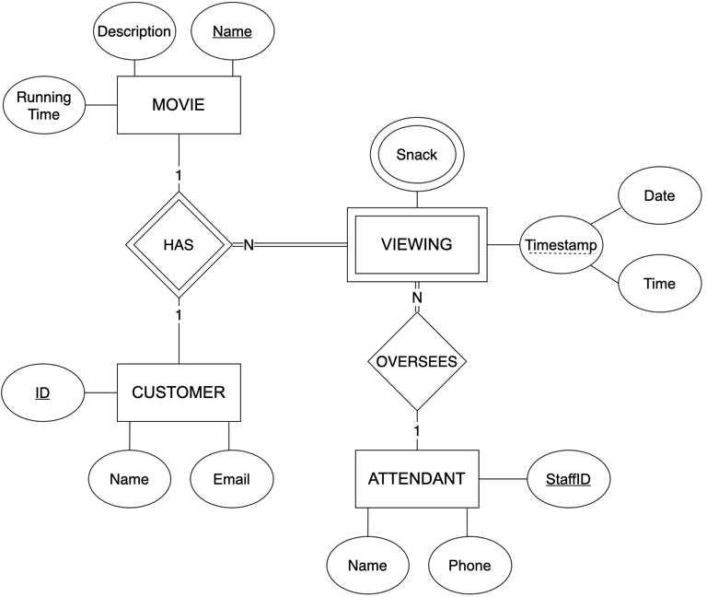

MOVIE[Name,Description,Running_Time]  
CUSTOMER[ID,Name,Email]  
VIEWING[Movie_Name,Customer_ID,Date,Time,StaffID]

* VIEWING.Movie_Name references MOVIE.Name
* VIEWING.Customer_ID references CUSTOMER.ID
* VIEWING.StaffID references ATTENDANT.StaffID

VIEWING_SNACK[Movie_Name,Customer_ID,Date,Time,Snack]

* VIEWING_SNACK.(Movie_Name, Customer_ID, Date, Time) references VIEWING

ATTENDANT[StaffID,Name,Phone]

**B.4**



BANK[Code,Name,Address]  
BRANCH[Bank_Code,Bank_Name,Number,Address]

* BRANCH.(Bank_Code, Bank_Name) references BANK(Code, Name)

LOAN[Number,Type,Amount,Bank_Code,Bank_Name,Branch_Number]

* LOAN.(Bank_Code, Bank_Name, Branch_Number) references BRANCH(Bank_Code, Bank_Name, Number)

ACCOUNT[Number,Type,Balance,Bank_Code,Bank_Name,Branch_Number]

* ACCOUNT.(Bank_Code, Bank_Name, Branch_Number) references BRANCH(Bank_Code, Bank_Name, Number)

CUSTOMER[ID,Name,Address,Phone]  
CUSTOMER_LOAN[Customer_ID,Loan_Number]

* CUSTOMER_LOAN.Customer_ID references CUSTOMER.ID
* CUSTOMER_LOAN.Loan_Number references LOAN.Number

CUSTOMER_ACCOUNT[Customer_ID,Account_Number]

* CUSTOMER_ACCOUNT.Customer_ID references CUSTOMER.ID
* CUSTOMER_ACCOUNT.Account_Number references ACCOUNT.Number

Section C: Extended Entity Relationship Diagram Mapping

Create relational mappings for the following EER Diagrams. Note: All foreign keys between tables must be stated. When mapping subclasses, please remember that there may be several correct ways. Using your intuition, try to select the most appropriate mapping method. Consult with your tutor if your answer differs from the sample solution.

## C.1

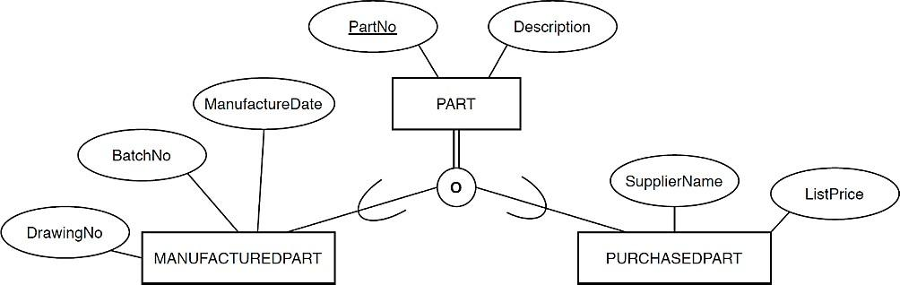

PART[PartNo,Description]  
MANUFACTURED_PART[PartNo,ManufactureDate,BatchNo,DrawingNo]

* MANUFACTURED_PART.PartNo references PART.PartNo

PURCHASED_PART[PartNo,SupplierName,ListPrice]

* PURCHASED_PART.PartNo references PART.PartNo

**C.2**

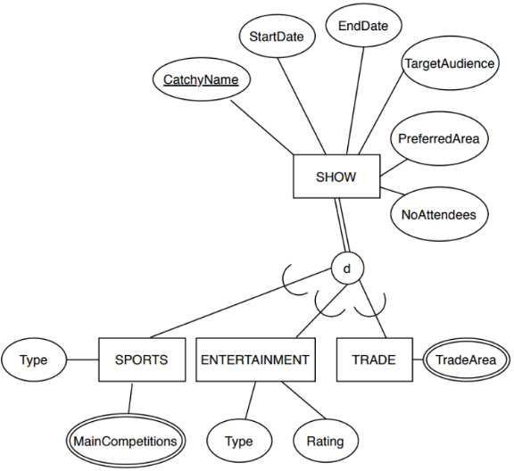

SHOW[CatchyName,StartDate,EndDate,TargetAudience,PreferredArea,NoAttendees]  
SPORTS[CatchyName,Type]

* SPORTS.CatchyName references SHOW.CatchyName

SPORTS_MAIN_COMPETITIONS[CatchyName,MainCompetition]

* SPORTS_MAIN_COMPETITIONS.CatchyName references SPORTS.CatchyName

ENTERTAINMENT[CatchyName,Type,Rating]

* ENTERTAINMENT.CatchyName references SHOW.CatchyName

TRADE[CatchyName]

* TRADE.CatchyName references SHOW.CatchyName

TRADE_TRADEAREA[CatchyName,TradeArea]

* TRADE_TRADEAREA.CatchyName references TRADE.CatchyName