# Lecture 4

Mean (Average) Memory Access Time: the average time it takes the CPU to fetch a word from sort of memory (the fetch in the fetch-decode-execute cycle).

Analogy:

You want some dinner:

Sometimes the food you want is in the fridge

Sometimes the food you want is at Costco

Sometimes the food is in between: corner store, save-on-foods, market etc

The Mean Food Access Time is the average time it takes you to get your food.

Computer:

CPU wants a word:

Sometimes the word the cpu wants is in the registers

Sometimes the word the cpu wants is on the hard disk drive

Sometimes the word the cpu wants is in between: cache(s), RAM

The Mean Memory Access Time is the average time it takes the cpu to get its word.

A “hit” is when the requested word is found.

A “miss” is when the requested word is not found there; in this case the next level of memory is checked.

Start with a simple case: ONE level of cache, plus main memory:

Mean Memory Access Time = cache access time + (1 – hit rate) * main-memory access time

MAT = c + (1-h)m

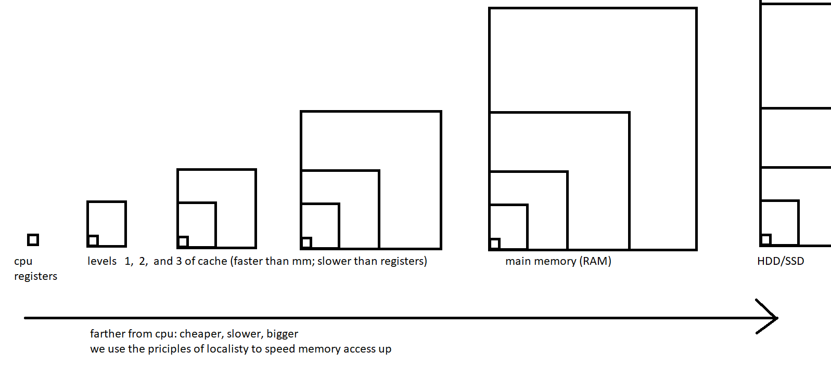

Start with a simple case: ONE level of cache, plus main memory:

Mean Memory Access Time = cache access time + (1 – hit rate) * main-memory access time

MAT = c + (1-h)m

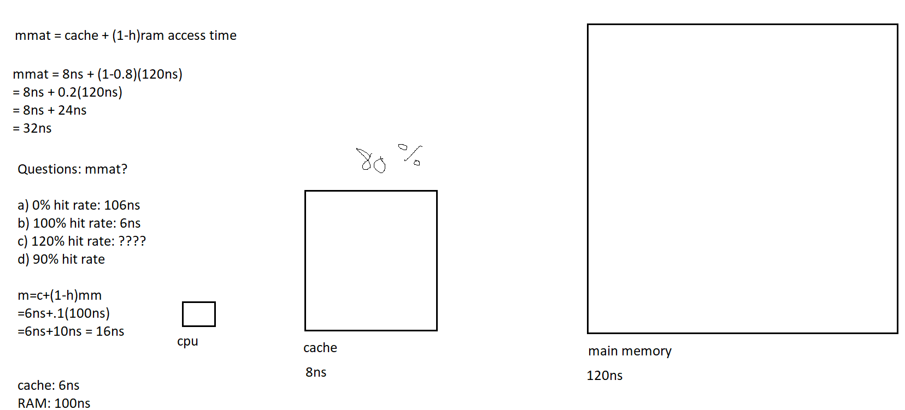

QUESTIONS:

1. What is the MAT if the hit rate is 100%?

The MAT would be the same as the cache access time. But this is impossible. Cache gets loaded only on misses. Main memory must be accessed sooner or later.

1. What is the MAT if the hit rate is 0%?

This means nothing that the cpu wants is found in the cache. Time was wasted by looking in the cache. Cache can therefore actually SLOW down the cpu, by having nothing in it, or by having the “wrong words” in it. The MAT is the cache time PLUS main memory access time.

1. What is the MAT if the hit rate is 90%? MM takes 80ns; cache takes 6ns.

MAT = 6ns + (1 – 0.9)80ns = 6ns + .1*80ns = 6ns + 8ns = 14ns

1. What is the MAT if there are TWO levels of cache? Level 1 has an access time of 2ns. Level 2 has an access time of 10ns. Main memory has an access time of 80ns. 200 requests by the cpu were made: 120 were hits in level 1. 60 were hits in level 2. The rest were hit in main memory.

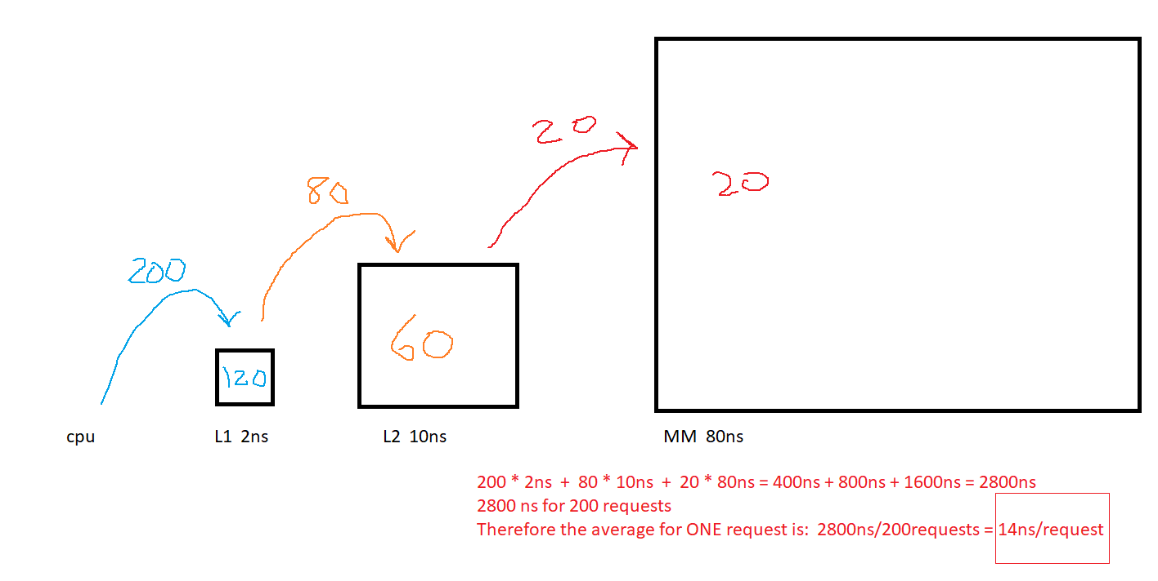

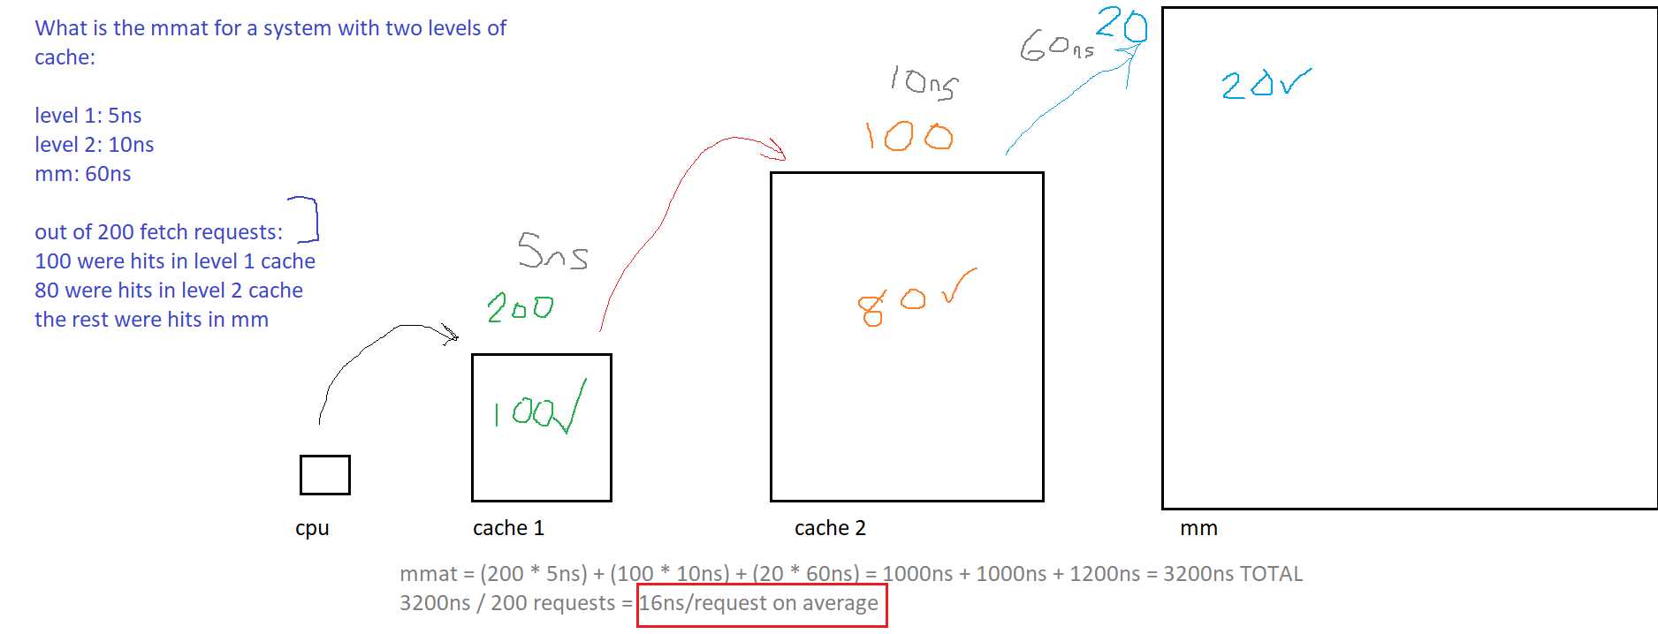

What is the mean access time for a system with three levels of cache:

level 1: 4ns

level 2: 12ns

level 3: 20ns

mm: 200ns

300 requests:

200 hits in level 1

50 hits in level 2

35 hits in level 3

the rest hits in mm

-------------------------------------------------

(300 * 4ns) + (100 * 12ns) + (50 * 20ns) + (15 * 200ns)

1200ns + 1200ns + 1000ns + 3000ns

6400ns total time for 300 requests

6400ns/300requests = 21.3333 ns/request

1. What is the MAT if there are THREE levels of cache? Level 1 has an access time of 3ns. Level 2 has an access time of 12ns. Level 3 has an access time of 20ns. Main memory has an access time of 100ns. 300 requests by the cpu were made: 200 were hits in level 1. 60 were hits in level 2. 30 were hits in level 3. The rest were hits in main memory.

Four levels? Good quiz question.

# Hard-Disk Drives

Secondary memory

HDDs are magnetic. They spin. They have concentric circles.

An optical drive (eg DVD) uses lasers and has spirals.

<https://www.youtube.com/watch?v=NtPc0jI21i0>

Question #20, Page 144:

How long does it take to read a disk with 10,000 cylinders, each containing four tracks of 2048 sectors? First, all the sectors of track 0 are to be read starting at sector 0, then all the sectors of track 1 starting at sector 0, and so on. The rotation time is 10 msec, and a seek takes 1 msec between adjacent cylinders and 20 msec for the worst case. Switching between tracks of a cylinder can be done instantaneously.

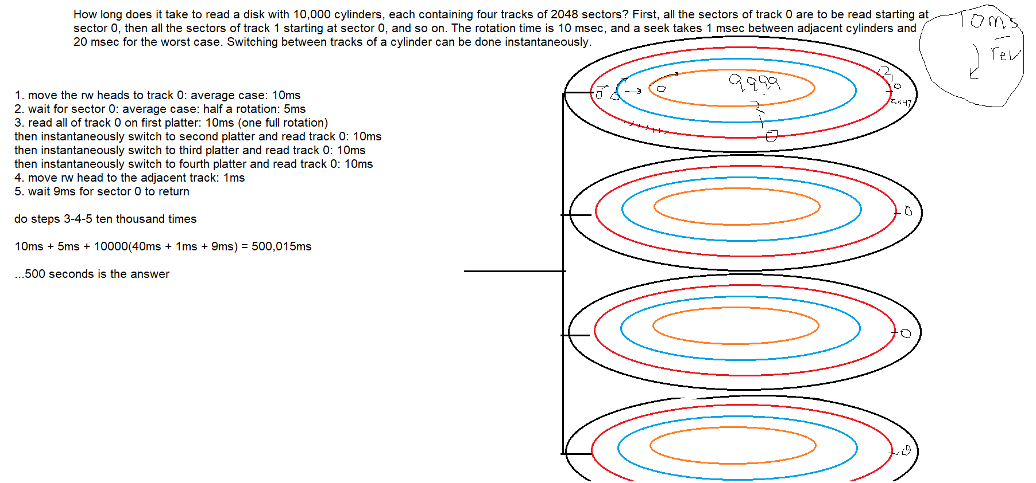

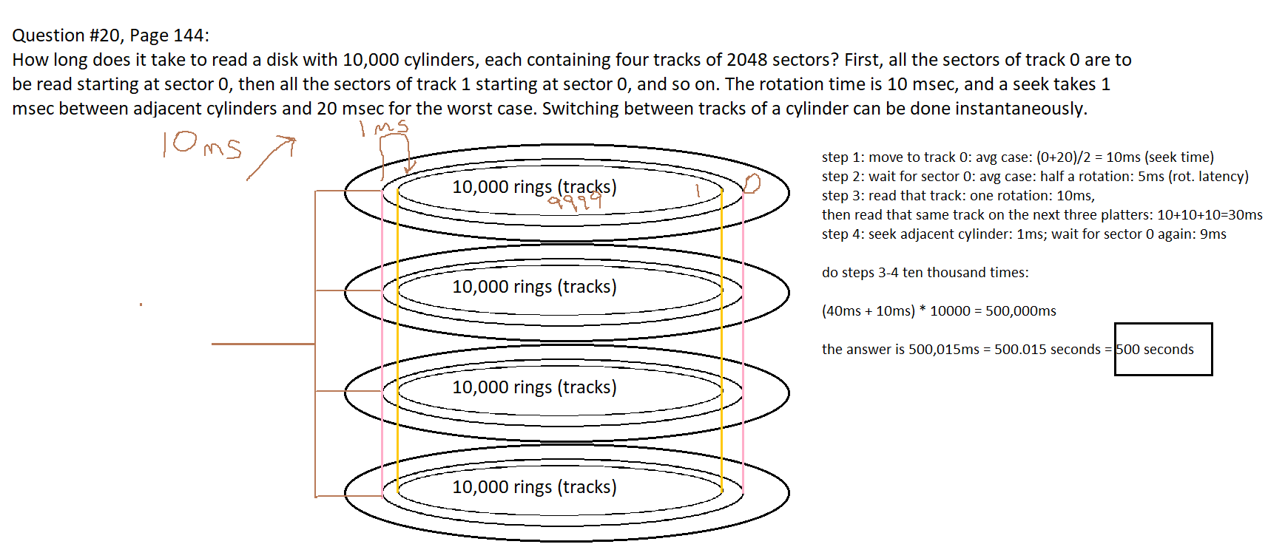

How long does it take to read a disk with 4000 cylinders, each containing five tracks of 128 sectors? First, all the sectors of track 0 are to be read starting at sector 0, then all the sectors of track 1 starting at sector 0, and so on. The rotation rate is 7200 RPM, and a seek takes 2 msec between adjacent cylinders and 18 msec for the worst case. Switching between tracks of a cylinder can be done in 3ms.

