Lesson 8

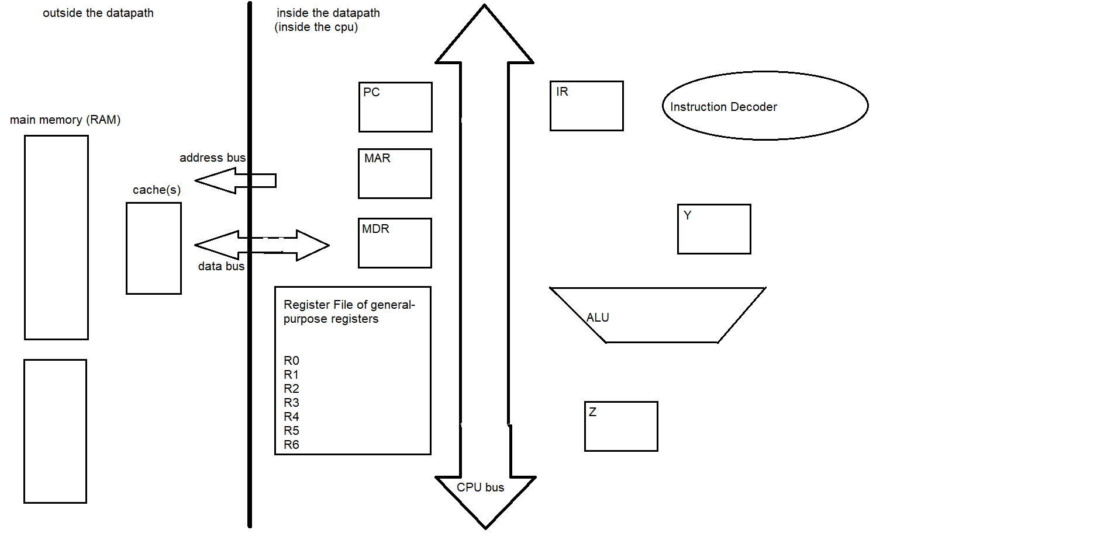

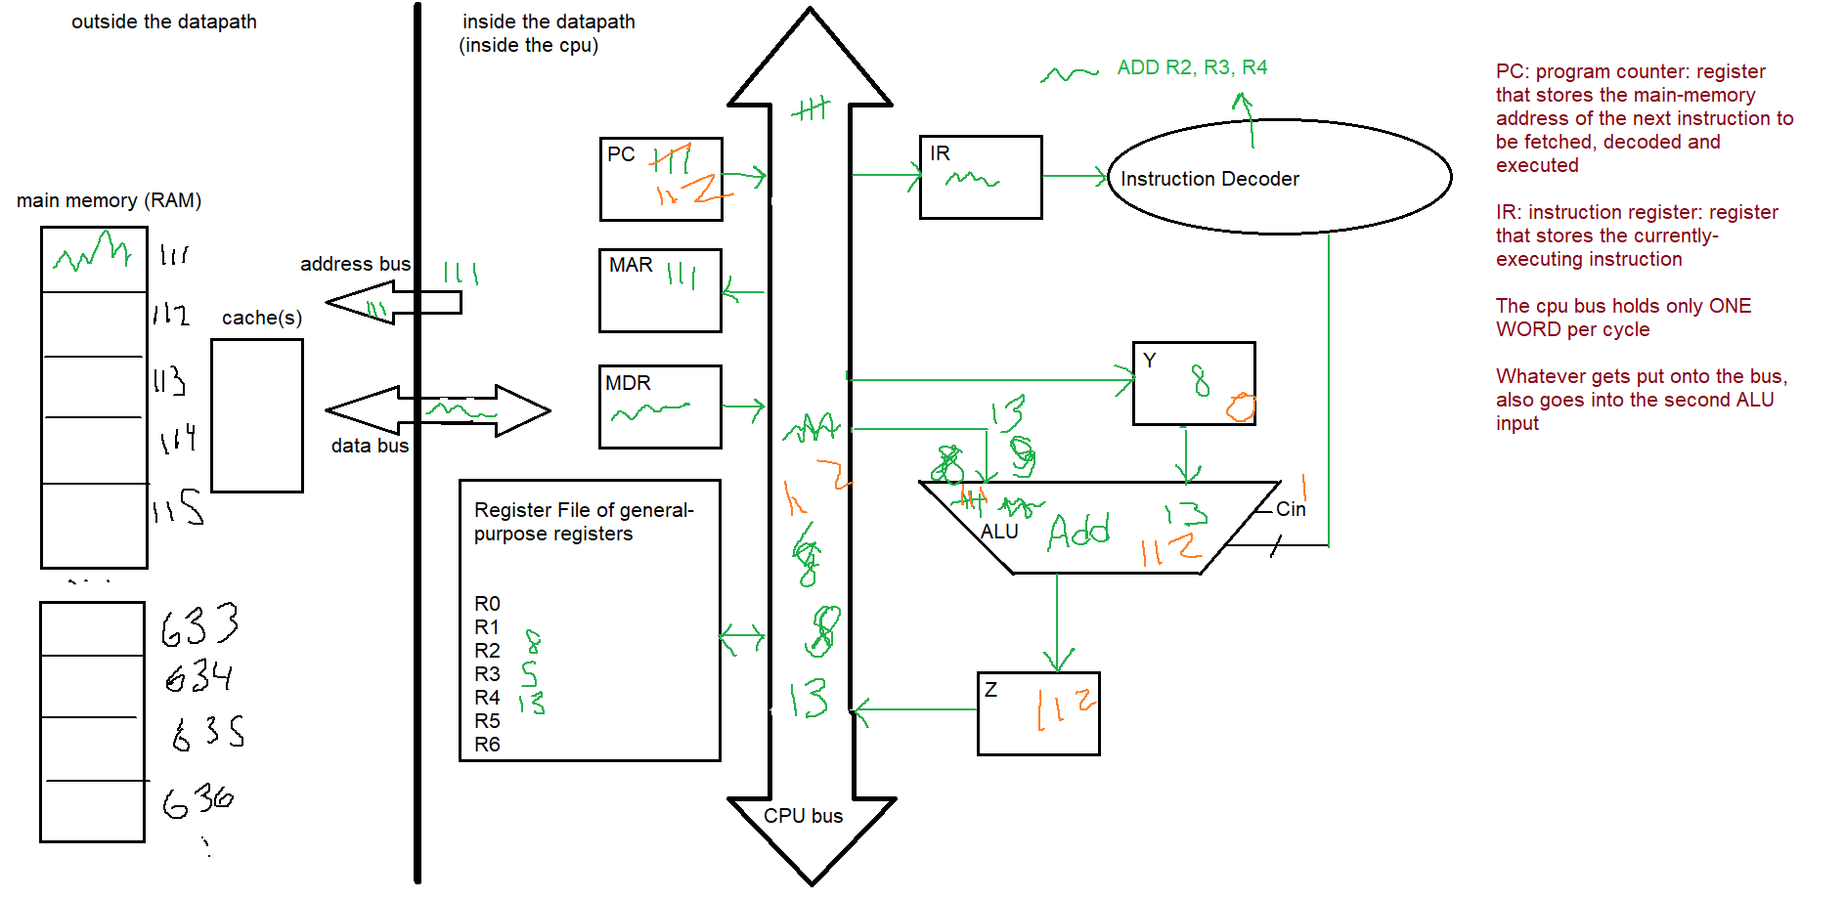

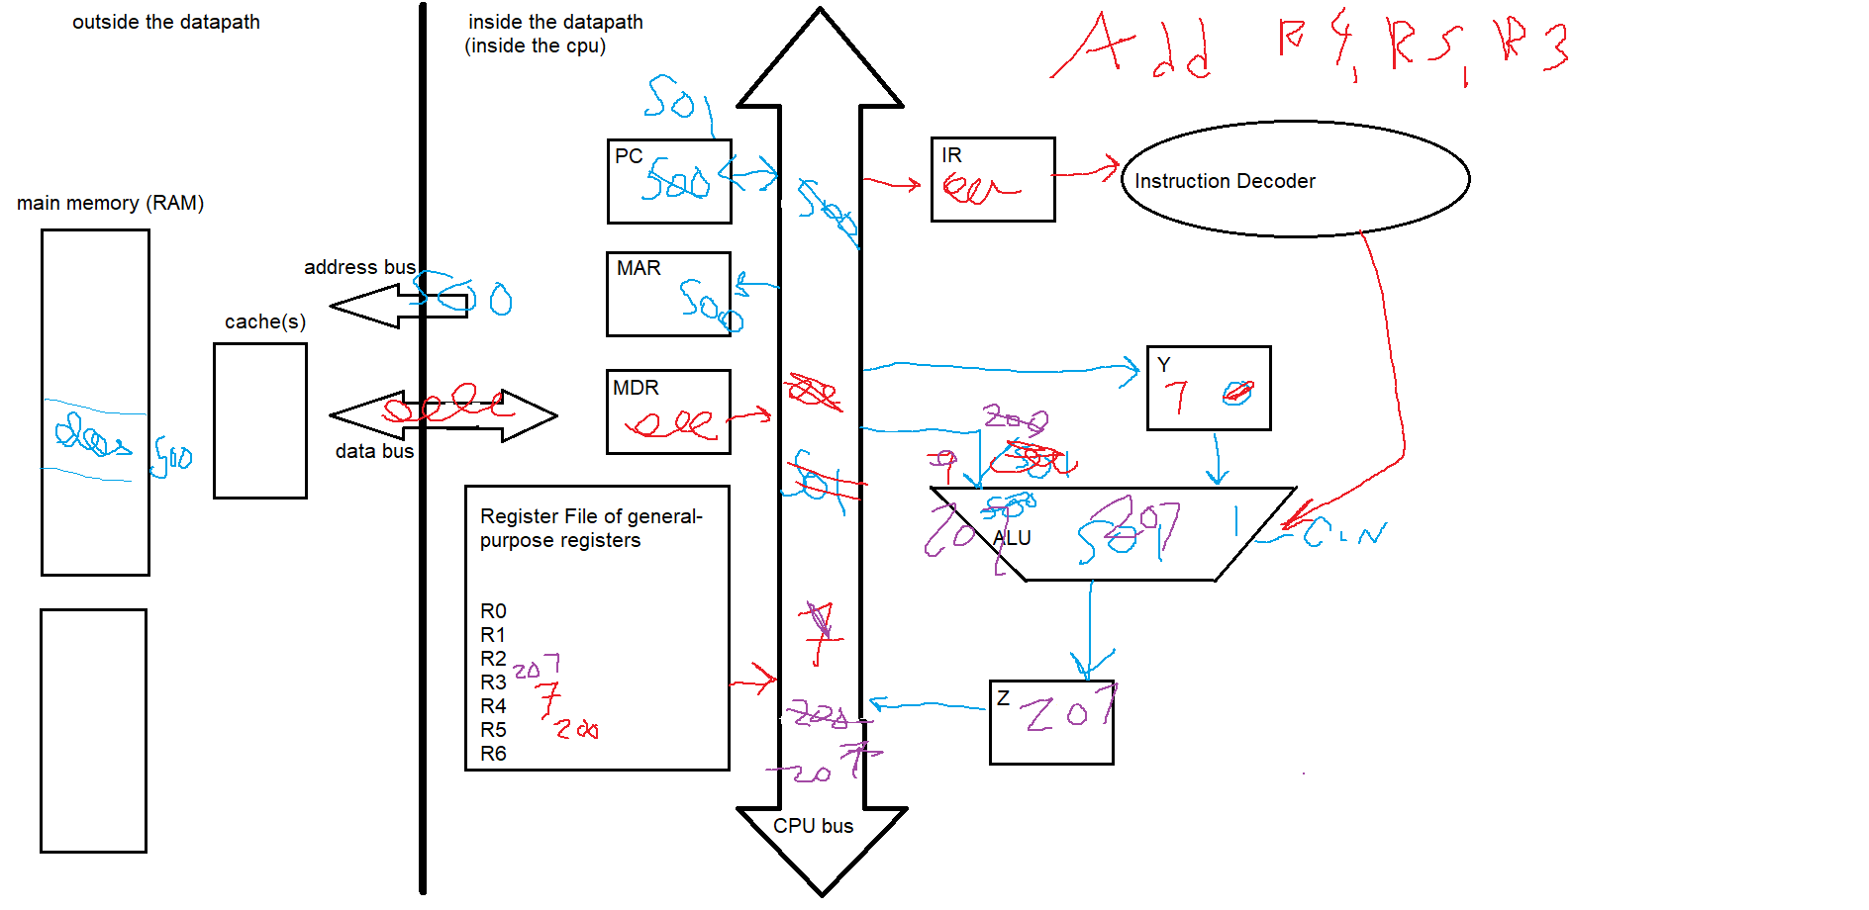

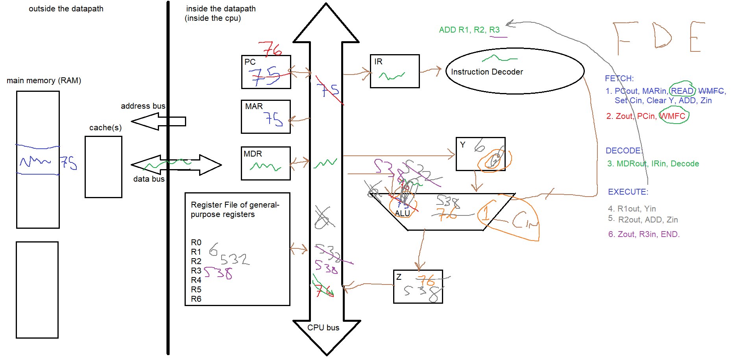

NEW QUESTION: Show the microcode to FDE the instruction “ADD R1, R1, R1” (note: the final operand always shows just where to put the result): add whatever is in register R1 to itself and store it back into R1.

FETCH and DECODE are identical always for this same datapath:

1. PCout, MARin, READ, Set Cin, Clear Y, ADD, Zin
2. Zout, PCin, WMFC
3. MDRout, IRin, DECODE
4. R1out, Yin, ADD, Zin
5. Zout, R1in, END.

NEW QUESTION: Show the microcode to FDE the instruction “ADD R1, R2, R3, R4” (note: the final operand always shows just where to put the result)

1. PCout, MARin, READ, Set Cin, Clear Y, Add, Zin  
2. Zout, PCin, WMFC  
3. MDRout, IRin, DECODE  
4. R1out, Yin  
5. R2out, ADD, Zin  
6. Zout, Yin  
7. R3out, ADD, Zin  
8. Zout, R4in, END.

NEW QUESTION: Show the microcode to FDE the instruction “ADD R1, R2, R3, R4” (note: the final operand always shows just where to put the result)

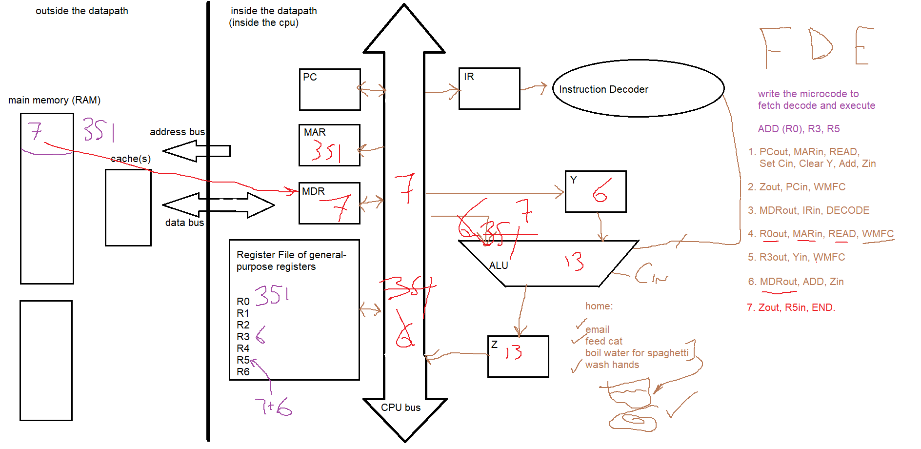

NEW QUESTION: Show the microcode to FDE the instruction “ADD R2, ((R1)), R3” (note: the final operand always shows just where to put the result)

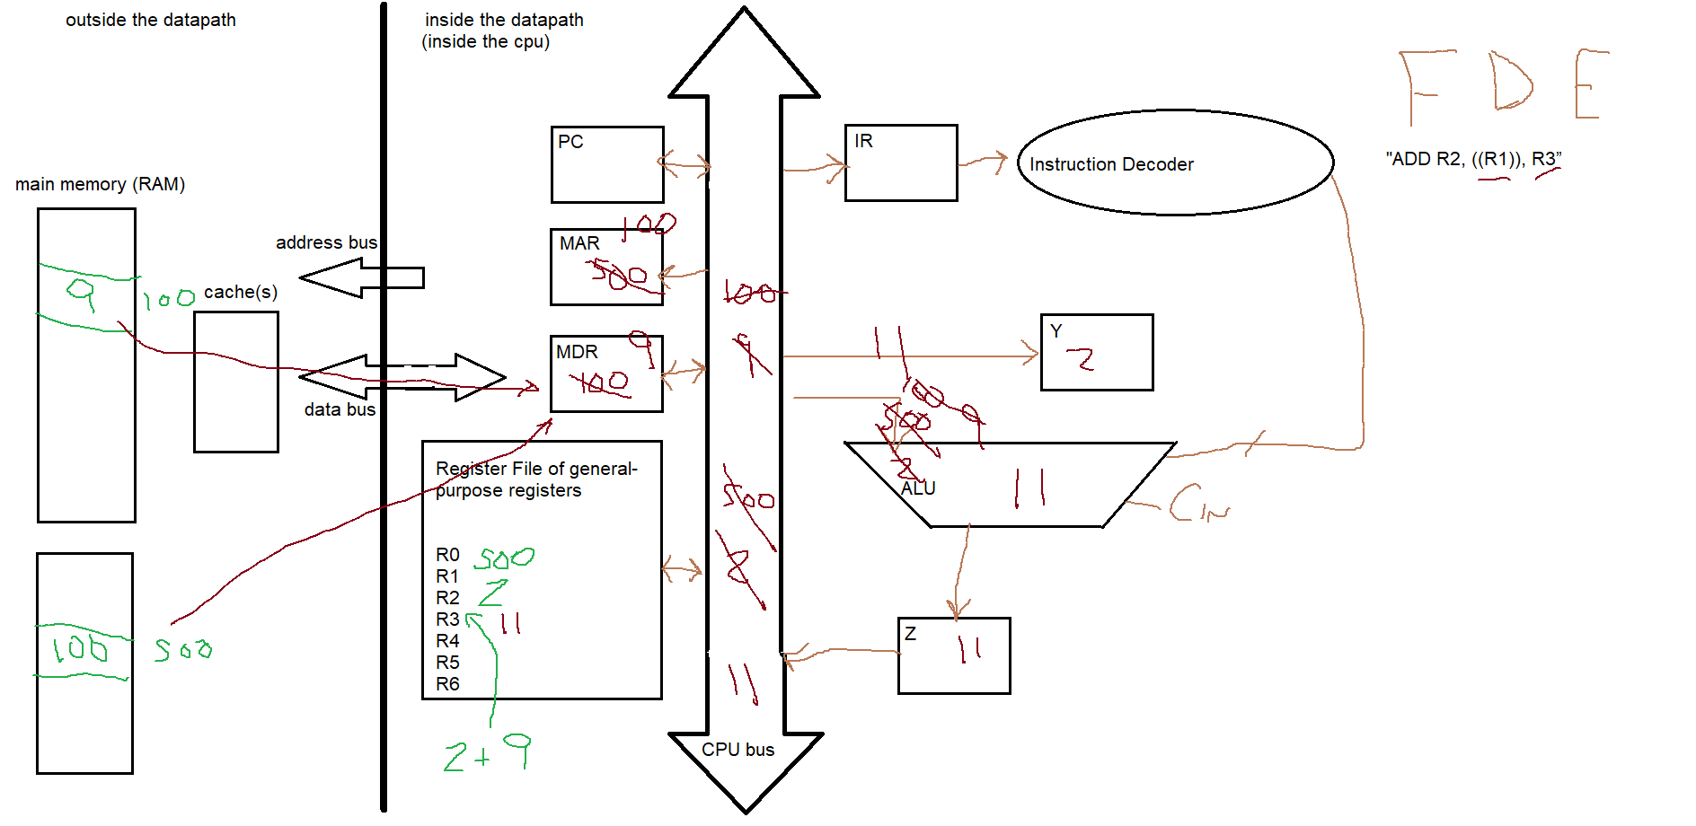

1. PCout, MARin, READ, Set Cin, Clear Y, ADD, Zin  
2. Zout, PCin, WMFC  
3. MDRout, IRin, DECODE  
4. R1out, MARin, READ  
5. R2out, Yin, WMFC  
6. MDRout, MARin, READ, WMFC  
7. MDRout, ADD, Zin  
8. Zout, R3in, END

NEW QUESTION: Show the microcode to FDE the instruction “ADD R1, R2, (R3)”

