|  |  |  |  |
| --- | --- | --- | --- |
| **a** | **b** | **a or b** | **a nor b** |
| 0 | 0 | 0 | 1 |
| 0 | 1 | 1 | 0 |
| 1 | 0 | 1 | 0 |
| 1 | 1 | 1 | 0 |

1 nor anything is 0

To build a 1-bit memory, we will begin with an S-R latch.

Q stores the bit

S means set Q to 1

R means set Q to 0

Neither set it, nor reset it: leave Q alone (memory)

|  |  |  |
| --- | --- | --- |
| **S** | **R** | **Q** |
| 0 | 0 | Q (MEMORY STATE) |
| 0 | 1 | 0 |
| 1 | 0 | 1 |
| 1 | 1 | ????? |

Today we will have to go through a process of evolution to try to build a memory:

1. SR Latch
2. Unclocked D Latch
3. Clocked D Latch
   1. Edge Trigger (aka Pulse Generator)
4. Flip Flop

THE SR LATCH performs the top three rows of the SRQ truth table just fine. It can remember a bit at Q. It can set the bit at Q to 1; it can reset the bit at Q to 0. Those are great. However:

1. It also allows us to do something stupid: set AND reset at the same time
2. S = R = 1 ends up with Q = ~Q

So the SR Latch is broken as a 1-bit memory. Let’s fix it.

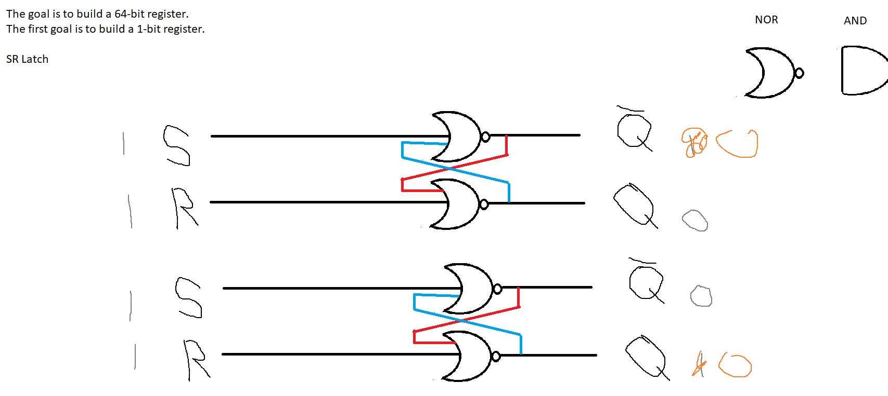

Introducing the unclocked D latch (D = data):

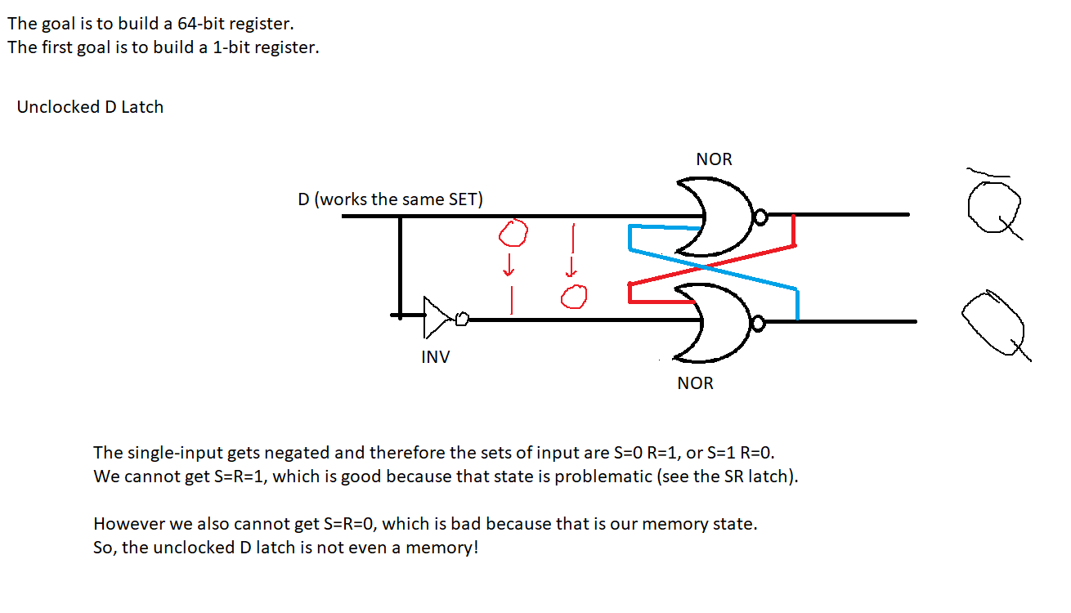

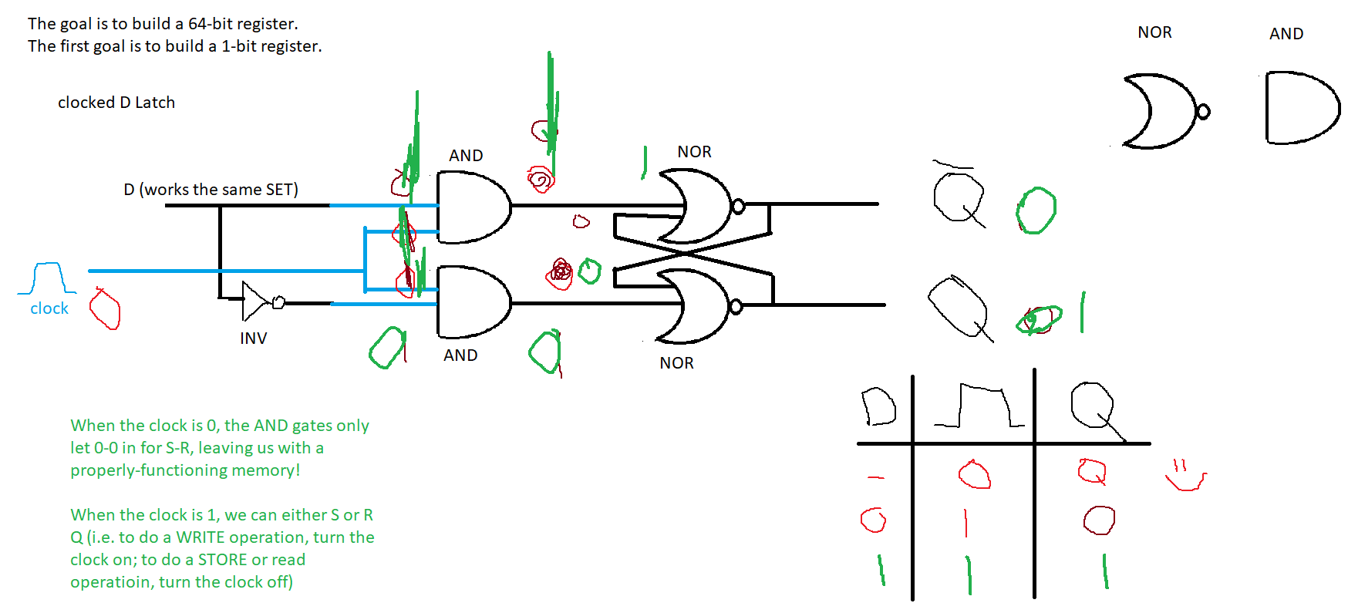

RISING EDGE TRIGGER (AKA PULSE GENERATOR)

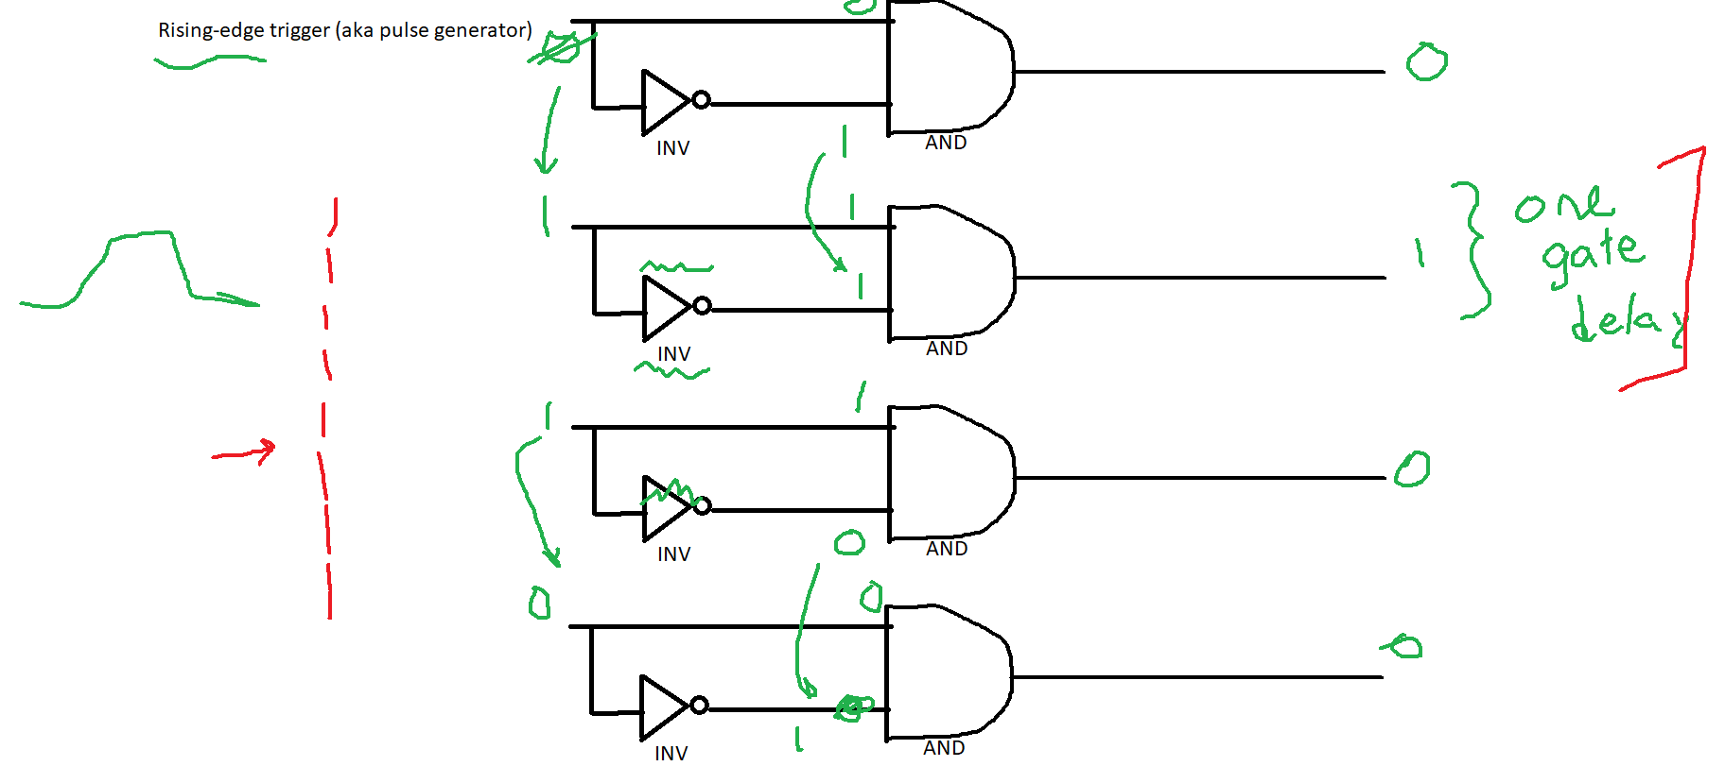

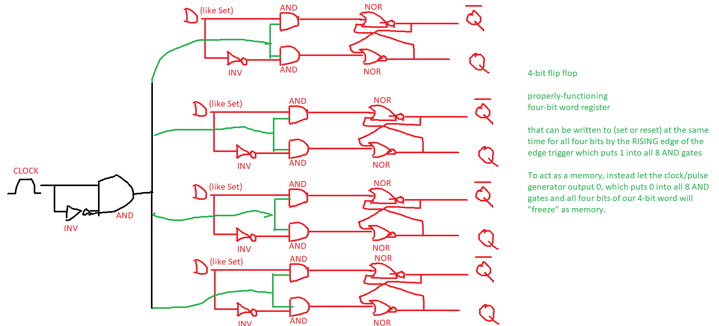

# Multiplexers

Combinational circuit with the following properties:

ONE output

n control signals

2^n inputs

The control signals select one input, to be the output

Analogy: American Idol or AGT

ONE output: the winning contestant

n control signals: the judges

many inputs: the contestants

The judges select one contestant, to be the winner

|  |  |  |  |  |
| --- | --- | --- | --- | --- |
| **row** | **a** | **b** | **Sum** | **Carry out** |
| 0 | 0 | 0 | 0 | 0 |
| 1 | 0 | 1 | 1 | 0 |
| 2 | 1 | 0 | 1 | 0 |
| 3 | 1 | 1 | 0 | 1 |

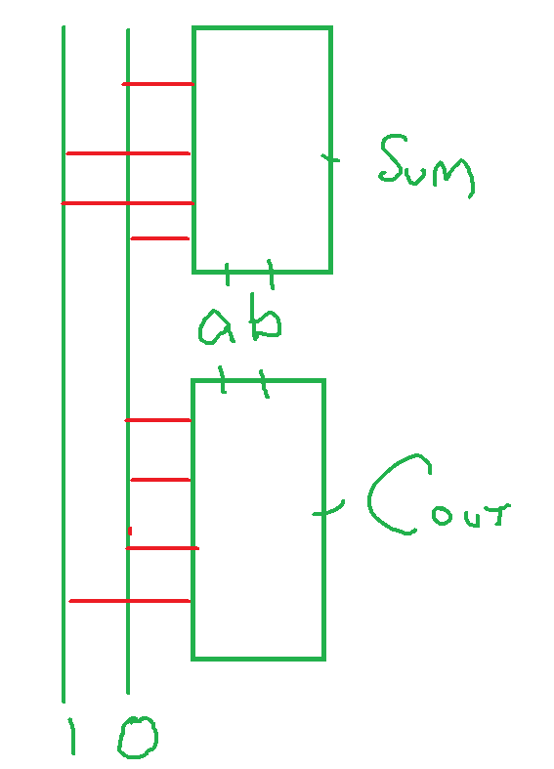

Draw a truth table and multiplexer implementation of the following problem:

A red light goes on if:

* The water is high and hot

A green light goes on if:

* The water is not hot
* Or
* The water is not high

A blue light goes on if:

* The water is hot and pressurized

|  |  |  |  |  |  |
| --- | --- | --- | --- | --- | --- |
| input | input | input | output | output | output |
| **High** | **Hot** | **Pressurized** | **red** | **green** | **blue** |
| 0 | 0 | 0 | 0 | 1 | 0 |
| 0 | 0 | 1 | 0 | 1 | 0 |
| 0 | 1 | 0 | 0 | 1 | 0 |
| 0 | 1 | 1 | 0 | 1 | 0 |
| 1 | 0 | 0 | 0 | 1 | 0 |
| 1 | 0 | 1 | 0 | 1 | 1 |
| 1 | 1 | 0 | 1 | 0 | 0 |
| 1 | 1 | 1 | 1 | 0 | 1 |

