# Decoder

Circuit with these properties:

ONE n-bit input

2^n outputs

Exactly one output is enabled (by the input)

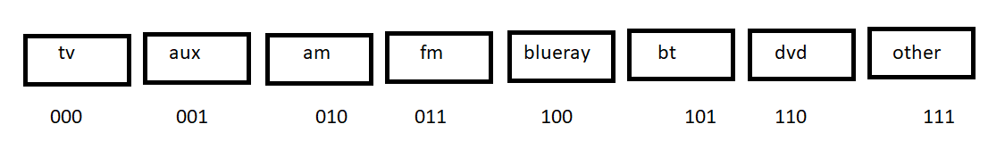

A decoder is a selector.

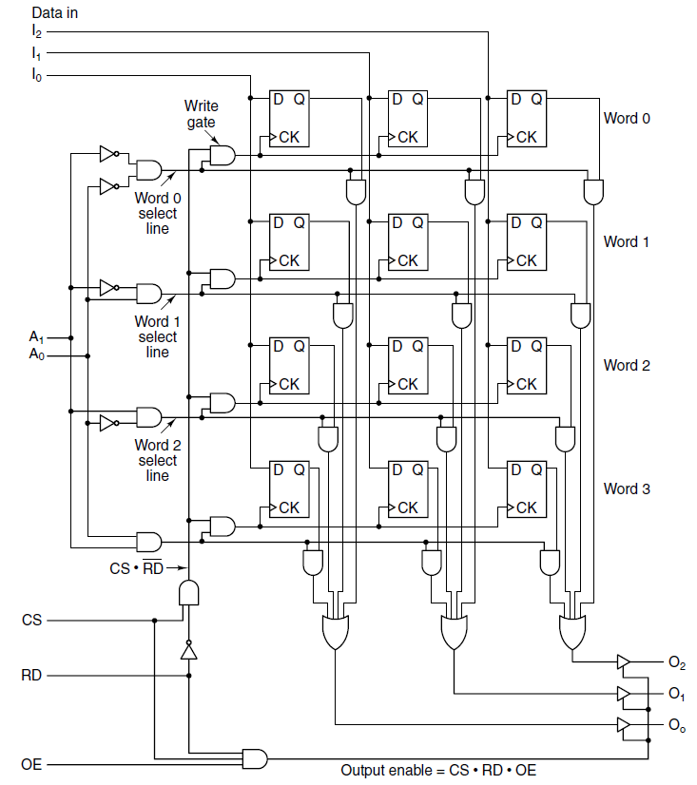

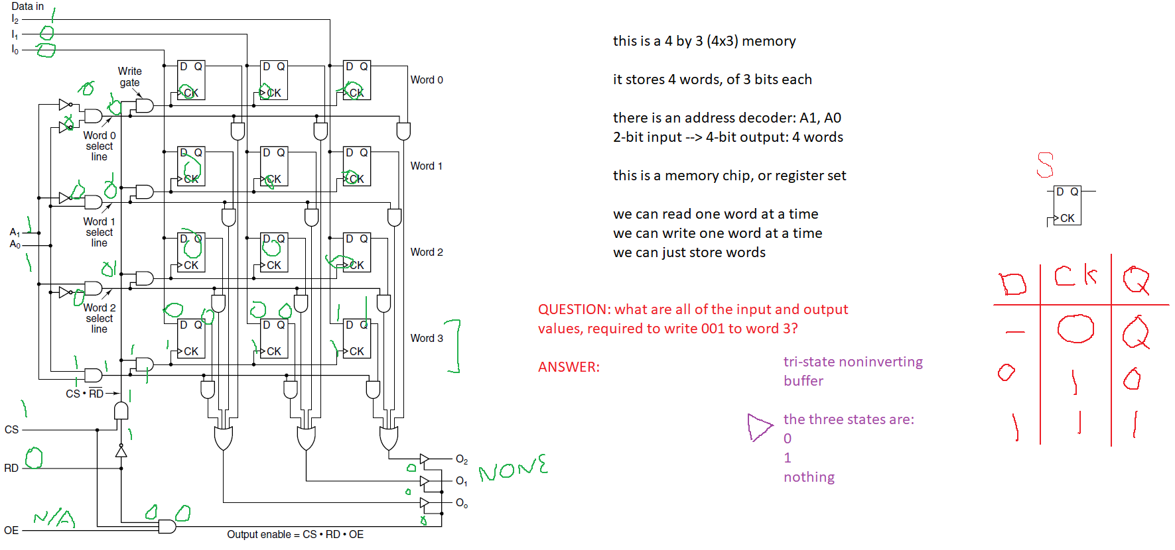

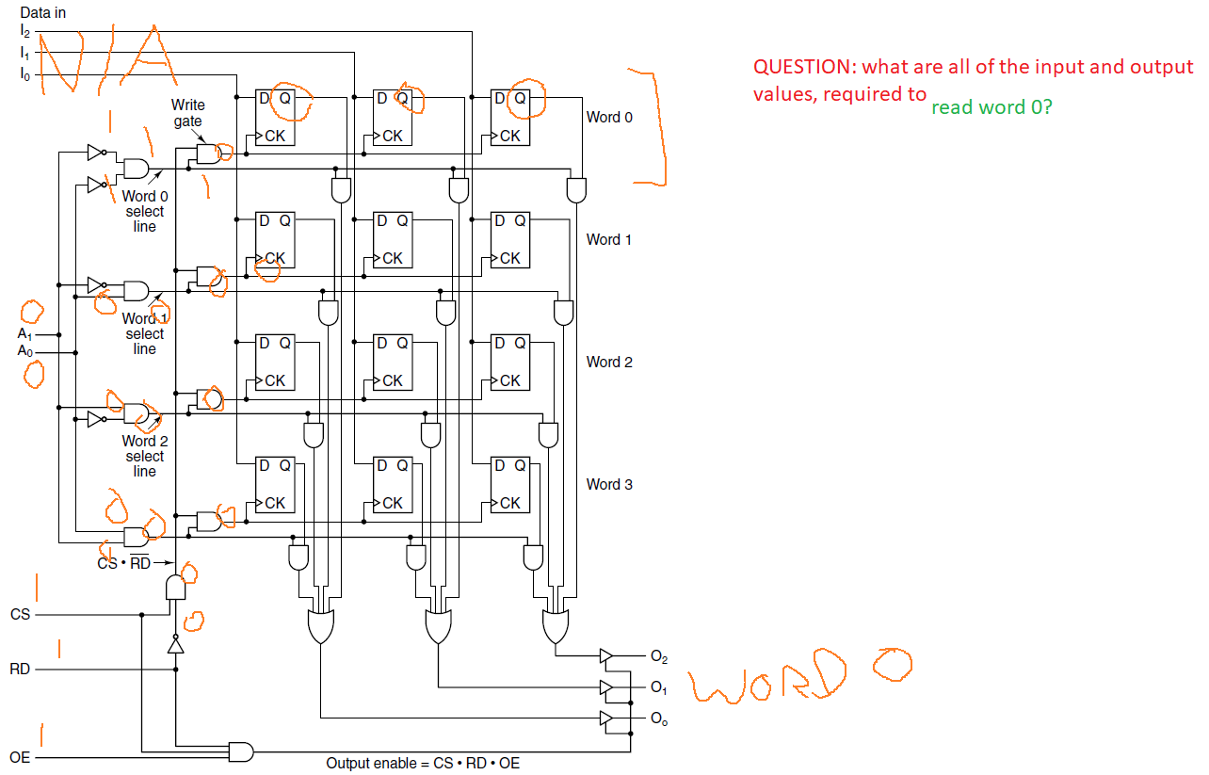

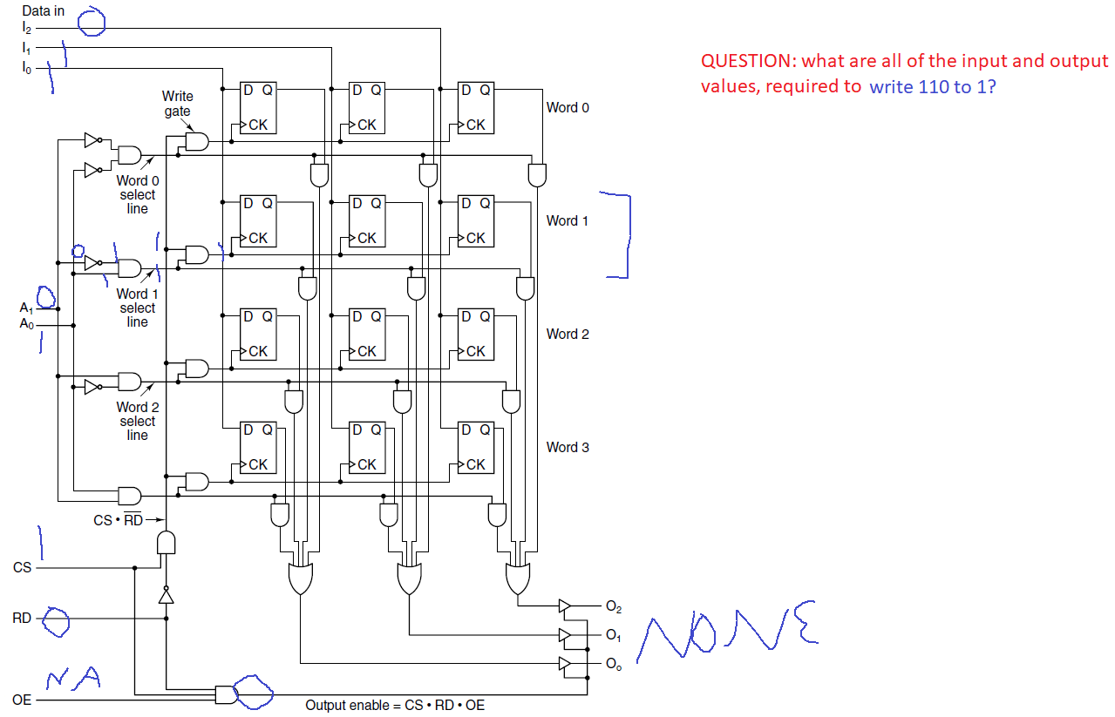

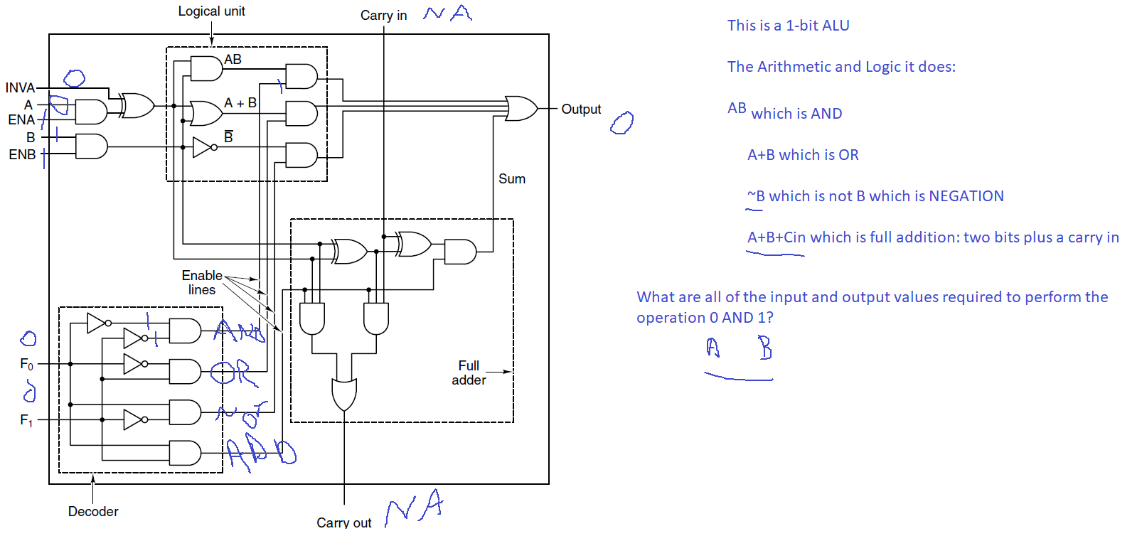

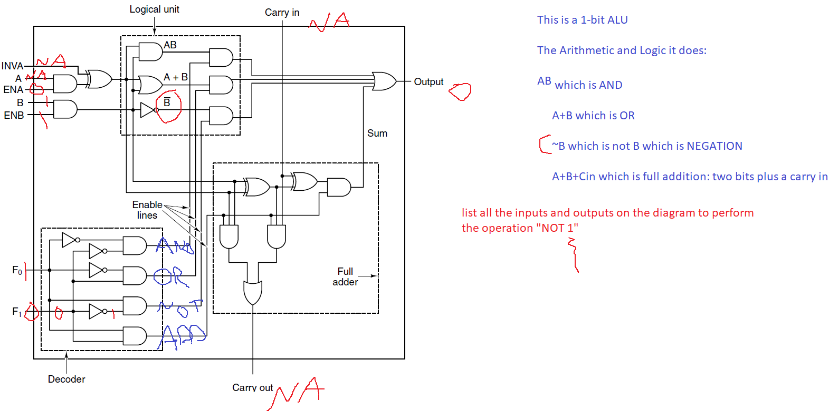

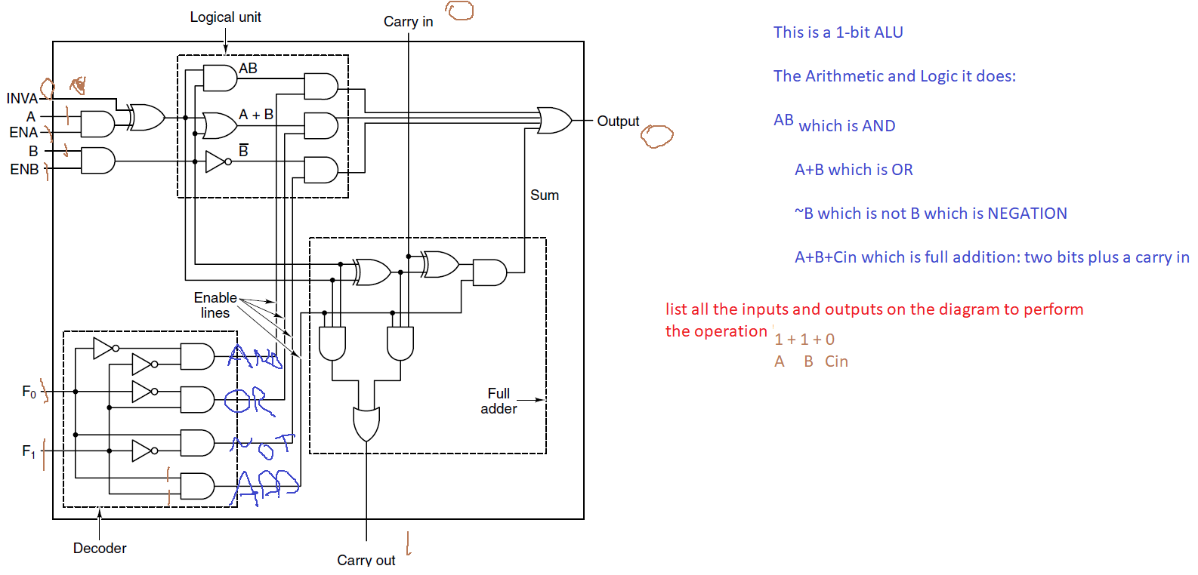

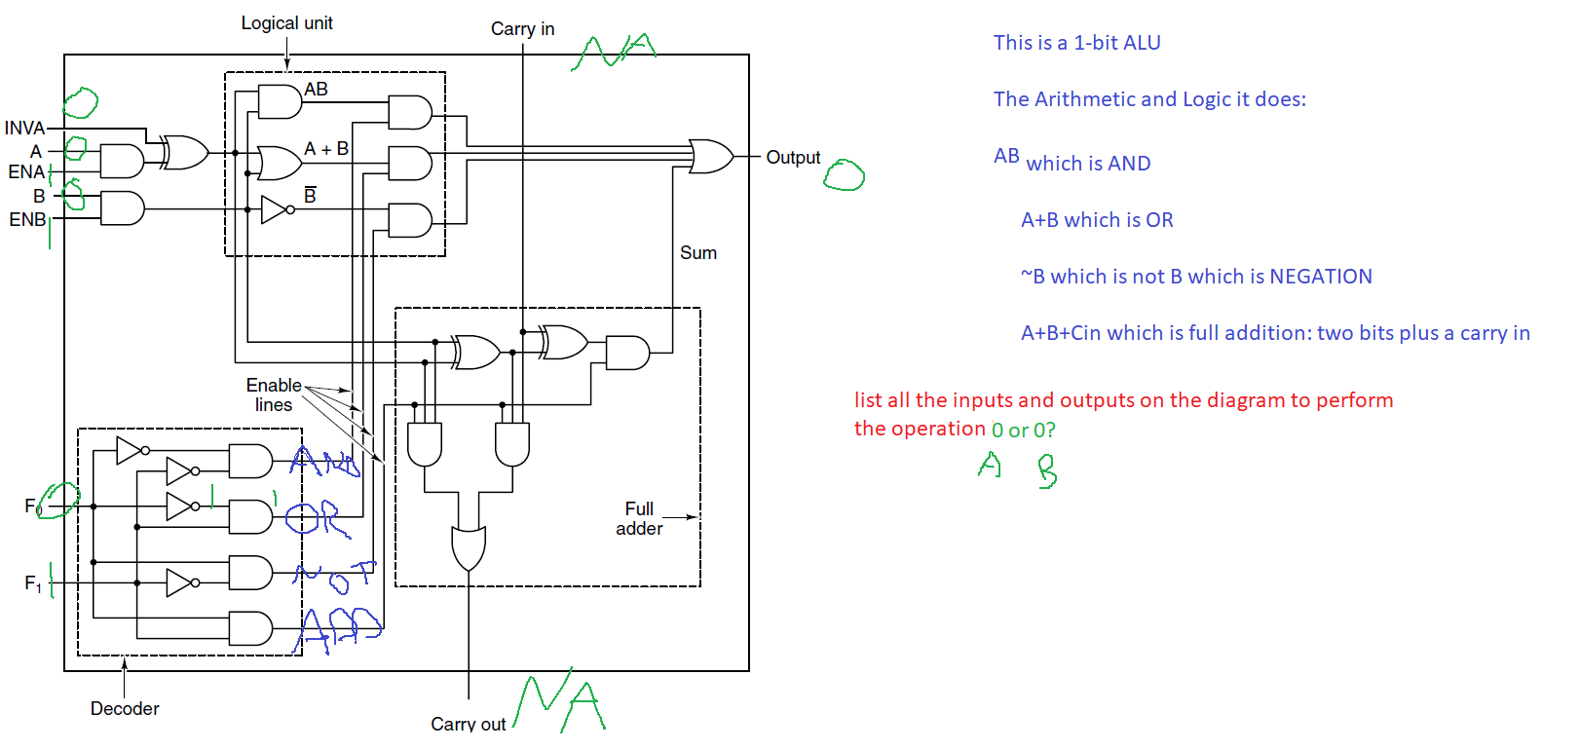

# Bit Shifters:

Imagine a 4-bit word:

0110 which is 6 in base ten

Now left shift it:

1100 which is 12 in base ten

Or right shift 0110 🡪 0011 which is 3 in base ten

So left shift means: multiply by 2

So left shift means: divide by 2

The result of shifting a four-bit word is another four-bit word (with the bits shifted)

