# Q1

## a.

**ConsoleApp/Activity.java**

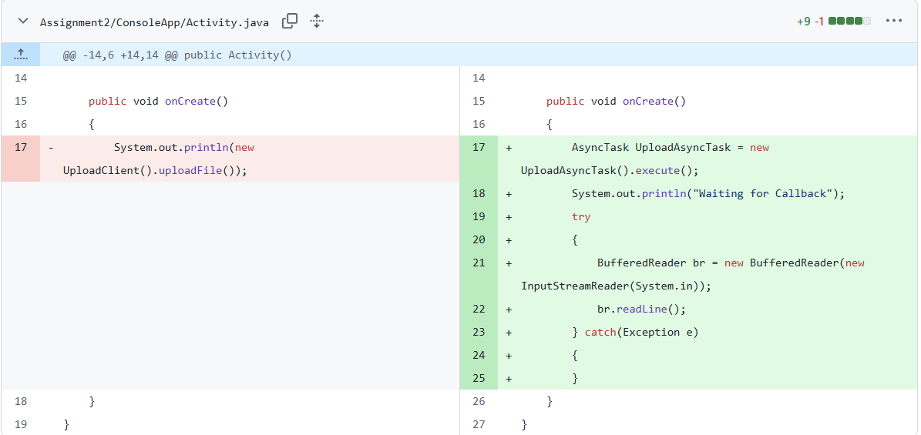

**ConsoleApp/UploadAsyncTask.java**

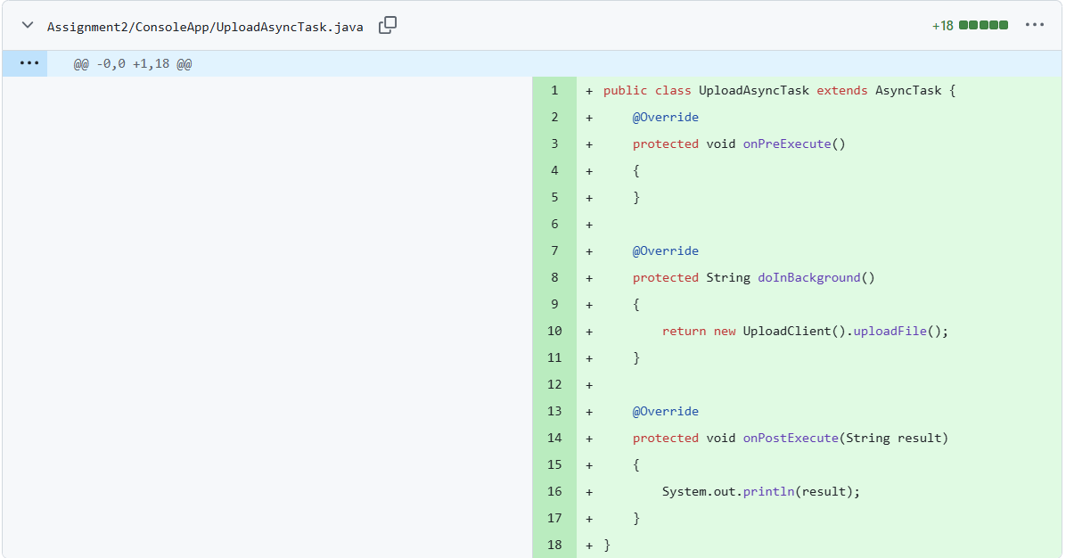

## b.

### A: Limit simultaneous file uploads to 3 using a fair Semaphore

**UploadServer/UploadServlet.java**

1. Declaration and creation of the semaphore: Added import and a static, fair semaphore

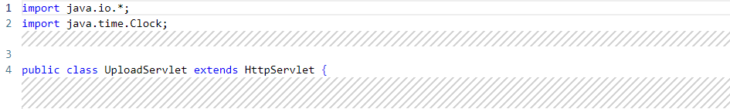

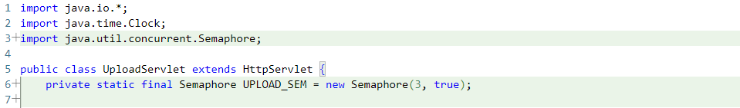

1. acquire() and release(): Wrapped the existing upload handling code in doPost() with acquire/release using try/finally:

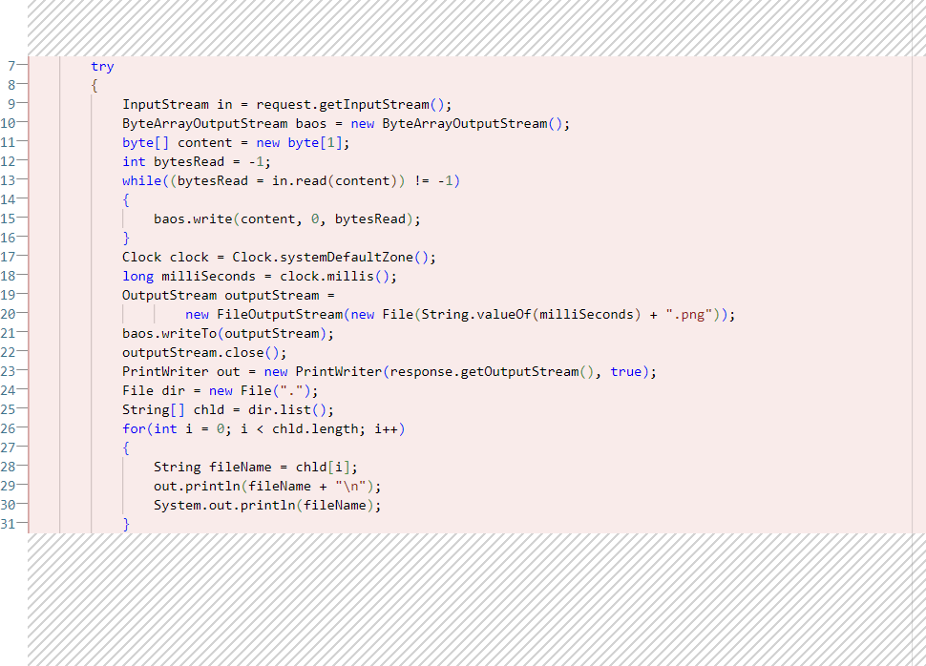

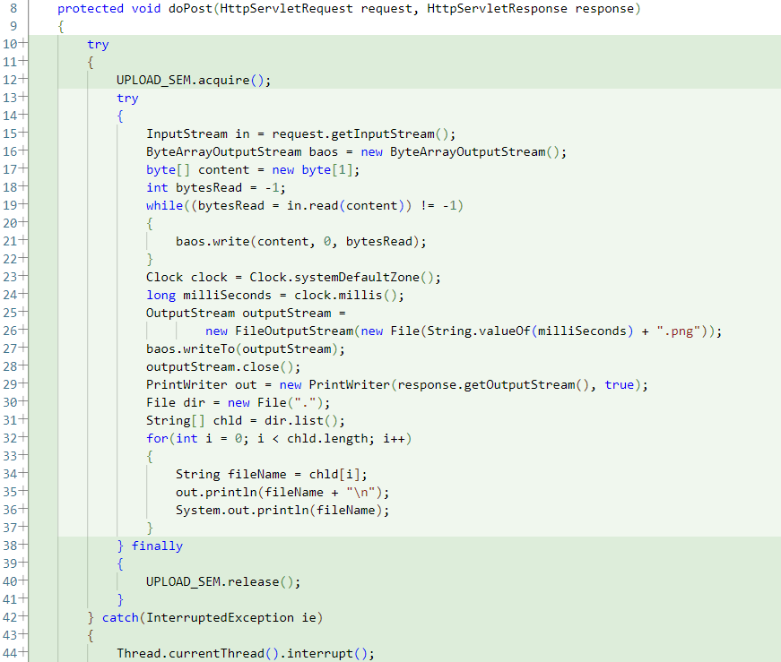

### B: Limit concurrently accepted TCP connections to 3 using a fair Semaphore

1. Declaration and creation of the semaphore:

Add the import and a static, fair semaphore

**UploadServer/UploadServer.java**

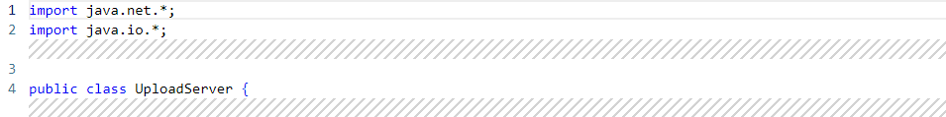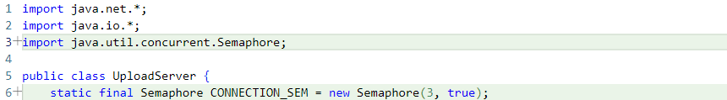

1. acquire() before accepting connections:

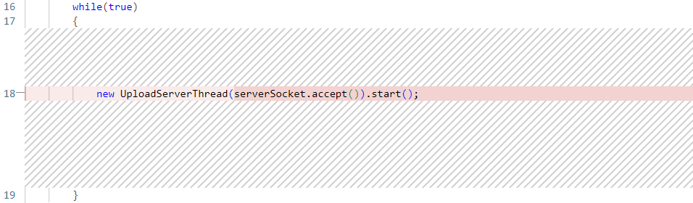

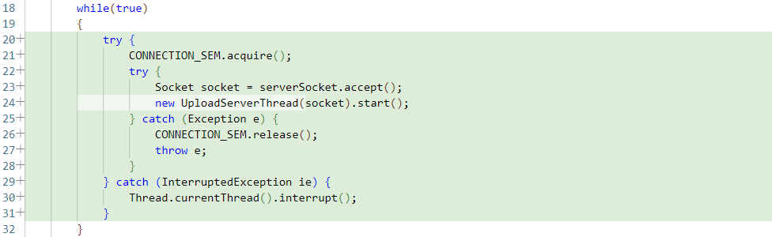

1. release() when the connection-handling thread completes: release the permit in a finally block when the per-connection handling is done

**UploadServer/UploadServerThread.java**

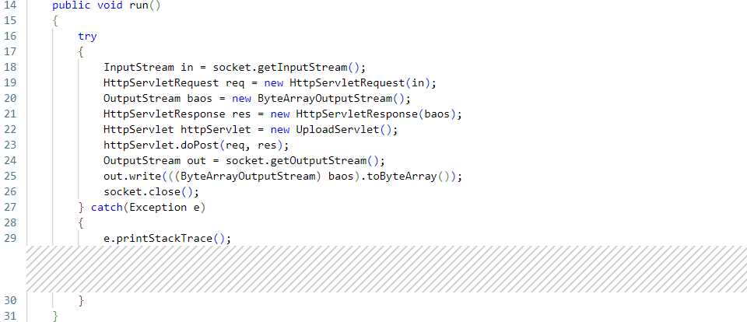

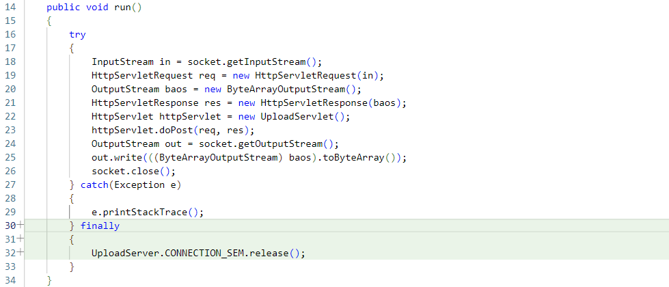

# Q2

## a.

T2: 1 T1: 1

T1: 1 T2: 1

T2: 1 T1: 2

T1: 1 T2: 2

T2: 2 T1: 2

T1: 2 T2: 2

## b.

T1: 1 T2: 2

T2: 1 T1: 2

## c.

T1: 1 T2: 2

T2: 1 T1: 2

## d.

