Lab 11 - Hypothesis Testing
Jerry Xing
Nov 20, 2025

Question 1
n <- sum(!is.na(survey$Pulse))
hist(survey$Pulse, breaks = 15)
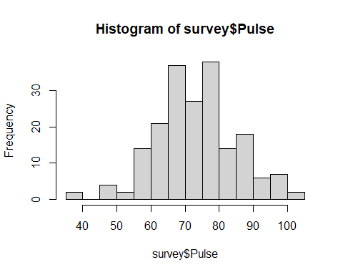

a
$H_{0}:μ=75$
$H_{1}:μ≠75$
t.test(survey$Pulse, mu = 75, alternative = "two.sided")$p.value
## [1] 0.3154326
There is not enough evidence to reject the claim that the mean pulse of students at University of Adelaide is 75.0 beats per minute(p-value = 0.3154)

b
$H_{0}:μ≤75$
$H_{1}:μ>75$
female.pulse <- filter(survey, survey$Sex == "Female")$Pulse
t.test(female.pulse, mu = 75, alternative = "greater")$p.value
## [1] 0.4571387
There is insufficient evidence at the 0.05 significance level to support the claim that the mean pulse rate of students at University of Adelaide is greater than 75 beats per minute(p-value = 0.4571 > 0.05)

Question 2

a
runHypothesis <- function(X.data, alpha, var, unit, mu0, alt){
p.val <- t.test(X.data, mu = mu0, alternative = alt)$p.value
if(p.val < alpha){
do.have <- "have"
}else{
do.have <- "do not have"
}
if(alt == "greater"){
relation <- "is greater than"
}else if(alt == "less"){
relation <- "is less than"
}else{
relation <- "is different from"
}
formatted.alpha <- paste0(alpha * 100, "%")
res <- paste(
"We",
do.have,
"strong enough evidence to support the claim that the mean",
var,
relation,mu0,unit,
"at the",
formatted.alpha,
"significance level."
)
print(res)
}
print("Test Q1a")
## [1] "Test Q1a"
runHypothesis(survey$Age, 0.01, "student age", "years", 20, "greater")
## [1] "We do not have strong enough evidence to support the claim that the mean student age is greater than 20 years at the 1% significance level."
The larger the sample size, the narrower the confidence interval.

b
runHypothesis(survey$Pulse, 0.1, "student pulse", "beats per minute", 70, "greater")
## [1] "We have strong enough evidence to support the claim that the mean student pulse is greater than 70 beats per minute at the 10% significance level."
####c
runHypothesis(survey$Age, 0.05, "student age", "years", 25, "less")
## [1] "We have strong enough evidence to support the claim that the mean student age is less than 25 years at the 5% significance level."

Question 3

a
$h_{0}:μ_{1}=μ_{2}$
$h_{1}:μ_{1}≠μ_{2}$
t.test(Pulse ~ Sex, data = survey, alternative = "two.sided")$p.value
## [1] 0.2563989
There is not enough evidence at the 5% significance level to reject the claim that the mean Pulse rates for male and female students at the University of Adelaide are equal (p-value = 0.2564 > 0.05).

b
$h_{0}:μ_{1}=μ_{2}$
$h_{1}:μ_{1}≠μ_{2}$
t.test(Age ~ Sex, data = survey, alternative = "two.sided")$p.value
## [1] 0.928929
There is insufficient evidence at the 5% significance level to support the claim that female students are older on average than male students at the University of Adelaide

Question 4
t.test(survey$Wr.Hnd, survey$NW.Hnd, paired = TRUE, alternative = "two.sided")$p.value
## [1] 0.03448138
We have strong enough evidence to support the claim that the span of students writing hand differs from the span of their non-writing hands at the 5% significance level(p-value = 0.0345 < 0.05)

Question 5

a
$h_{0}:p=0.10$
$h_{1}:p>0.10$
female.data <- subset(survey, Sex == "Female")
x <- sum(female.data$W.Hnd == "Left", na.rm = TRUE)
n <- sum(!is.na(female.data$W.Hnd))
prop.test(x, n, p = 0.10, alternative = "greater")$p.value
## [1] 0.9022192
There is insufficient evidence to conclude that the proportion of left-handed female students at the University of Adelaide is greater than 10%(p-value = 0.9022 > 0.05)

b
$h_{0}:p=0.10$
$h_{1}:p>0.10$
right.data <- subset(survey, W.Hnd == "Right")
x <- sum(right.data$Exer == "Freq", na.rm = TRUE)
n <- sum(!is.na(right.data$Exer))
prop.test(x, n, p = 0.5, alternative = "two.sided")$p.value
## [1] 0.8389899
There is insufficient evidence to conclude that the proportion of frequent exercisers among right-handed students is different from 50%(p-value = 0.8390 > 0.05)

c
$h_{0}:p_{1}=p_{2}$
$h_{1}:p_{1}≠p_{2}$
never.data <- subset(survey, Smoke == "Never")
heavy.data <- subset(survey, Smoke == "Heavy")
x <- c(sum(never.data$Exer == "Freq", na.rm = TRUE),
sum(heavy.data$Exer == "Freq", na.rm = TRUE))
n <- c(sum(!is.na(never.data$Exer)), sum(!is.na(heavy.data$Exer)))
prop.test(x, n, alternative = "two.sided")$p.value
## [1] 0.4085101
There is insufficient evidence to conclude that the proportion of frequent exercisers differs between students who never smoke and those who are heavy smokers(p-value = 0.4085 > 0.05)

