Q1
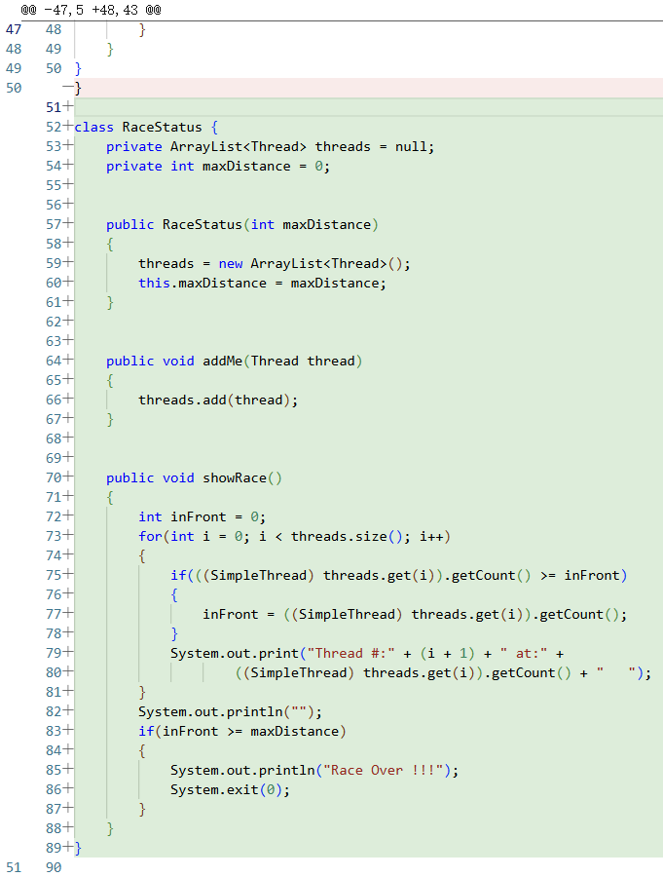

class RaceStatus {
private ArrayList<Thread> threads = null;
private int maxDistance = 0;

public RaceStatus(int maxDistance)
{
threads = new ArrayList<Thread>();
this.maxDistance = maxDistance;
}

public void addMe(Thread thread)
{
threads.add(thread);
}

public void showRace()
{
int inFront = 0;
for(int i = 0; i < threads.size(); i++)
{
if(((SimpleThread) threads.get(i)).getCount() >= inFront)
{
inFront = ((SimpleThread) threads.get(i)).getCount();
}
System.out.print("Thread #:" + (i + 1) + " at:" +
((SimpleThread) threads.get(i)).getCount() + " ");
}
System.out.println("");
if(inFront >= maxDistance)
{
System.out.println("Race Over !!!");
System.exit(0);
}
}
}

Q2

i.
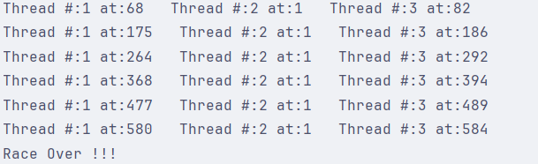

ii.
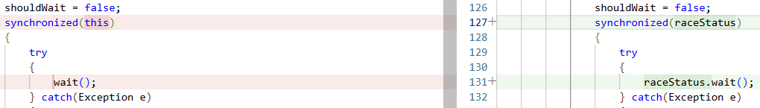

iii.
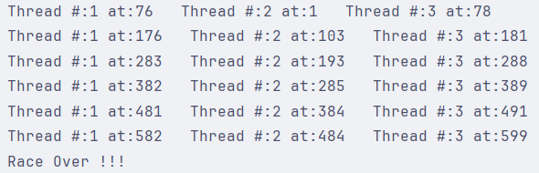
synchronized(raceStatus)
{
try
{
raceStatus.wait();
} catch(Exception e){}
}

Q3
RaceStatus.h
#pragma once

#include <vector>

class SimpleThread;

class RaceStatus{
public:
explicit RaceStatus(int maxDistance);

void addMe(SimpleThread *thread);

void showRace();

private:
std::vector<SimpleThread *> threads;
int maxDistance;
};
RaceStatus.cpp
#include "RaceStatus.h"
#include "SimpleThread.h"
#include <iostream>
#include <cstdlib>

RaceStatus::RaceStatus(int maxDistance) : maxDistance(maxDistance){}

void RaceStatus::addMe(SimpleThread *thread){ threads.push_back(thread); }

void RaceStatus::showRace(){
int inFront = 0;
for(size_t i = 0; i < threads.size(); ++ i){
int cnt = threads[i]->getCount();
if(cnt >= inFront){ inFront = cnt; }
std::cout << "Thread #:" << (i + 1) << " at:" << cnt << " ";
}
std::cout << std::endl;
if(inFront >= maxDistance){
std::cout << "Race Over !!!" << std::endl;
std::exit(0);
}
}

SimpleThread.h
#pragma once

#include "Thread.h"

class RaceStatus;

class SimpleThread : public Thread{
public:
explicit SimpleThread(RaceStatus *raceStatus);

void run();

~SimpleThread();

int getCount() const;

private:
RaceStatus *raceStatus;
int curDistance;
};

SimpleThread.cpp
#include "Thread.h"
#include "SimpleThread.h"
#include <pthread.h>
#include <stdlib.h>
#include <string.h>

void *startMethodInThread(void *arg){
if(arg == NULL){
return 0;
}
SimpleThread *thread = (SimpleThread *) arg;
thread->run();
return NULL;
}

Thread::Thread(Thread *childThread){
this->state = malloc(sizeof(pthread_t));
this->childThread = childThread;
}

void Thread::start(){
pthread_t tid;
pthread_create(&tid, NULL, startMethodInThread, (void *) this);
memcpy(this->state, (const void *) &tid, sizeof(pthread_t));
}

Thread::~Thread(){
free(this->state);
}
ThreadRace.cpp
#include "RaceStatus.h"
#include "SimpleThread.h"
#include <unistd.h>

int main(){
RaceStatus raceStatus(500);
(new SimpleThread(&raceStatus))->start();
(new SimpleThread(&raceStatus))->start();
while(true){
raceStatus.showRace();
sleep(5);
}
return 0;
}
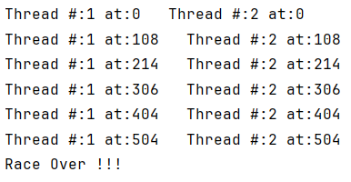

Q4
RaceStatus.h
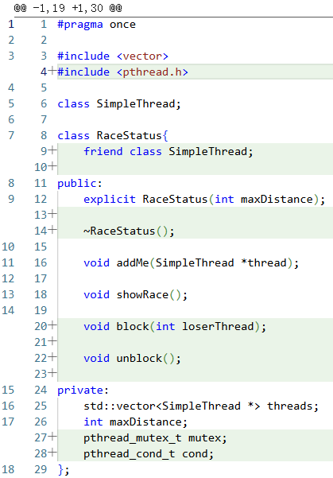

#pragma once

#include <vector>
#include <pthread.h>

class SimpleThread;

class RaceStatus{
friend class SimpleThread;

public:
explicit RaceStatus(int maxDistance);

~RaceStatus();

void addMe(SimpleThread *thread);

void showRace();

void block(int loserThread);

void unblock();

private:
std::vector<SimpleThread *> threads;
int maxDistance;
pthread_mutex_t mutex;
pthread_cond_t cond;
};

RaceStatus.cpp
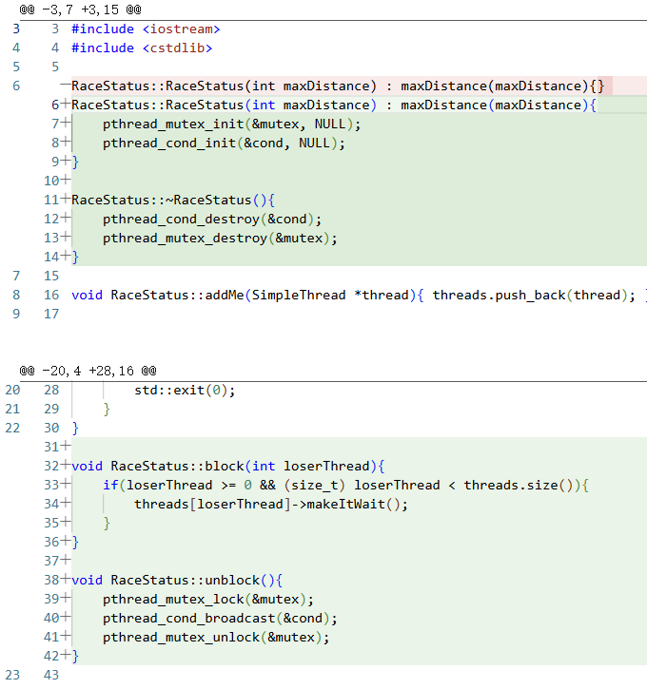

#include "RaceStatus.h"
#include "SimpleThread.h"
#include <iostream>
#include <cstdlib>

RaceStatus::RaceStatus(int maxDistance) : maxDistance(maxDistance){
pthread_mutex_init(&mutex, NULL);
pthread_cond_init(&cond, NULL);
}

RaceStatus::~RaceStatus(){
pthread_cond_destroy(&cond);
pthread_mutex_destroy(&mutex);
}

void RaceStatus::addMe(SimpleThread *thread){ threads.push_back(thread); }

void RaceStatus::showRace(){
int inFront = 0;
for(size_t i = 0; i < threads.size(); ++ i){
int cnt = threads[i]->getCount();
if(cnt >= inFront){ inFront = cnt; }
std::cout << "Thread #:" << (i + 1) << " at:" << cnt << " ";
}
std::cout << std::endl;
if(inFront >= maxDistance){
std::cout << "Race Over !!!" << std::endl;
std::exit(0);
}
}

void RaceStatus::block(int loserThread){
if(loserThread >= 0 && (size_t) loserThread < threads.size()){
threads[loserThread]->makeItWait();
}
}

void RaceStatus::unblock(){
pthread_mutex_lock(&mutex);
pthread_cond_broadcast(&cond);
pthread_mutex_unlock(&mutex);
}

SimpleThread.h
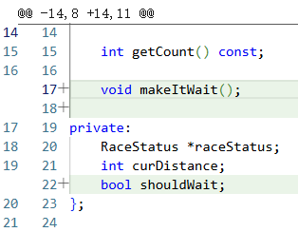

#pragma once

#include "Thread.h"

class RaceStatus;

class SimpleThread : public Thread{
public:
explicit SimpleThread(RaceStatus *raceStatus);

void run();

~SimpleThread();

int getCount() const;

void makeItWait();

private:
RaceStatus *raceStatus;
int curDistance;
bool shouldWait;
};

SimpleThread.cpp
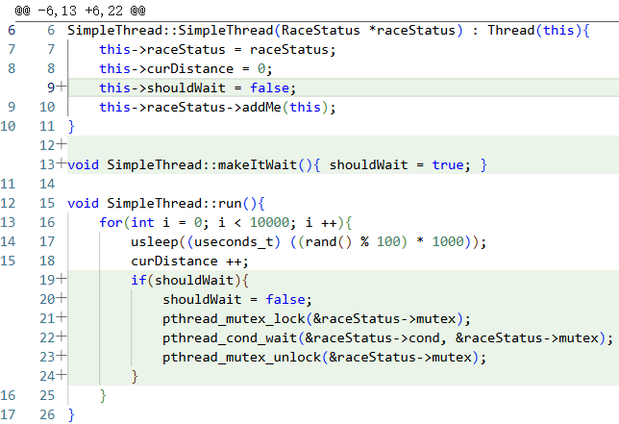

#include "SimpleThread.h"
#include "RaceStatus.h"
#include <unistd.h>
#include <stdlib.h>

SimpleThread::SimpleThread(RaceStatus *raceStatus) : Thread(this){
this->raceStatus = raceStatus;
this->curDistance = 0;
this->shouldWait = false;
this->raceStatus->addMe(this);
}

void SimpleThread::makeItWait(){ shouldWait = true; }

void SimpleThread::run(){
for(int i = 0; i < 10000; i ++){
usleep((useconds_t) ((rand() % 100) * 1000));
curDistance ++;
if(shouldWait){
shouldWait = false;
pthread_mutex_lock(&raceStatus->mutex);
pthread_cond_wait(&raceStatus->cond, &raceStatus->mutex);
pthread_mutex_unlock(&raceStatus->mutex);
}
}
}

int SimpleThread::getCount() const{ return curDistance; }

SimpleThread::~SimpleThread(){}

ThreadRace.cpp
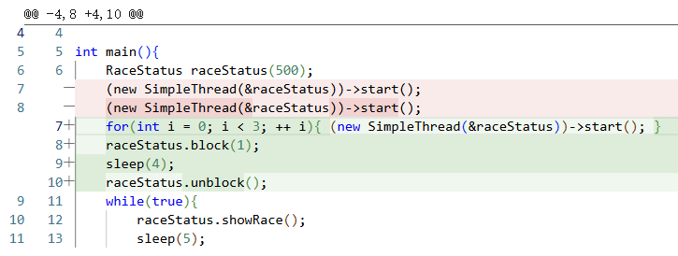

#include "RaceStatus.h"
#include "SimpleThread.h"
#include <unistd.h>

int main(){
RaceStatus raceStatus(500);
for(int i = 0; i < 3; ++ i){ (new SimpleThread(&raceStatus))->start(); }
raceStatus.block(1);
sleep(4);
raceStatus.unblock();
while(true){
raceStatus.showRace();
sleep(5);
}
return 0;
}
