Fall 2024
Course Project Technical Report
Version 0.4
Fall 2024
COMP 2714-BCIT
Course Project Technical Report

Team (Project) Name:

Team Members:

 | Student Name | Student-ID
1 | Jiarui Xing | A01354731
2
3
4

About the Project 3
Project Goal 3
Project Evaluation 3
Project Timeline 3
Milestone1 4
Milestone1-Task1: Universe of Discourse (Mini-World) Description 4
Milestone1-Task2: Conceptual Design using ER/EER Diagram 4
Milestone1-Task3: Conceptual Design using UML Notation [Optional but Recommended] 4
Milestone1-Task4: Defining functional dependencies in your mini-world 4
Milestone2 6
Milestone2-Task1: Updated Universe of Discourse (Mini-World) Description 6
Milestone2-Task2: Updated Conceptual Design 6
Milestone2-Task3: Updating functional dependencies in your mini-world 6
Milestone2-Task4: Creating the relational model of your conceptual model 6
Milestone3 7
Milestone3-Task1: Update your conceptual and relational models 7
Milestone3-Task1: Create your database schema 7
Milestone3-Task2: Populate your tables with some sample data 7
Milestone3-Task3: Write SQL Statement 7
Milestone4 9
Milestone4-Task1:Identify full, partial and transitive functional dependencies in your design 9
Milestone4-Task2: Highest Normal Form 9
Milestone4-Task3: Converting to 3NF 10
Milestone4-Task4: Converting to BCNF 10

About the Project

Project Goal
The objective of the project activity is to provide this opportunity to create a database system from the beginning to the database development. In this project, you will:
- Come up with a universe of discourse and corresponding conceptual model
- Convert your conceptual model to a relational model
- Use a SQL product (such as MySQL) to create your database, populate it with some data and write some DML statements
- Normalize your database schema

The project could be done in groups of up to 4 people. Depending on the number of people in the group the scope of the project would change.

Project Evaluation
Each Milestone will be evaluated independently.
Once you join a group, it is expected to stay in the group until the end of the project.
The project final grade for each individual will be based on the following metrics:
- The completion of the Milestones 1-4 on time and completeness of this technical report
- Evaluation of teammates in a group

Project Timeline

Milestones | Due date
Milestone 1 | Please refer to Learning Hub
Milestone 2 | Please refer to Learning Hub
Milestone 3 | Please refer to Learning Hub
Milestone 4 | Please refer to Learning Hub

Milestone1

- You need to describe a mini world.
- You can come up with a new idea for the mini-world or describe an existing application.
- A good mini-world is the one with a conceptual model including all the topics we have studies in Module 1:
  - Entities, Weak entities, Total and partial participations, Classes and sub-classes, composite attributes, derived attributes, super/sub classes, …
- The conceptual model in 2 formats (ER/EER) and UML Class Notation
  - UML Notation is Optional (for practice only).

Note: The scope of the project is adjusted based on how many people work on a project in a group.

If you work individually (group of 1) on this project:
- Then it is expected between 8-10+ entity types in your conceptual model.

If you work in a group of 2 on the project:
- Then it is expected between 12-15+ entity types in your conceptual model.

If you work in a group of 3/4 on the project:
- Then it is expected between 18-20+ entity types in your conceptual model.

Milestone1-Task1: Universe of Discourse (Mini-World) Description
[Write your answer here]

Milestone1-Task2: Conceptual Design using ER/EER Diagram
[Write your answer here]

Milestone1-Task3: Conceptual Design using UML Notation [Optional but Recommended]
[Write your answer here]

Milestone1-Task4: Defining functional dependencies in your mini-world
If you work individually (group of 1) on this project:
- Then it is expected between 4+ functional dependencies in your mini-world.

If you work in a group of 2 on the project:
- Then it is expected between 6+ functional dependencies in your mini-world.

If you work in a group of 3/4 on the project:
- Then it is expected between 7+ functional dependencies in your mini-world.

List all functional dependencies here: Make sure to include visuals as discussed during the lecture:

- Primary-Key Functional Dependencies: List them here:

- Partial Functional Dependencies: List them here

- Transitive Functional Dependencies: List them here

Milestone2

In Milestone 2, you are going to continue working on what you have done in Milestone1.

Milestone2-Task1: Updated Universe of Discourse (Mini-World) Description
- [Optional]: If your mini-world needs to be updated for any reasons, you have the chance to update it here. Please notice, if the original version of the Mini-World is not comprehensive enough (having different types of entities and relationships and … and enough number of entities) you need to update the original mini-world and submit it in this Milestone.

- The Milestone2-Task1 is not going to be graded, yet an update is a must if needed based on the comment above. Please also see the Task3 below.

[Write your answer here]

Milestone2-Task2: Updated Conceptual Design
- If an update to the Conceptual design is needed, please do it and add it here. (Particularly If you have to update your original mini-world in Task1 above)

[Write your answer here]

Milestone2-Task3: Updating functional dependencies in your mini-world
If you work individually (group of 1) on this project:
- Then it is expected between 4+ functional dependencies in your mini-world.

If you work in a group of 2 on the project:
- Then it is expected between 6+ functional dependencies in your mini-world.

If you work in a group of 3/4 on the project:
- Then it is expected between 7+ functional dependencies in your mini-world.

Note: If you cannot extract enough number of functional dependencies in your mini-world, you will need to update it and submit it under Milestone2-Task1.

[Write your answer here]

Milestone2-Task4: Creating the relational model of your conceptual model
- You need to create the relational models following the steps we defined in the lecture.

[Write your answer here]

Milestone3
In Milestone 3, In Milestone 3 you are doing to work with the database that you have designed.

Note: By the end of Milestone 2, it is expected that you have designed your relational model (database).

Milestone3-Task1: Update your conceptual and relational models
If you have received any feedback from the evaluator of Milestone 1 and 2, that you need to make some changes in your conceptual and relation models, you need to do it now and insert the updated answer:

Milestone3-Task1: Create your database schema
- Please use the SQL DDL statements to create your database schema.
- Provide a name for each table.
- Include all attributes
- Define PK and FK.
- Please add a snapshot of the statement you have written and the results

[Write your answer here]

Milestone3-Task2: Populate your tables with some sample data
- Insert some sample data to your tables
- The volume of inserted data is not important. Just insert enough amount of data that makes sense for your project.
- Please add a snapshot of the tables with some data in them

[Write your answer here]

Milestone3-Task3: Write SQL Statement
- You need to define several use-cases and write their corresponding queries.
- At least 10 queries should be written
- For group of 2 or more people, in addition to the first 10 queries, for each group member you need to add extra 3 use-cases.
- Write the SQL Statements, run them and take a snapshot from the results and insert them here.
- So the following items are expected:
- The usecase
- The SQL query
- The screenshot of the data

Example:
- Use case: As an admin, I need to know the name and SSN of the managers of all department.
- SQL Statement: Please see below
- Snapshot: Please see below

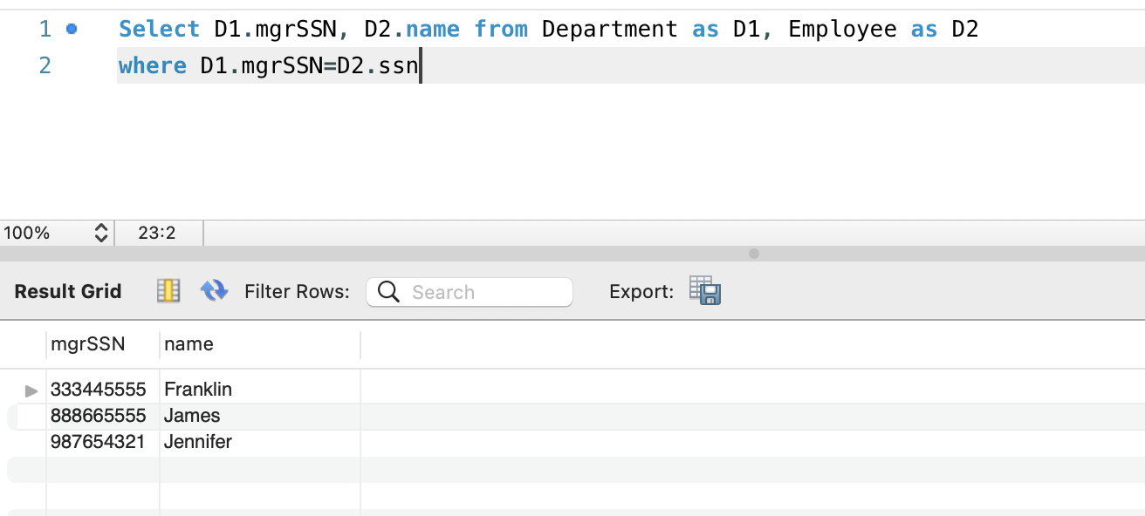

[Write your answer here]

Milestone4
In Milestone 4, you are going to normalize the database (relational model) you have developed in Milestone 2.

Note: It is expected in this Milestone to change the relational model you have completed in Milestone 2 and consequently the database you have developed in Milestone 3. While it is expected to normalize your database schema in this milestone, it is not expected you to re-create your database and update the sql statements you have developed in module 3.

Milestone4-Task1:Identify full, partial and transitive functional dependencies in your design
- In Module 4, we learned about full, partial and transitive functional dependencies and we discussed how normalization process deals with such functional dependencies.

- The Milestone4-Task1: List all functional dependencies you have identified in Milestone 2. For each functional dependency identify whether it is full, partial or transitive functional dependencies and briefly explain why. Complete the following table. (Expand the table as needed)

Functional Dependency
Partial, full or transitive? And why
Functional Dependency
Partial, full or transitive? And why

Milestone4-Task2: Highest Normal Form
- Take your relational models and test them against the Normalization tests and complete this section:

Relation NOT in 1NF: (List all relations that are NOT even in 1NF, if any):

Relation with 1NF as highest normal form: (List all relations that are in 1NF but not 2NF)

Relation with 2NF as highest normal form: (List all relations that are in 2NF but not 3NF)

Relation with 3NF as highest normal form: (List all relations that are in 3NF but not BCNF)

Relation with BCNF as highest normal form:

Milestone4-Task3: Converting to 3NF
In this task you will normalize all your relations to 3NF and BCNF. If a relation is already in BCNF or 3NF, no change is needed.

Milestone4-Task4: Converting to BCNF
In this task you will normalize all your relations to BCNF. If a relation is already in BCNF, no change is needed.

- Check whether there are any functional dependencies that are not preserved as a result of normalization to BCNF.

