Lab 09
Jerry Xing
Nov 4, 2025

Question 1
NormalMeans <- function(n.sample, n.trials){
sample.mean <- replicate(n.trials, mean(rnorm(n.sample, 0, 1)))
grand.mean <- mean(sample.mean)
sd <- sd(sample.mean)
print(paste0("n.sample = ", n.sample))
print(paste0("mean = ", grand.mean))
print(paste0("sd = ", sd))
hist(sample.mean,
breaks = 100,
probability = TRUE,
main = paste("Sampling Distribution (n =", n.sample, ")"),
xlab = "Sample Means",
ylab = "Frequency")
}
NormalMeans(1,1e5)
## [1] "n.sample = 1"
## [1] "mean = 0.00196031278726863"
## [1] "sd = 1.00161754151231"
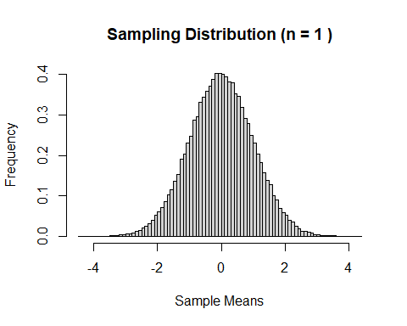
NormalMeans(2,1e5)
## [1] "n.sample = 2"
## [1] "mean = -0.00353532558821173"
## [1] "sd = 0.706240519829324"
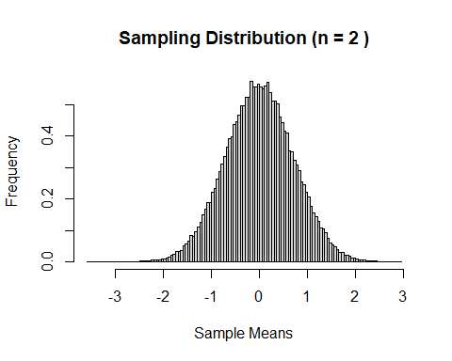
NormalMeans(10,1e5)
## [1] "n.sample = 10"
## [1] "mean = 0.000451741571551692"
## [1] "sd = 0.317221462431654"
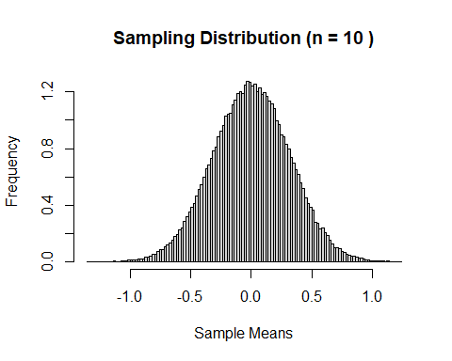
NormalMeans(50,1e5)
## [1] "n.sample = 50"
## [1] "mean = 0.000289505619265849"
## [1] "sd = 0.141197927888179"
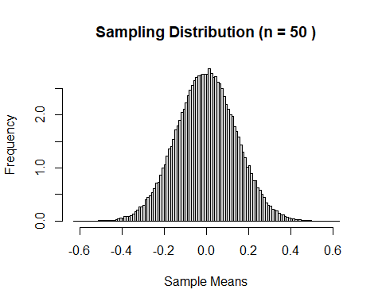
NormalMeans(100,1e5)
## [1] "n.sample = 100"
## [1] "mean = 0.000163985045838778"
## [1] "sd = 0.100176201900116"
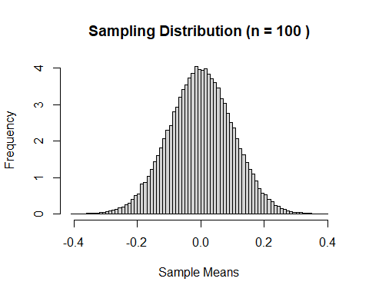 When n.sample increase, the mean and sd gradually approach 0;
From the histogram, it can be seen that as n.sample increases, the distribution of the sample means becomes more concentrated, shrinking from the range of -4 to 4 to approximately -0.4 to 0.4. If they are plotted on the same coordinate axis, the graph should become narrower as the n.sample increases.

Question 2
ExponentialMeans <- function(n.sample, n.trials){
sample.mean <- replicate(n.trials, mean(rexp(n.sample, 1)))
grand.mean <- mean(sample.mean)
sd <- sd(sample.mean)
print(paste0("n.sample = ", n.sample))
print(paste0("mean = ", grand.mean))
print(paste0("sd = ", sd))
hist(sample.mean,
breaks = 100,
probability = TRUE,
main = paste("Sampling Distribution (n =", n.sample, ")"),
xlab = "Sample Means",
ylab = "Frequency")
}
ExponentialMeans(1,1e5)
## [1] "n.sample = 1"
## [1] "mean = 1.00000548691565"
## [1] "sd = 0.99537275101655"
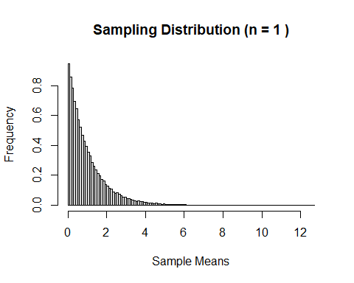
ExponentialMeans(2,1e5)
## [1] "n.sample = 2"
## [1] "mean = 0.99964506837191"
## [1] "sd = 0.704622035759486"
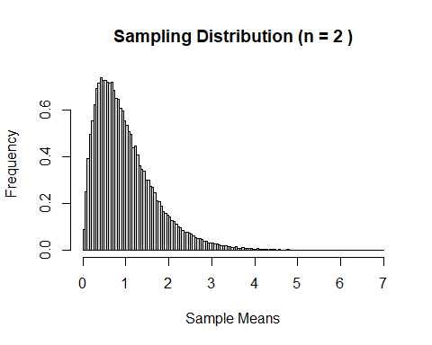
ExponentialMeans(10,1e5)
## [1] "n.sample = 10"
## [1] "mean = 0.998691472921467"
## [1] "sd = 0.315988669451663"
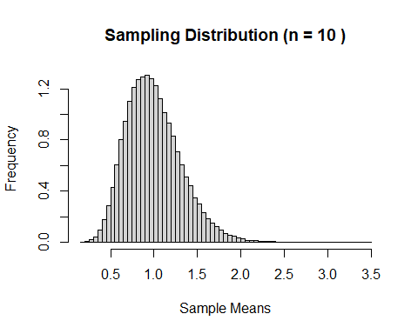
ExponentialMeans(50,1e5)
## [1] "n.sample = 50"
## [1] "mean = 0.999344771468685"
## [1] "sd = 0.141117099671876"
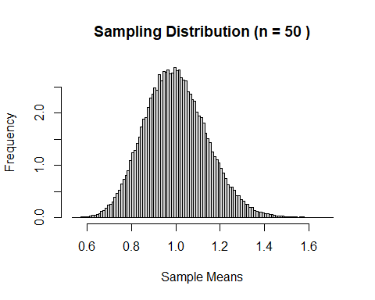
ExponentialMeans(100,1e5)
## [1] "n.sample = 100"
## [1] "mean = 0.999630665519923"
## [1] "sd = 0.10020484370085"
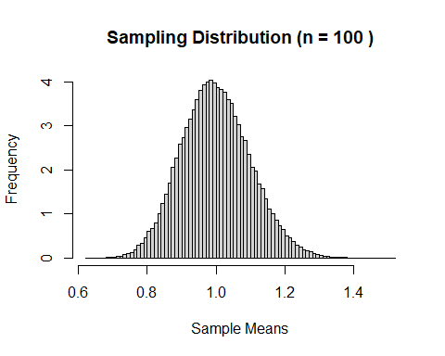 When n.sample increase, the mean gradually approaches 1, and the sd gradually approaches 0.
From the histogram, it can be seen that as n.sample increases, the distribution of the sample means becomes more concentrated (or narrower), and its shape gradually resembles a normal distribution.

Question 3
ExponentialMeansProb <- function(n.trials, beta, n.sample, z){
mu <- beta
sigma <- beta
sample.means <- replicate(n.trials, mean(rexp(n.sample, 1/beta)))
lower.val <- mu - z * sigma/sqrt(n.sample)
upper.val <- mu + z * sigma/sqrt(n.sample)
result <- mean(sample.means > lower.val & sample.means < upper.val)
print(result)
}
ExponentialMeansProb(1e5, 1, 1, 1)
ExponentialMeansProb(1e5, 1, 1, 2)
ExponentialMeansProb(1e5, 1, 1, 3)
ExponentialMeansProb(1e5, 1, 5, 1)
ExponentialMeansProb(1e5, 1, 5, 2)
ExponentialMeansProb(1e5, 1, 5, 3)
ExponentialMeansProb(1e5, 1, 50, 1)
ExponentialMeansProb(1e5, 1, 50, 2)
ExponentialMeansProb(1e5, 1, 50, 3)
 | $z=1$ | $z=2$ | $z=3$
n.sample $=1$ | 0.86536 | 0.95022 | 0.98208
n.sample $=5$ | 0.70228 | 0.95956 | 0.99099
n.sample $=50$ | 0.68454 | 0.95553 | 0.99638
When n.sample is small, the range for z = 1 does not follow the empirical rule, while the others mostly do; as n.sample increases, the results align more closely with the empirical rule.

Question 4
library(MASS)
##
## Attaching package: 'MASS'
## The following object is masked from 'package:dplyr':
##
## select
data("genotype")
A <- subset(genotype, Litter == "A")
B <- subset(genotype, Litter == "B")
I <- subset(genotype, Litter == "I")
J <- subset(genotype, Litter == "J")
qq.Plot <- function(set){
qqnorm(set$Wt,
main = paste0("QQ Plot for Genotype ",unique(set$Litter))
)
qqline(set$Wt, col="red", lty="dashed")
}
qq.Plot(A)
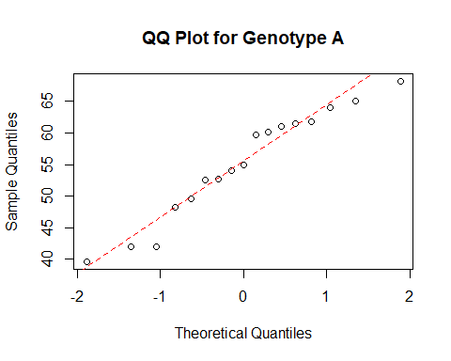
qq.Plot(B)
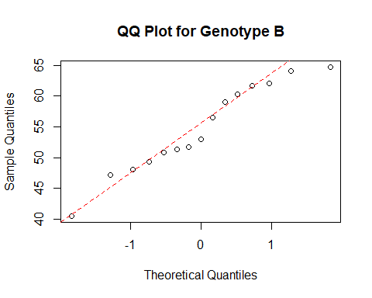
qq.Plot(I)
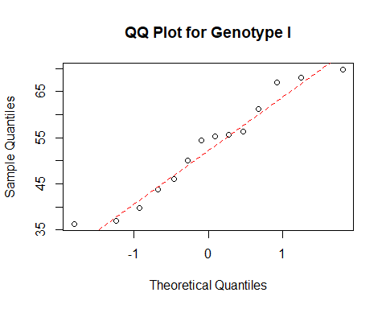
qq.Plot(J)
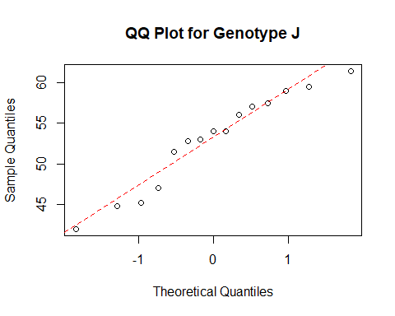
They appear to follow a normal distribution because all four QQ plots are approximately linear overall. For group I, there may be some deviations, but it still generally lies along the straight line.

