Lab 12 - Correlation and Regression
Jerry Xing
Nov 27, 2025

Question 1
X <- survey$Age
Y <- survey$Height
cor(X, Y, use = "complete.obs")
## [1] -0.0372773
cor.test(X, Y, alternative = "two.sided")
##
## Pearson's product-moment correlation
##
## data: X and Y
## t = -0.5367, df = 207, p-value = 0.5921
## alternative hypothesis: true correlation is not equal to 0
## 95 percent confidence interval:
## -0.17212114 0.09893785
## sample estimates:
## cor
## -0.0372773
CorrelationTest <- function(X.data, Y.data, X.label, Y.label, alpha) {
valid <- complete.cases(X.data, Y.data)
test <- cor.test(X.data[valid], Y.data[valid], alternative = "two.sided")
level <- alpha * 100
pval <- signif(test$p.value, 4)
if (test$p.value < alpha) {
paste0("At the ", level,
"% significance level, we have evidence of linear correlation between ",
X.label, " and ", Y.label,
" (p-value = ", pval, ").")
} else {
paste0("At the ", level,
"% significance level, we do not have evidence of linear correlation between ",
X.label, " and ", Y.label,
" (p-value = ", pval, ").")
}
}
CorrelationTest(X, Y, "student age", "student height", 0.05)
## [1] "At the 5% significance level, we do not have evidence of linear correlation between student age and student height (p-value = 0.5921)."

Question2
cor(survey$Wr.Hnd, survey$NW.Hnd, use = "complete.obs")
## [1] 0.9483103

Question3
CorrelationTest(survey$Wr.Hnd, survey$NW.Hnd, "writing hand span", "non-writing hand span", 0.05)
## [1] "At the 5% significance level, we have evidence of linear correlation between writing hand span and non-writing hand span (p-value = 1.253e-118)."

Question4
plot(survey$Wr.Hnd, survey$NW.Hnd,
xlab = "Writing hand span (cm)",
ylab = "Non-writing hand span (cm)",
main = "Writing vs non-writing hand span")
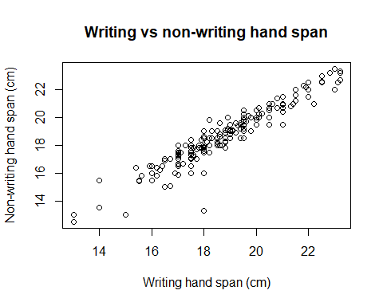

Question5
model <- lm(NW.Hnd ~ Wr.Hnd, data = survey)
b <- coef(model)
x0 <- 20
b[1] + b[2] * x0
## (Intercept)
## 19.90393

Question6
cor(survey$Height, survey$NW.Hnd, use = "complete.obs")
## [1] 0.584127
This correlation coefficient is smaller. The lengths of the left and right hands come from different parts of the same organ, so their correlation is stronger. Although height is related to hand length, the relationship is not as direct, so the correlation is weaker. This matches our expectations.

Question7
CorrelationTest(survey$Height, survey$NW.Hnd, "student height", "non-writing hand span", 0.05)
## [1] "At the 5% significance level, we have evidence of linear correlation between student height and non-writing hand span (p-value = 2.02e-20)."

Question8
plot(survey$Height, survey$NW.Hnd,
xlab = "Height (cm)",
ylab = "Non-writing hand span (cm)",
main = "Height vs non-writing hand span")
abline(lm(NW.Hnd ~ Height, data = survey))
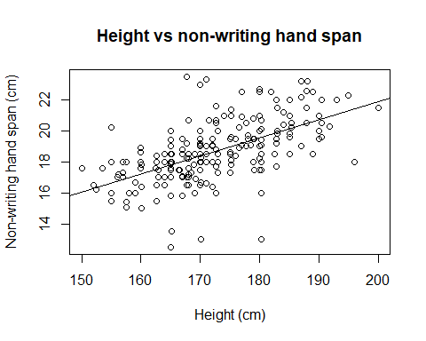

Question9
model_height <- lm(NW.Hnd ~ Height, data = survey)
new_student <- data.frame(Height = 173)
predict(model_height, new_student, interval = "predict", level = 0.95)
## fit lwr upr
## 1 18.74496 15.55958 21.93034
We are 95% confident that for a student with a height of 173 cm, the predicted value of the non-writing hand length is the “fit” shown in the output above, and the corresponding 95% prediction interval is from 15.55958 to 21.93034.

Question10
summary(model)$sigma
## [1] 0.6255705
summary(model_height)$sigma
## [1] 1.611792
Wider. Because the correlation coefficient between Height and NW.Hnd is smaller in Q6, the residual standard error becomes larger and the model has weaker explanatory power for NW.Hnd, resulting in greater prediction uncertainty.

Question11
x <- survey$Height
y <- survey$NW.Hnd
valid <- complete.cases(x, y)
x <- x[valid]
y <- y[valid]
n <- length(x)
model_height <- lm(y ~ x)
a <- coef(model_height)[1]
b <- coef(model_height)[2]
x0 <- 173
yhat <- a + b * x0
Se <- sqrt((sum(y^2) - a * sum(y) - b * sum(x * y)) / (n - 2))
alpha <- 0.05
tcrit <- qt(1 - alpha / 2, df = n - 2)
sx <- sd(x)
E <- tcrit * Se * sqrt(1 + 1 / n + (x0 - mean(x))^2 / ((n - 1) * sx^2))
c(yhat - E, yhat + E)
## (Intercept) (Intercept)
## 15.55958 21.93034

