Dataset Analysis Report

# Missing Values Analysis

concrete(kg/m³) 0  
Fly Ash (kg/m³) 0  
Silica Fume (kg/m³) 0  
Coarse Aggregate (kg/m³) 0  
Fine Aggregate (kg/m³) 0  
Water (kg/m³) 0  
Water Reducer (kg/m³) 0  
Fiber Diameter (mm) 0  
Fiber Length (mm) 0  
Fiber Content (%) 0  
Compressive Strength (MPa) 0

# Descriptive Statistics

concrete(kg/m³) Fly Ash (kg/m³) Silica Fume (kg/m³) Coarse Aggregate (kg/m³) Fine Aggregate (kg/m³) Water (kg/m³) Water Reducer (kg/m³) Fiber Diameter (mm) Fiber Length (mm) Fiber Content (%) Compressive Strength (MPa)  
count 267.000000 267.000000 267.000000 267.000000 267.000000 267.000000 267.000000 267.000000 267.000000 267.000000 267.000000  
mean 401.094532 45.342921 13.136330 1078.721685 704.494195 175.749064 2.928202 0.015825 16.584270 0.123670 49.518839  
std 75.927664 56.515023 28.859165 176.902265 108.877599 30.903305 1.944353 0.001851 5.931582 0.117605 11.438847  
min 217.000000 0.000000 0.000000 512.000000 507.000000 112.000000 0.000000 0.013000 6.000000 0.000000 23.330000  
25% 350.000000 0.000000 0.000000 992.500000 613.000000 160.000000 1.080000 0.015000 12.000000 0.050000 41.800000  
50% 402.000000 0.000000 0.000000 1125.000000 689.600000 175.000000 3.360000 0.015000 18.000000 0.100000 48.600000  
75% 450.000000 86.000000 0.000000 1181.300000 786.500000 185.000000 4.200000 0.017200 20.000000 0.160000 59.100000  
max 613.330000 168.000000 126.000000 1540.000000 1193.660000 301.000000 8.000000 0.021000 30.000000 0.730000 69.900000

# Correlation Matrix

concrete(kg/m³) Fly Ash (kg/m³) Silica Fume (kg/m³) Coarse Aggregate (kg/m³) Fine Aggregate (kg/m³) Water (kg/m³) Water Reducer (kg/m³) Fiber Diameter (mm) Fiber Length (mm) Fiber Content (%) Compressive Strength (MPa)  
concrete(kg/m³) 1.000000 -0.048688 0.201550 -0.030551 -0.006824 0.623543 -0.011334 -0.074715 0.184296 -0.216842 0.403855  
Fly Ash (kg/m³) -0.048688 1.000000 -0.213611 -0.277220 0.346910 0.189923 0.037969 -0.371402 -0.134008 0.067410 -0.129470  
Silica Fume (kg/m³) 0.201550 -0.213611 1.000000 -0.039269 -0.107322 -0.064309 0.250723 -0.153715 -0.014531 -0.144975 0.296514  
Coarse Aggregate (kg/m³) -0.030551 -0.277220 -0.039269 1.000000 -0.519399 -0.094608 -0.041174 0.182900 0.086780 0.136899 0.036662  
Fine Aggregate (kg/m³) -0.006824 0.346910 -0.107322 -0.519399 1.000000 0.153693 0.068448 0.094180 -0.093490 -0.029871 -0.204273  
Water (kg/m³) 0.623543 0.189923 -0.064309 -0.094608 0.153693 1.000000 -0.410088 -0.194273 0.268978 0.097187 -0.075488  
Water Reducer (kg/m³) -0.011334 0.037969 0.250723 -0.041174 0.068448 -0.410088 1.000000 -0.055874 -0.317791 -0.079767 0.222341  
Fiber Diameter (mm) -0.074715 -0.371402 -0.153715 0.182900 0.094180 -0.194273 -0.055874 1.000000 0.215444 0.131816 -0.160752  
Fiber Length (mm) 0.184296 -0.134008 -0.014531 0.086780 -0.093490 0.268978 -0.317791 0.215444 1.000000 0.081632 -0.014886  
Fiber Content (%) -0.216842 0.067410 -0.144975 0.136899 -0.029871 0.097187 -0.079767 0.131816 0.081632 1.000000 -0.292306  
Compressive Strength (MPa) 0.403855 -0.129470 0.296514 0.036662 -0.204273 -0.075488 0.222341 -0.160752 -0.014886 -0.292306 1.000000

# Histograms of Features

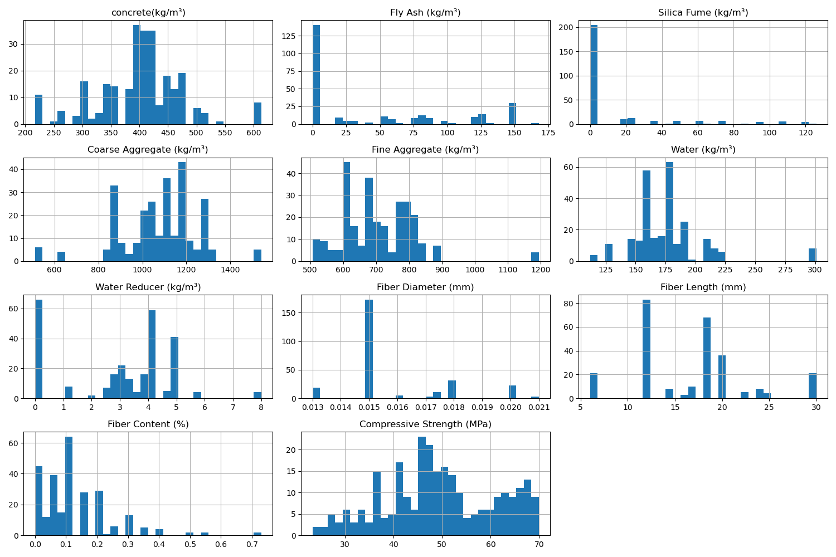

# Correlation Heatmap

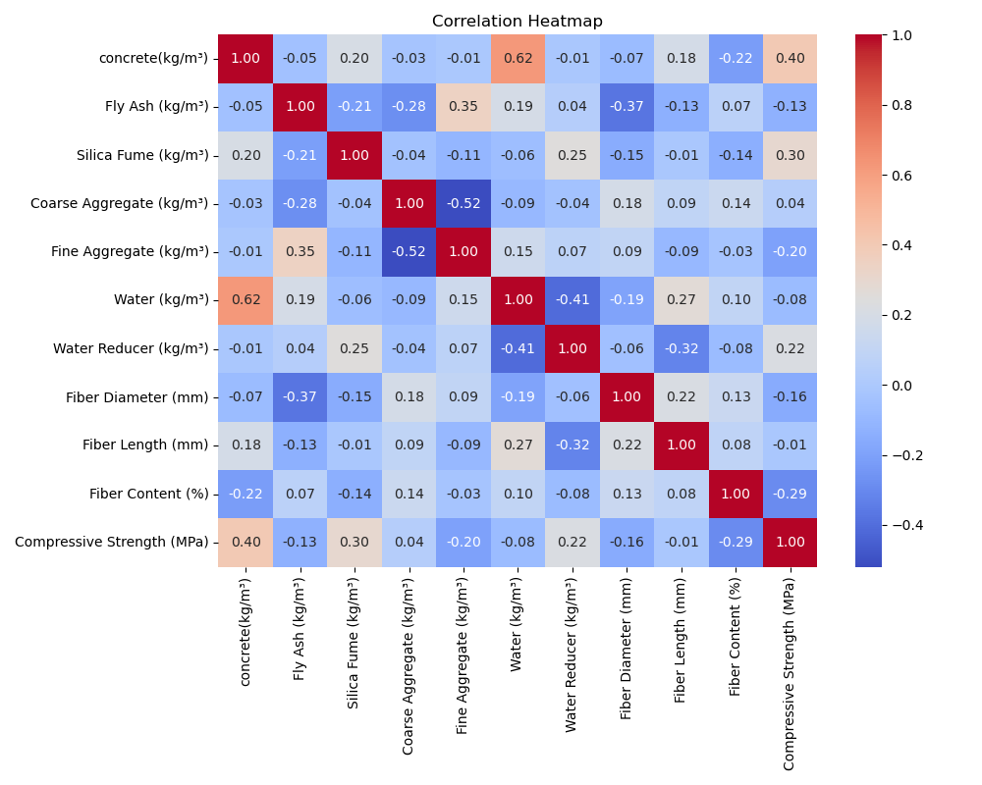

# Feature Importances

