Dataset Analysis Report

# Missing Values Analysis

concrete(kg/m³) 0  
Fly Ash (kg/m³) 0  
Silica Fume (kg/m³) 0  
Coarse Aggregate (kg/m³) 0  
Fine Aggregate (kg/m³) 0  
Water (kg/m³) 0  
Water Reducer (kg/m³) 0  
Fiber Diameter (mm) 0  
Fiber Length (mm) 0  
Fiber Content (%) 0  
Flexural Strength (MPa) 0

# Descriptive Statistics

concrete(kg/m³) Fly Ash (kg/m³) Silica Fume (kg/m³) Coarse Aggregate (kg/m³) Fine Aggregate (kg/m³) Water (kg/m³) Water Reducer (kg/m³) Fiber Diameter (mm) Fiber Length (mm) Fiber Content (%) Flexural Strength (MPa)  
count 245.000000 245.000000 245.000000 245.000000 245.000000 245.000000 245.000000 245.000000 245.000000 245.000000 245.000000  
mean 393.583020 29.230041 12.637551 1117.715061 691.240612 174.963265 3.104122 0.016226 16.595918 0.139020 6.515592  
std 73.976837 44.338406 25.081341 174.452720 109.697894 32.529827 2.379172 0.002834 6.275439 0.119422 2.314375  
min 217.000000 0.000000 0.000000 512.000000 507.000000 112.000000 0.000000 0.013000 6.000000 0.000000 2.430000  
25% 346.000000 0.000000 0.000000 1047.000000 613.000000 159.600000 0.000000 0.015000 12.000000 0.050000 4.940000  
50% 400.000000 0.000000 0.000000 1135.000000 671.000000 170.000000 3.360000 0.015000 17.000000 0.100000 5.730000  
75% 425.000000 60.000000 20.000000 1188.600000 758.000000 184.000000 4.200000 0.017400 20.000000 0.200000 8.060000  
max 613.330000 168.000000 126.000000 1540.000000 1193.660000 301.000000 8.360000 0.030000 30.000000 0.600000 13.600000

# Correlation Matrix

concrete(kg/m³) Fly Ash (kg/m³) Silica Fume (kg/m³) Coarse Aggregate (kg/m³) Fine Aggregate (kg/m³) Water (kg/m³) Water Reducer (kg/m³) Fiber Diameter (mm) Fiber Length (mm) Fiber Content (%) Flexural Strength (MPa)  
concrete(kg/m³) 1.000000 0.030527 0.064324 -0.037662 0.020084 0.733793 -0.070708 -0.136385 0.216085 -0.145688 0.395475  
Fly Ash (kg/m³) 0.030527 1.000000 0.027969 -0.082009 0.263888 0.225188 -0.162576 -0.297577 0.006123 -0.023791 0.165177  
Silica Fume (kg/m³) 0.064324 0.027969 1.000000 -0.080244 -0.115384 -0.074204 0.328343 -0.177924 -0.237884 -0.117679 0.361400  
Coarse Aggregate (kg/m³) -0.037662 -0.082009 -0.080244 1.000000 -0.487002 -0.173413 0.131993 0.069864 -0.052387 0.169439 0.014597  
Fine Aggregate (kg/m³) 0.020084 0.263888 -0.115384 -0.487002 1.000000 0.205541 -0.130389 0.212062 0.025993 -0.064565 -0.220718  
Water (kg/m³) 0.733793 0.225188 -0.074204 -0.173413 0.205541 1.000000 -0.262028 -0.193325 0.281658 -0.029443 0.122849  
Water Reducer (kg/m³) -0.070708 -0.162576 0.328343 0.131993 -0.130389 -0.262028 1.000000 -0.021457 -0.054790 0.063693 -0.100286  
Fiber Diameter (mm) -0.136385 -0.297577 -0.177924 0.069864 0.212062 -0.193325 -0.021457 1.000000 0.184153 0.198003 -0.344685  
Fiber Length (mm) 0.216085 0.006123 -0.237884 -0.052387 0.025993 0.281658 -0.054790 0.184153 1.000000 0.064984 0.048421  
Fiber Content (%) -0.145688 -0.023791 -0.117679 0.169439 -0.064565 -0.029443 0.063693 0.198003 0.064984 1.000000 -0.119228  
Flexural Strength (MPa) 0.395475 0.165177 0.361400 0.014597 -0.220718 0.122849 -0.100286 -0.344685 0.048421 -0.119228 1.000000

# Histograms of Features

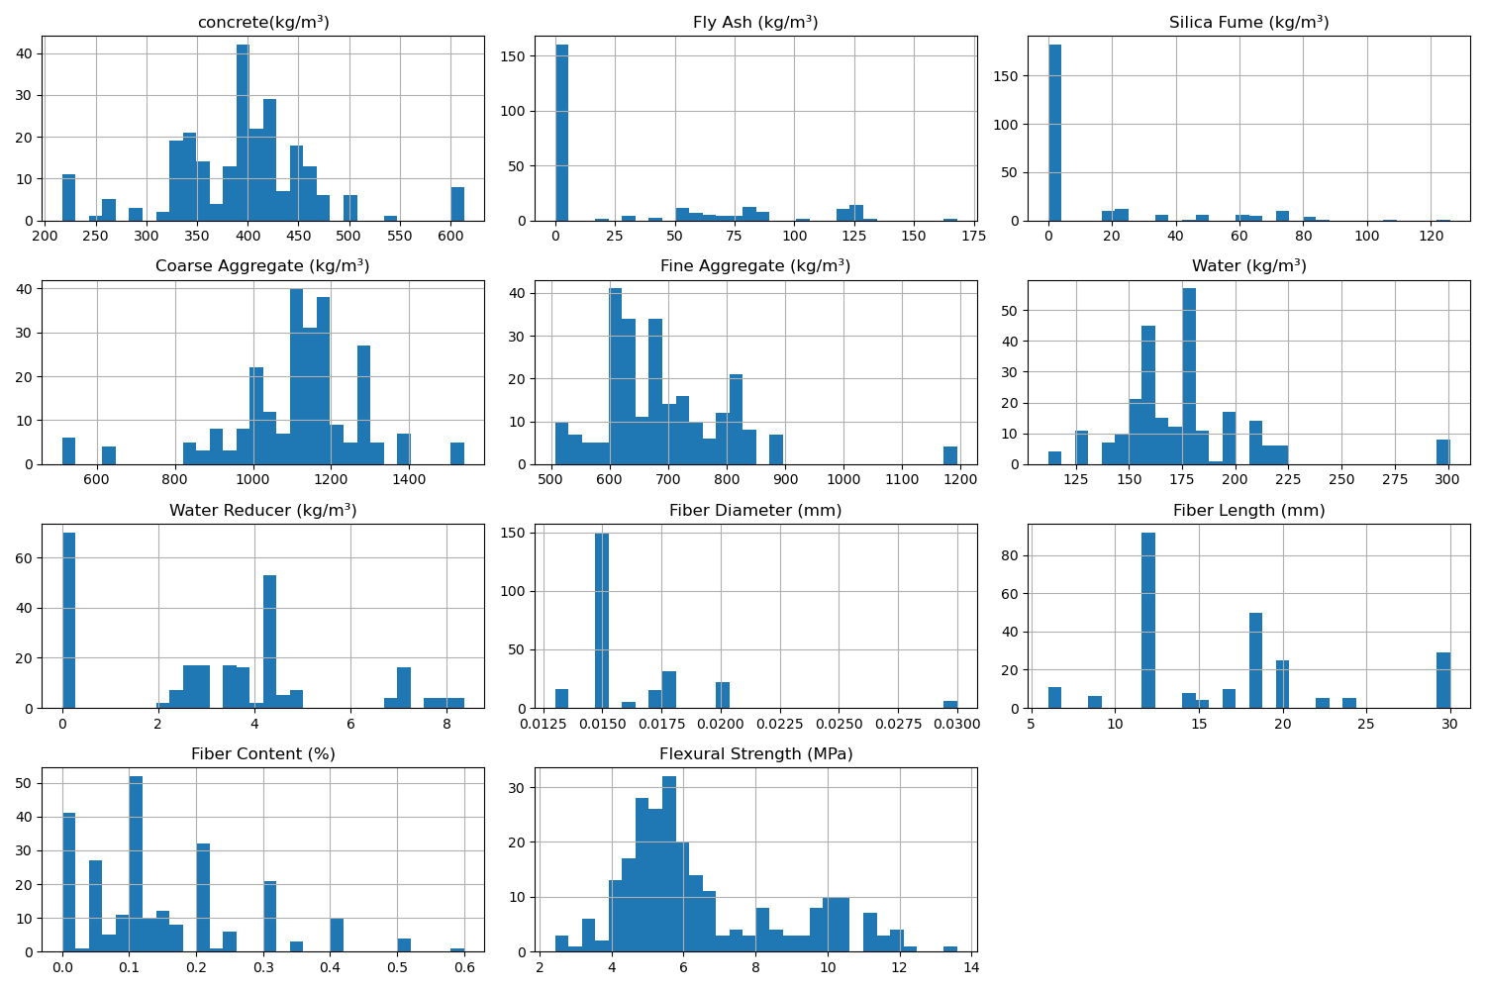

# Correlation Heatmap

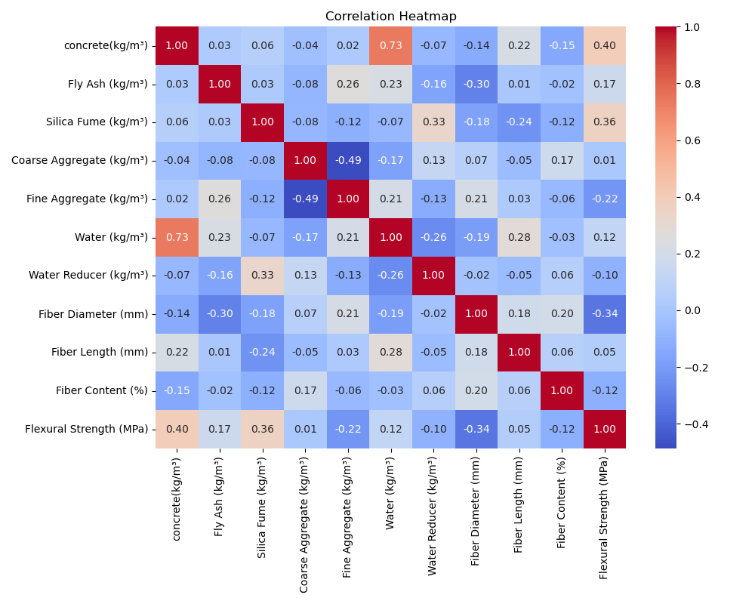

# Feature Importances

