Dataset Analysis Report

# Missing Values Analysis

concrete(kg/m³) 0  
Fly Ash (kg/m³) 0  
Silica Fume (kg/m³) 0  
Coarse Aggregate (kg/m³) 0  
Fine Aggregate (kg/m³) 0  
Water (kg/m³) 0  
Water Reducer (kg/m³) 0  
Fiber Diameter (mm) 0  
Fiber Length (mm) 0  
Fiber Content (%) 0  
Splitting Tensile Strength (MPa) 0

# Descriptive Statistics

concrete(kg/m³) Fly Ash (kg/m³) Silica Fume (kg/m³) Coarse Aggregate (kg/m³) Fine Aggregate (kg/m³) Water (kg/m³) Water Reducer (kg/m³) Fiber Diameter (mm) Fiber Length (mm) Fiber Content (%) Splitting Tensile Strength (MPa)  
count 267.000000 267.000000 267.000000 267.000000 267.000000 267.000000 267.000000 267.000000 267.000000 267.000000 267.000000  
mean 402.544719 45.717453 16.429213 1079.504644 697.829438 177.606742 3.337865 0.015930 16.749064 0.126592 4.348101  
std 73.920000 56.470326 31.284398 161.986898 88.452215 29.875916 2.242625 0.002699 6.376704 0.106337 1.739823  
min 217.000000 0.000000 0.000000 512.000000 507.000000 125.000000 0.000000 0.013000 6.000000 0.000000 2.200000  
25% 353.500000 0.000000 0.000000 998.000000 633.000000 160.000000 2.400000 0.015000 12.000000 0.050000 3.182500  
50% 402.000000 0.000000 0.000000 1125.000000 688.000000 179.000000 4.000000 0.015000 18.000000 0.100000 3.724000  
75% 450.000000 86.000000 20.000000 1180.000000 781.000000 188.000000 4.810000 0.015500 20.000000 0.200000 4.885000  
max 613.330000 168.000000 126.000000 1540.000000 875.000000 301.000000 8.360000 0.030000 30.000000 0.500000 9.800000

# Correlation Matrix

concrete(kg/m³) Fly Ash (kg/m³) Silica Fume (kg/m³) Coarse Aggregate (kg/m³) Fine Aggregate (kg/m³) Water (kg/m³) Water Reducer (kg/m³) Fiber Diameter (mm) Fiber Length (mm) Fiber Content (%) Splitting Tensile Strength (MPa)  
concrete(kg/m³) 1.000000 -0.035504 0.133679 0.003876 -0.061056 0.708138 -0.128188 -0.137989 0.192668 -0.169290 0.229583  
Fly Ash (kg/m³) -0.035504 1.000000 -0.156940 -0.318502 0.493797 0.072165 0.014571 -0.303287 -0.210047 -0.038094 0.044086  
Silica Fume (kg/m³) 0.133679 -0.156940 1.000000 -0.002621 -0.131309 -0.168619 0.327221 -0.150023 -0.102046 -0.136230 0.092773  
Coarse Aggregate (kg/m³) 0.003876 -0.318502 -0.002621 1.000000 -0.402870 -0.025605 -0.009120 0.183709 0.093962 0.146024 -0.078662  
Fine Aggregate (kg/m³) -0.061056 0.493797 -0.131309 -0.402870 1.000000 0.122644 0.073397 0.083060 -0.056050 0.036646 -0.171432  
Water (kg/m³) 0.708138 0.072165 -0.168619 -0.025605 0.122644 1.000000 -0.312315 -0.129056 0.219448 0.007268 0.077095  
Water Reducer (kg/m³) -0.128188 0.014571 0.327221 -0.009120 0.073397 -0.312315 1.000000 -0.127891 -0.154464 0.112166 -0.222922  
Fiber Diameter (mm) -0.137989 -0.303287 -0.150023 0.183709 0.083060 -0.129056 -0.127891 1.000000 0.217077 0.235674 -0.343024  
Fiber Length (mm) 0.192668 -0.210047 -0.102046 0.093962 -0.056050 0.219448 -0.154464 0.217077 1.000000 0.069533 0.134164  
Fiber Content (%) -0.169290 -0.038094 -0.136230 0.146024 0.036646 0.007268 0.112166 0.235674 0.069533 1.000000 -0.153591  
Splitting Tensile Strength (MPa) 0.229583 0.044086 0.092773 -0.078662 -0.171432 0.077095 -0.222922 -0.343024 0.134164 -0.153591 1.000000

# Histograms of Features

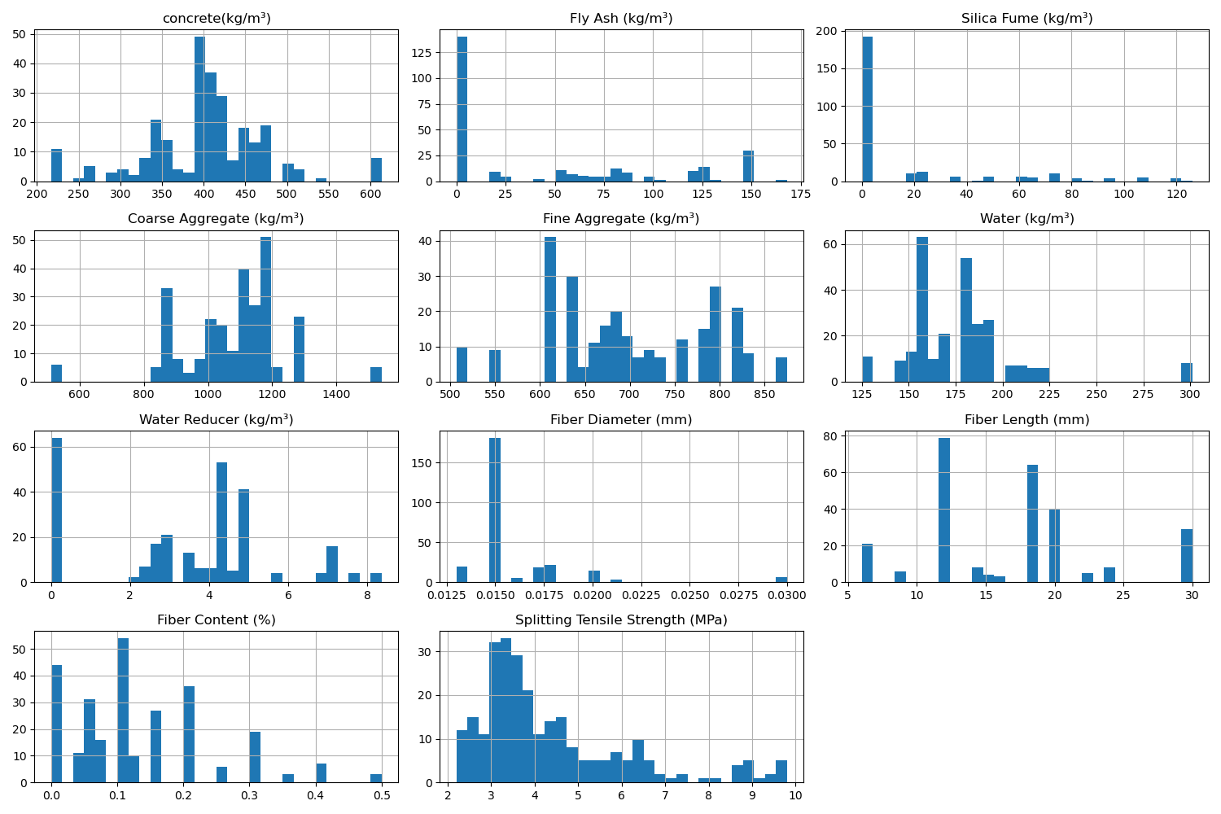

# Correlation Heatmap

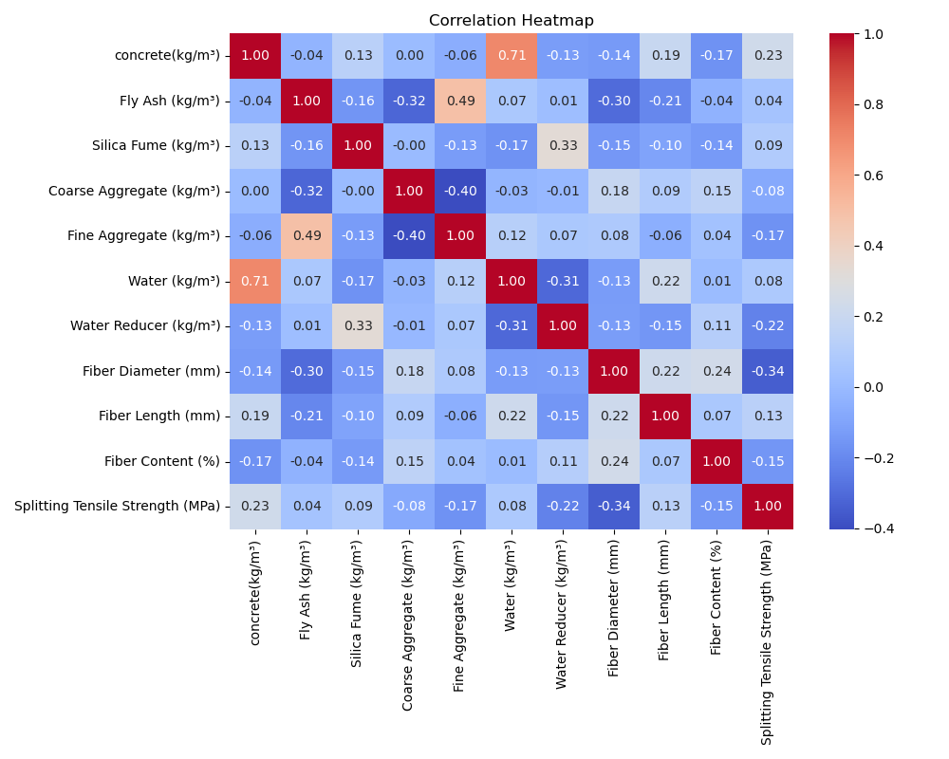

# Feature Importances

