Dataset Analysis Report

# Missing Values Analysis

Cement 0  
Slag 0  
Fly ash 0  
Water 0  
SP 0  
Coarse Aggr. 0  
Fine Aggr. 0  
SLUMP(cm) 0  
FLOW(cm) 0  
Compressive Strength (28-day)(Mpa) 0

# Descriptive Statistics

Cement Slag Fly ash Water SP Coarse Aggr. Fine Aggr. SLUMP(cm) FLOW(cm) Compressive Strength (28-day)(Mpa)  
count 103.000000 103.000000 103.000000 103.000000 103.000000 103.000000 103.000000 103.000000 103.00000 103.000000  
mean 229.894175 77.973786 149.014563 197.167961 8.539806 883.978641 739.604854 18.048544 49.61068 36.039417  
std 78.877230 60.461363 85.418080 20.208158 2.807530 88.391393 63.342117 8.750844 17.56861 7.838232  
min 137.000000 0.000000 0.000000 160.000000 4.400000 708.000000 640.600000 0.000000 20.00000 17.190000  
25% 152.000000 0.050000 115.500000 180.000000 6.000000 819.500000 684.500000 14.500000 38.50000 30.900000  
50% 248.000000 100.000000 164.000000 196.000000 8.000000 879.000000 742.700000 21.500000 54.00000 35.520000  
75% 303.900000 125.000000 235.950000 209.500000 10.000000 952.800000 788.000000 24.000000 63.75000 41.205000  
max 374.000000 193.000000 260.000000 240.000000 19.000000 1049.900000 902.000000 29.000000 78.00000 58.530000

# Correlation Matrix

Cement Slag Fly ash Water SP Coarse Aggr. Fine Aggr. SLUMP(cm) FLOW(cm) Compressive Strength (28-day)(Mpa)  
Cement 1.000000 -0.243553 -0.486535 0.221091 -0.106387 -0.309857 0.056959 0.145913 0.186461 0.445725  
Slag -0.243553 1.000000 -0.322619 -0.026775 0.306504 -0.223792 -0.183522 -0.284037 -0.327231 -0.331588  
Fly ash -0.486535 -0.322619 1.000000 -0.241321 -0.143508 0.172620 -0.282854 -0.118621 -0.055423 0.444393  
Water 0.221091 -0.026775 -0.241321 1.000000 -0.155456 -0.602201 0.114591 0.466568 0.632026 -0.254235  
SP -0.106387 0.306504 -0.143508 -0.155456 1.000000 -0.104159 0.058290 -0.212902 -0.176314 -0.037871  
Coarse Aggr. -0.309857 -0.223792 0.172620 -0.602201 -0.104159 1.000000 -0.488537 -0.188157 -0.325787 -0.160684  
Fine Aggr. 0.056959 -0.183522 -0.282854 0.114591 0.058290 -0.488537 1.000000 0.202272 0.190370 -0.154484  
SLUMP(cm) 0.145913 -0.284037 -0.118621 0.466568 -0.212902 -0.188157 0.202272 1.000000 0.906135 -0.223358  
FLOW(cm) 0.186461 -0.327231 -0.055423 0.632026 -0.176314 -0.325787 0.190370 0.906135 1.000000 -0.124029  
Compressive Strength (28-day)(Mpa) 0.445725 -0.331588 0.444393 -0.254235 -0.037871 -0.160684 -0.154484 -0.223358 -0.124029 1.000000

# Histograms of Features

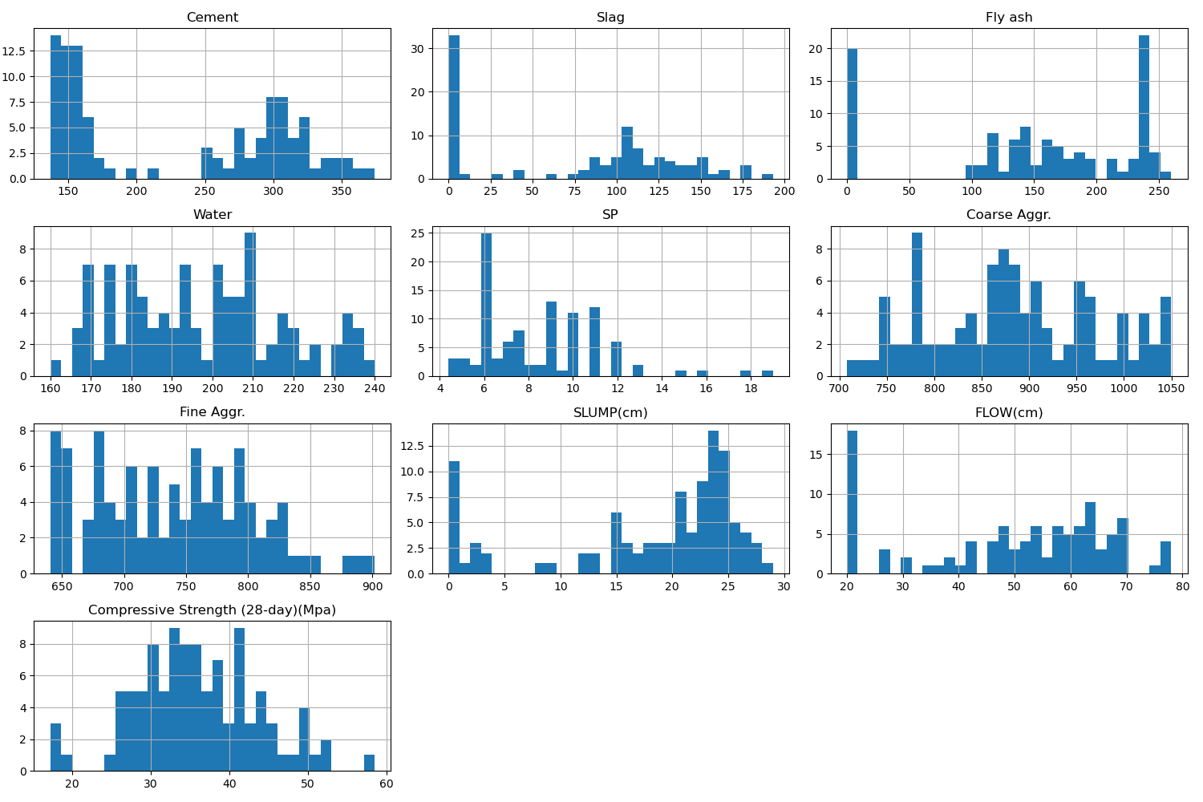

# Correlation Heatmap

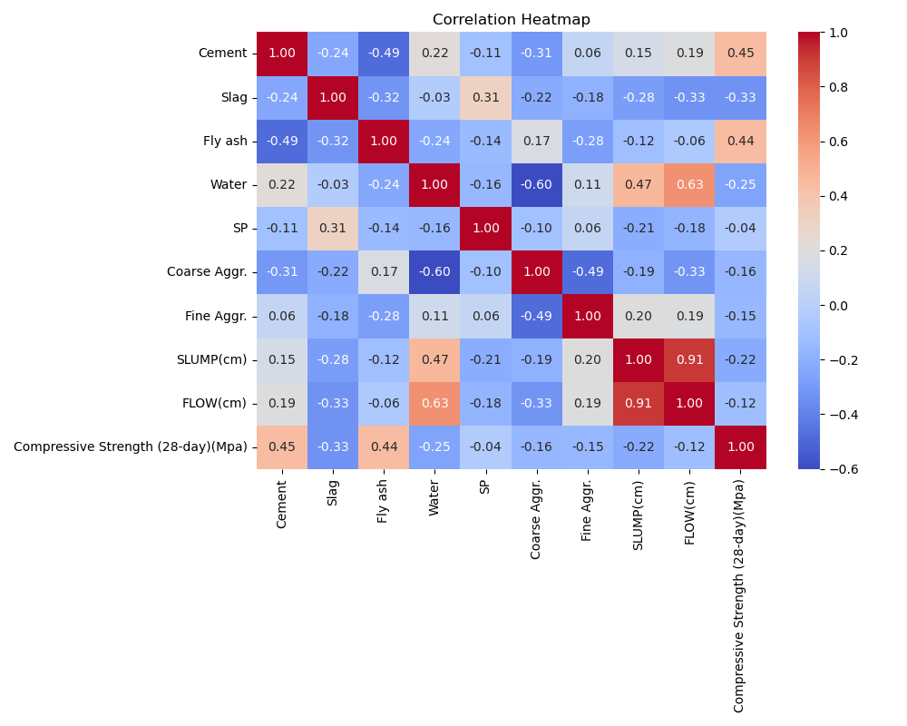

# Feature Importances

