Dataset Analysis Report

# Missing Values Analysis

X1 0  
X2 0  
X3 0  
X4 0  
X5 0  
X6 0  
X7 0  
X8 0  
Y2 0

# Descriptive Statistics

X1 X2 X3 X4 X5 X6 X7 X8 Y2  
count 768.000000 768.000000 768.000000 768.000000 768.00000 768.000000 768.000000 768.00000 768.000000  
mean 0.764167 671.708333 318.500000 176.604167 5.25000 3.500000 0.234375 2.81250 24.587760  
std 0.105777 88.086116 43.626481 45.165950 1.75114 1.118763 0.133221 1.55096 9.513306  
min 0.620000 514.500000 245.000000 110.250000 3.50000 2.000000 0.000000 0.00000 10.900000  
25% 0.682500 606.375000 294.000000 140.875000 3.50000 2.750000 0.100000 1.75000 15.620000  
50% 0.750000 673.750000 318.500000 183.750000 5.25000 3.500000 0.250000 3.00000 22.080000  
75% 0.830000 741.125000 343.000000 220.500000 7.00000 4.250000 0.400000 4.00000 33.132500  
max 0.980000 808.500000 416.500000 220.500000 7.00000 5.000000 0.400000 5.00000 48.030000

# Correlation Matrix

X1 X2 X3 X4 X5 X6 X7 X8 Y2  
X1 1.000000e+00 -9.919015e-01 -2.037817e-01 -8.688234e-01 8.277473e-01 4.678592e-17 -2.960552e-15 -7.107006e-16 0.634339  
X2 -9.919015e-01 1.000000e+00 1.955016e-01 8.807195e-01 -8.581477e-01 -3.459372e-17 3.636925e-15 2.438409e-15 -0.672999  
X3 -2.037817e-01 1.955016e-01 1.000000e+00 -2.923165e-01 2.809757e-01 -2.429499e-17 -8.567455e-17 2.067384e-16 0.427117  
X4 -8.688234e-01 8.807195e-01 -2.923165e-01 1.000000e+00 -9.725122e-01 -5.830058e-17 -1.759011e-15 -1.078071e-15 -0.862547  
X5 8.277473e-01 -8.581477e-01 2.809757e-01 -9.725122e-01 1.000000e+00 4.492205e-17 1.489134e-17 -2.920613e-17 0.895785  
X6 4.678592e-17 -3.459372e-17 -2.429499e-17 -5.830058e-17 4.492205e-17 1.000000e+00 -9.406007e-16 -2.549352e-16 0.014290  
X7 -2.960552e-15 3.636925e-15 -8.567455e-17 -1.759011e-15 1.489134e-17 -9.406007e-16 1.000000e+00 2.129642e-01 0.207505  
X8 -7.107006e-16 2.438409e-15 2.067384e-16 -1.078071e-15 -2.920613e-17 -2.549352e-16 2.129642e-01 1.000000e+00 0.050525  
Y2 6.343391e-01 -6.729989e-01 4.271170e-01 -8.625466e-01 8.957852e-01 1.428960e-02 2.075050e-01 5.052512e-02 1.000000

# Histograms of Features

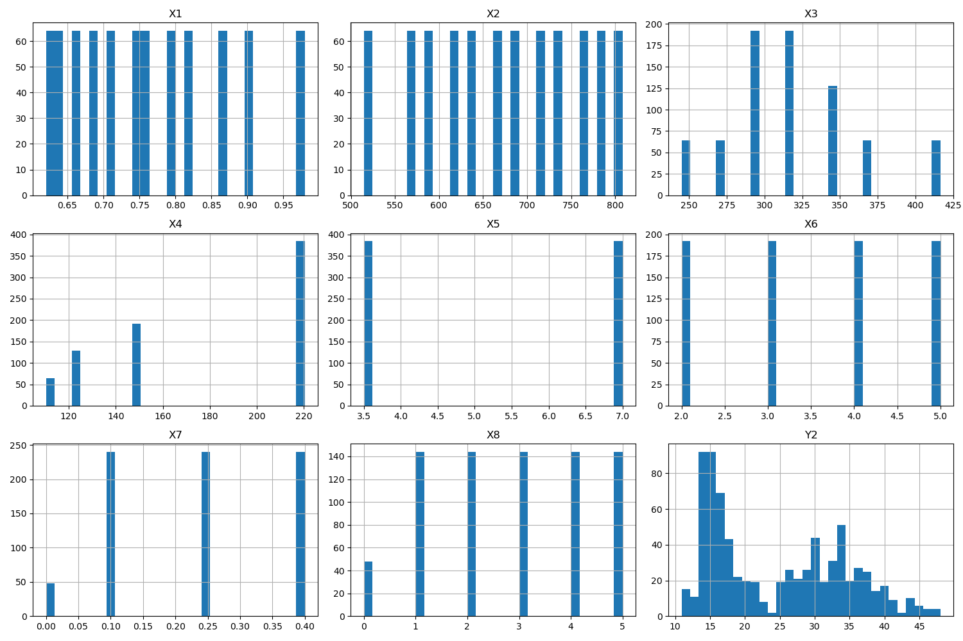

# Correlation Heatmap

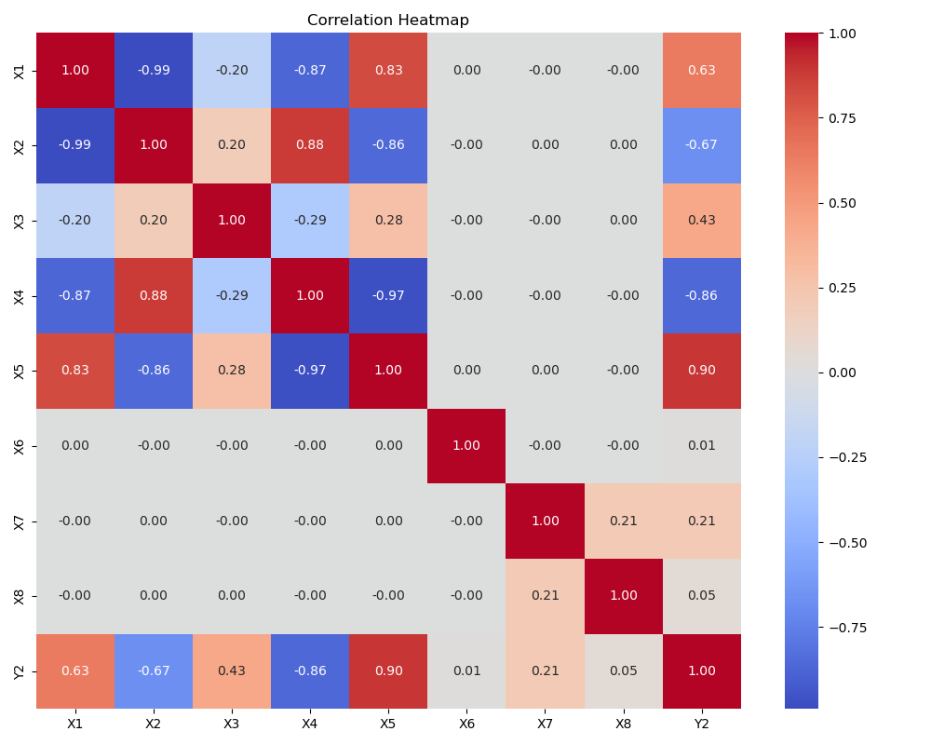

# Feature Importances

