Dataset Analysis Report

# Missing Values Analysis

X1 0  
X2 0  
X3 0  
X4 0  
X5 0  
X6 0  
X7 0  
X8 0  
Y1 0

# Descriptive Statistics

X1 X2 X3 X4 X5 X6 X7 X8 Y1  
count 768.000000 768.000000 768.000000 768.000000 768.00000 768.000000 768.000000 768.00000 768.000000  
mean 0.764167 671.708333 318.500000 176.604167 5.25000 3.500000 0.234375 2.81250 22.307195  
std 0.105777 88.086116 43.626481 45.165950 1.75114 1.118763 0.133221 1.55096 10.090204  
min 0.620000 514.500000 245.000000 110.250000 3.50000 2.000000 0.000000 0.00000 6.010000  
25% 0.682500 606.375000 294.000000 140.875000 3.50000 2.750000 0.100000 1.75000 12.992500  
50% 0.750000 673.750000 318.500000 183.750000 5.25000 3.500000 0.250000 3.00000 18.950000  
75% 0.830000 741.125000 343.000000 220.500000 7.00000 4.250000 0.400000 4.00000 31.667500  
max 0.980000 808.500000 416.500000 220.500000 7.00000 5.000000 0.400000 5.00000 43.100000

# Correlation Matrix

X1 X2 X3 X4 X5 X6 X7 X8 Y1  
X1 1.000000e+00 -9.919015e-01 -2.037817e-01 -8.688234e-01 8.277473e-01 4.678592e-17 -2.960552e-15 -7.107006e-16 0.622272  
X2 -9.919015e-01 1.000000e+00 1.955016e-01 8.807195e-01 -8.581477e-01 -3.459372e-17 3.636925e-15 2.438409e-15 -0.658120  
X3 -2.037817e-01 1.955016e-01 1.000000e+00 -2.923165e-01 2.809757e-01 -2.429499e-17 -8.567455e-17 2.067384e-16 0.455671  
X4 -8.688234e-01 8.807195e-01 -2.923165e-01 1.000000e+00 -9.725122e-01 -5.830058e-17 -1.759011e-15 -1.078071e-15 -0.861828  
X5 8.277473e-01 -8.581477e-01 2.809757e-01 -9.725122e-01 1.000000e+00 4.492205e-17 1.489134e-17 -2.920613e-17 0.889430  
X6 4.678592e-17 -3.459372e-17 -2.429499e-17 -5.830058e-17 4.492205e-17 1.000000e+00 -9.406007e-16 -2.549352e-16 -0.002587  
X7 -2.960552e-15 3.636925e-15 -8.567455e-17 -1.759011e-15 1.489134e-17 -9.406007e-16 1.000000e+00 2.129642e-01 0.269842  
X8 -7.107006e-16 2.438409e-15 2.067384e-16 -1.078071e-15 -2.920613e-17 -2.549352e-16 2.129642e-01 1.000000e+00 0.087368  
Y1 6.222719e-01 -6.581199e-01 4.556714e-01 -8.618281e-01 8.894305e-01 -2.586763e-03 2.698417e-01 8.736846e-02 1.000000

# Histograms of Features

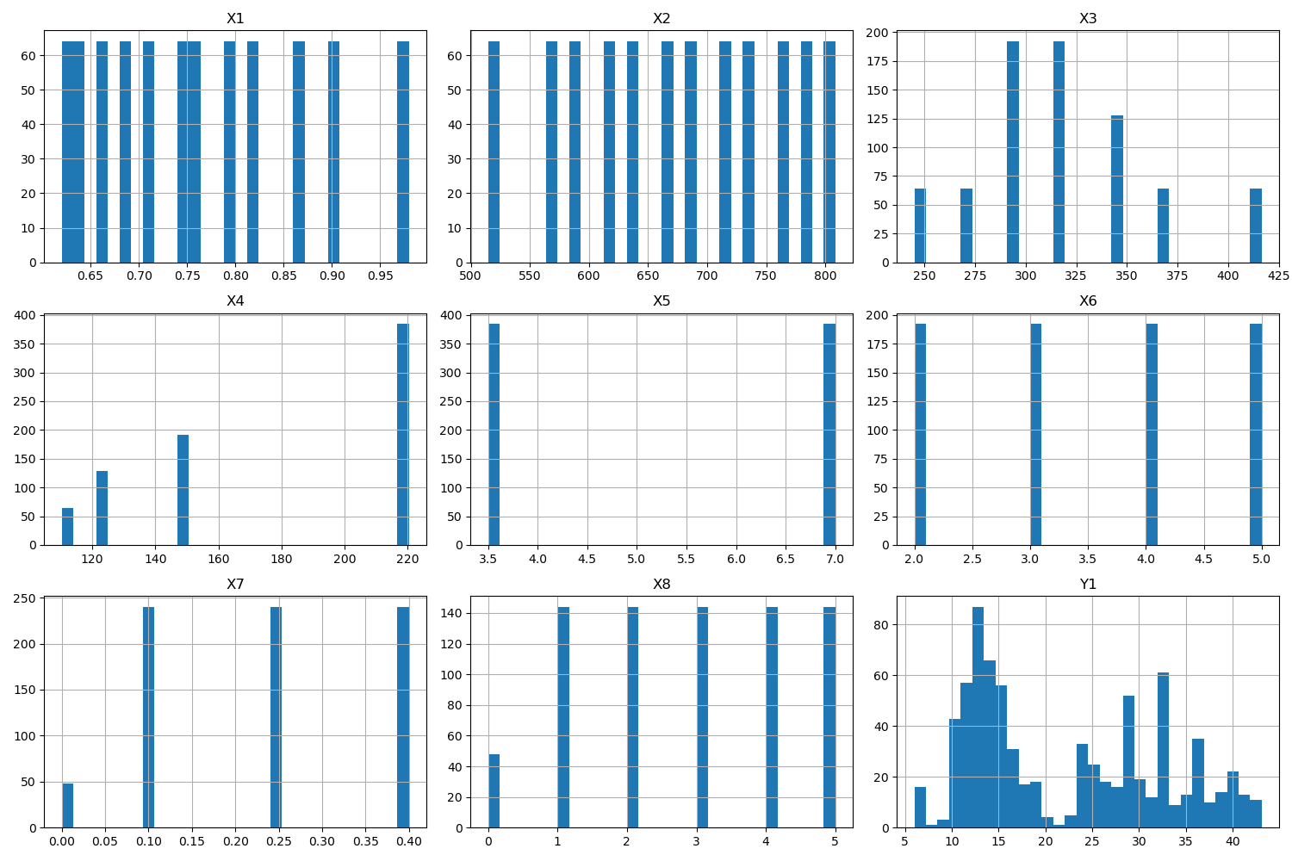

# Correlation Heatmap

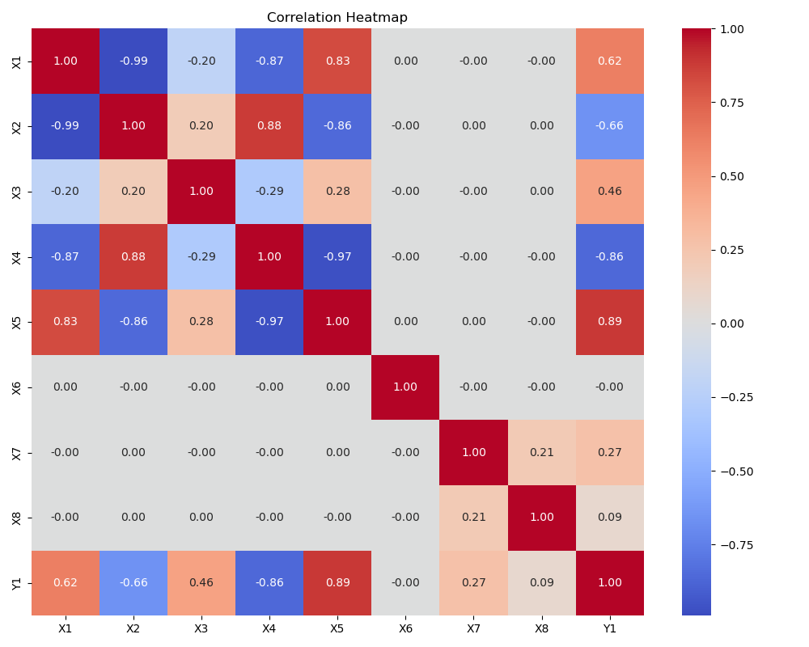

# Feature Importances

