Dataset Analysis Report

# Missing Values Analysis

Type_of_fiber 0  
Fiber_diameter 0  
Embedded_length 0  
Youngs_modulus_of_fiber 0  
Poisson_ratio_of_fiber 0  
Type_of_matrix 0  
Youngs_modulus_of_matrix 0  
Poissons_ratio_of_matrix 0  
Loading_rate 0  
Prepare_temperature 0  
Test_temperature 0  
IFSS 0

# Descriptive Statistics

Type_of_fiber Fiber_diameter Embedded_length Youngs_modulus_of_fiber Poisson_ratio_of_fiber Type_of_matrix Youngs_modulus_of_matrix Poissons_ratio_of_matrix Loading_rate Prepare_temperature Test_temperature IFSS  
count 918.000000 918.000000 918.000000 918.000000 918.000000 918.000000 918.000000 918.000000 918.000000 918.000000 918.000000 918.000000  
mean 5.044662 43.853377 393.328649 156.120011 0.254662 5.324619 2.874815 0.344891 0.098755 138.776688 20.853595 34.109041  
std 2.859709 81.276812 599.030812 99.150546 0.069780 2.933517 0.755931 0.020811 0.707716 89.393127 56.887546 28.645963  
min 1.000000 5.000000 24.500000 3.390000 0.170000 1.000000 1.200000 0.310000 0.001700 20.000000 -196.000000 2.300000  
25% 3.000000 7.000000 63.125000 75.700000 0.200000 3.000000 2.740000 0.310000 0.010000 70.000000 25.000000 9.125000  
50% 4.000000 7.150000 82.150000 230.000000 0.260000 4.000000 3.259000 0.360000 0.014000 150.000000 25.000000 25.800000  
75% 6.000000 17.500000 329.400000 230.000000 0.260000 9.000000 3.500000 0.360000 0.020000 150.000000 25.000000 52.075000  
max 10.000000 300.000000 2018.000000 294.000000 0.370000 10.000000 3.960000 0.370000 6.000000 370.000000 120.000000 137.500000

# Correlation Matrix

Type_of_fiber Fiber_diameter Embedded_length Youngs_modulus_of_fiber Poisson_ratio_of_fiber Type_of_matrix Youngs_modulus_of_matrix Poissons_ratio_of_matrix Loading_rate Prepare_temperature Test_temperature IFSS  
Type_of_fiber 1.000000 0.735924 0.787492 -0.819545 0.677912 0.657725 0.277786 -0.811583 -0.168918 -0.726643 0.215901 -0.674421  
Fiber_diameter 0.735924 1.000000 0.955074 -0.663785 0.671532 0.519979 0.222253 -0.690456 -0.054370 -0.532707 0.049037 -0.475764  
Embedded_length 0.787492 0.955074 1.000000 -0.739683 0.645729 0.528400 0.209623 -0.691324 -0.068796 -0.566468 0.096892 -0.549229  
Youngs_modulus_of_fiber -0.819545 -0.663785 -0.739683 1.000000 -0.452996 -0.492180 -0.122530 0.573344 0.165941 0.593836 -0.240017 0.689618  
Poisson_ratio_of_fiber 0.677912 0.671532 0.645729 -0.452996 1.000000 0.650264 0.295014 -0.800622 0.080727 -0.527156 0.021820 -0.384262  
Type_of_matrix 0.657725 0.519979 0.528400 -0.492180 0.650264 1.000000 -0.332143 -0.644276 -0.180319 -0.450664 0.173000 -0.626009  
Youngs_modulus_of_matrix 0.277786 0.222253 0.209623 -0.122530 0.295014 -0.332143 1.000000 -0.245114 -0.086607 -0.340928 -0.113226 0.134944  
Poissons_ratio_of_matrix -0.811583 -0.690456 -0.691324 0.573344 -0.800622 -0.644276 -0.245114 1.000000 -0.027400 0.547352 0.041313 0.318969  
Loading_rate -0.168918 -0.054370 -0.068796 0.165941 0.080727 -0.180319 -0.086607 -0.027400 1.000000 0.307808 0.116011 0.132590  
Prepare_temperature -0.726643 -0.532707 -0.566468 0.593836 -0.527156 -0.450664 -0.340928 0.547352 0.307808 1.000000 -0.172095 0.526085  
Test_temperature 0.215901 0.049037 0.096892 -0.240017 0.021820 0.173000 -0.113226 0.041313 0.116011 -0.172095 1.000000 -0.641591  
IFSS -0.674421 -0.475764 -0.549229 0.689618 -0.384262 -0.626009 0.134944 0.318969 0.132590 0.526085 -0.641591 1.000000

# Histograms of Features

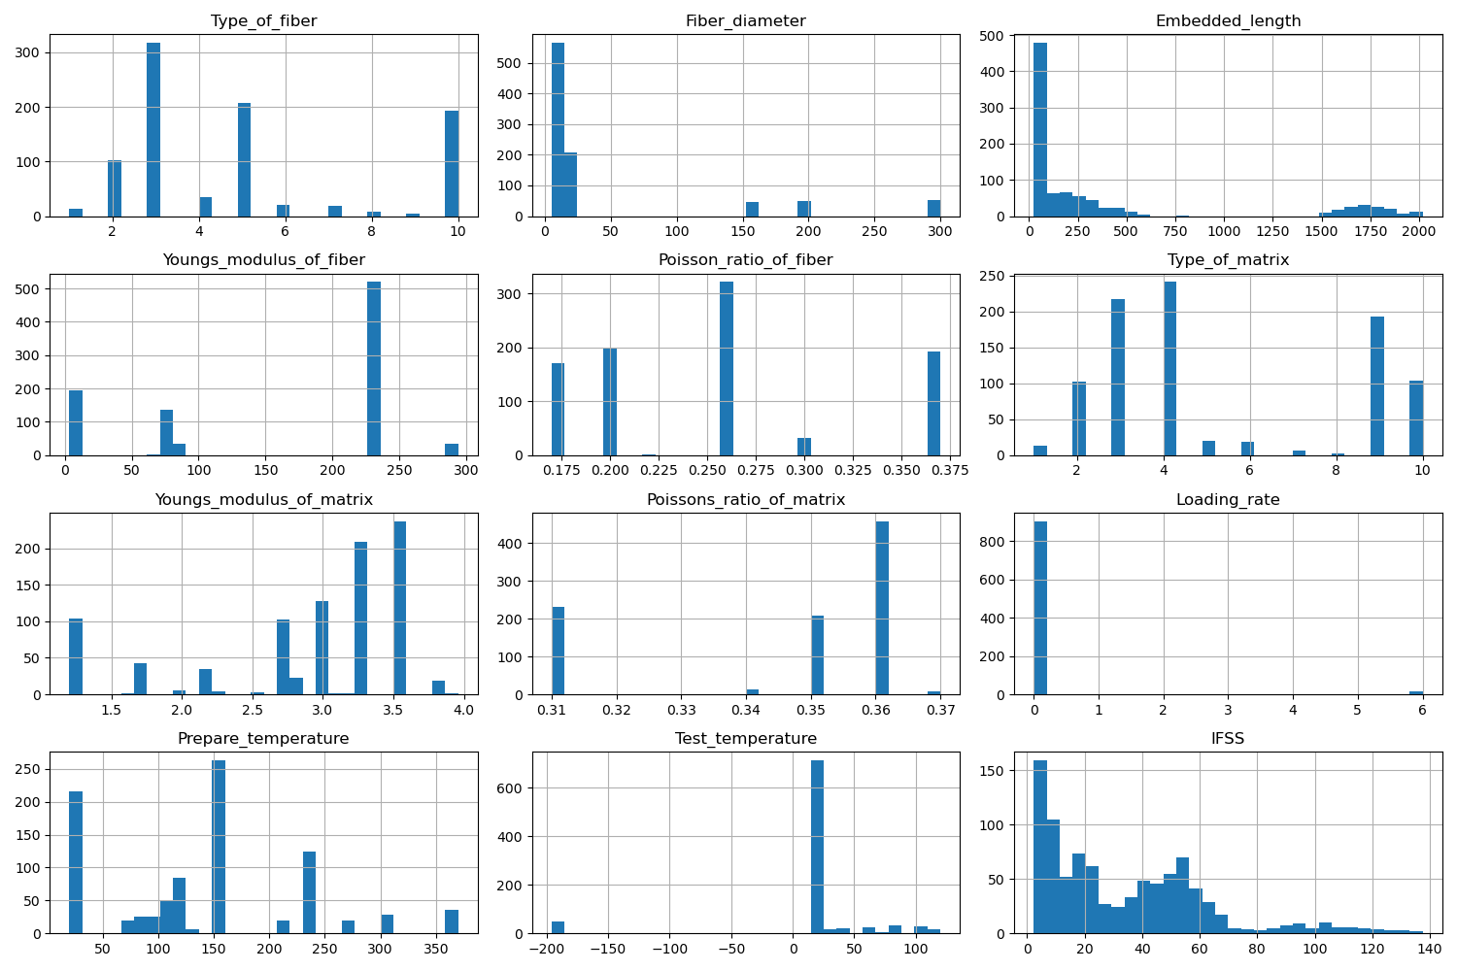

# Correlation Heatmap

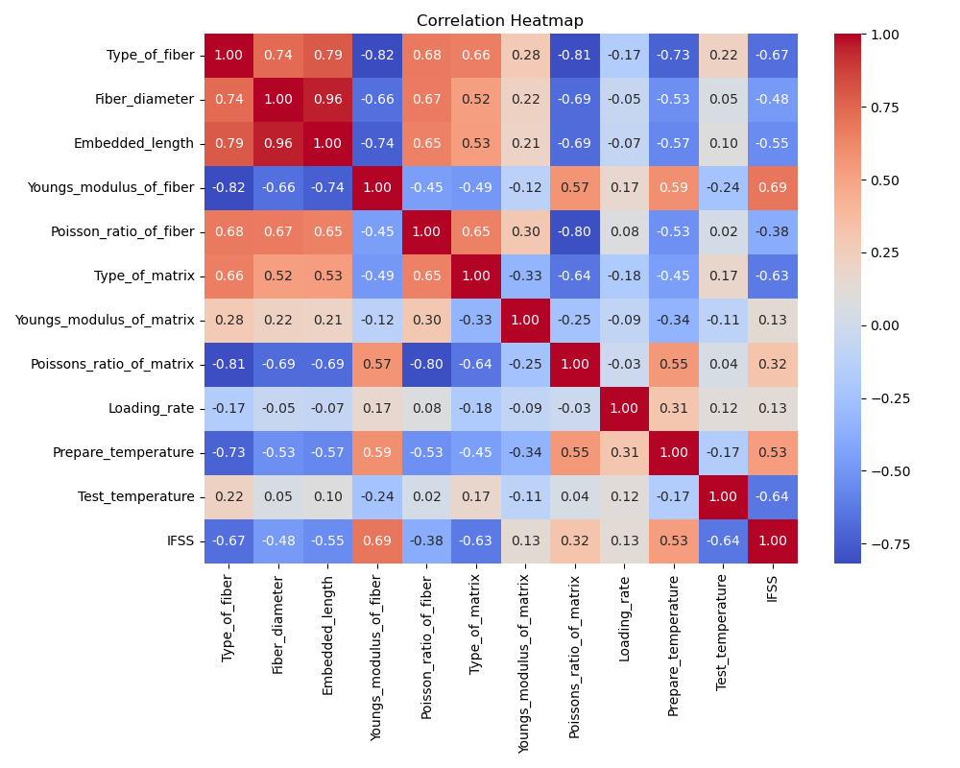

# Feature Importances

