Dataset Analysis Report

# Missing Values Analysis

cement 0  
blast_furnace_slag 0  
fly_ash 0  
water 0  
superplasticizer 0  
coarse_aggregate 0  
fine_aggregate 0  
age 0  
concrete_compressive_strength 0

# Descriptive Statistics

cement blast_furnace_slag fly_ash water superplasticizer coarse_aggregate fine_aggregate age concrete_compressive_strength  
count 1030.000000 1030.000000 1030.000000 1030.000000 1030.000000 1030.000000 1030.000000 1030.000000 1030.000000  
mean 281.167864 73.895825 54.188350 181.567282 6.204660 972.918932 773.580485 45.662136 35.817961  
std 104.506364 86.279342 63.997004 21.354219 5.973841 77.753954 80.175980 63.169912 16.705742  
min 102.000000 0.000000 0.000000 121.800000 0.000000 801.000000 594.000000 1.000000 2.330000  
25% 192.375000 0.000000 0.000000 164.900000 0.000000 932.000000 730.950000 7.000000 23.710000  
50% 272.900000 22.000000 0.000000 185.000000 6.400000 968.000000 779.500000 28.000000 34.445000  
75% 350.000000 142.950000 118.300000 192.000000 10.200000 1029.400000 824.000000 56.000000 46.135000  
max 540.000000 359.400000 200.100000 247.000000 32.200000 1145.000000 992.600000 365.000000 82.600000

# Correlation Matrix

cement blast_furnace_slag fly_ash water superplasticizer coarse_aggregate fine_aggregate age concrete_compressive_strength  
cement 1.000000 -0.275216 -0.397467 -0.081587 0.092386 -0.109349 -0.222718 0.081946 0.497832  
blast_furnace_slag -0.275216 1.000000 -0.323580 0.107252 0.043270 -0.283999 -0.281603 -0.044246 0.134829  
fly_ash -0.397467 -0.323580 1.000000 -0.256984 0.377503 -0.009961 0.079108 -0.154371 -0.105755  
water -0.081587 0.107252 -0.256984 1.000000 -0.657533 -0.182294 -0.450661 0.277618 -0.289633  
superplasticizer 0.092386 0.043270 0.377503 -0.657533 1.000000 -0.265999 0.222691 -0.192700 0.366079  
coarse_aggregate -0.109349 -0.283999 -0.009961 -0.182294 -0.265999 1.000000 -0.178481 -0.003016 -0.164935  
fine_aggregate -0.222718 -0.281603 0.079108 -0.450661 0.222691 -0.178481 1.000000 -0.156095 -0.167241  
age 0.081946 -0.044246 -0.154371 0.277618 -0.192700 -0.003016 -0.156095 1.000000 0.328873  
concrete_compressive_strength 0.497832 0.134829 -0.105755 -0.289633 0.366079 -0.164935 -0.167241 0.328873 1.000000

# Histograms of Features

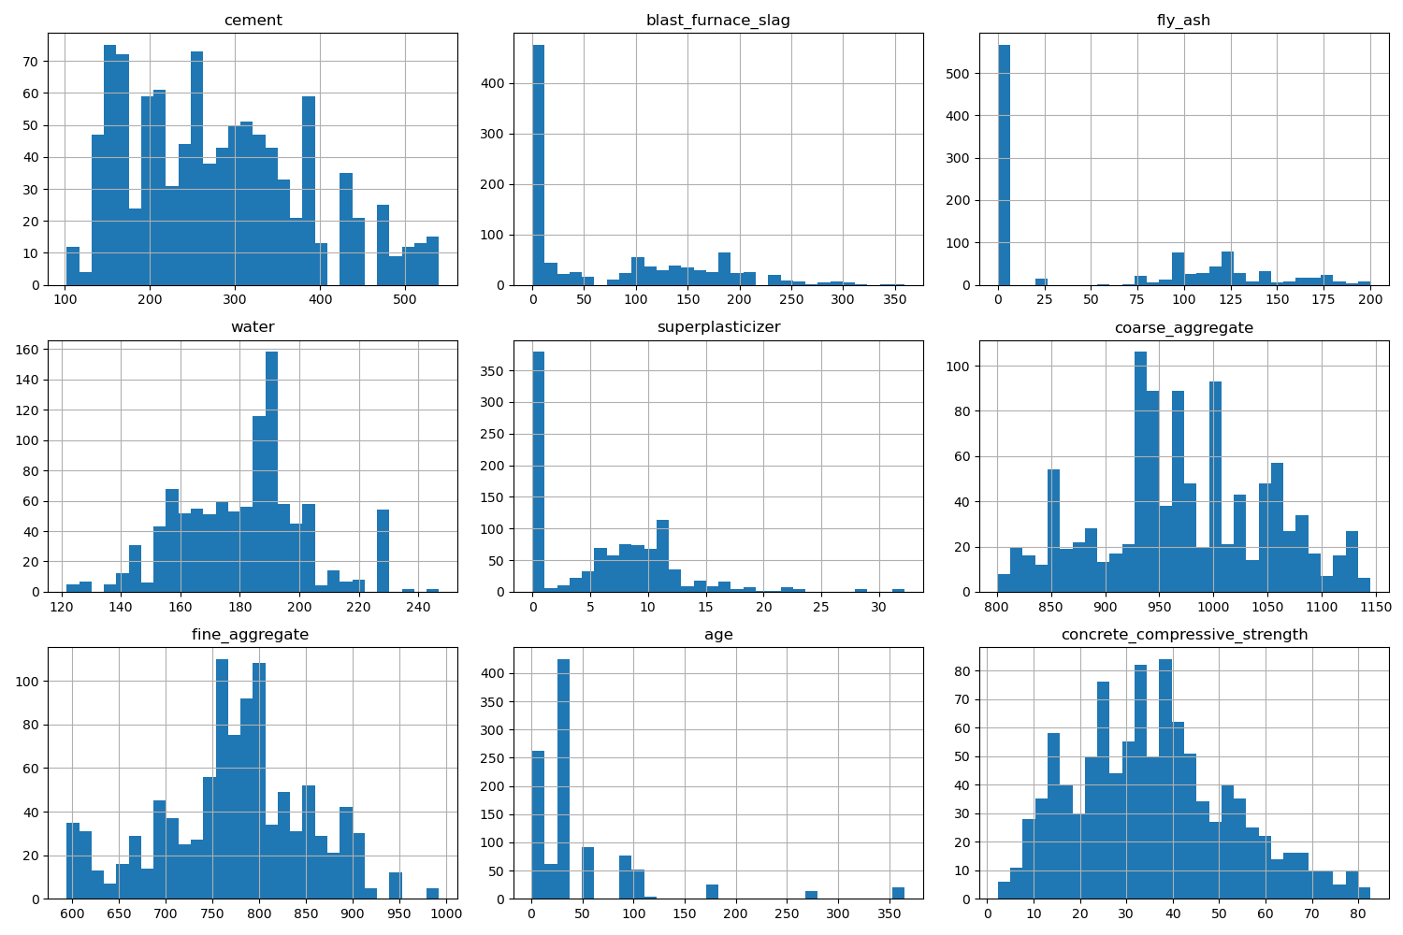

# Correlation Heatmap

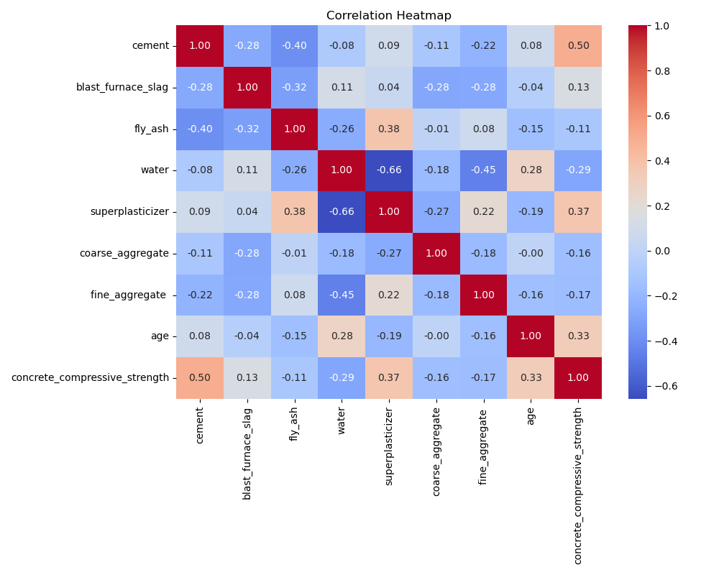

# Feature Importances

