Dataset Analysis Report

# Missing Values Analysis

Cement-to-cm³ 0  
Cement type (MPa) 0  
Fly ash-to-cm 0  
Slag-to-cm 0  
Silica fume-to-cm 0  
Metakaolin-to-cm 0  
Nano silica-to-cm 0  
Limestone-to-cm 0  
Quartz powder-to-cm 0  
Sand-to-cm 0  
Maximum aggregate size (mm) 0  
Water-to-cm 0  
Superplasticizer-to-cm 0  
Steel fiber volume (%) 0  
Aspect ratio of fibers 0  
Size of specimen (mm) 0  
28-day compressive strength (MPa) 0

# Descriptive Statistics

Cement-to-cm³ Cement type (MPa) Fly ash-to-cm Slag-to-cm Silica fume-to-cm Metakaolin-to-cm Nano silica-to-cm Limestone-to-cm Quartz powder-to-cm Sand-to-cm Maximum aggregate size (mm) Water-to-cm Superplasticizer-to-cm Steel fiber volume (%) Aspect ratio of fibers Size of specimen (mm) 28-day compressive strength (MPa)  
count 379.000000 379.000000 379.000000 379.000000 379.000000 379.000000 379.000000 379.000000 379.000000 379.000000 379.000000 379.000000 379.000000 379.000000 379.000000 379.000000 379.000000  
mean 0.751578 48.835092 0.048723 0.028469 0.158377 0.008990 0.003863 0.018555 0.077802 1.013845 2.232612 0.189277 0.026658 1.052996 37.792524 48.935884 139.067570  
std 0.135006 4.822358 0.109678 0.094391 0.081581 0.036976 0.013872 0.091442 0.127137 0.422198 1.783399 0.028234 0.020168 1.440825 53.518506 17.040712 32.925546  
min 0.173913 42.500000 0.000000 0.000000 0.000000 0.000000 0.000000 0.000000 0.000000 0.000000 0.075000 0.098415 0.000000 0.000000 0.000000 40.000000 57.011907  
25% 0.738857 42.500000 0.000000 0.000000 0.100000 0.000000 0.000000 0.000000 0.000000 0.879630 0.600000 0.169685 0.018536 0.000000 0.000000 40.000000 116.180808  
50% 0.793388 52.500000 0.000000 0.000000 0.180328 0.000000 0.000000 0.000000 0.000000 1.000000 2.000000 0.191667 0.023143 0.002564 37.500000 40.000000 141.467960  
75% 0.822388 52.500000 0.000000 0.000000 0.212952 0.000000 0.000000 0.000000 0.196038 1.224233 5.000000 0.200000 0.030797 2.000000 65.000000 50.000000 161.036923  
max 1.000000 52.500000 0.502806 0.695652 0.333333 0.285751 0.171875 1.088219 0.789474 2.071667 5.000000 0.285761 0.238402 6.558363 400.000000 110.000000 217.000000

# Correlation Matrix

Cement-to-cm³ Cement type (MPa) Fly ash-to-cm Slag-to-cm Silica fume-to-cm Metakaolin-to-cm Nano silica-to-cm Limestone-to-cm Quartz powder-to-cm Sand-to-cm Maximum aggregate size (mm) Water-to-cm Superplasticizer-to-cm Steel fiber volume (%) Aspect ratio of fibers Size of specimen (mm) 28-day compressive strength (MPa)  
Cement-to-cm³ 1.000000 0.094822 -0.562590 -0.617670 -0.192653 -0.046365 0.175226 0.103013 0.120171 0.089142 0.030867 0.326891 0.239035 -0.165217 -0.064698 0.063710 -0.034159  
Cement type (MPa) 0.094822 1.000000 0.009324 -0.057854 -0.097808 -0.055501 0.120243 -0.028530 0.321200 -0.148480 -0.076442 -0.116138 0.180809 -0.099629 0.085537 -0.276153 0.179764  
Fly ash-to-cm -0.562590 0.009324 1.000000 -0.076205 -0.343066 0.069450 -0.080150 -0.090379 -0.259202 0.027522 0.080894 -0.134081 -0.140770 0.078629 0.044810 -0.169432 0.028191  
Slag-to-cm -0.617670 -0.057854 -0.076205 1.000000 0.002144 -0.073524 -0.007186 0.012016 -0.089481 0.036559 -0.053701 -0.221179 -0.029142 0.107584 0.106475 0.054208 -0.095304  
Silica fume-to-cm -0.192653 -0.097808 -0.343066 0.002144 1.000000 -0.373277 -0.313191 -0.155313 0.306275 -0.304290 -0.086824 -0.273721 -0.182282 0.044001 -0.045173 -0.008551 0.212461  
Metakaolin-to-cm -0.046365 -0.055501 0.069450 -0.073524 -0.373277 1.000000 -0.067874 0.166089 -0.149177 0.085518 0.009380 0.315511 -0.083374 -0.034221 -0.065475 0.125347 -0.148726  
Nano silica-to-cm 0.175226 0.120243 -0.080150 -0.007186 -0.313191 -0.067874 1.000000 0.100936 0.085120 0.227650 -0.088971 0.152424 0.279139 0.086666 -0.008945 0.066875 -0.094990  
Limestone-to-cm 0.103013 -0.028530 -0.090379 0.012016 -0.155313 0.166089 0.100936 1.000000 -0.037169 0.115039 -0.113596 0.388697 0.029434 -0.049635 -0.062646 0.085208 -0.073717  
Quartz powder-to-cm 0.120171 0.321200 -0.259202 -0.089481 0.306275 -0.149177 0.085120 -0.037169 1.000000 -0.008104 -0.241775 0.071575 0.263845 0.088637 0.178017 0.213628 0.157782  
Sand-to-cm 0.089142 -0.148480 0.027522 0.036559 -0.304290 0.085518 0.227650 0.115039 -0.008104 1.000000 -0.247399 0.355302 0.173697 -0.122711 -0.161538 0.096918 -0.419418  
Maximum aggregate size (mm) 0.030867 -0.076442 0.080894 -0.053701 -0.086824 0.009380 -0.088971 -0.113596 -0.241775 -0.247399 1.000000 -0.126620 0.106808 -0.154265 -0.108677 -0.026771 0.223831  
Water-to-cm 0.326891 -0.116138 -0.134081 -0.221179 -0.273721 0.315511 0.152424 0.388697 0.071575 0.355302 -0.126620 1.000000 0.198396 -0.138734 -0.051158 0.155651 -0.125477  
Superplasticizer-to-cm 0.239035 0.180809 -0.140770 -0.029142 -0.182282 -0.083374 0.279139 0.029434 0.263845 0.173697 0.106808 0.198396 1.000000 -0.088922 0.055687 -0.062103 -0.064633  
Steel fiber volume (%) -0.165217 -0.099629 0.078629 0.107584 0.044001 -0.034221 0.086666 -0.049635 0.088637 -0.122711 -0.154265 -0.138734 -0.088922 1.000000 0.529665 0.220083 0.326696  
Aspect ratio of fibers -0.064698 0.085537 0.044810 0.106475 -0.045173 -0.065475 -0.008945 -0.062646 0.178017 -0.161538 -0.108677 -0.051158 0.055687 0.529665 1.000000 0.007286 0.202658  
Size of specimen (mm) 0.063710 -0.276153 -0.169432 0.054208 -0.008551 0.125347 0.066875 0.085208 0.213628 0.096918 -0.026771 0.155651 -0.062103 0.220083 0.007286 1.000000 0.071540  
28-day compressive strength (MPa) -0.034159 0.179764 0.028191 -0.095304 0.212461 -0.148726 -0.094990 -0.073717 0.157782 -0.419418 0.223831 -0.125477 -0.064633 0.326696 0.202658 0.071540 1.000000

# Histograms of Features

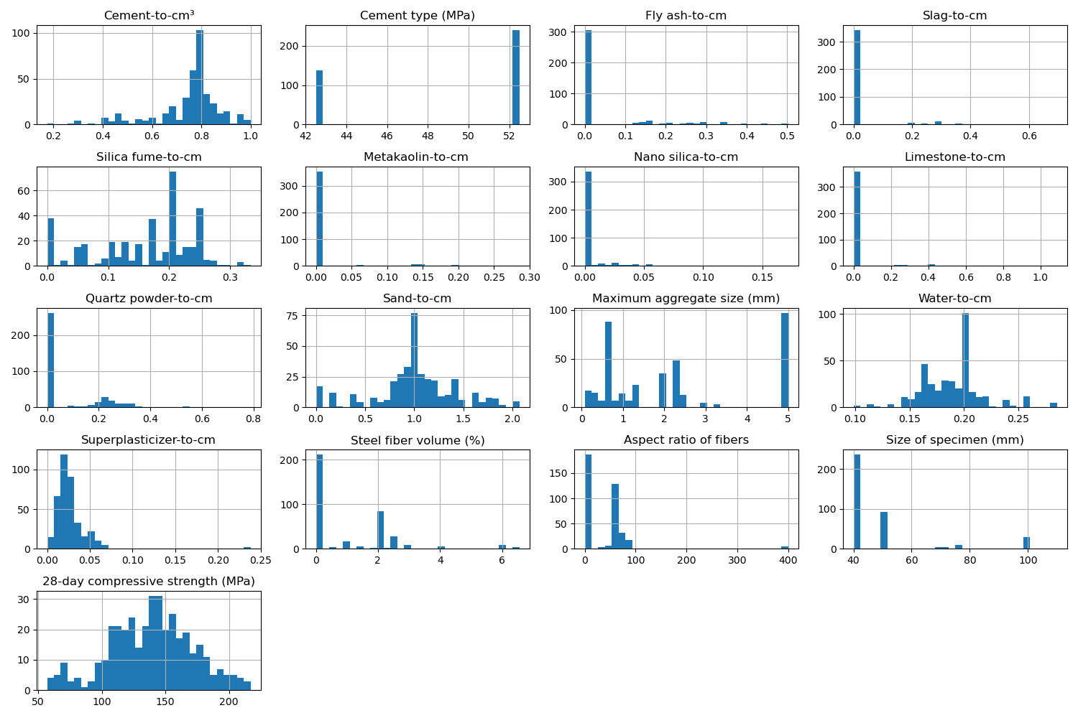

# Correlation Heatmap

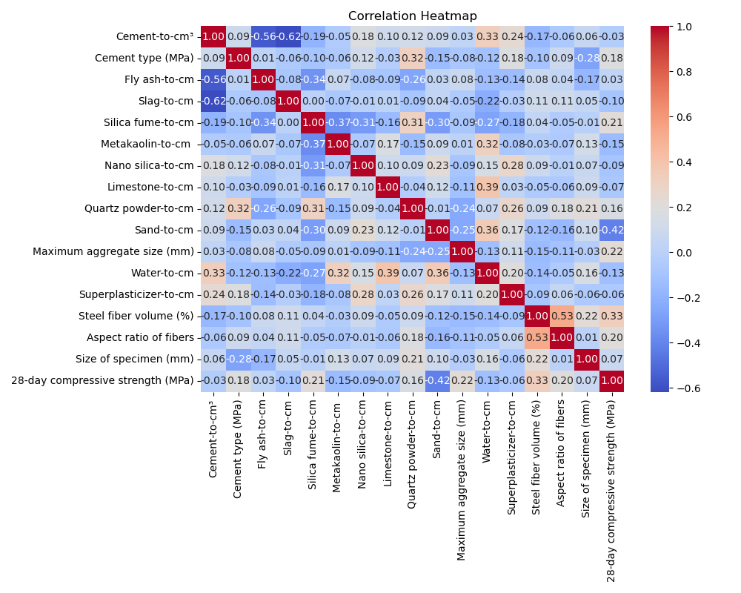

# Feature Importances

