Dataset Analysis Report

# Missing Values Analysis

Cement-to-cm 0  
Cement type (MPa) 0  
Fly ash-to-cm 0  
Slag-to-cm 0  
Silica fume-to-cm 0  
Metakaolin-to-cm 0  
Nano silica-to-cm 0  
Limestone-to-cm 0  
Quartz powder-to-cm 0  
Sand-to-cm 0  
Maximum aggregate size (mm) 0  
Water-to-cm 0  
Superplasticizer-to-cm 0  
Steel fiber volume (%) 0  
Aspect ratio of fibers 0  
Length of specimen (mm) 0  
28-day flexural strength (MPa) 0

# Descriptive Statistics

Cement-to-cm Cement type (MPa) Fly ash-to-cm Slag-to-cm Silica fume-to-cm Metakaolin-to-cm Nano silica-to-cm Limestone-to-cm Quartz powder-to-cm Sand-to-cm Maximum aggregate size (mm) Water-to-cm Superplasticizer-to-cm Steel fiber volume (%) Aspect ratio of fibers Length of specimen (mm) 28-day flexural strength (MPa)  
count 146.000000 146.000000 146.000000 146.000000 146.000000 146.000000 146.000000 146.000000 146.000000 146.000000 146.000000 146.000000 146.000000 146.000000 146.000000 146.000000 146.000000  
mean 0.727922 47.910959 0.078680 0.043556 0.120772 0.022304 0.006766 0.017612 1.171914 1.745000 0.026943 0.191831 0.026368 1.155319 36.574527 176.506849 24.265203  
std 0.165759 5.000236 0.124795 0.107680 0.092464 0.055838 0.015792 0.085368 0.305324 1.049466 0.081039 0.032423 0.014423 1.062215 33.611268 57.960658 7.637082  
min 0.300189 42.500000 0.000000 0.000000 0.000000 0.000000 0.000000 0.000000 0.793388 0.100000 0.000000 0.135537 0.006817 0.000000 0.000000 100.000000 7.729258  
25% 0.655652 42.500000 0.000000 0.000000 0.045710 0.000000 0.000000 0.000000 1.000000 0.950000 0.000000 0.164435 0.018523 0.000000 0.000000 160.000000 18.228170  
50% 0.793388 52.500000 0.000000 0.000000 0.100000 0.000000 0.000000 0.000000 1.008205 2.000000 0.000000 0.180808 0.020019 1.500000 62.500000 160.000000 23.506873  
75% 0.833333 52.500000 0.166667 0.000000 0.200000 0.000000 0.000000 0.000000 1.380719 2.360000 0.000000 0.200034 0.033333 2.000000 65.000000 160.000000 29.924749  
max 1.000000 52.500000 0.449811 0.449811 0.250234 0.285751 0.055548 0.428641 2.071667 5.000000 0.319797 0.285761 0.071508 4.000000 81.250000 400.000000 41.931419

# Correlation Matrix

Cement-to-cm Cement type (MPa) Fly ash-to-cm Slag-to-cm Silica fume-to-cm Metakaolin-to-cm Nano silica-to-cm Limestone-to-cm Quartz powder-to-cm Sand-to-cm Maximum aggregate size (mm) Water-to-cm Superplasticizer-to-cm Steel fiber volume (%) Aspect ratio of fibers Length of specimen (mm) 28-day flexural strength (MPa)  
Cement-to-cm 1.000000 0.146311 -0.540298 -0.620592 -0.399909 -0.008125 0.375168 0.181630 0.414996 -0.236802 0.223338 0.541110 0.371692 -0.337511 -0.260768 0.154174 -0.145092  
Cement type (MPa) 0.146311 1.000000 0.339357 -0.138913 -0.605506 -0.031717 0.387169 -0.017050 -0.018782 -0.183664 0.307232 0.043671 0.595520 0.095610 0.122852 0.113260 -0.127221  
Fly ash-to-cm -0.540298 0.339357 1.000000 -0.140024 -0.196360 0.016087 -0.183690 -0.130970 -0.281857 0.061482 -0.211058 -0.380309 -0.096270 0.237716 0.185858 -0.272126 0.037148  
Slag-to-cm -0.620592 -0.138913 -0.140024 1.000000 0.247542 -0.162689 -0.072322 -0.084026 -0.145929 0.151455 -0.135408 -0.334706 -0.056513 0.202893 0.127886 -0.026741 0.045549  
Silica fume-to-cm -0.399909 -0.605506 -0.196360 0.247542 1.000000 -0.392144 -0.407140 -0.271330 -0.269629 0.023588 0.079186 -0.407858 -0.506483 0.203564 0.182607 0.116832 0.339895  
Metakaolin-to-cm -0.008125 -0.031717 0.016087 -0.162689 -0.392144 1.000000 -0.172319 0.315608 -0.021720 0.218521 -0.133721 0.442207 -0.178241 -0.215383 -0.180474 0.043365 -0.244455  
Nano silica-to-cm 0.375168 0.387169 -0.183690 -0.072322 -0.407140 -0.172319 1.000000 0.174206 0.521973 0.056222 0.256122 0.432439 0.840462 -0.149691 -0.034683 -0.122857 -0.206980  
Limestone-to-cm 0.181630 -0.017050 -0.130970 -0.084026 -0.271330 0.315608 0.174206 1.000000 0.393363 -0.053433 -0.069064 0.513658 0.278994 -0.225940 -0.226047 -0.059161 -0.241549  
Quartz powder-to-cm 0.414996 -0.018782 -0.281857 -0.145929 -0.269629 -0.021720 0.521973 0.393363 1.000000 -0.111991 -0.011822 0.605929 0.408503 -0.566506 -0.531353 -0.135036 -0.441662  
Sand-to-cm -0.236802 -0.183664 0.061482 0.151455 0.023588 0.218521 0.056222 -0.053433 -0.111991 1.000000 0.128019 0.053595 0.011489 0.064320 0.066294 0.324098 -0.047334  
Maximum aggregate size (mm) 0.223338 0.307232 -0.211058 -0.135408 0.079186 -0.133721 0.256122 -0.069064 -0.011822 0.128019 1.000000 0.159531 0.305626 0.060239 0.125015 0.703114 0.173033  
Water-to-cm 0.541110 0.043671 -0.380309 -0.334706 -0.407858 0.442207 0.432439 0.513658 0.605929 0.053595 0.159531 1.000000 0.364646 -0.489270 -0.409562 0.064691 -0.408750  
Superplasticizer-to-cm 0.371692 0.595520 -0.096270 -0.056513 -0.506483 -0.178241 0.840462 0.278994 0.408503 0.011489 0.305626 0.364646 1.000000 -0.056863 -0.000058 0.003760 -0.203412  
Steel fiber volume (%) -0.337511 0.095610 0.237716 0.202893 0.203564 -0.215383 -0.149691 -0.225940 -0.566506 0.064320 0.060239 -0.489270 -0.056863 1.000000 0.875556 -0.068815 0.698625  
Aspect ratio of fibers -0.260768 0.122852 0.185858 0.127886 0.182607 -0.180474 -0.034683 -0.226047 -0.531353 0.066294 0.125015 -0.409562 -0.000058 0.875556 1.000000 -0.029275 0.646287  
Length of specimen (mm) 0.154174 0.113260 -0.272126 -0.026741 0.116832 0.043365 -0.122857 -0.059161 -0.135036 0.324098 0.703114 0.064691 0.003760 -0.068815 -0.029275 1.000000 0.112129  
28-day flexural strength (MPa) -0.145092 -0.127221 0.037148 0.045549 0.339895 -0.244455 -0.206980 -0.241549 -0.441662 -0.047334 0.173033 -0.408750 -0.203412 0.698625 0.646287 0.112129 1.000000

# Histograms of Features

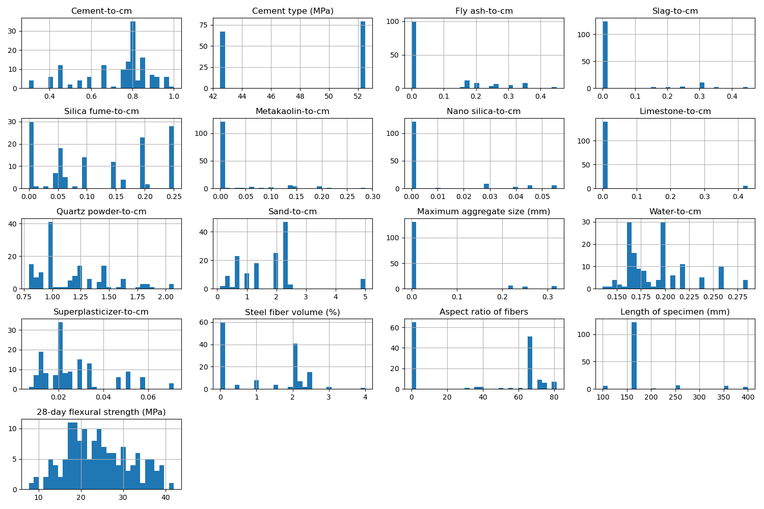

# Correlation Heatmap

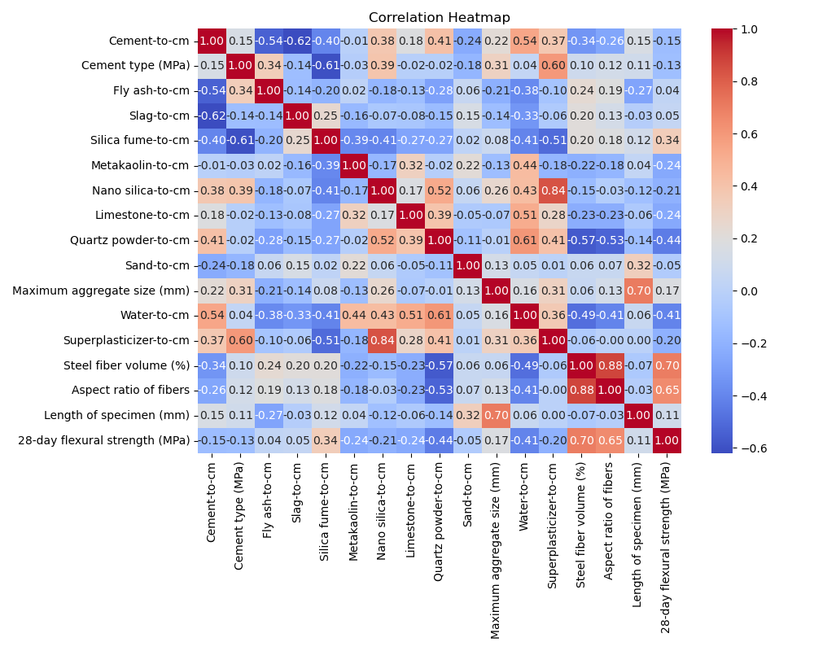

# Feature Importances

