Dataset Analysis Report

# Missing Values Analysis

Cement-to-cm 0  
Cement type (MPa) 0  
Fly ash-to-cm 0  
Slag-to-cm 0  
Silica fume-to-cm 0  
Metakaolin-to-cm 0  
Nano silica-to-cm 0  
Limestone-to-cm 0  
Quartz powder-to-cm 0  
Sand-to-cm 0  
Maximum aggregate size (mm) 0  
Water-to-cm 0  
Superplasticizer-to-cm 0  
Steel fiber volume (%) 0  
Aspect ratio of fibers 0  
Mini-slump spread (mm) 0

# Descriptive Statistics

Cement-to-cm Cement type (MPa) Fly ash-to-cm Slag-to-cm Silica fume-to-cm Metakaolin-to-cm Nano silica-to-cm Limestone-to-cm Quartz powder-to-cm Sand-to-cm Maximum aggregate size (mm) Water-to-cm Superplasticizer-to-cm Steel fiber volume (%) Aspect ratio of fibers Mini-slump spread (mm)  
count 152.000000 152.000000 152.000000 152.000000 152.000000 152.000000 152.000000 152.000000 152.000000 152.000000 152.000000 152.000000 152.000000 152.000000 152.000000 152.000000  
mean 0.707888 50.263158 0.035526 0.062757 0.183053 0.005776 0.005132 0.030395 1.078118 1.046513 0.109257 0.190579 0.023711 1.007368 32.920250 232.604855  
std 0.154389 4.180904 0.089048 0.137471 0.082405 0.032188 0.014130 0.122599 0.220381 0.741751 0.128368 0.027072 0.011403 1.014501 32.478883 63.671092  
min 0.280000 42.500000 0.000000 0.000000 0.000000 0.000000 0.000000 0.000000 0.264000 0.110000 0.000000 0.131000 0.002000 0.000000 0.000000 100.820000  
25% 0.656000 52.500000 0.000000 0.000000 0.123000 0.000000 0.000000 0.000000 0.970000 0.600000 0.000000 0.172000 0.020000 0.000000 0.000000 183.057250  
50% 0.758000 52.500000 0.000000 0.000000 0.200000 0.000000 0.000000 0.000000 1.031500 0.600000 0.000000 0.190000 0.023000 1.000000 45.000000 211.000000  
75% 0.800000 52.500000 0.000000 0.000000 0.250000 0.000000 0.000000 0.000000 1.227000 1.250000 0.225250 0.200000 0.026000 2.000000 65.000000 283.284000  
max 0.909000 52.500000 0.450000 0.520000 0.333000 0.286000 0.056000 1.088000 1.630000 2.360000 0.379000 0.286000 0.058000 3.000000 80.000000 382.675000

# Correlation Matrix

Cement-to-cm Cement type (MPa) Fly ash-to-cm Slag-to-cm Silica fume-to-cm Metakaolin-to-cm Nano silica-to-cm Limestone-to-cm Quartz powder-to-cm Sand-to-cm Maximum aggregate size (mm) Water-to-cm Superplasticizer-to-cm Steel fiber volume (%) Aspect ratio of fibers Mini-slump spread (mm)  
Cement-to-cm 1.000000 0.414308 -0.239171 -0.819061 -0.325280 0.036771 0.368255 0.101710 0.141137 -0.146015 0.353760 0.483644 0.524796 -0.071026 -0.002046 0.275609  
Cement type (MPa) 0.414308 1.000000 -0.105324 -0.278066 -0.126521 -0.219776 0.090213 -0.261061 0.062174 -0.697415 0.294878 0.142580 0.150238 -0.388300 -0.317501 0.238837  
Fly ash-to-cm -0.239171 -0.105324 1.000000 -0.183333 -0.328282 0.072359 -0.145850 -0.099565 -0.082118 0.310497 -0.341808 -0.161021 0.132909 0.293317 0.226109 0.218431  
Slag-to-cm -0.819061 -0.278066 -0.183333 1.000000 0.116790 -0.082465 -0.123580 -0.019773 0.024667 0.024774 -0.323742 -0.294274 -0.433565 -0.012312 -0.065895 -0.106147  
Silica fume-to-cm -0.325280 -0.126521 -0.328282 0.116790 1.000000 -0.388966 -0.470670 -0.214131 -0.355901 -0.161908 0.301523 -0.483188 -0.534259 -0.158752 -0.141108 -0.675941  
Metakaolin-to-cm 0.036771 -0.219776 0.072359 -0.082465 -0.388966 1.000000 -0.065605 0.417417 0.155138 -0.003949 -0.153748 0.424974 0.012975 -0.084056 -0.086335 0.110109  
Nano silica-to-cm 0.368255 0.090213 -0.145850 -0.123580 -0.470670 -0.065605 1.000000 0.000268 0.466031 0.354619 0.026222 0.449100 0.746311 0.166203 0.258334 0.347002  
Limestone-to-cm 0.101710 -0.261061 -0.099565 -0.019773 -0.214131 0.417417 0.000268 1.000000 -0.083153 0.011878 -0.071394 0.489281 -0.149163 -0.059424 -0.079099 0.226416  
Quartz powder-to-cm 0.141137 0.062174 -0.082118 0.024667 -0.355901 0.155138 0.466031 -0.083153 1.000000 0.085206 0.094677 0.457027 0.365089 -0.183081 -0.132184 0.267848  
Sand-to-cm -0.146015 -0.697415 0.310497 0.024774 -0.161908 -0.003949 0.354619 0.011878 0.085206 1.000000 -0.331871 -0.022384 0.424600 0.498476 0.476224 0.075634  
Maximum aggregate size (mm) 0.353760 0.294878 -0.341808 -0.323742 0.301523 -0.153748 0.026222 -0.071394 0.094677 -0.331871 1.000000 0.172868 0.188843 -0.185071 -0.061059 -0.255104  
Water-to-cm 0.483644 0.142580 -0.161021 -0.294274 -0.483188 0.424974 0.449100 0.489281 0.457027 -0.022384 0.172868 1.000000 0.406551 -0.174522 -0.105160 0.514325  
Superplasticizer-to-cm 0.524796 0.150238 0.132909 -0.433565 -0.534259 0.012975 0.746311 -0.149163 0.365089 0.424600 0.188843 0.406551 1.000000 0.252936 0.321312 0.336658  
Steel fiber volume (%) -0.071026 -0.388300 0.293317 -0.012312 -0.158752 -0.084056 0.166203 -0.059424 -0.183081 0.498476 -0.185071 -0.174522 0.252936 1.000000 0.865517 0.021108  
Aspect ratio of fibers -0.002046 -0.317501 0.226109 -0.065895 -0.141108 -0.086335 0.258334 -0.079099 -0.132184 0.476224 -0.061059 -0.105160 0.321312 0.865517 1.000000 0.036641  
Mini-slump spread (mm) 0.275609 0.238837 0.218431 -0.106147 -0.675941 0.110109 0.347002 0.226416 0.267848 0.075634 -0.255104 0.514325 0.336658 0.021108 0.036641 1.000000

# Histograms of Features

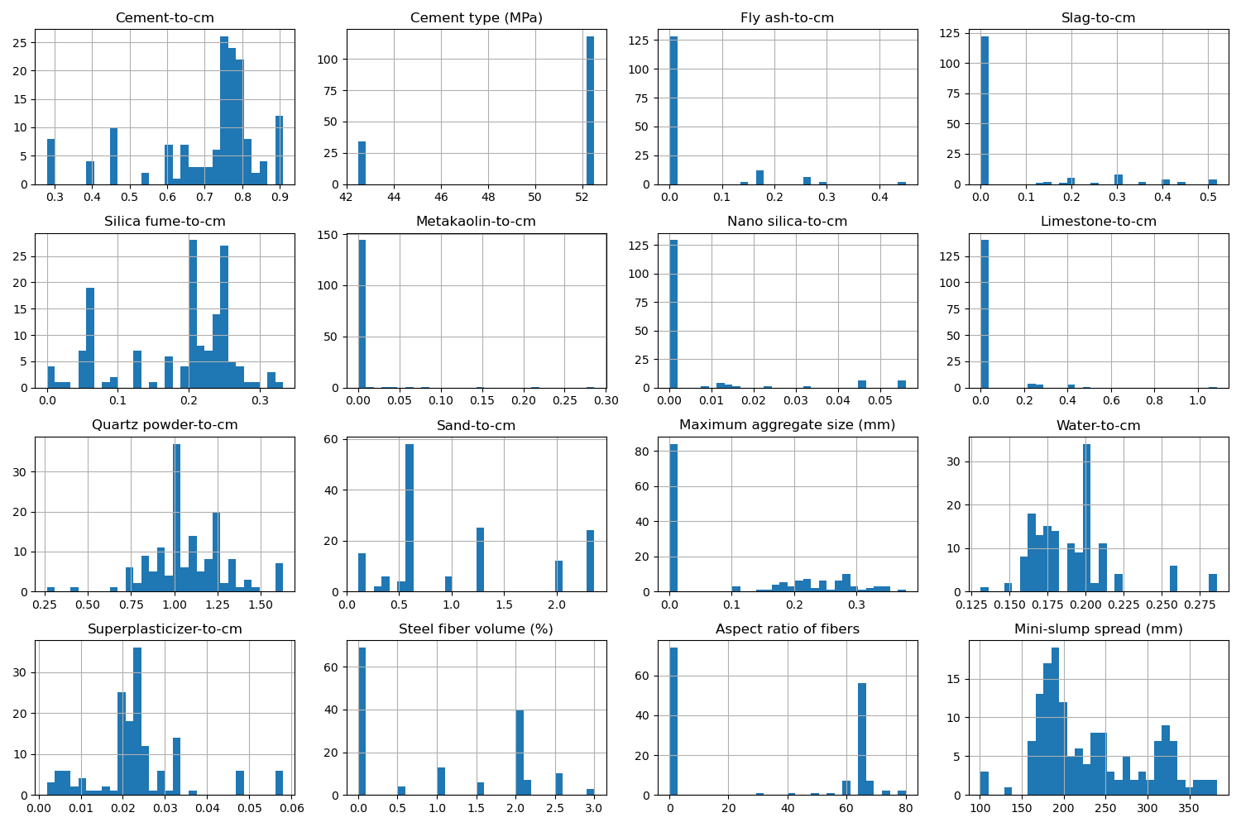

# Correlation Heatmap

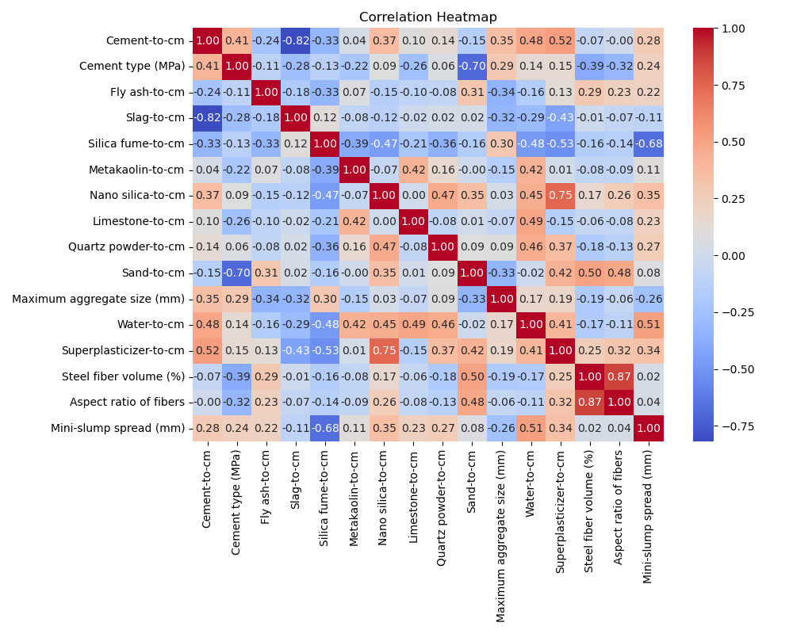

# Feature Importances

