Dataset Analysis Report

# Missing Values Analysis

Cement-to-cm 0  
Cement type (MPa) 0  
Fly ash-to-cm 0  
Slag-to-cm 0  
Silica fume-to-cm 0  
Metakaolin-to-cm 0  
Nano silica-to-cm 0  
Limestone-to-cm 0  
Quartz powder-to-cm 0  
Sand-to-cm 0  
Maximum aggregate size (mm) 0  
Water-to-cm 0  
Superplasticizer-to-cm 0  
Steel fiber volume (%) 0  
Aspect ratio of fibers 0  
28-day porosity (%) 0

# Descriptive Statistics

Cement-to-cm Cement type (MPa) Fly ash-to-cm Slag-to-cm Silica fume-to-cm Metakaolin-to-cm Nano silica-to-cm Limestone-to-cm Quartz powder-to-cm Sand-to-cm Maximum aggregate size (mm) Water-to-cm Superplasticizer-to-cm Steel fiber volume (%) Aspect ratio of fibers 28-day porosity (%)  
count 108.000000 108.000000 108.000000 108.000000 108.000000 108.000000 108.000000 108.000000 108.000000 108.000000 108.000000 108.000000 108.000000 108.000000 108.000000 108.000000  
mean 0.879816 51.944444 0.011212 0.027442 0.052427 0.008929 0.020175 0.285016 1.488307 2.887130 0.049971 0.272045 0.051862 1.250000 32.528807 11.274815  
std 0.128480 2.301293 0.054112 0.104025 0.065925 0.038301 0.021482 0.417628 0.659139 4.017969 0.110333 0.094649 0.024865 1.733534 29.946827 4.700227  
min 0.173913 42.500000 0.000000 0.000000 0.000000 0.000000 0.000000 0.000000 0.000000 0.500000 0.000000 0.130567 0.006512 0.000000 0.000000 2.350000  
25% 0.845634 52.500000 0.000000 0.000000 0.000000 0.000000 0.000000 0.000000 0.928318 1.000000 0.000000 0.209952 0.026846 0.000000 0.000000 8.377500  
50% 0.900012 52.500000 0.000000 0.000000 0.000000 0.000000 0.019922 0.374946 1.450114 2.000000 0.000000 0.275787 0.050022 0.500000 13.000000 10.820000  
75% 0.960157 52.500000 0.000000 0.000000 0.100000 0.000000 0.039843 0.428641 1.908393 2.000000 0.000000 0.328543 0.074951 2.000000 65.000000 16.762500  
max 1.000000 52.500000 0.300034 0.695652 0.211618 0.285751 0.062420 3.564510 3.714966 16.000000 0.400228 0.899960 0.099886 7.600000 72.222222 17.660000

# Correlation Matrix

Cement-to-cm Cement type (MPa) Fly ash-to-cm Slag-to-cm Silica fume-to-cm Metakaolin-to-cm Nano silica-to-cm Limestone-to-cm Quartz powder-to-cm Sand-to-cm Maximum aggregate size (mm) Water-to-cm Superplasticizer-to-cm Steel fiber volume (%) Aspect ratio of fibers 28-day porosity (%)  
Cement-to-cm 1.000000 0.061120 -0.291581 -0.801242 -0.442064 -0.094361 0.158500 0.274656 0.473561 0.033250 -0.033135 0.497492 0.449272 -0.179134 -0.008377 0.473872  
Cement type (MPa) 0.061120 1.000000 0.050488 0.064278 0.070458 -0.700560 0.228842 -0.042057 0.052999 0.103224 0.110360 0.016710 0.353801 0.128847 0.176528 0.022282  
Fly ash-to-cm -0.291581 0.050488 1.000000 -0.055170 -0.139269 -0.048753 0.006420 -0.142729 -0.047270 -0.064881 0.015573 -0.179628 -0.035810 0.084550 -0.119612 0.090047  
Slag-to-cm -0.801242 0.064278 -0.055170 1.000000 0.112089 -0.062070 -0.144708 -0.181714 -0.224735 -0.030062 0.086244 -0.300139 -0.151789 0.116113 0.146022 -0.282742  
Silica fume-to-cm -0.442064 0.070458 -0.139269 0.112089 1.000000 -0.187117 -0.283300 -0.150234 -0.668720 0.168876 -0.054963 -0.389094 -0.670071 0.181022 0.013468 -0.676155  
Metakaolin-to-cm -0.094361 -0.700560 -0.048753 -0.062070 -0.187117 1.000000 -0.220978 0.080868 0.023083 -0.097497 -0.106567 0.059340 -0.155716 -0.099284 -0.123174 0.109764  
Nano silica-to-cm 0.158500 0.228842 0.006420 -0.144708 -0.283300 -0.220978 1.000000 -0.086333 0.386105 -0.234278 0.099992 0.018745 0.472205 -0.082388 -0.177418 0.187513  
Limestone-to-cm 0.274656 -0.042057 -0.142729 -0.181714 -0.150234 0.080868 -0.086333 1.000000 0.594423 -0.212765 -0.019752 0.897559 0.204624 -0.178221 -0.066804 0.288168  
Quartz powder-to-cm 0.473561 0.052999 -0.047270 -0.224735 -0.668720 0.023083 0.386105 0.594423 1.000000 -0.326772 0.333219 0.769482 0.831519 -0.039241 0.029341 0.540861  
Sand-to-cm 0.033250 0.103224 -0.064881 -0.030062 0.168876 -0.097497 -0.234278 -0.212765 -0.326772 1.000000 -0.123600 -0.095410 -0.226482 -0.147249 -0.062686 -0.406970  
Maximum aggregate size (mm) -0.033135 0.110360 0.015573 0.086244 -0.054963 -0.106567 0.099992 -0.019752 0.333219 -0.123600 1.000000 0.142868 0.342901 0.519478 -0.059314 -0.103122  
Water-to-cm 0.497492 0.016710 -0.179628 -0.300139 -0.389094 0.059340 0.018745 0.897559 0.769482 -0.095410 0.142868 1.000000 0.460817 -0.113687 0.009587 0.430316  
Superplasticizer-to-cm 0.449272 0.353801 -0.035810 -0.151789 -0.670071 -0.155716 0.472205 0.204624 0.831519 -0.226482 0.342901 0.460817 1.000000 0.085606 0.296057 0.620850  
Steel fiber volume (%) -0.179134 0.128847 0.084550 0.116113 0.181022 -0.099284 -0.082388 -0.178221 -0.039241 -0.147249 0.519478 -0.113687 0.085606 1.000000 0.403406 0.060110  
Aspect ratio of fibers -0.008377 0.176528 -0.119612 0.146022 0.013468 -0.123174 -0.177418 -0.066804 0.029341 -0.062686 -0.059314 0.009587 0.296057 0.403406 1.000000 0.353489  
28-day porosity (%) 0.473872 0.022282 0.090047 -0.282742 -0.676155 0.109764 0.187513 0.288168 0.540861 -0.406970 -0.103122 0.430316 0.620850 0.060110 0.353489 1.000000

# Histograms of Features

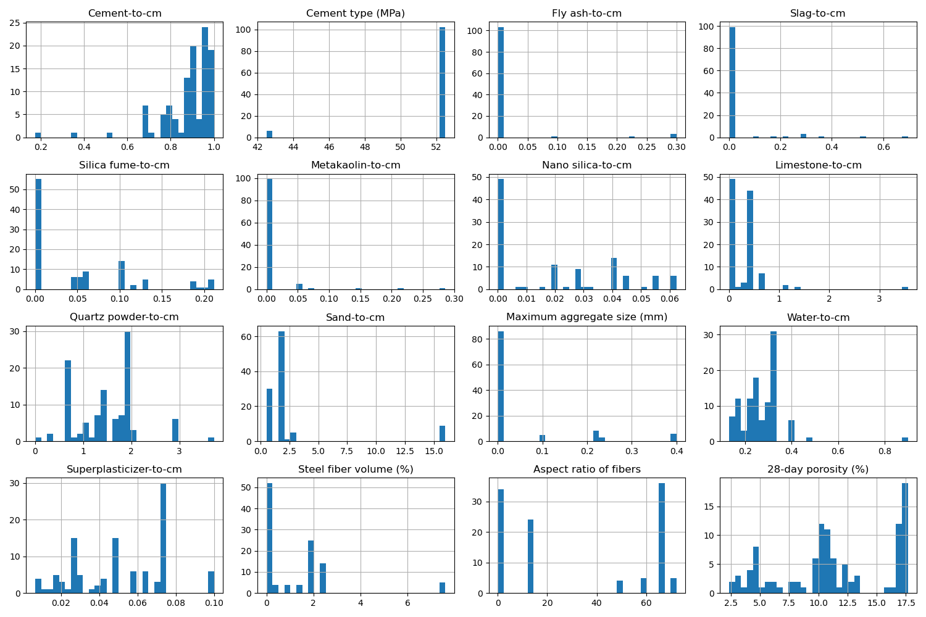

# Correlation Heatmap

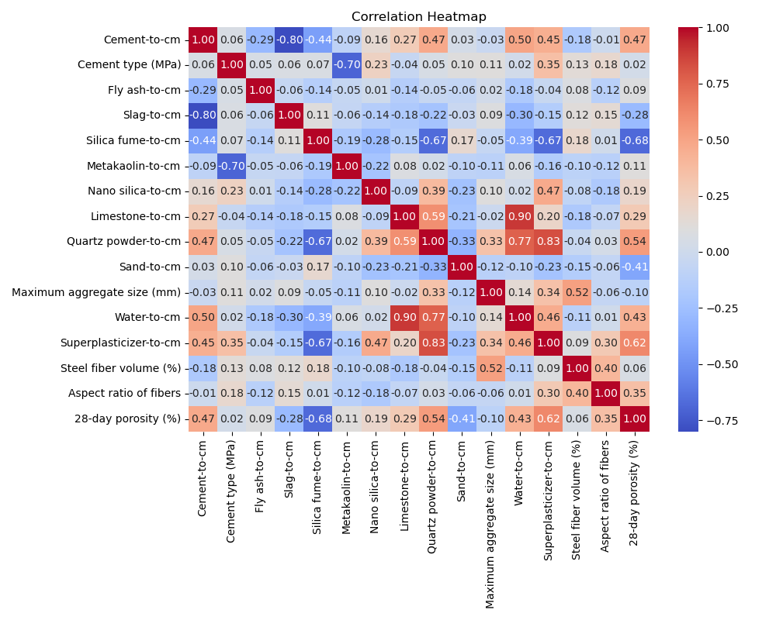

# Feature Importances

