R2 Samples Report for 3 Thresholds

|  |  |  |  |
| --- | --- | --- | --- |
| Strategy | R2 >= 0.6 | R2 >= 0.7 | R2 >= 0.8 |
| RS | 10 (1.14%) | 20 (2.27%) | 30 (3.41%) |
| LL4AL | 10 (1.14%) | 80 (9.09%) | 90 (10.23%) |
| LCMD | 10 (1.14%) | 40 (4.55%) | 50 (5.68%) |
| MCD | 10 (1.14%) | 30 (3.41%) | 40 (4.55%) |
| EGAL | 10 (1.14%) | 40 (4.55%) | 80 (9.09%) |
| BayesianAL | 10 (1.14%) | 50 (5.68%) | 50 (5.68%) |
| GSx | 10 (1.14%) | 20 (2.27%) | 60 (6.82%) |
| GSy | 10 (1.14%) | 20 (2.27%) | 20 (2.27%) |
| iGS | 10 (1.14%) | 30 (3.41%) | 30 (3.41%) |
| GSBAG | 10 (1.14%) | 50 (5.68%) | 70 (7.95%) |

All_Strategies_on_GEN3f5n.png

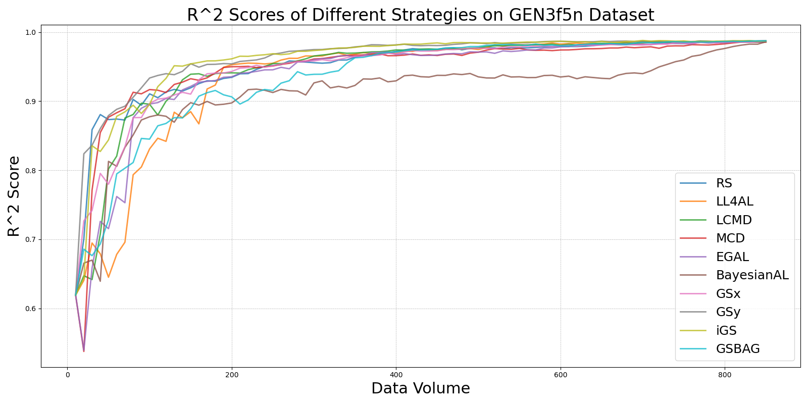

BayesianAL_vs_RS_on_GEN3f5n.png

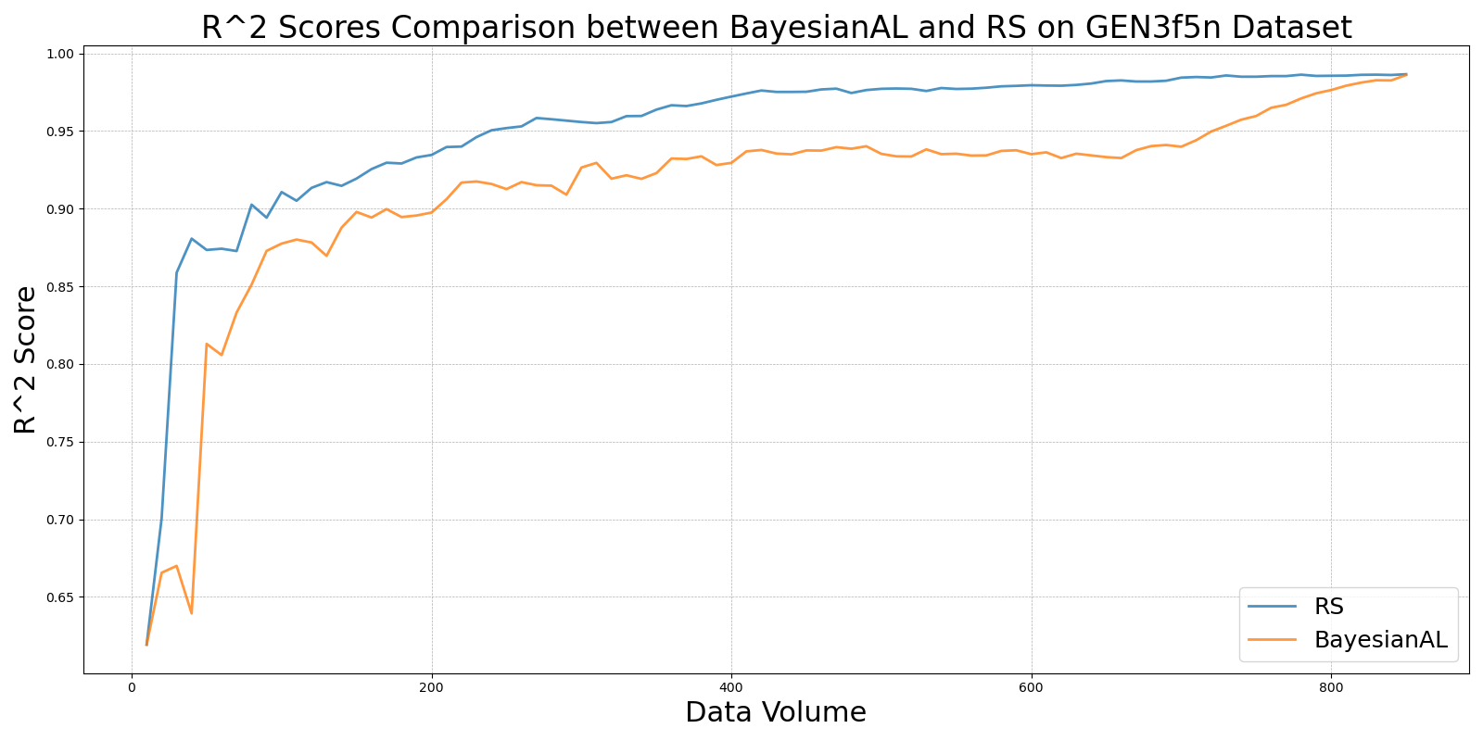

EGAL_vs_RS_on_GEN3f5n.png

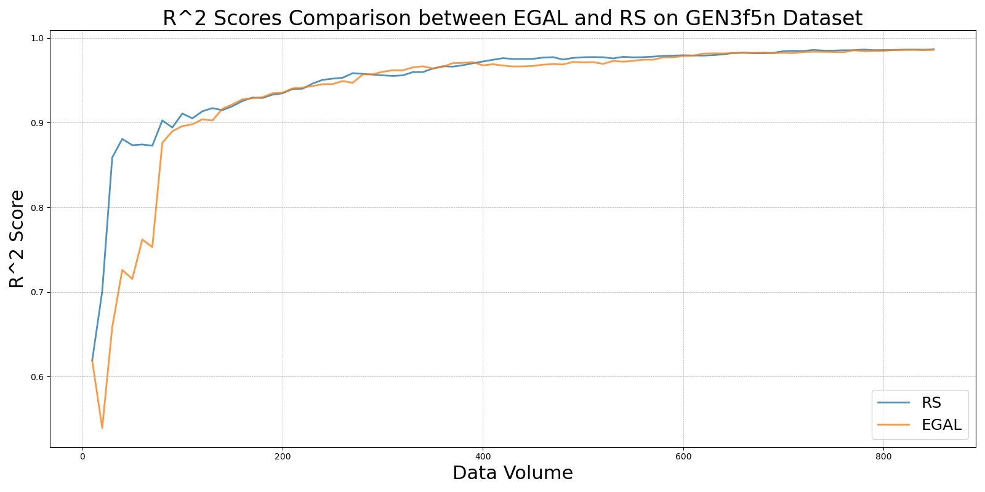

GSBAG_vs_RS_on_GEN3f5n.png

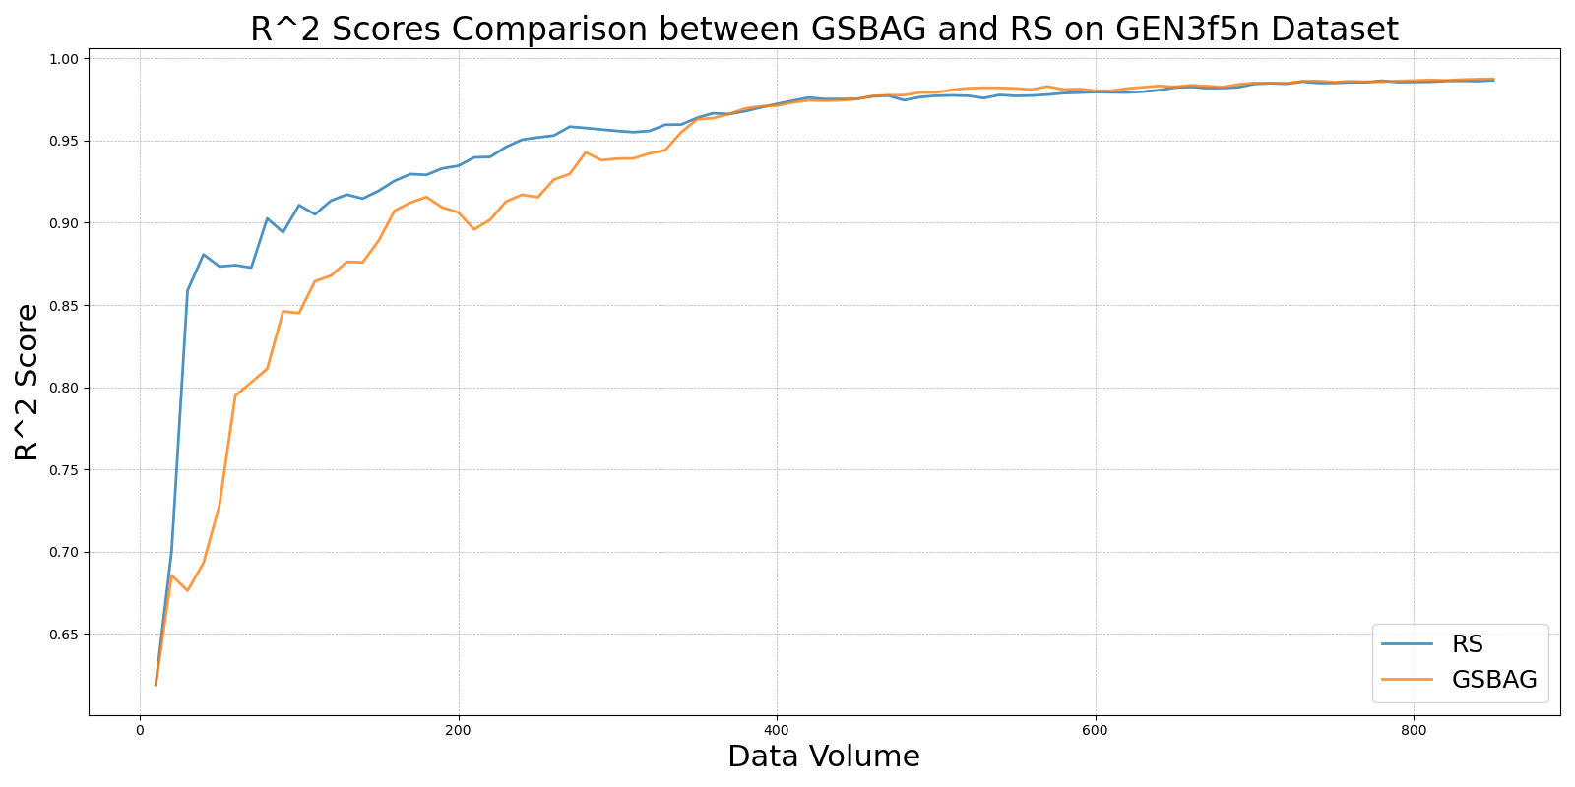

GSx_vs_RS_on_GEN3f5n.png

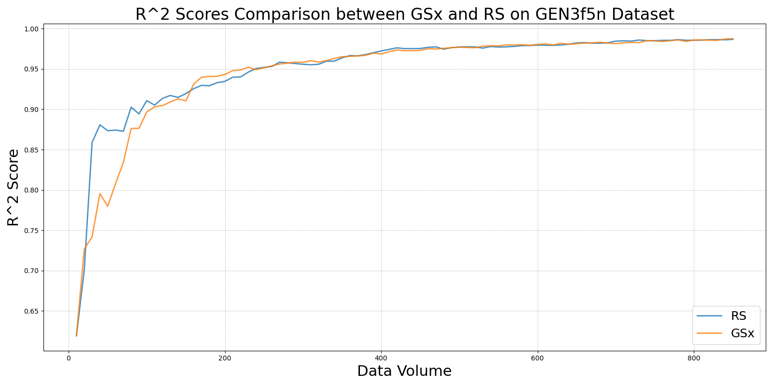

GSy_vs_RS_on_GEN3f5n.png

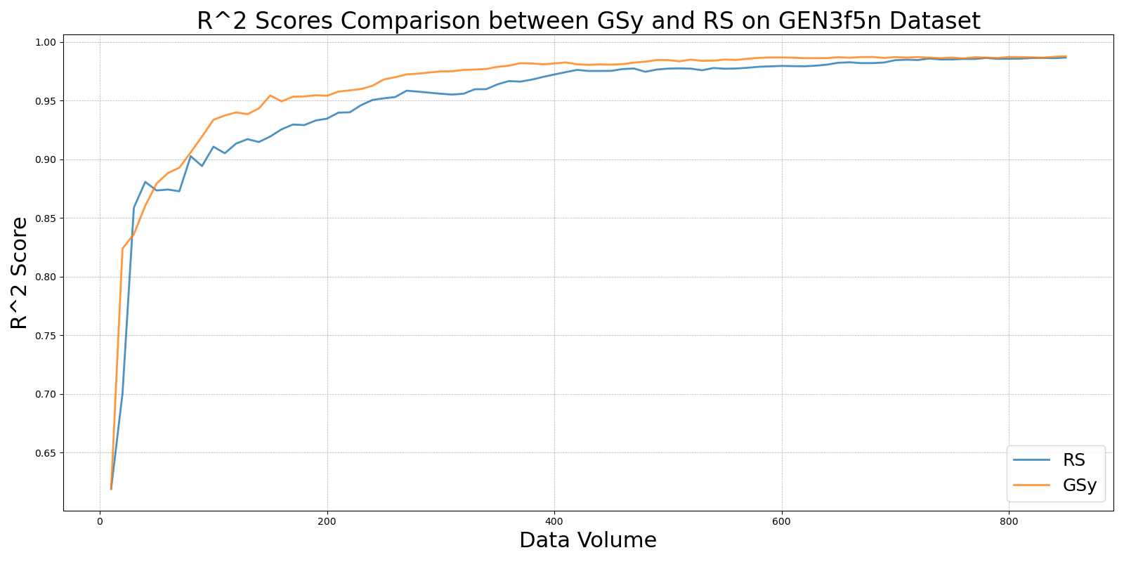

iGS_vs_RS_on_GEN3f5n.png

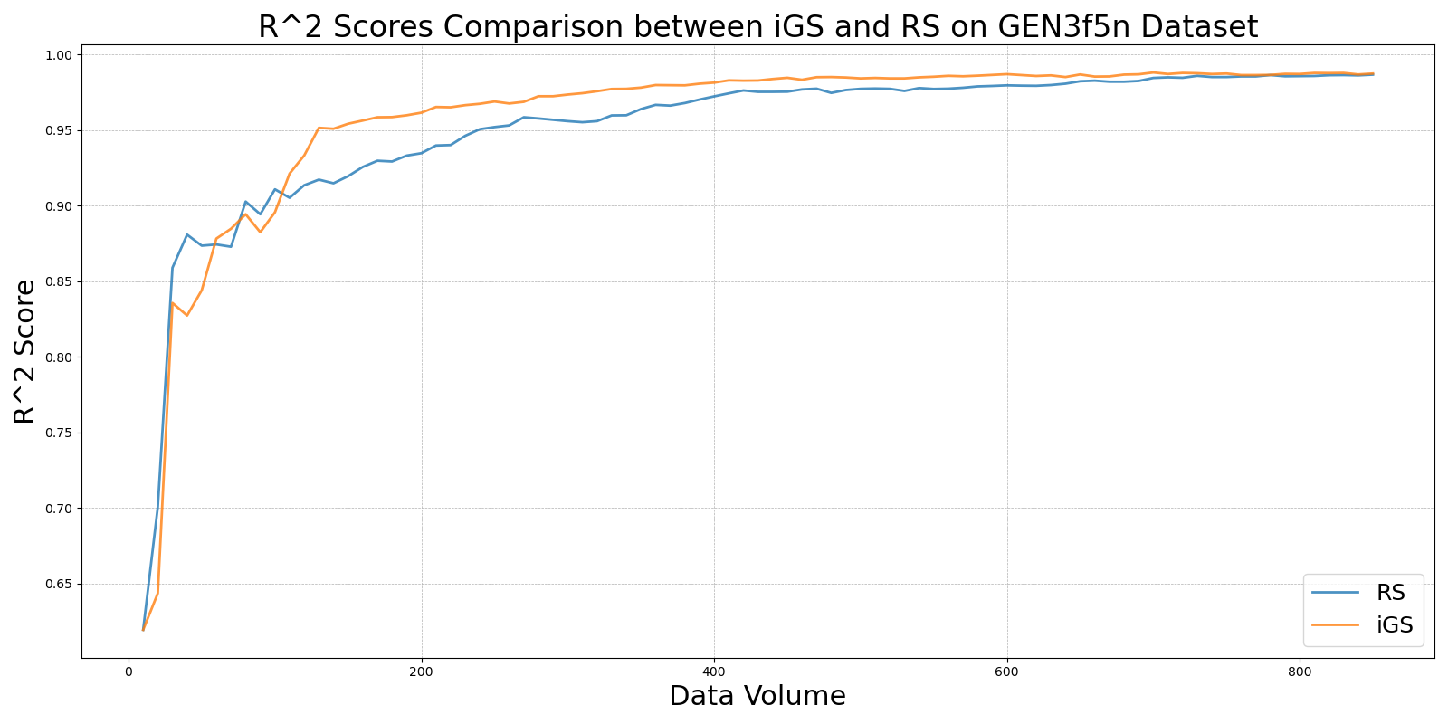

LCMD_vs_RS_on_GEN3f5n.png

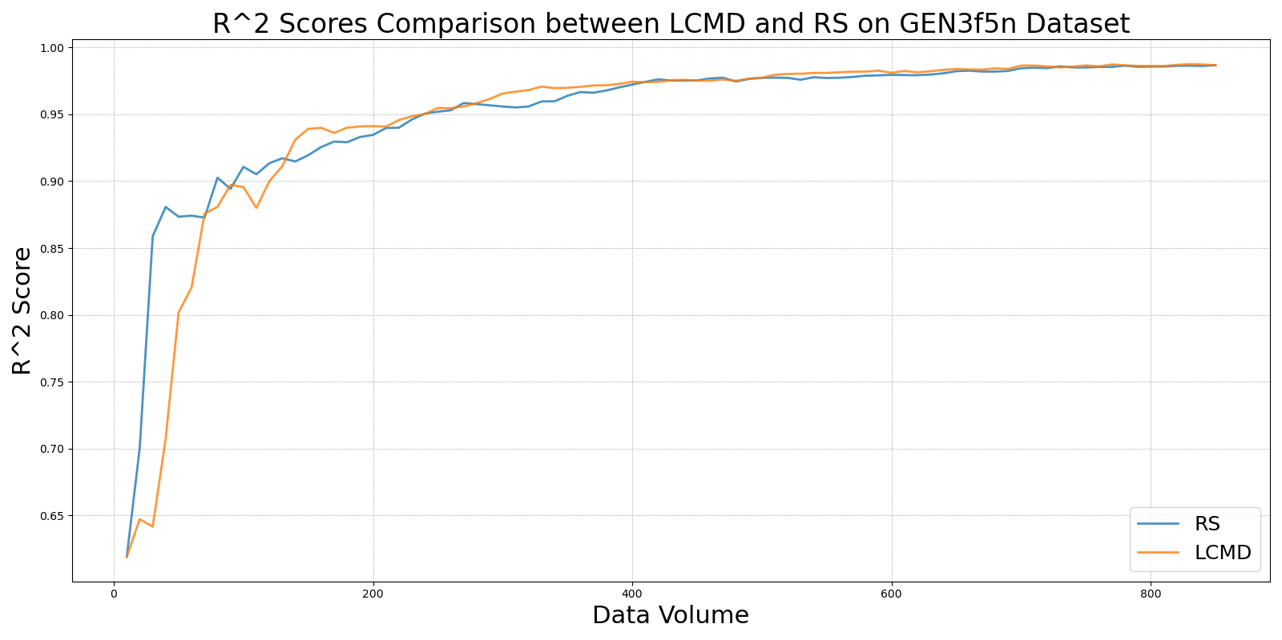

LL4AL_vs_RS_on_GEN3f5n.png

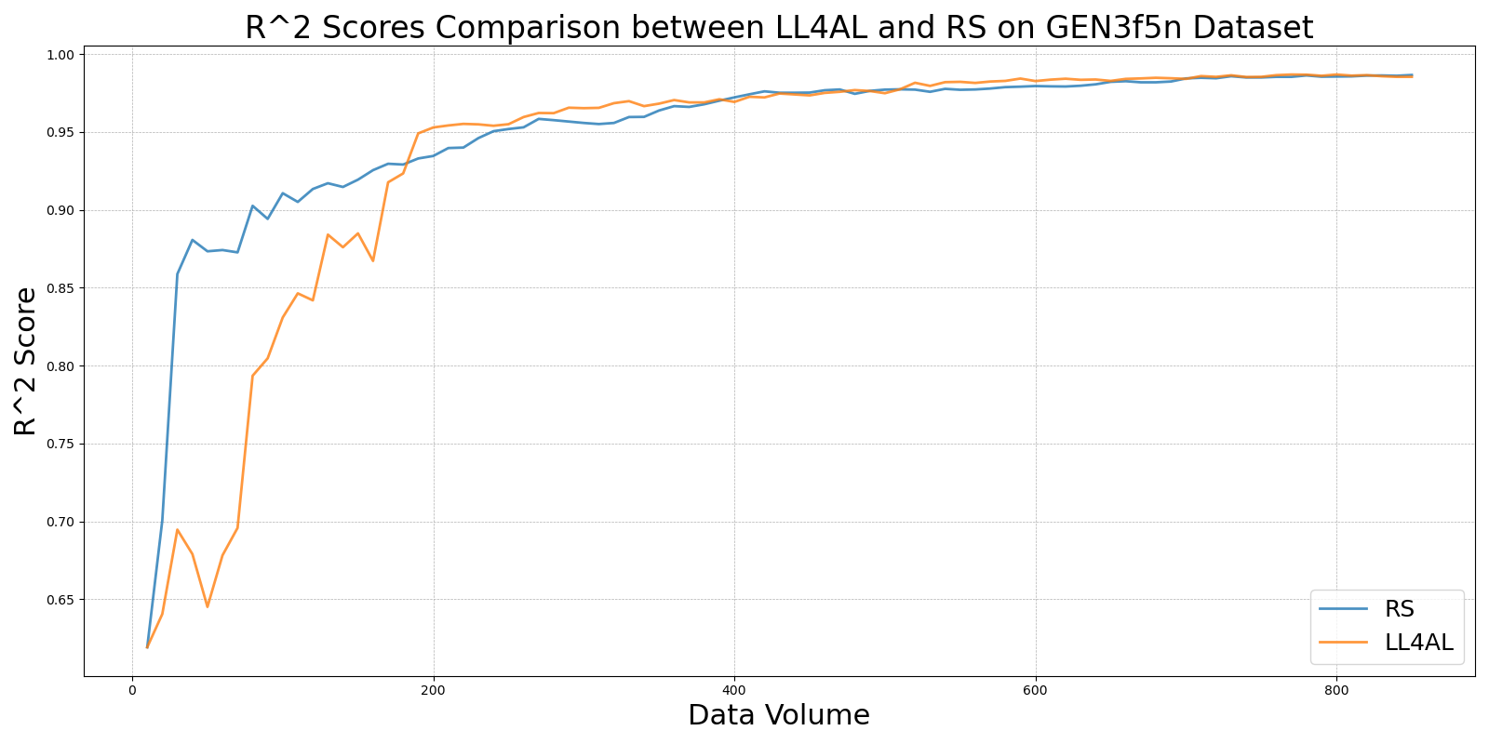

MCD_vs_RS_on_GEN3f5n.png

