R2 Samples Report for 3 Thresholds

|  |  |  |  |
| --- | --- | --- | --- |
| Strategy | R2 >= 0.6 | R2 >= 0.7 | R2 >= 0.8 |
| RS | 50 (5.68%) | 80 (9.09%) | 120 (13.64%) |
| LL4AL | 80 (9.09%) | 180 (20.45%) | 300 (34.09%) |
| LCMD | 40 (4.55%) | 50 (5.68%) | 130 (14.77%) |
| MCD | 40 (4.55%) | 40 (4.55%) | 150 (17.05%) |
| EGAL | 30 (3.41%) | 80 (9.09%) | 140 (15.91%) |
| BayesianAL | 50 (5.68%) | 60 (6.82%) | 450 (51.14%) |
| GSx | 60 (6.82%) | 100 (11.36%) | 150 (17.05%) |
| GSy | 80 (9.09%) | 140 (15.91%) | 250 (28.41%) |
| iGS | 30 (3.41%) | 130 (14.77%) | 150 (17.05%) |
| GSBAG | 60 (6.82%) | 130 (14.77%) | 210 (23.86%) |

All_Strategies_on_GEN5f5n.png

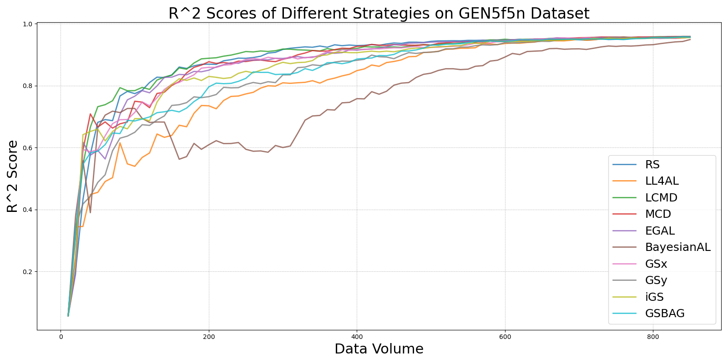

BayesianAL_vs_RS_on_GEN5f5n.png

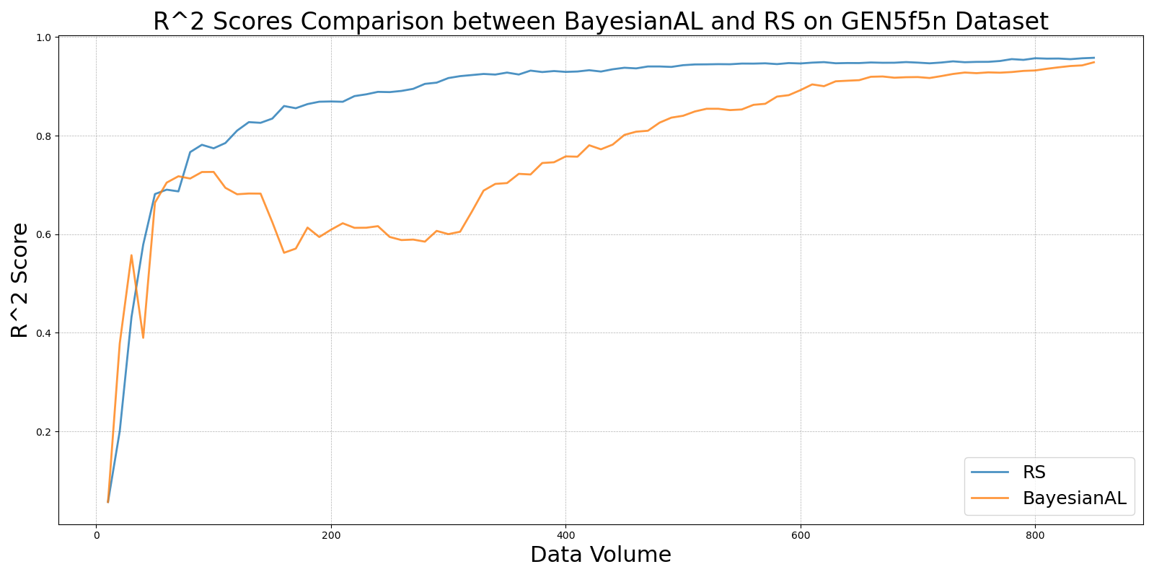

EGAL_vs_RS_on_GEN5f5n.png

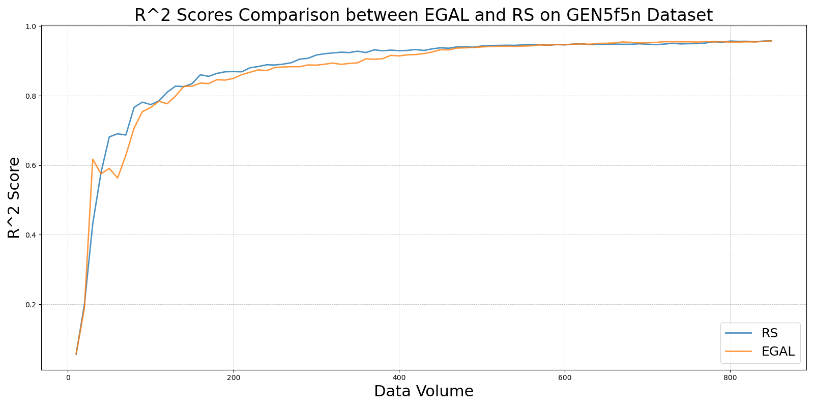

GSBAG_vs_RS_on_GEN5f5n.png

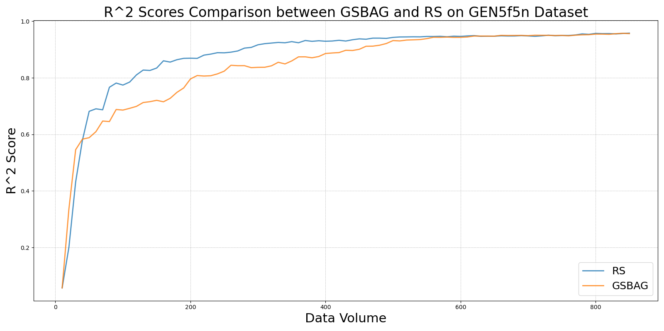

GSx_vs_RS_on_GEN5f5n.png

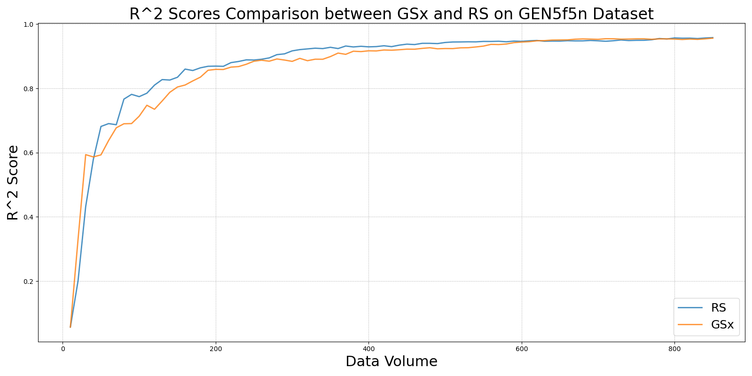

GSy_vs_RS_on_GEN5f5n.png

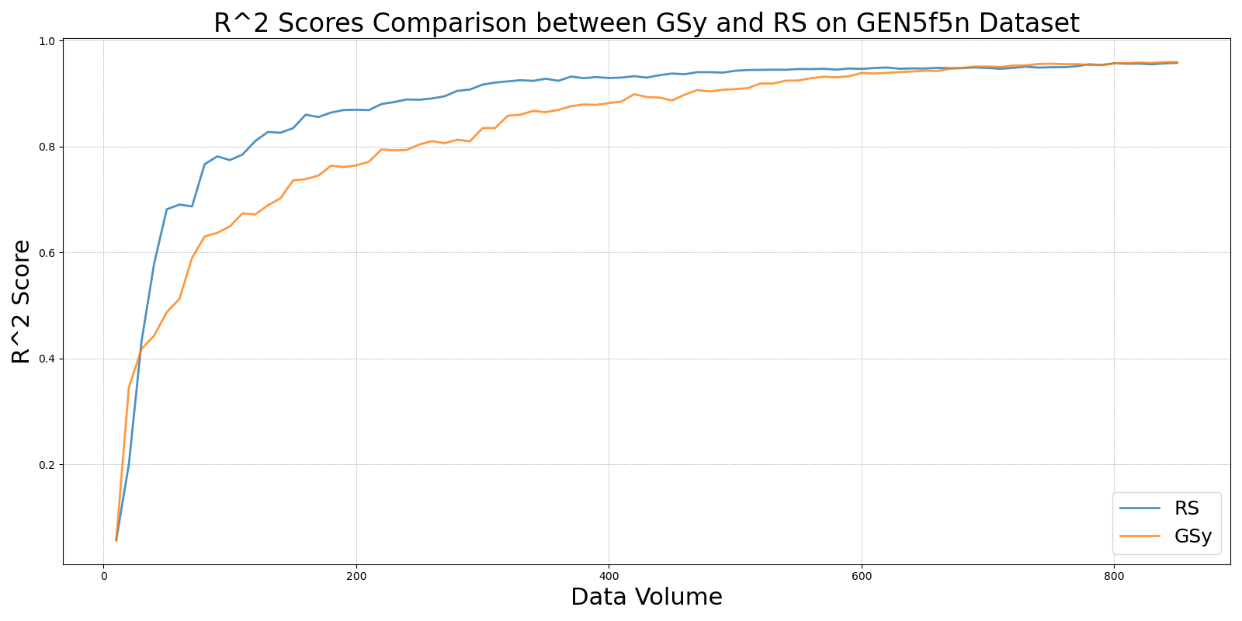

iGS_vs_RS_on_GEN5f5n.png

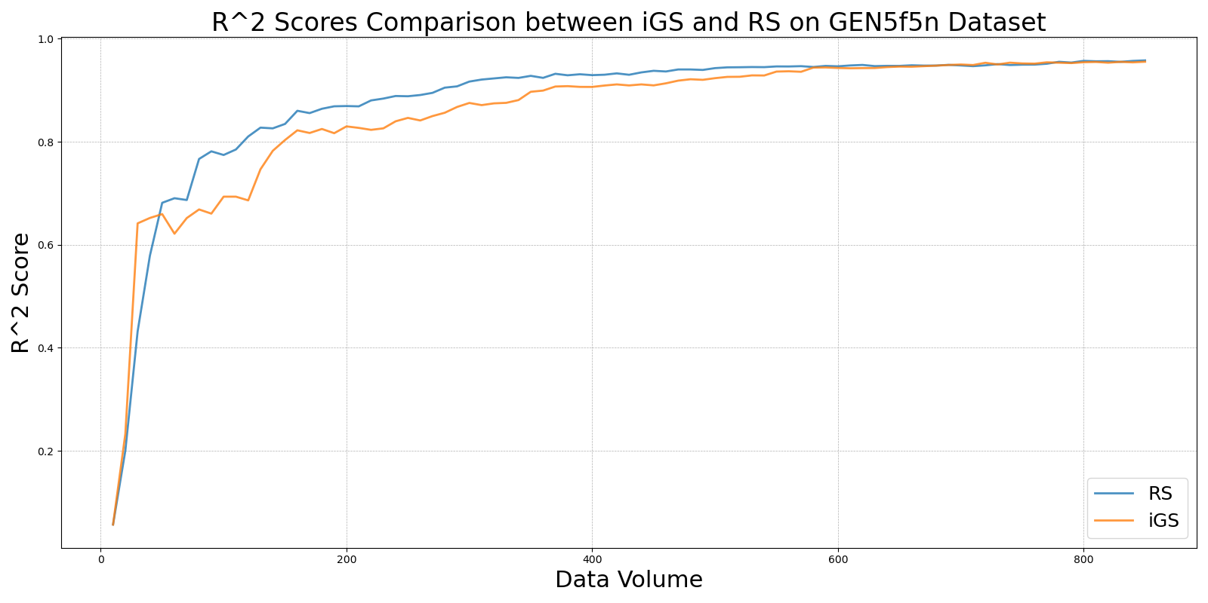

LCMD_vs_RS_on_GEN5f5n.png

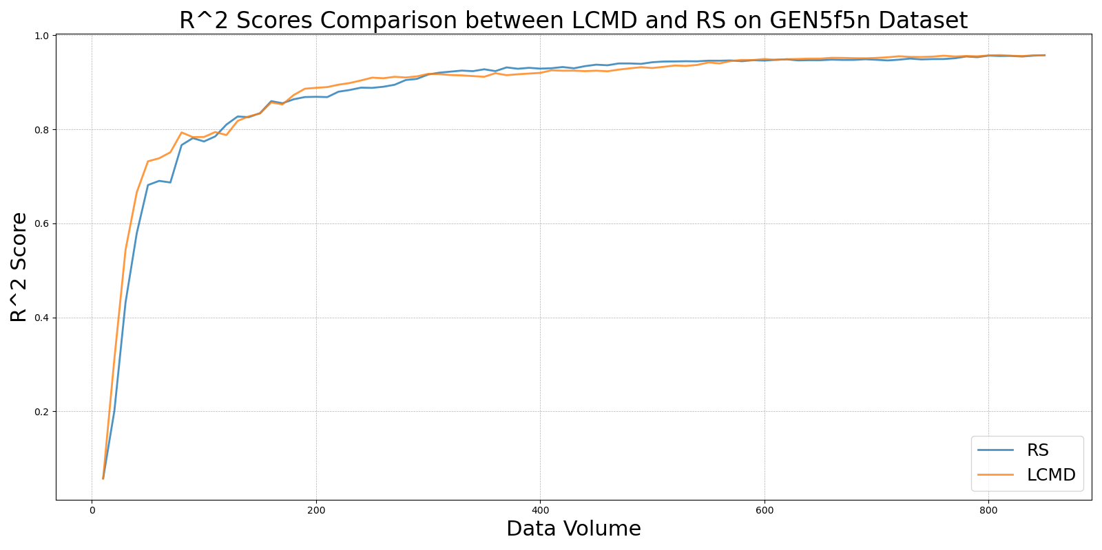

LL4AL_vs_RS_on_GEN5f5n.png

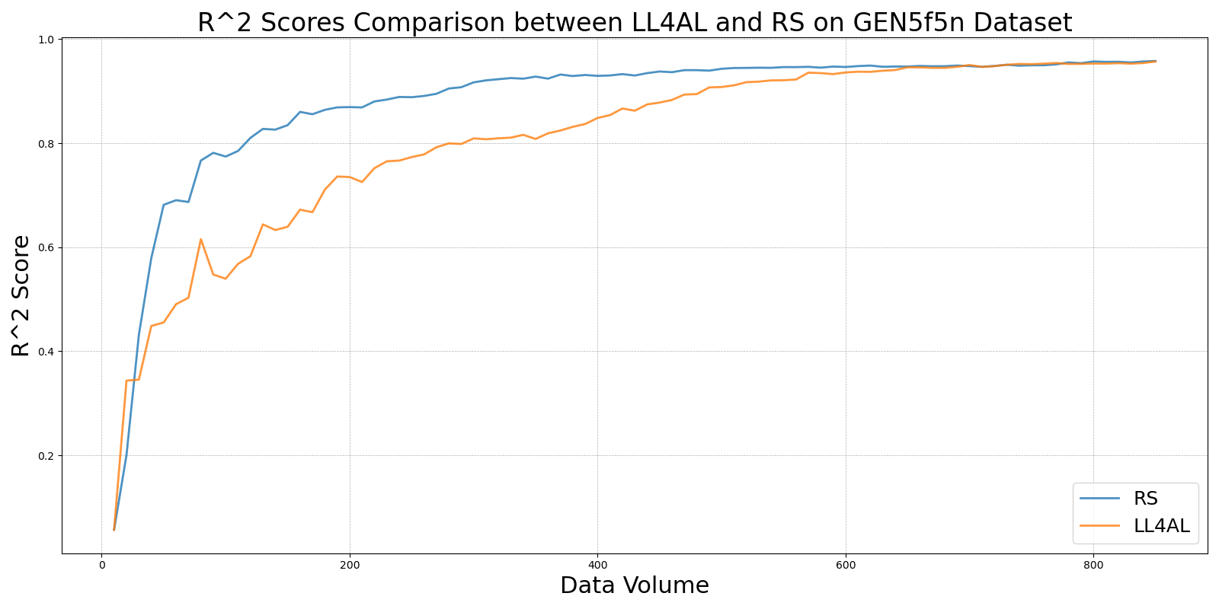

MCD_vs_RS_on_GEN5f5n.png

