R2 Samples Report for 3 Thresholds

|  |  |  |  |
| --- | --- | --- | --- |
| Strategy | R2 >= 0.6 | R2 >= 0.7 | R2 >= 0.8 |
| RS | 70 (7.95%) | 100 (11.36%) | 200 (22.73%) |
| LL4AL | 150 (17.05%) | 390 (44.32%) | 520 (59.09%) |
| LCMD | 80 (9.09%) | 150 (17.05%) | 250 (28.41%) |
| MCD | 80 (9.09%) | 140 (15.91%) | 230 (26.14%) |
| EGAL | 50 (5.68%) | 90 (10.23%) | 190 (21.59%) |
| BayesianAL | 290 (32.95%) | 400 (45.45%) | 570 (64.77%) |
| GSx | 70 (7.95%) | 130 (14.77%) | 260 (29.55%) |
| GSy | 60 (6.82%) | 70 (7.95%) | 150 (17.05%) |
| iGS | 70 (7.95%) | 120 (13.64%) | 220 (25.00%) |
| GSBAG | 90 (10.23%) | 180 (20.45%) | 320 (36.36%) |

All_Strategies_on_GEN7f5n.png

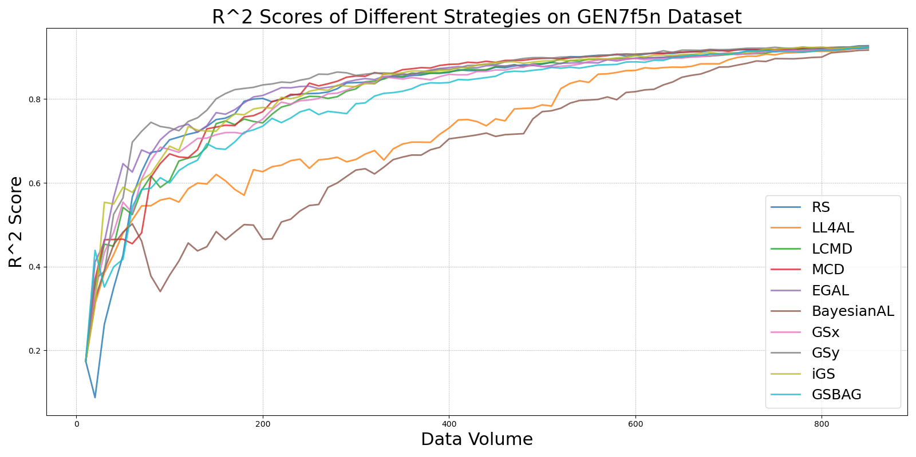

BayesianAL_vs_RS_on_GEN7f5n.png

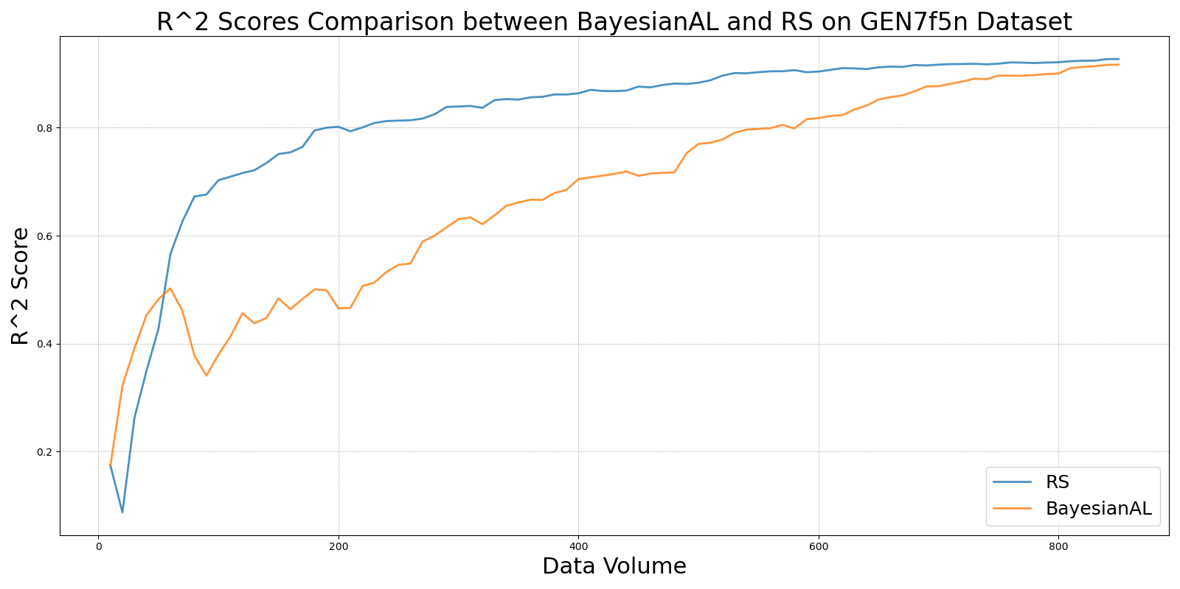

EGAL_vs_RS_on_GEN7f5n.png

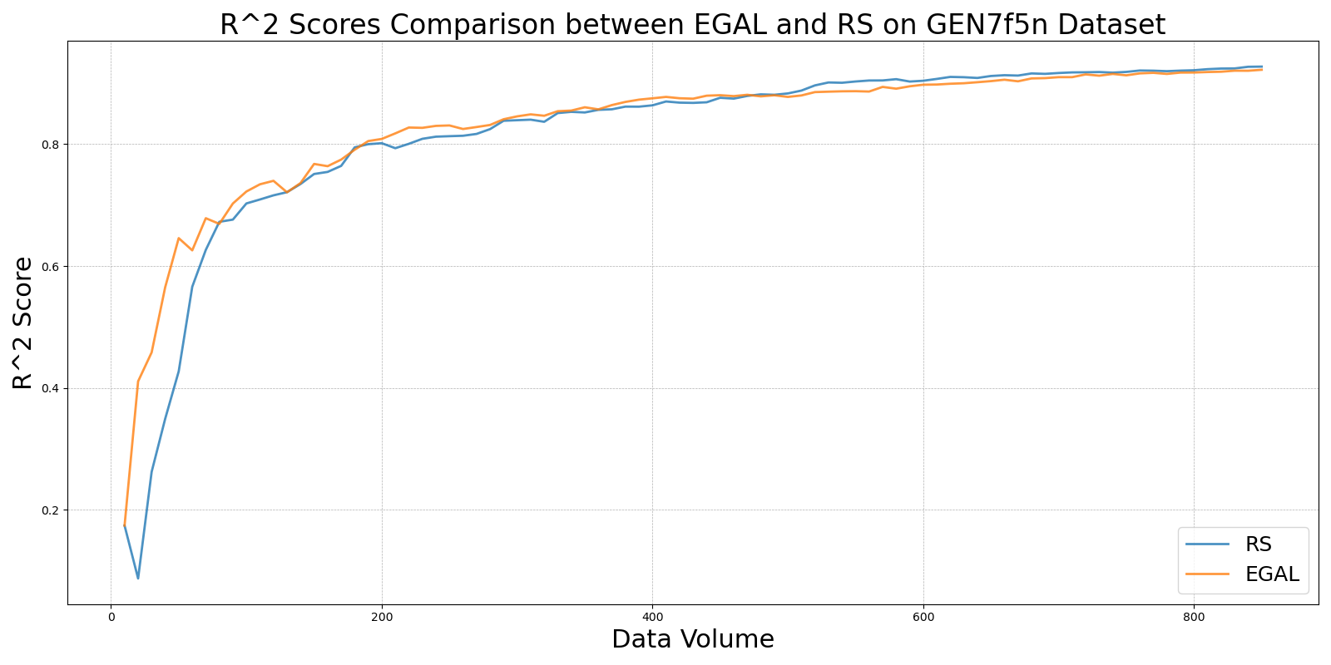

GSBAG_vs_RS_on_GEN7f5n.png

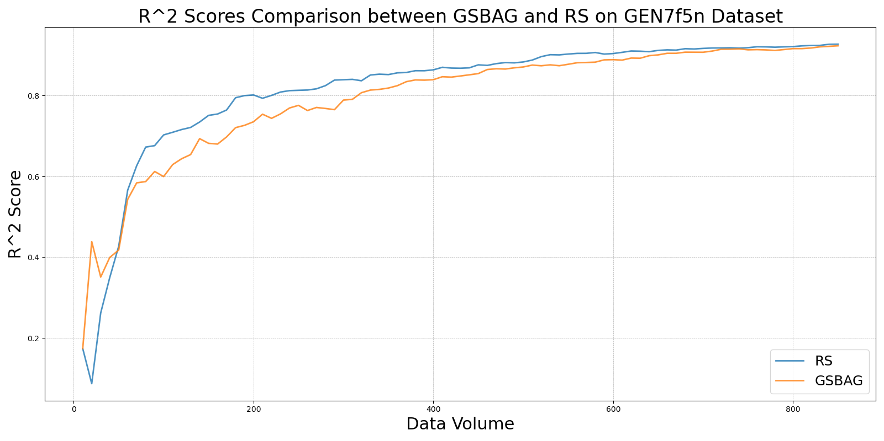

GSx_vs_RS_on_GEN7f5n.png

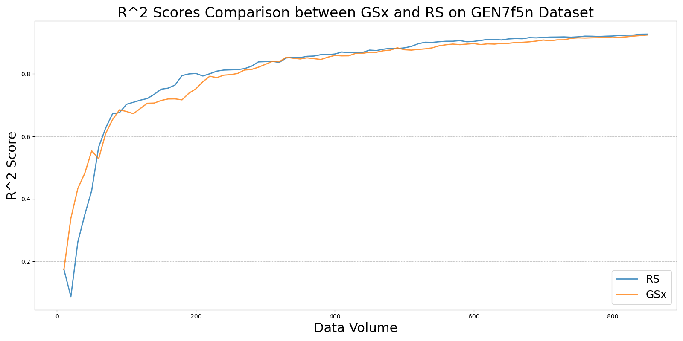

GSy_vs_RS_on_GEN7f5n.png

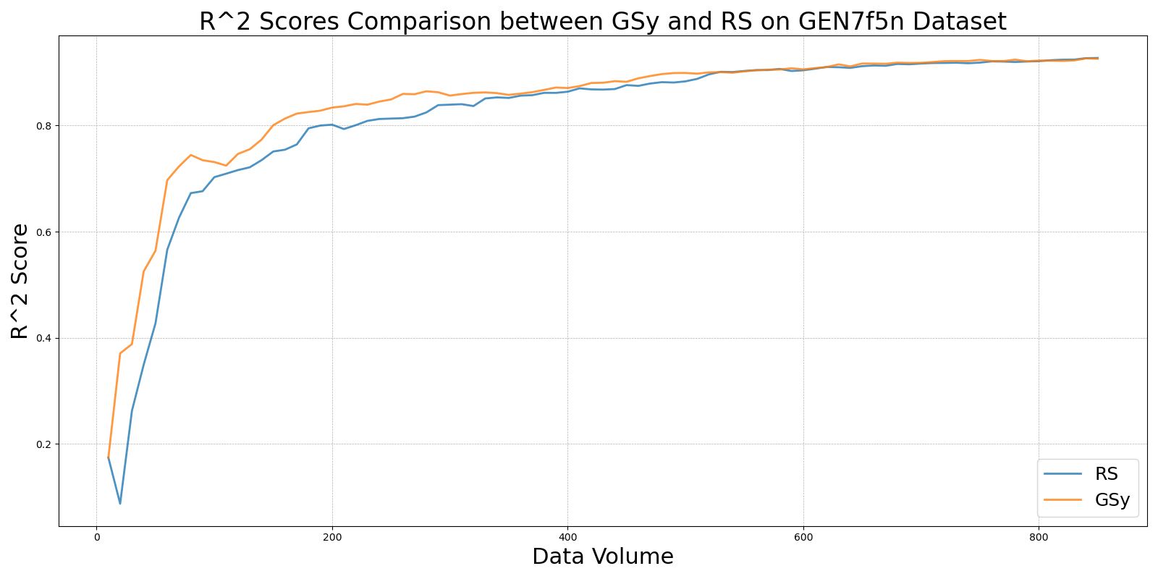

iGS_vs_RS_on_GEN7f5n.png

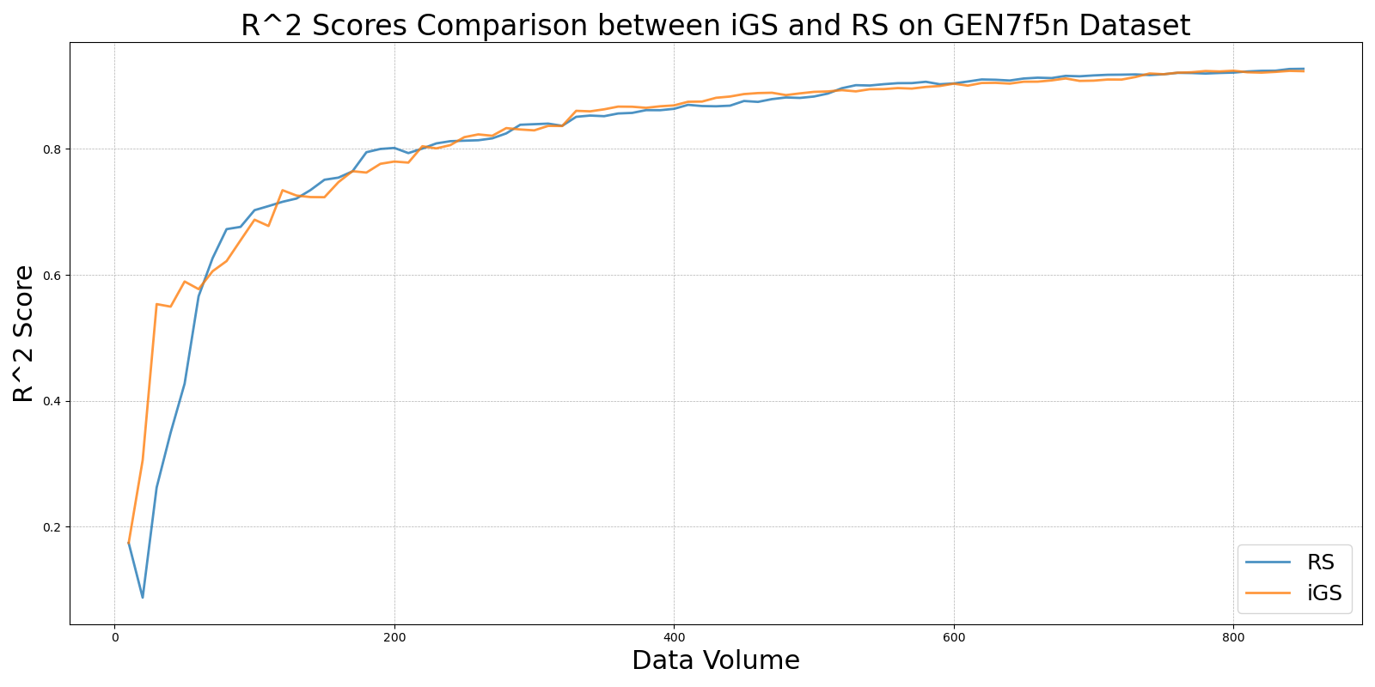

LCMD_vs_RS_on_GEN7f5n.png

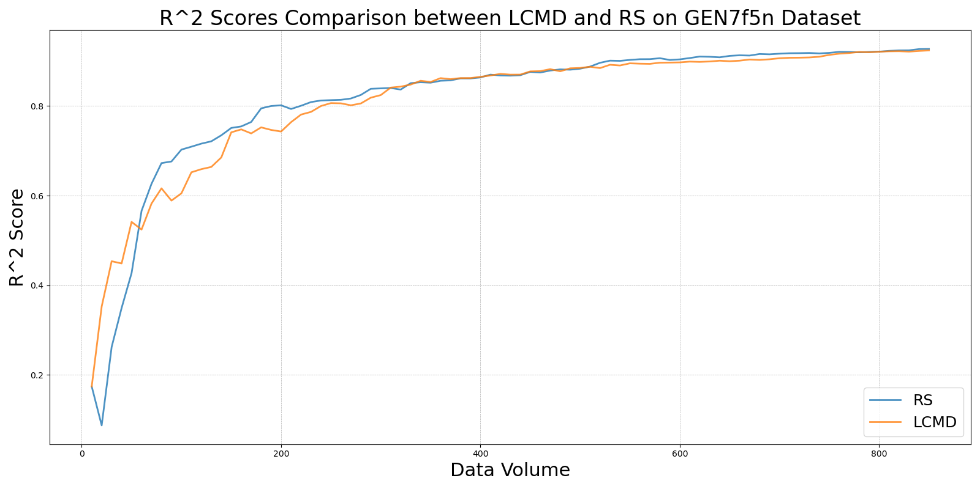

LL4AL_vs_RS_on_GEN7f5n.png

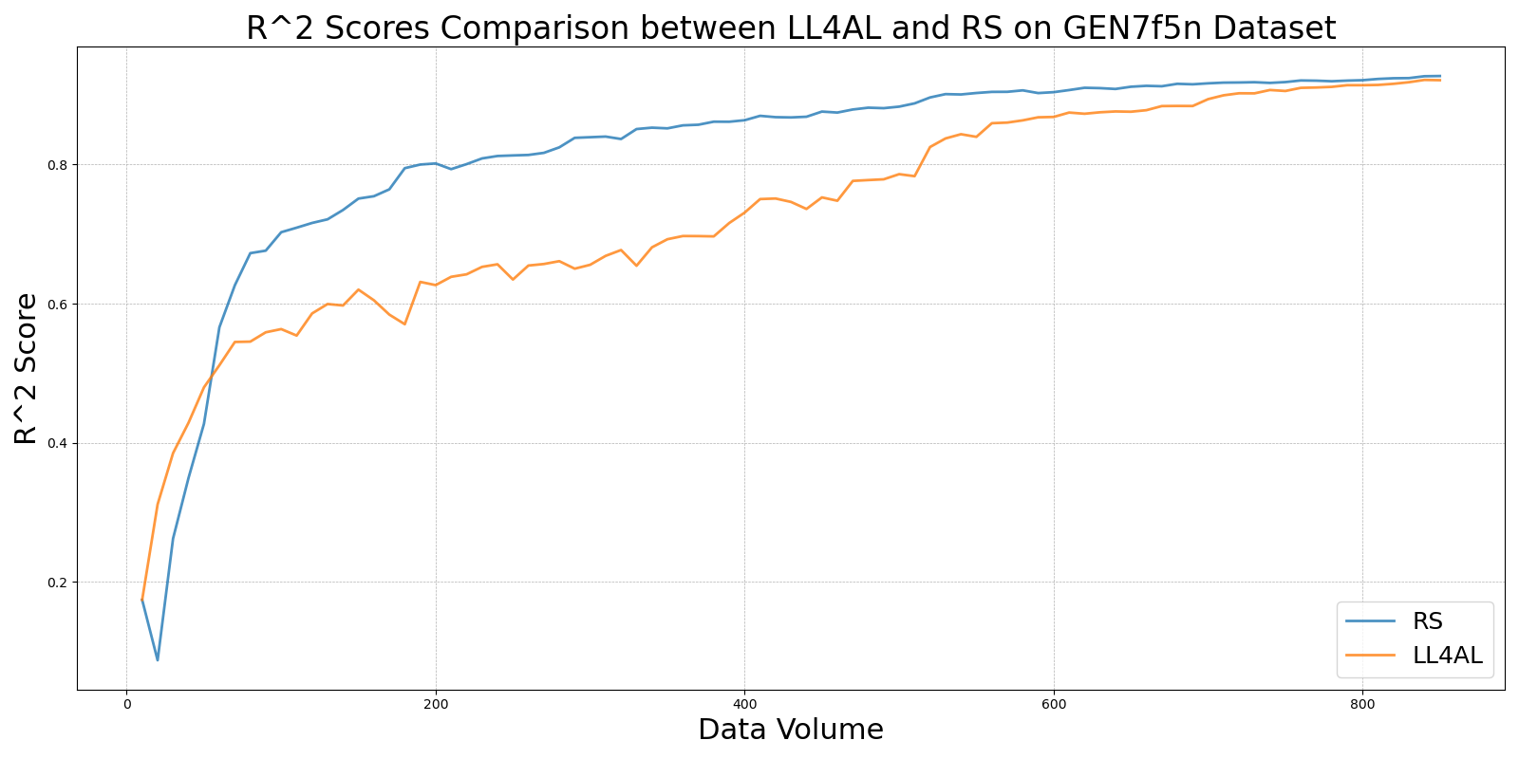

MCD_vs_RS_on_GEN7f5n.png

