R2 Samples Report for 3 Thresholds

|  |  |  |  |
| --- | --- | --- | --- |
| Strategy | R2 >= 0.6 | R2 >= 0.7 | R2 >= 0.8 |
| RS | 170 (19.32%) | 310 (35.23%) | 540 (61.36%) |
| LL4AL | 230 (26.14%) | 320 (36.36%) | 540 (61.36%) |
| LCMD | 110 (12.50%) | 200 (22.73%) | 440 (50.00%) |
| MCD | 220 (25.00%) | 400 (45.45%) | 620 (70.45%) |
| EGAL | 150 (17.05%) | 260 (29.55%) | 530 (60.23%) |
| BayesianAL | 190 (21.59%) | 330 (37.50%) | 570 (64.77%) |
| GSx | 200 (22.73%) | 290 (32.95%) | 500 (56.82%) |
| GSy | 150 (17.05%) | 380 (43.18%) | 670 (76.14%) |
| iGS | 210 (23.86%) | 330 (37.50%) | 540 (61.36%) |
| GSBAG | 200 (22.73%) | 380 (43.18%) | 630 (71.59%) |

All_Strategies_on_GEN9f5n.png

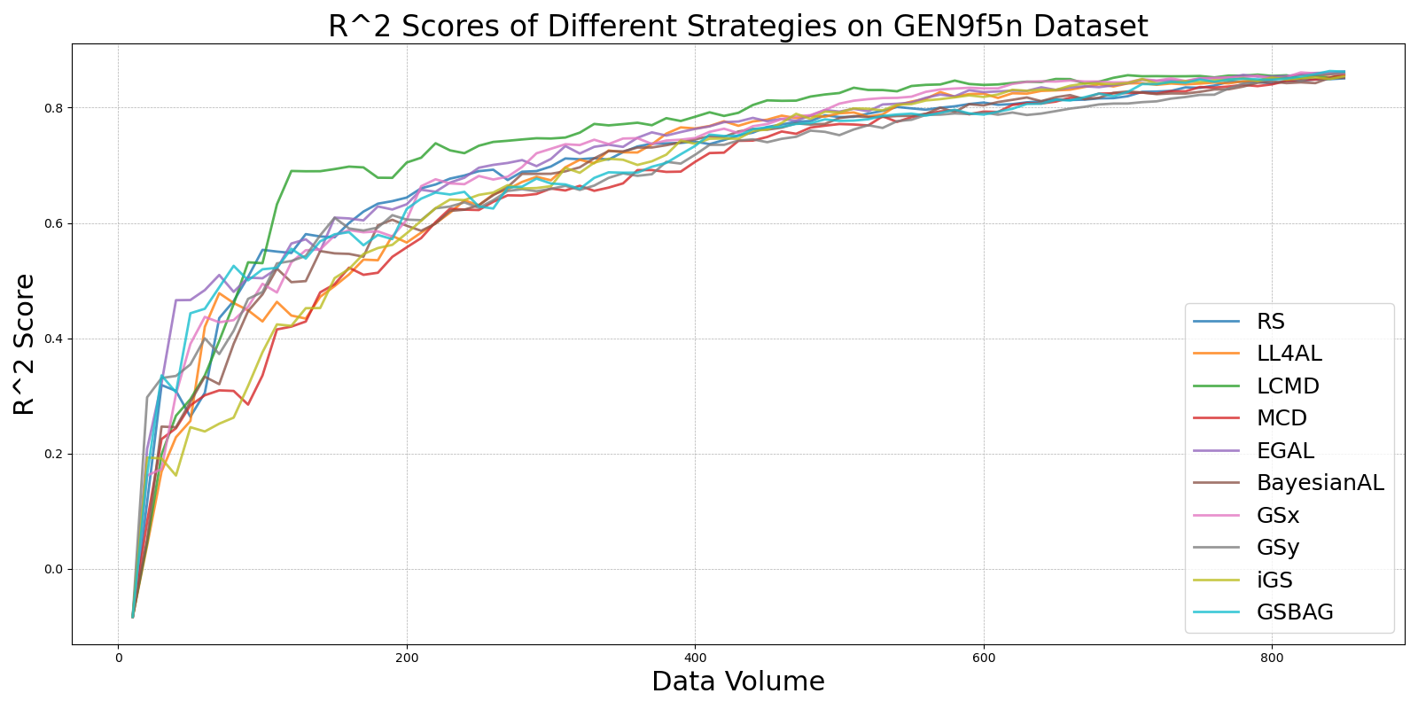

BayesianAL_vs_RS_on_GEN9f5n.png

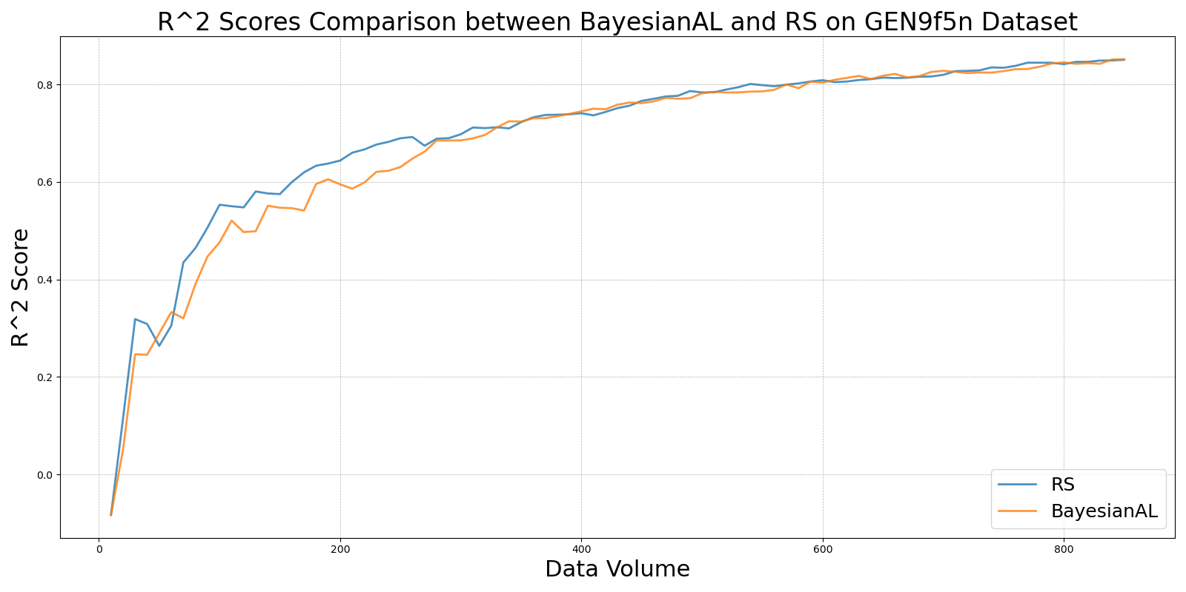

EGAL_vs_RS_on_GEN9f5n.png

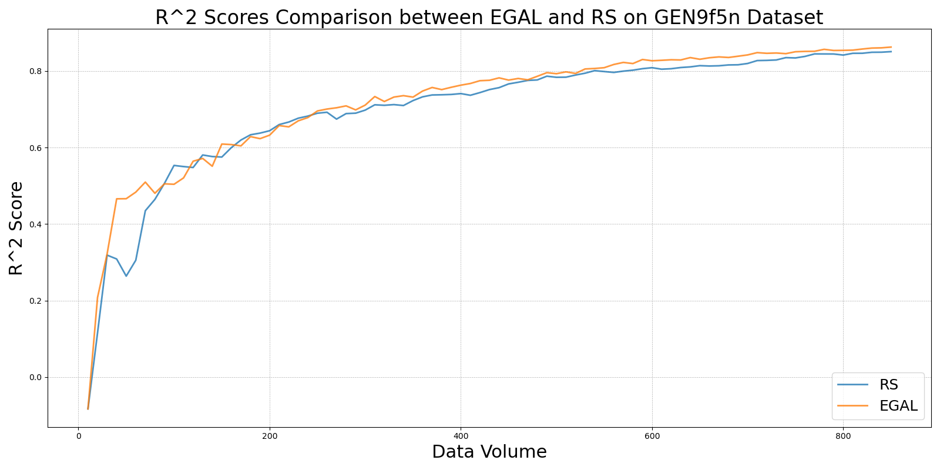

GSBAG_vs_RS_on_GEN9f5n.png

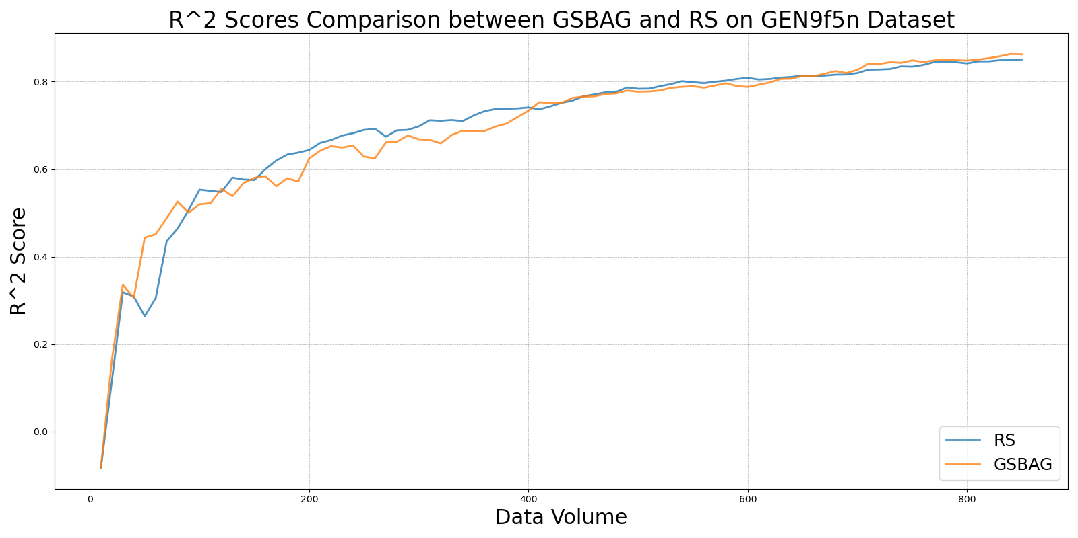

GSx_vs_RS_on_GEN9f5n.png

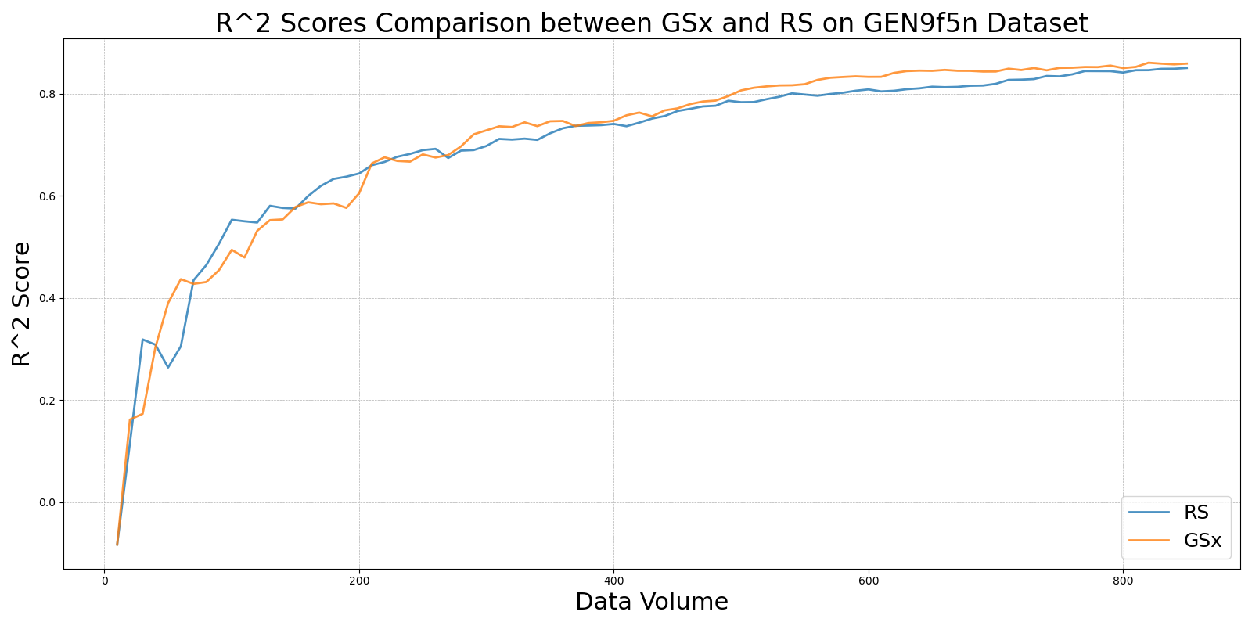

GSy_vs_RS_on_GEN9f5n.png

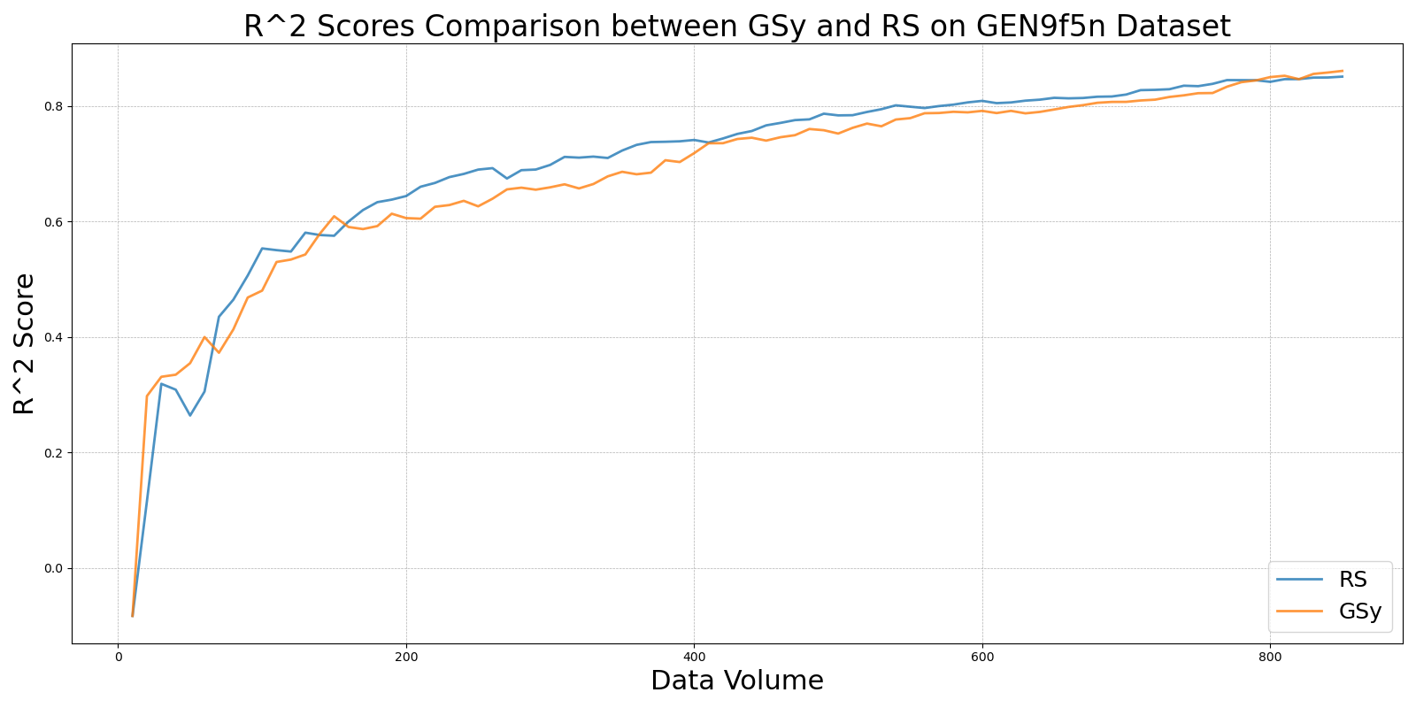

iGS_vs_RS_on_GEN9f5n.png

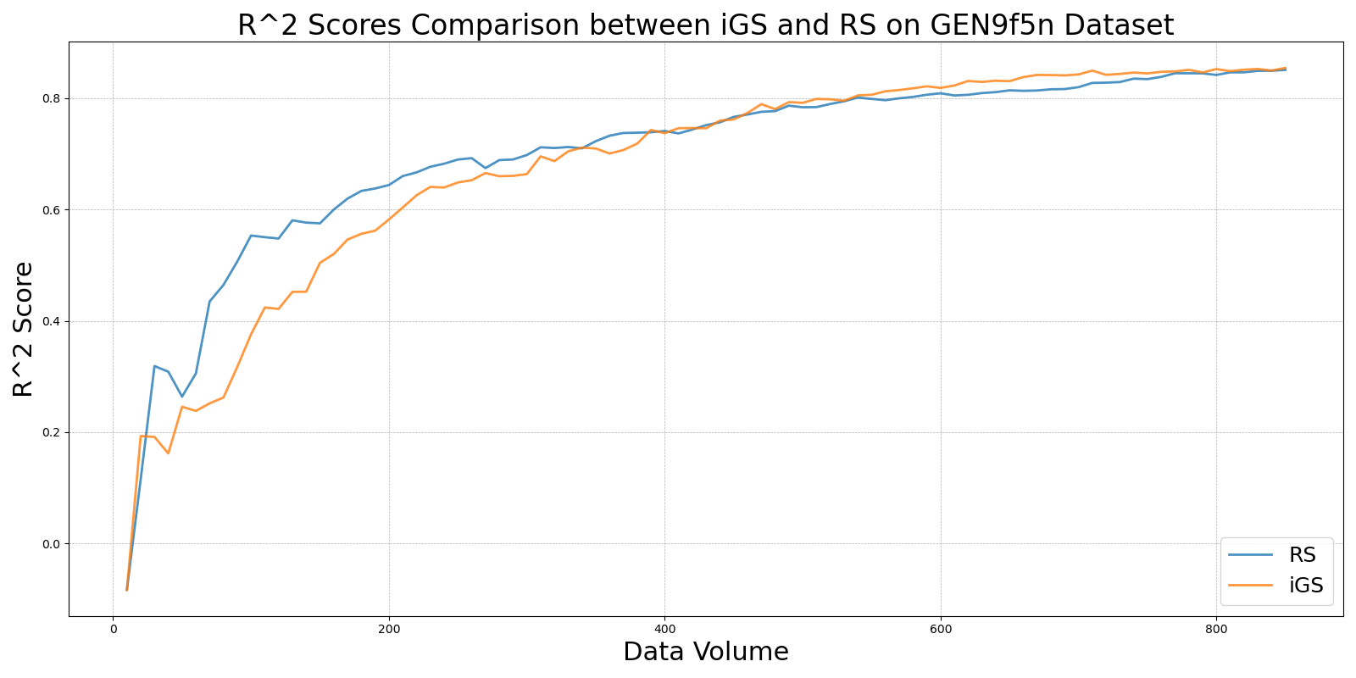

LCMD_vs_RS_on_GEN9f5n.png

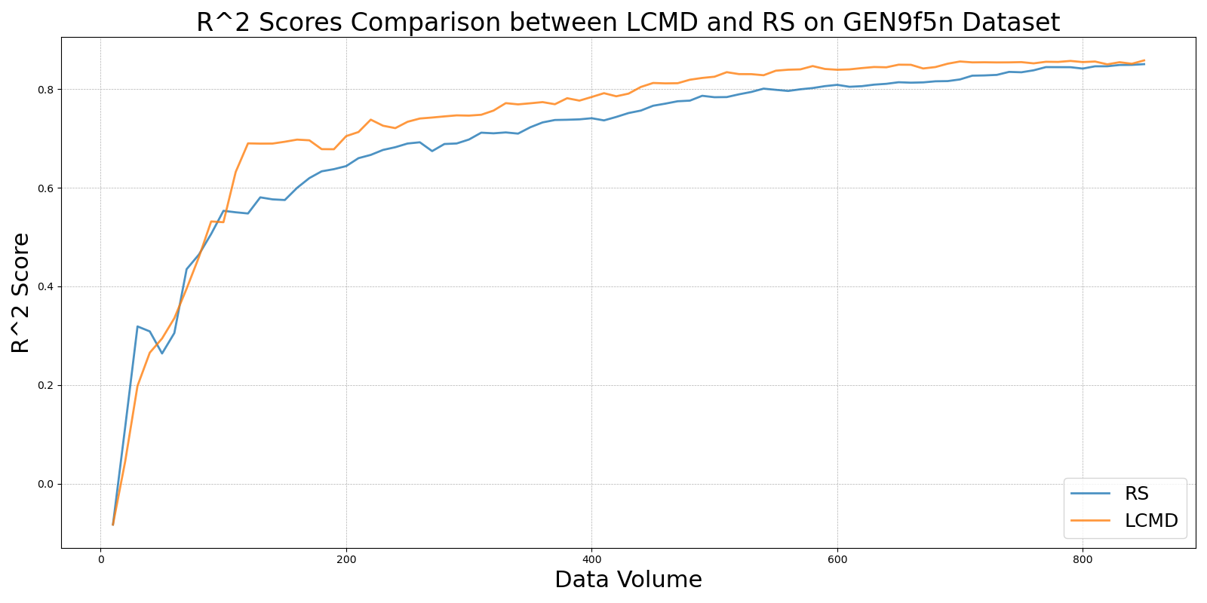

LL4AL_vs_RS_on_GEN9f5n.png

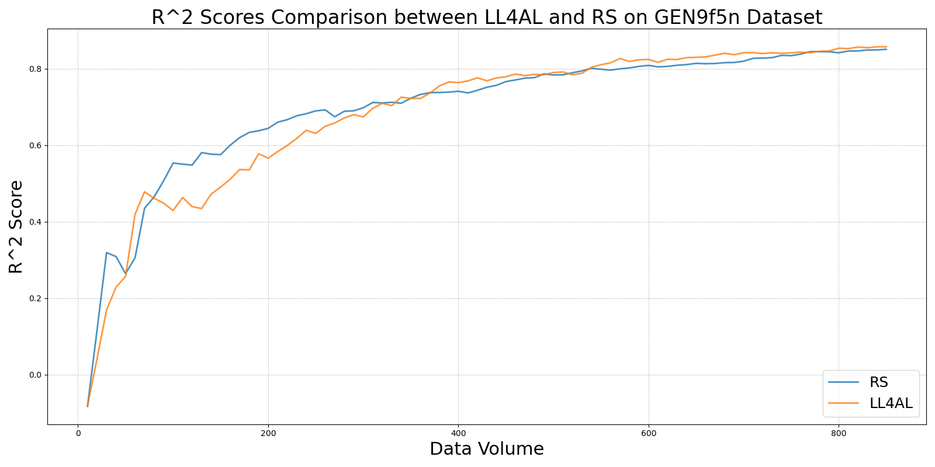

MCD_vs_RS_on_GEN9f5n.png

