R2 Samples Report for 3 Thresholds

|  |  |  |  |
| --- | --- | --- | --- |
| Strategy | R2 >= 0.6 | R2 >= 0.7 | R2 >= 0.8 |
| RS | 210 (23.86%) | 310 (35.23%) | 650 (73.86%) |
| LL4AL | 230 (26.14%) | 350 (39.77%) | 700 (79.55%) |
| LCMD | 190 (21.59%) | 350 (39.77%) | 730 (82.95%) |
| MCD | 230 (26.14%) | 340 (38.64%) | 700 (79.55%) |
| EGAL | 240 (27.27%) | 410 (46.59%) | 680 (77.27%) |
| BayesianAL | 300 (34.09%) | 420 (47.73%) | 680 (77.27%) |
| GSx | 210 (23.86%) | 310 (35.23%) | 690 (78.41%) |
| GSy | 180 (20.45%) | 340 (38.64%) | 700 (79.55%) |
| iGS | 270 (30.68%) | 380 (43.18%) | 670 (76.14%) |
| GSBAG | 180 (20.45%) | 370 (42.05%) | 710 (80.68%) |

All_Strategies_on_GEN11f5n.png

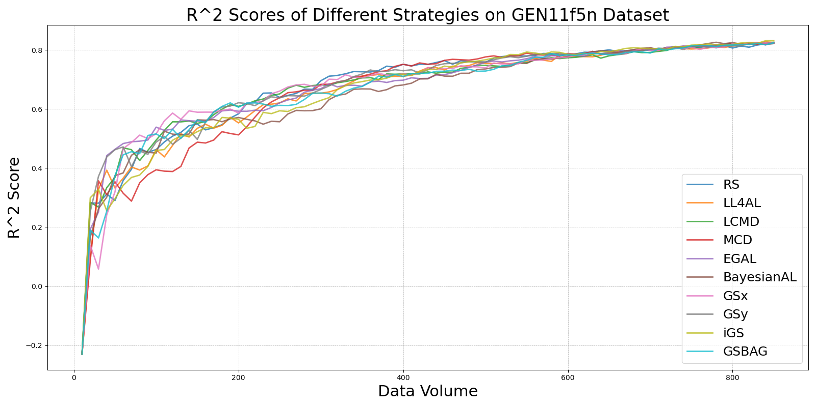

BayesianAL_vs_RS_on_GEN11f5n.png

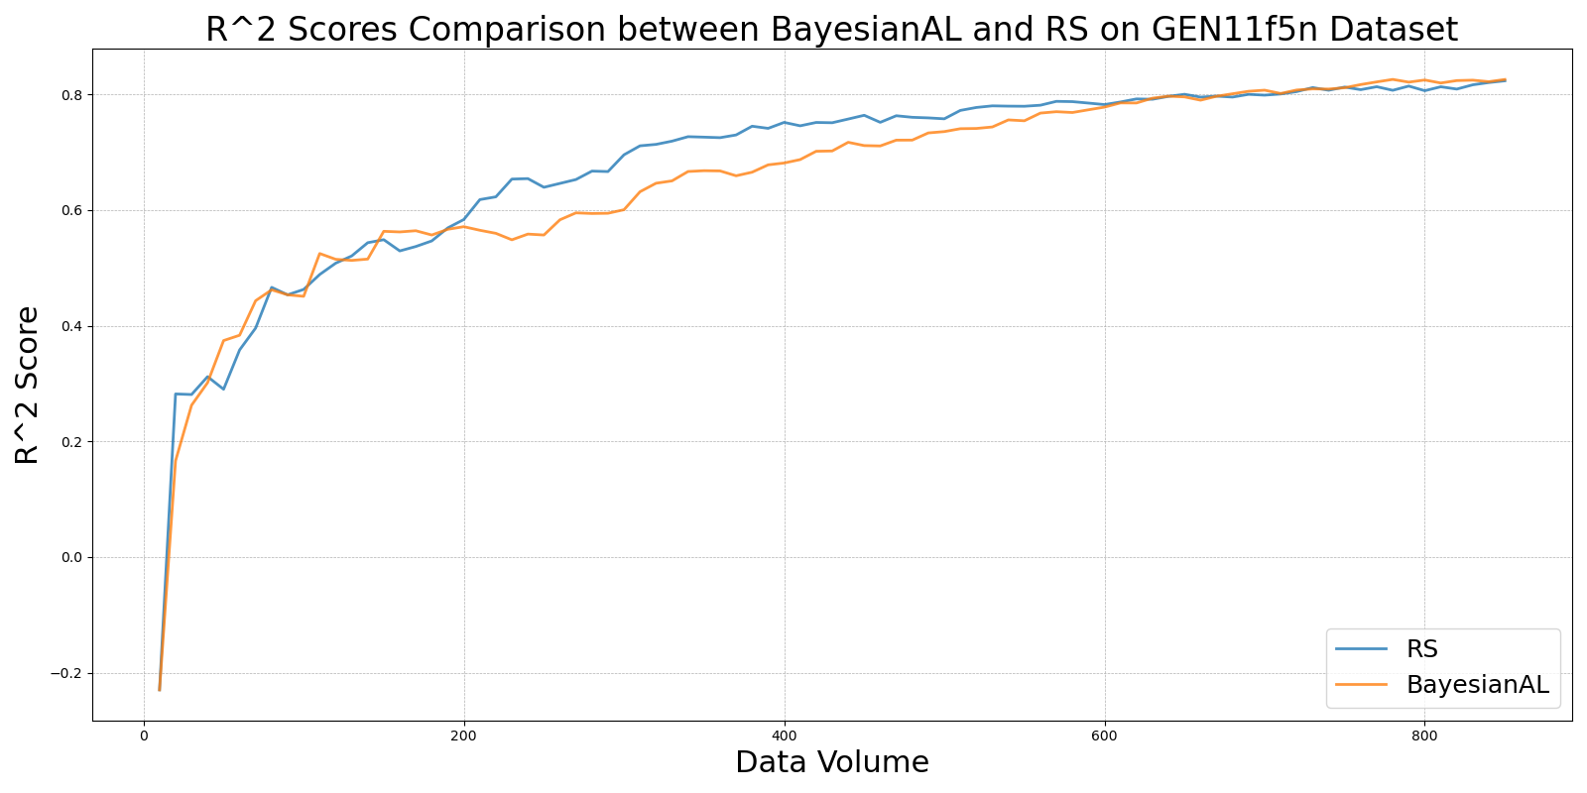

EGAL_vs_RS_on_GEN11f5n.png

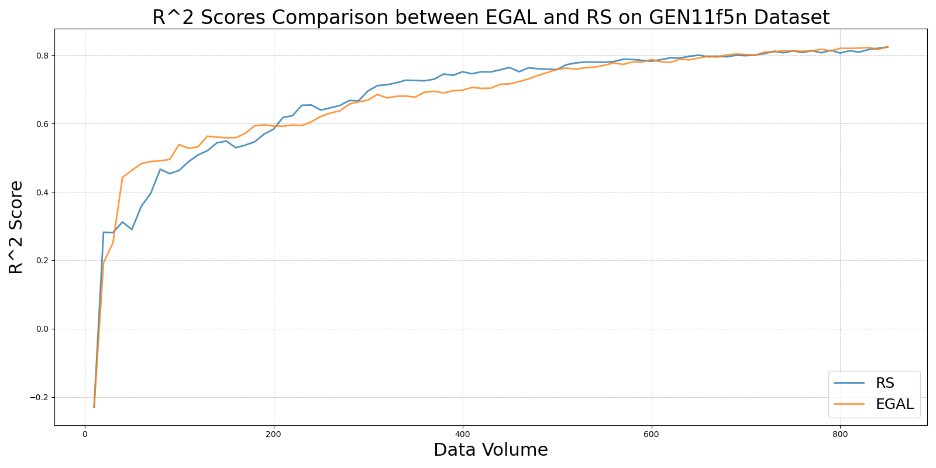

GSBAG_vs_RS_on_GEN11f5n.png

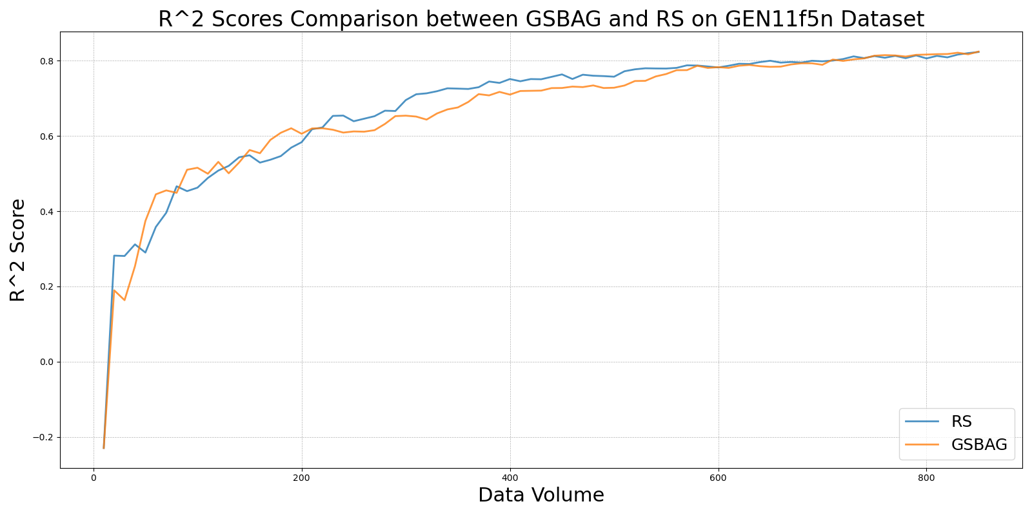

GSx_vs_RS_on_GEN11f5n.png

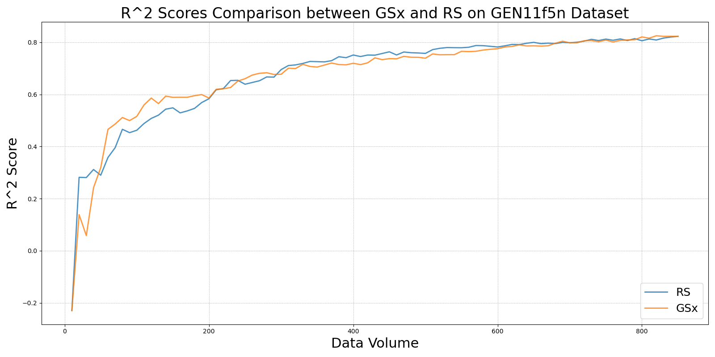

GSy_vs_RS_on_GEN11f5n.png

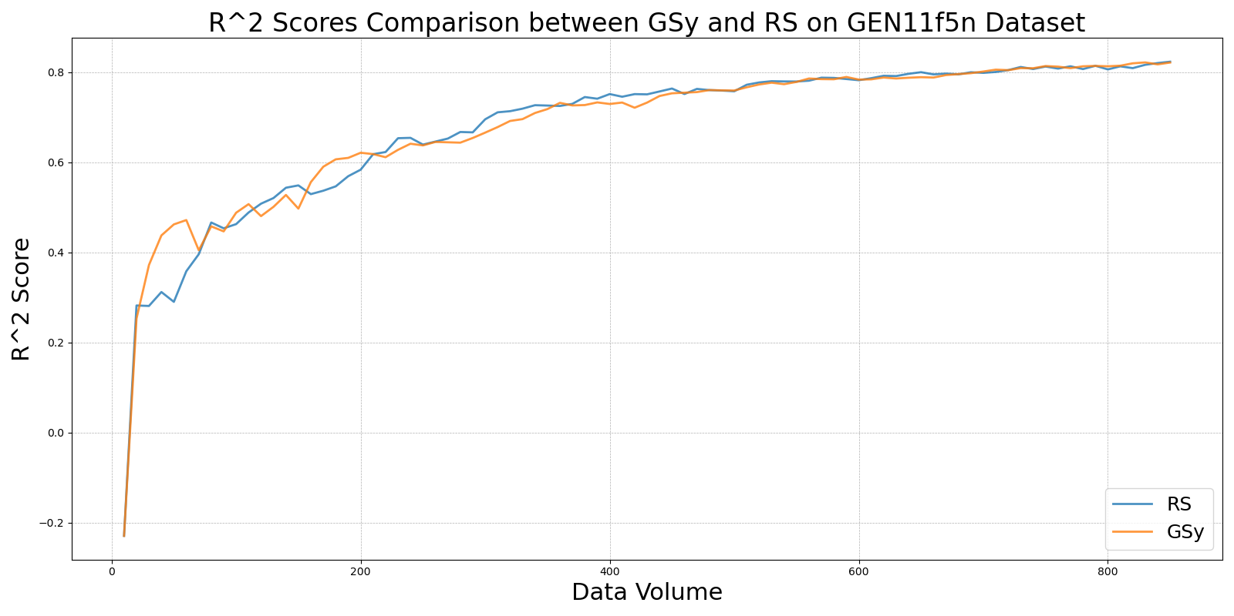

iGS_vs_RS_on_GEN11f5n.png

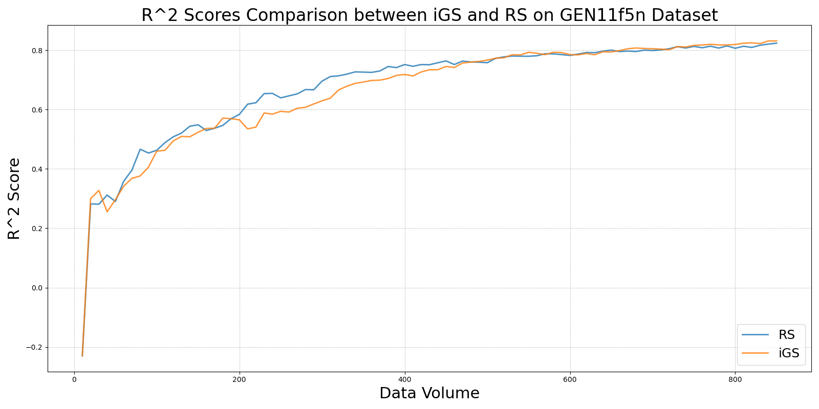

LCMD_vs_RS_on_GEN11f5n.png

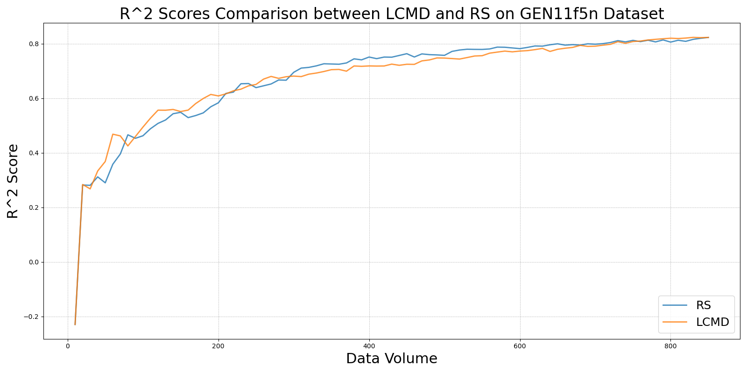

LL4AL_vs_RS_on_GEN11f5n.png

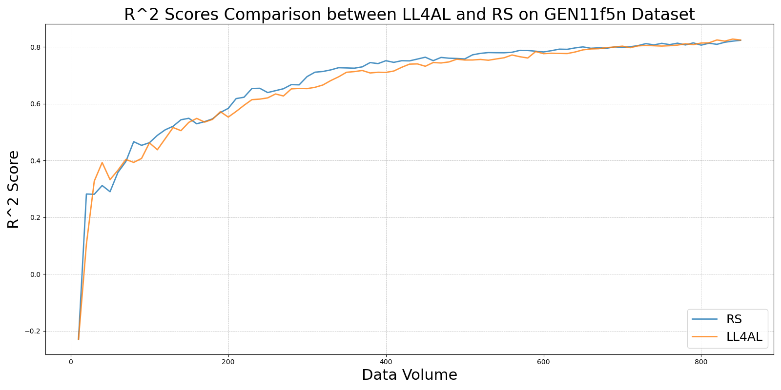

MCD_vs_RS_on_GEN11f5n.png

