R2 Samples Report for 3 Thresholds

|  |  |  |  |
| --- | --- | --- | --- |
| Strategy | R2 >= 0.6 | R2 >= 0.7 | R2 >= 0.8 |
| RS | 90 (10.23%) | 220 (25.00%) | 350 (39.77%) |
| LL4AL | 160 (18.18%) | 230 (26.14%) | 370 (42.05%) |
| LCMD | 90 (10.23%) | 160 (18.18%) | 310 (35.23%) |
| MCD | 110 (12.50%) | 210 (23.86%) | 400 (45.45%) |
| EGAL | 60 (6.82%) | 150 (17.05%) | 240 (27.27%) |
| BayesianAL | 130 (14.77%) | 210 (23.86%) | 410 (46.59%) |
| GSx | 130 (14.77%) | 240 (27.27%) | 380 (43.18%) |
| GSy | 120 (13.64%) | 200 (22.73%) | 360 (40.91%) |
| iGS | 100 (11.36%) | 140 (15.91%) | 320 (36.36%) |
| GSBAG | 190 (21.59%) | 230 (26.14%) | 320 (36.36%) |

All_Strategies_on_GEN7f10n.png

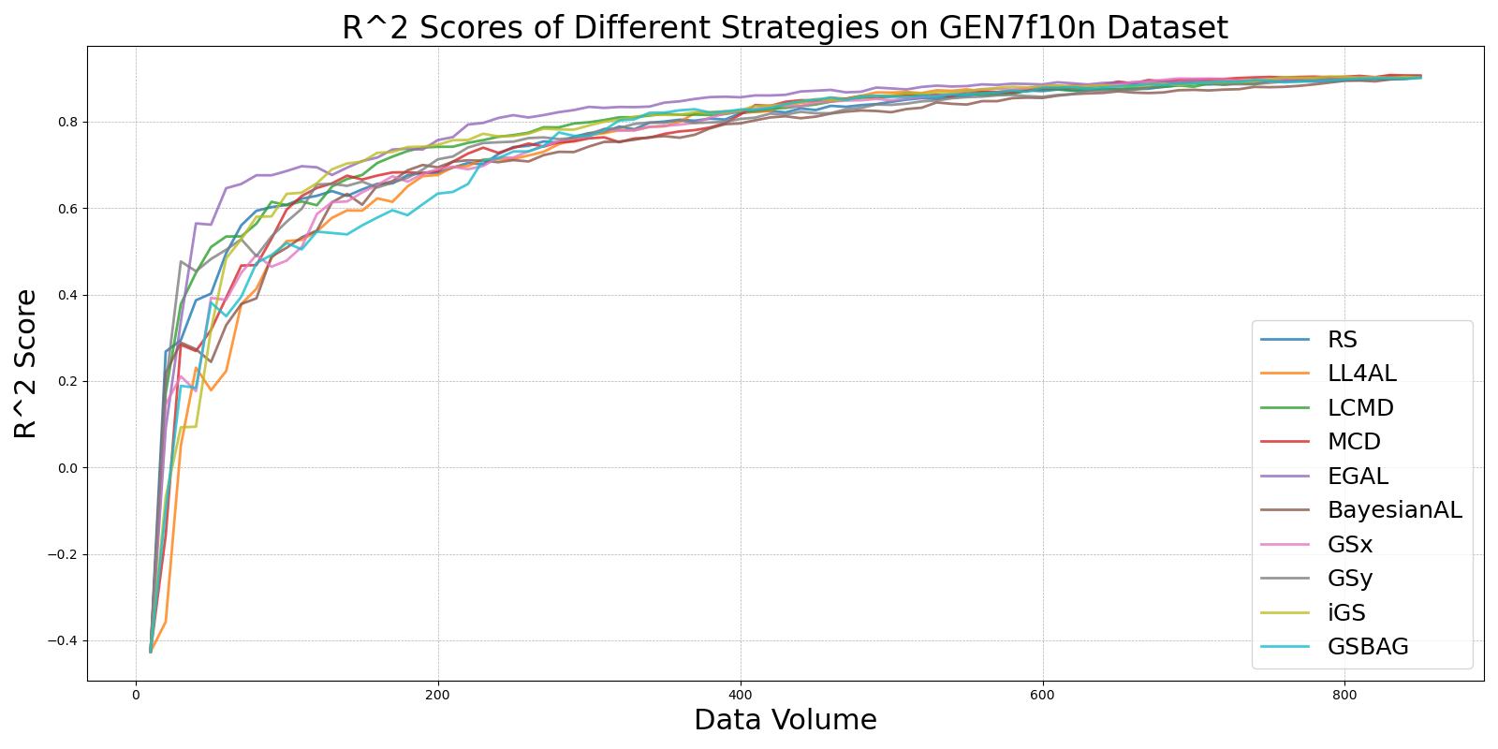

BayesianAL_vs_RS_on_GEN7f10n.png

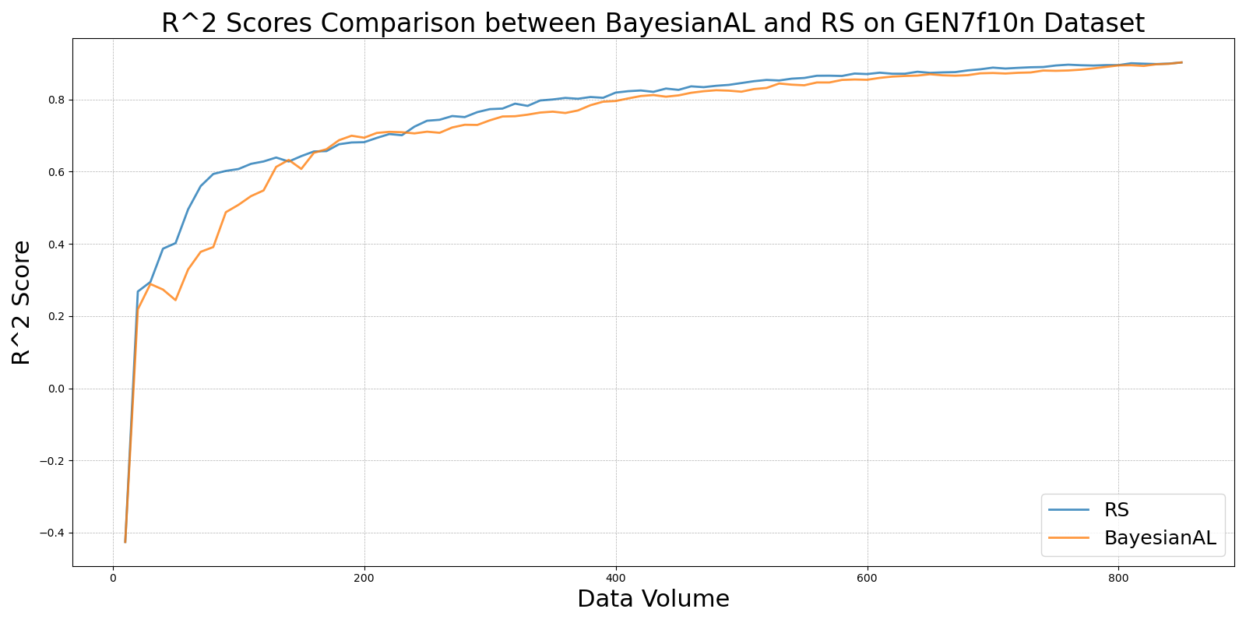

EGAL_vs_RS_on_GEN7f10n.png

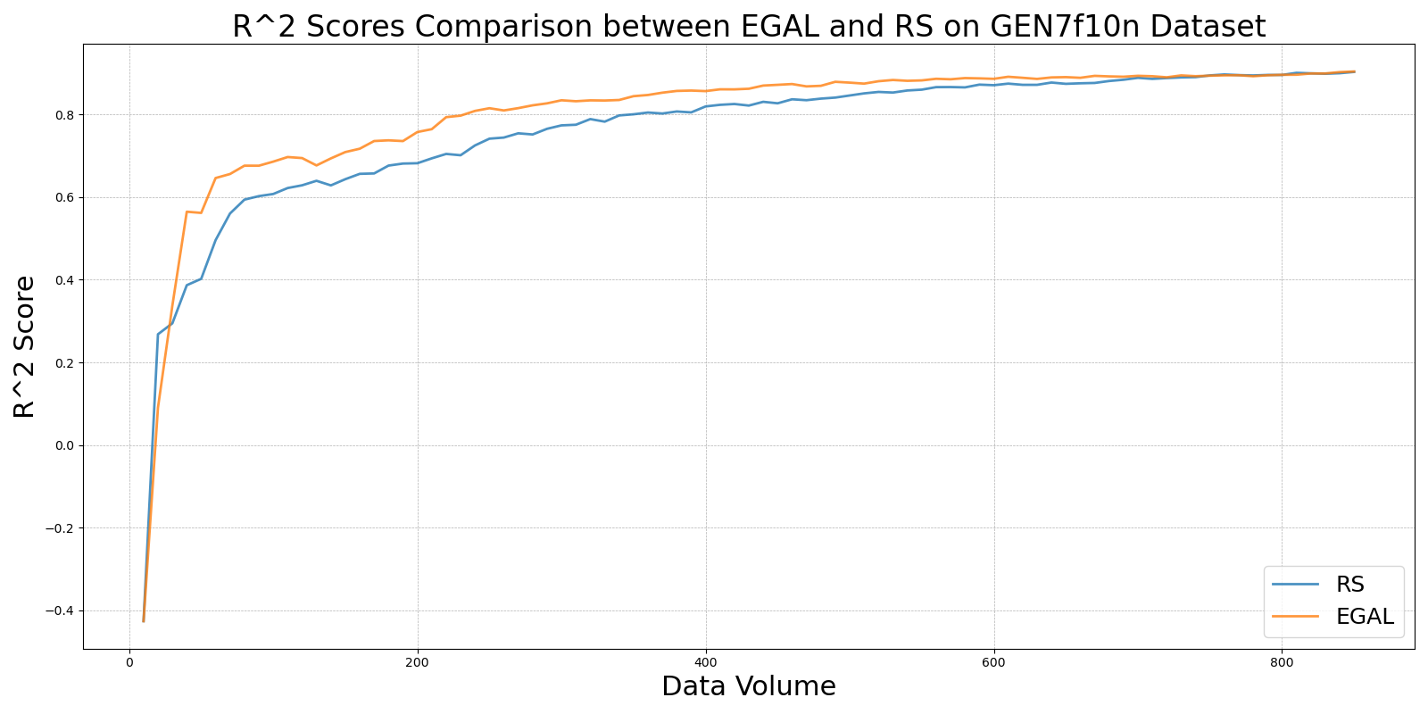

GSBAG_vs_RS_on_GEN7f10n.png

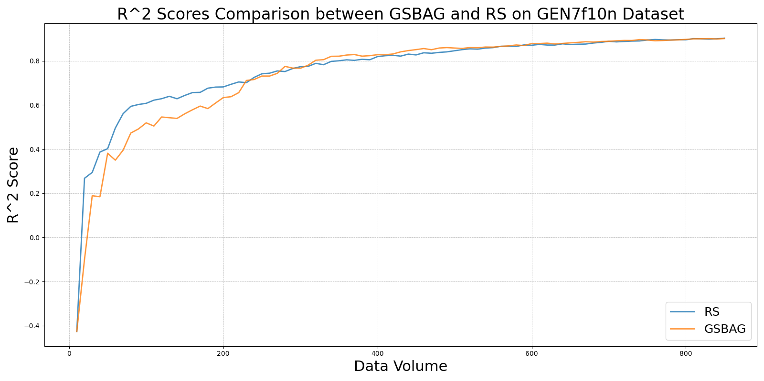

GSx_vs_RS_on_GEN7f10n.png

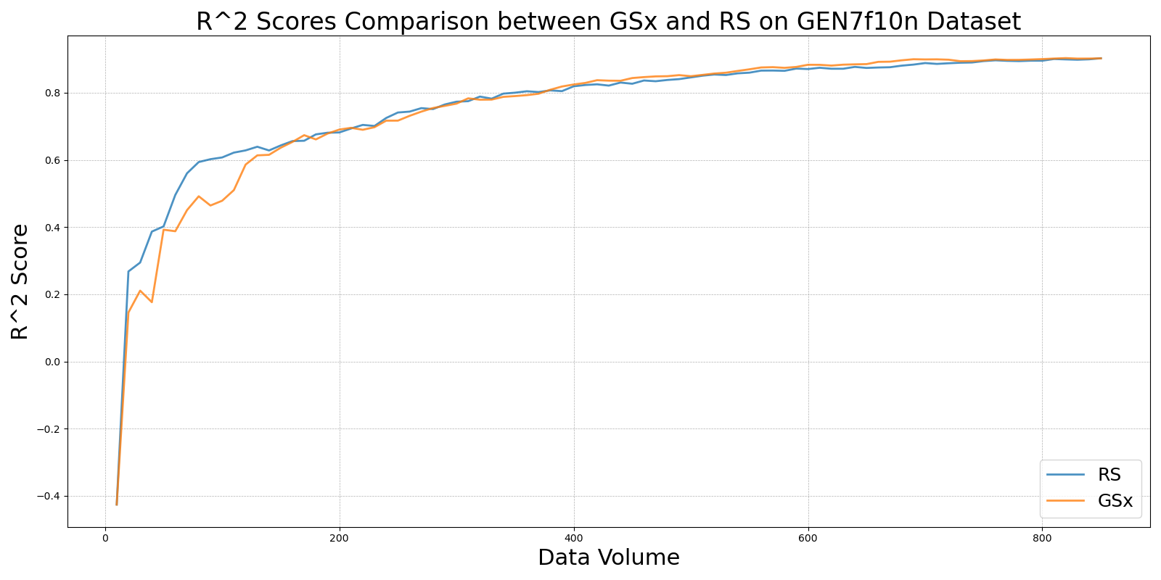

GSy_vs_RS_on_GEN7f10n.png

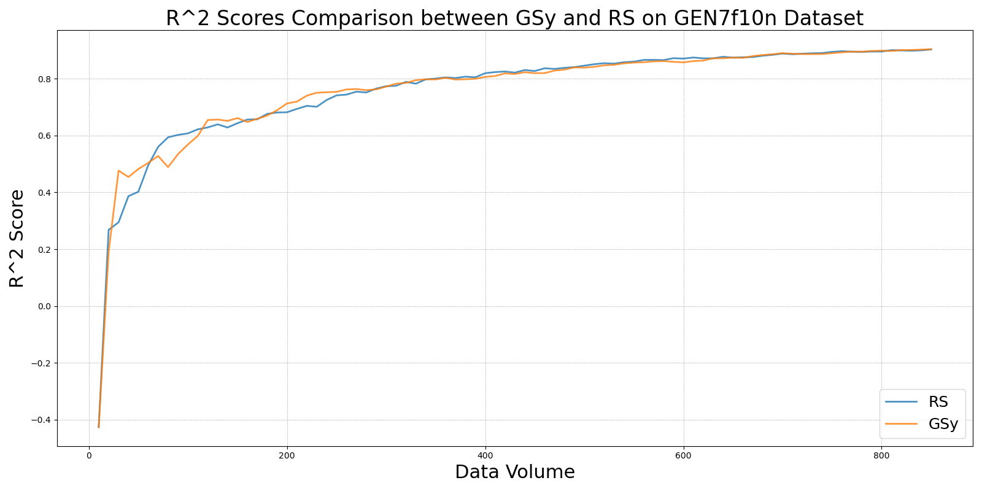

iGS_vs_RS_on_GEN7f10n.png

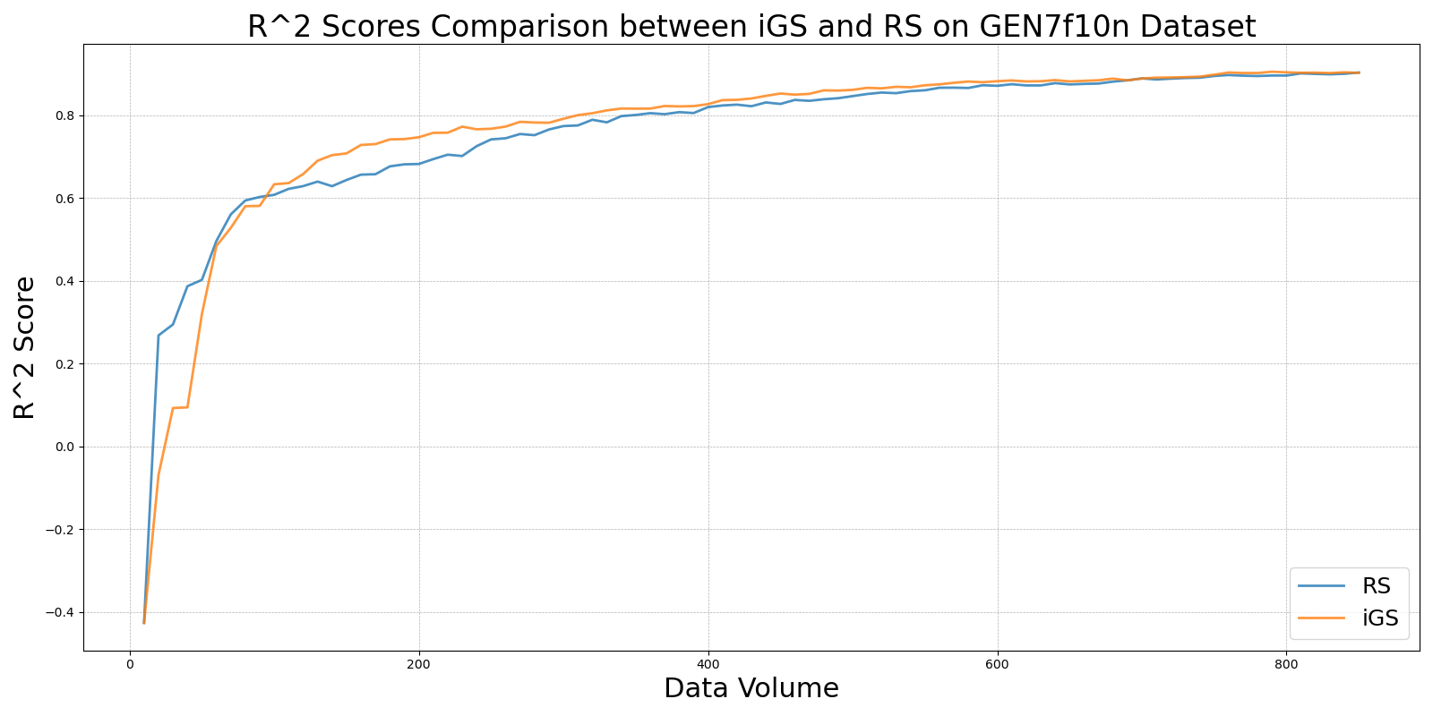

LCMD_vs_RS_on_GEN7f10n.png

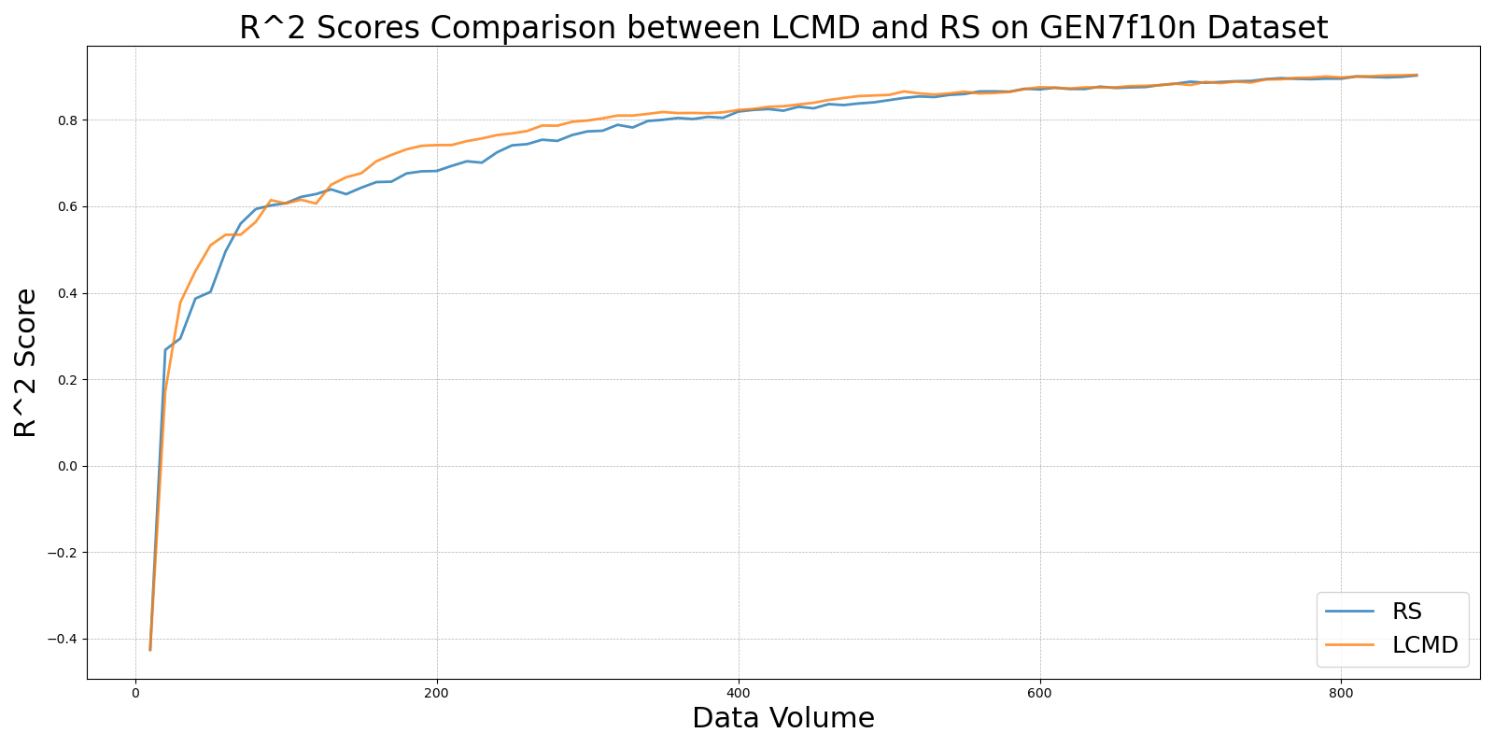

LL4AL_vs_RS_on_GEN7f10n.png

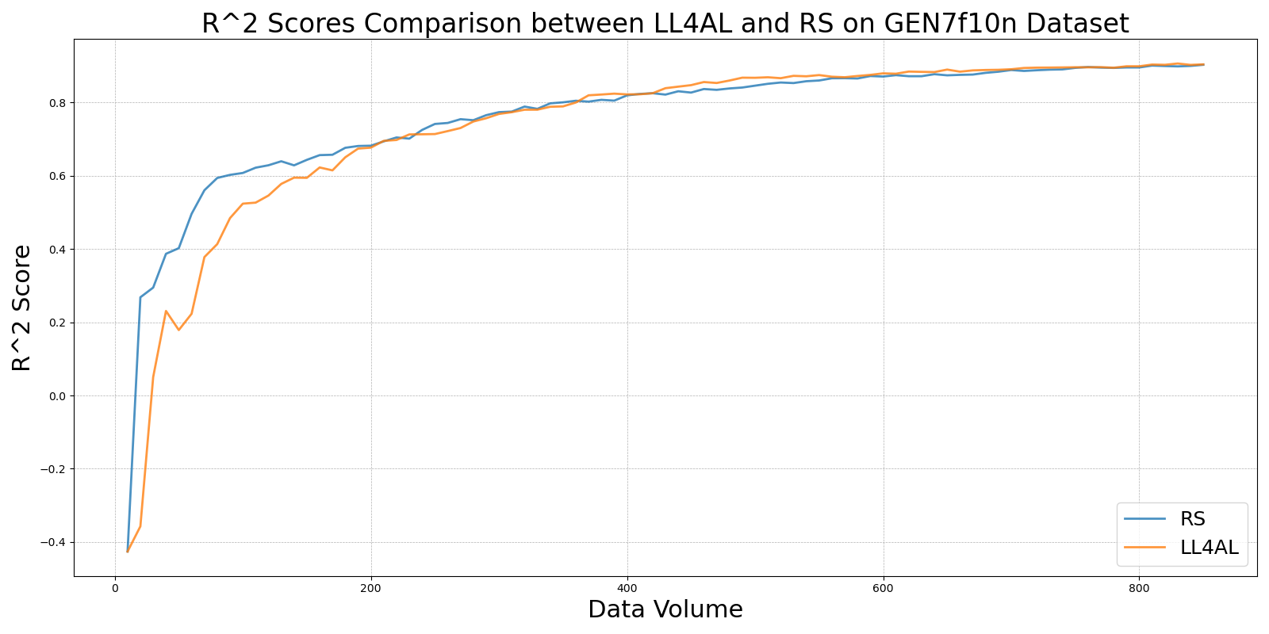

MCD_vs_RS_on_GEN7f10n.png

