R2 Samples Report for 3 Thresholds

|  |  |  |  |
| --- | --- | --- | --- |
| Strategy | R2 >= 0.6 | R2 >= 0.7 | R2 >= 0.8 |
| RS | 150 (17.05%) | 250 (28.41%) | 460 (52.27%) |
| LL4AL | 130 (14.77%) | 230 (26.14%) | 470 (53.41%) |
| LCMD | 130 (14.77%) | 180 (20.45%) | 420 (47.73%) |
| MCD | 110 (12.50%) | 180 (20.45%) | 370 (42.05%) |
| EGAL | 60 (6.82%) | 160 (18.18%) | 350 (39.77%) |
| BayesianAL | 160 (18.18%) | 250 (28.41%) | 480 (54.55%) |
| GSx | 130 (14.77%) | 240 (27.27%) | 400 (45.45%) |
| GSy | 170 (19.32%) | 250 (28.41%) | 460 (52.27%) |
| iGS | 110 (12.50%) | 220 (25.00%) | 370 (42.05%) |
| GSBAG | 200 (22.73%) | 260 (29.55%) | 410 (46.59%) |

All_Strategies_on_GEN7f20n.png

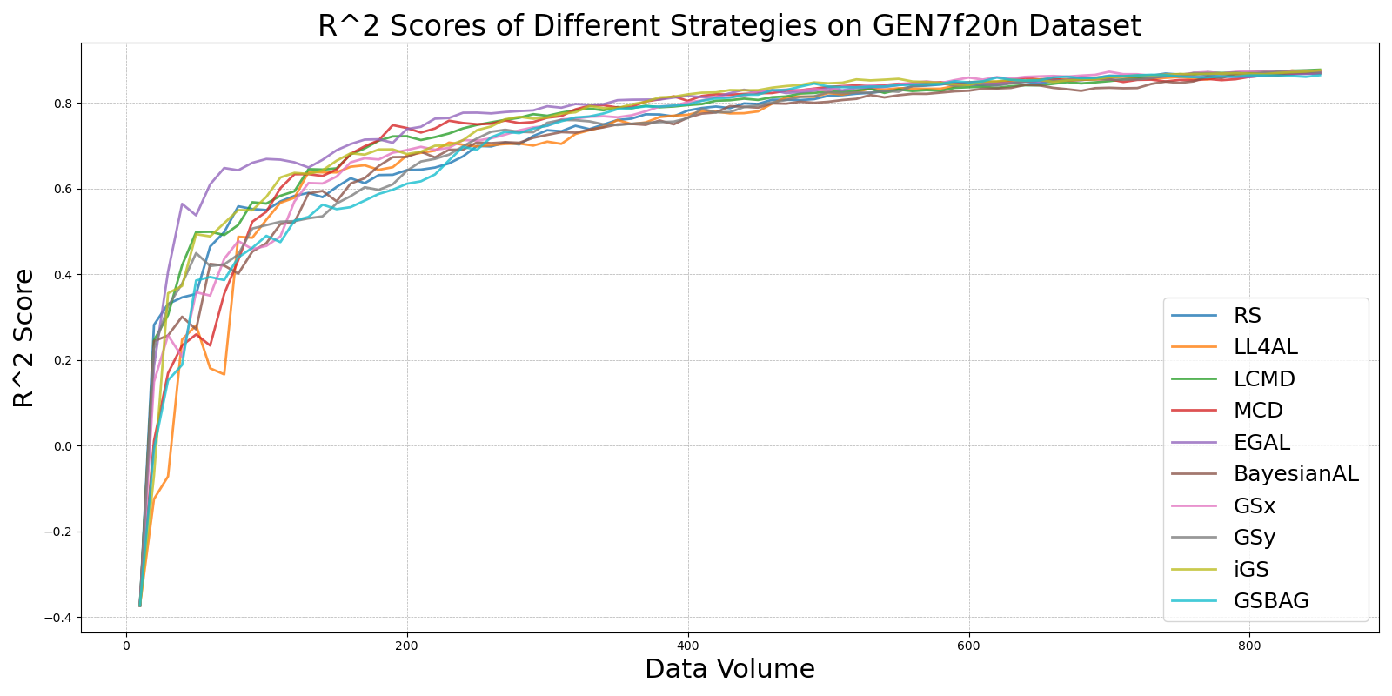

BayesianAL_vs_RS_on_GEN7f20n.png

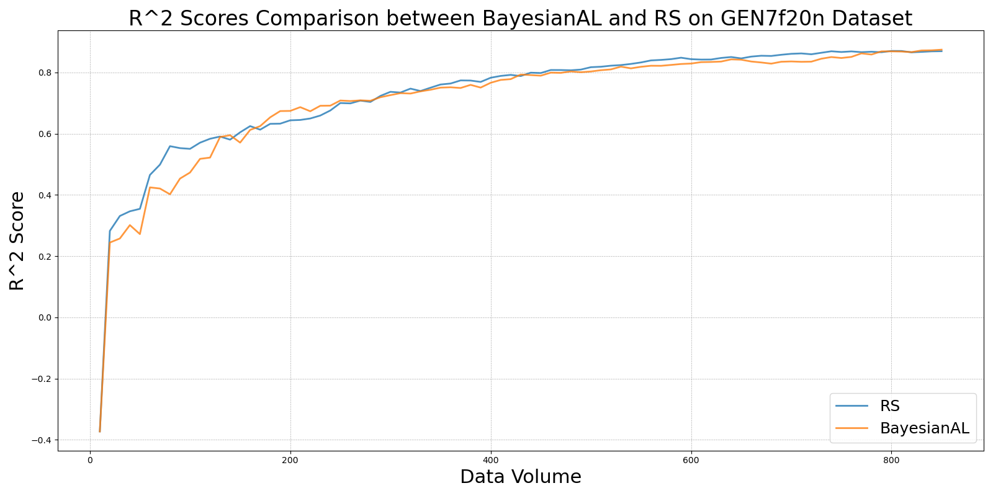

EGAL_vs_RS_on_GEN7f20n.png

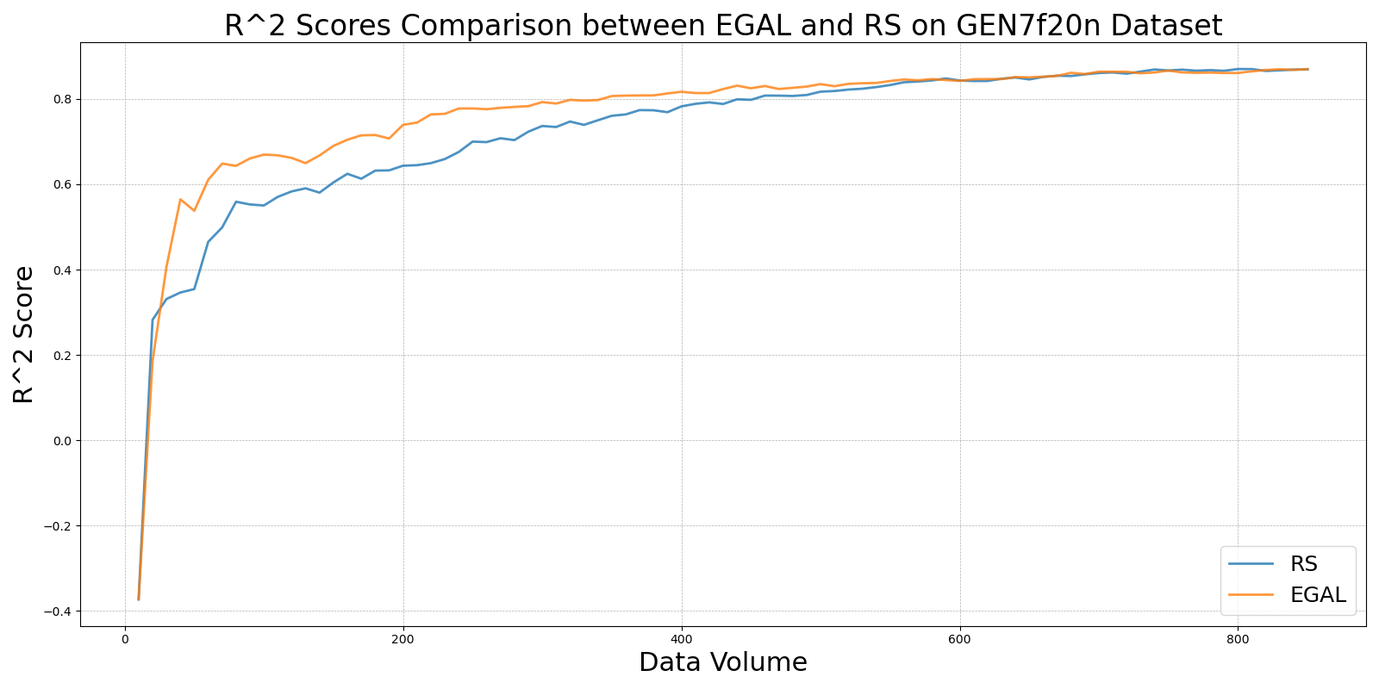

GSBAG_vs_RS_on_GEN7f20n.png

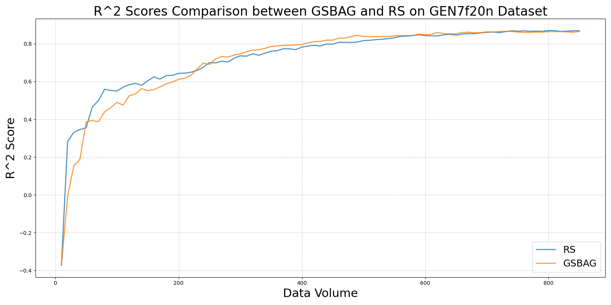

GSx_vs_RS_on_GEN7f20n.png

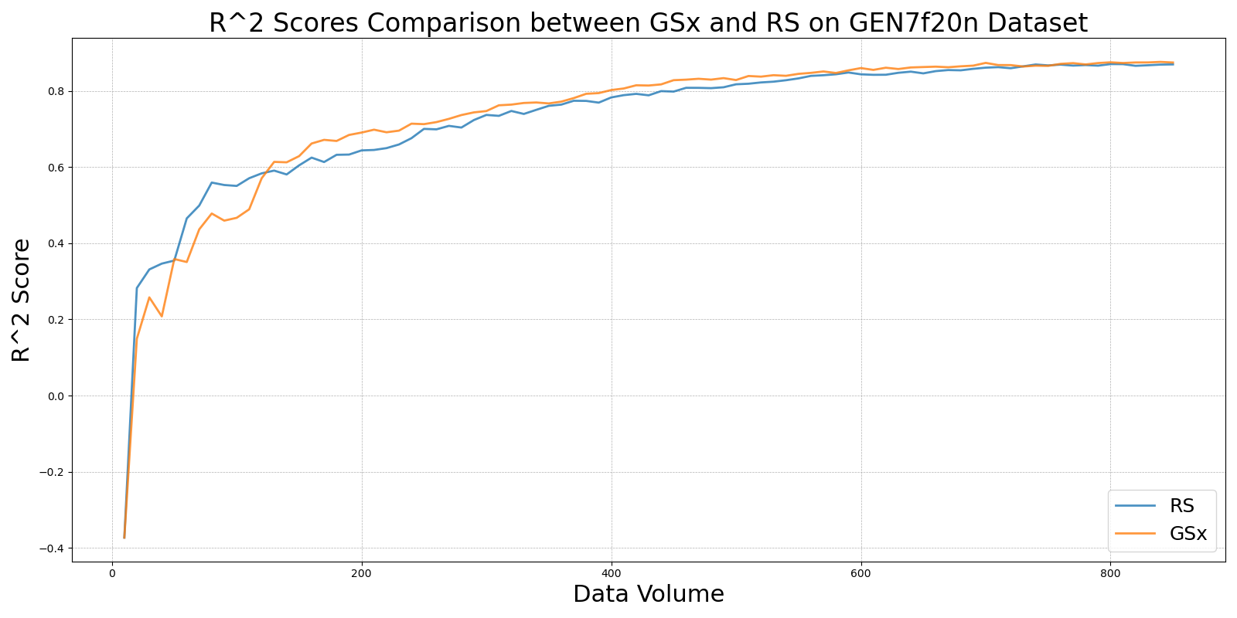

GSy_vs_RS_on_GEN7f20n.png

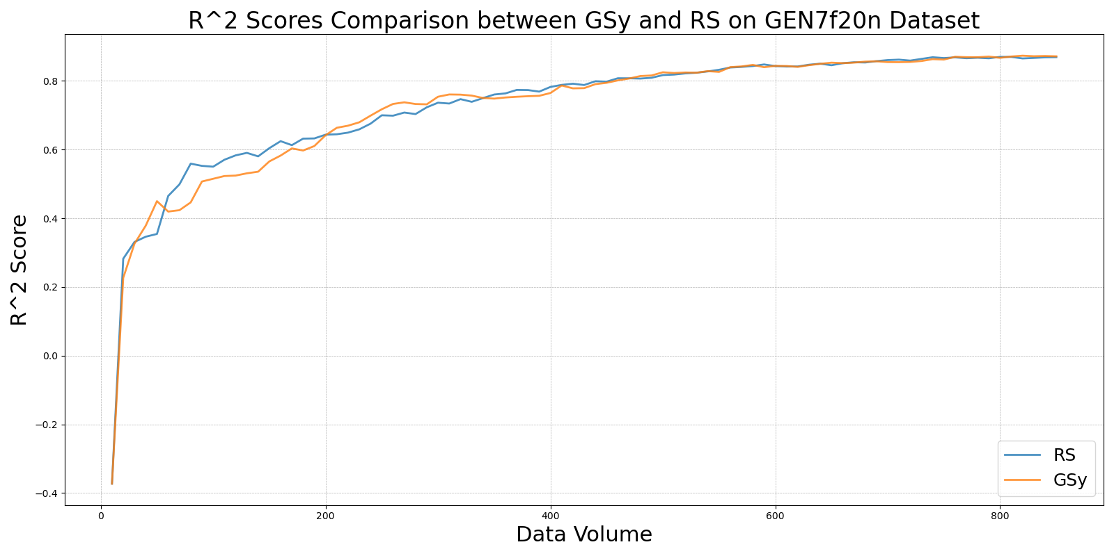

iGS_vs_RS_on_GEN7f20n.png

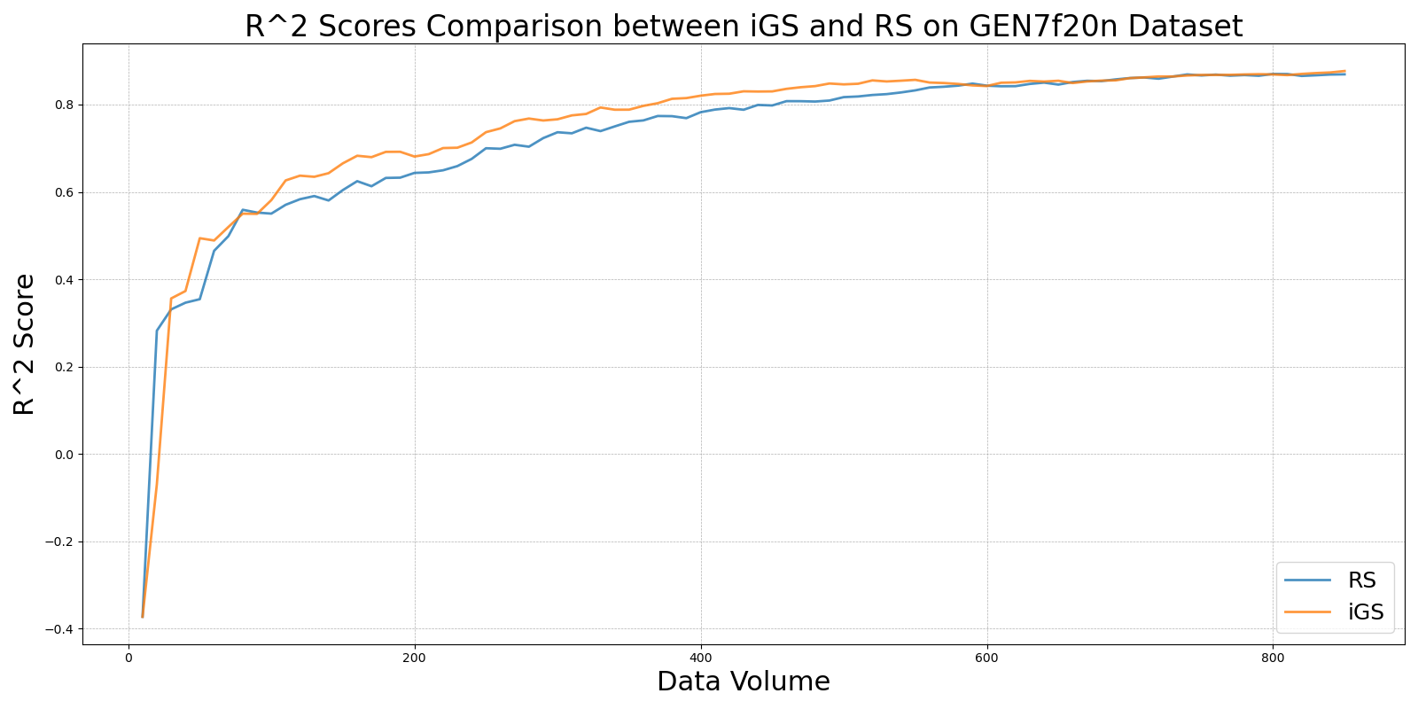

LCMD_vs_RS_on_GEN7f20n.png

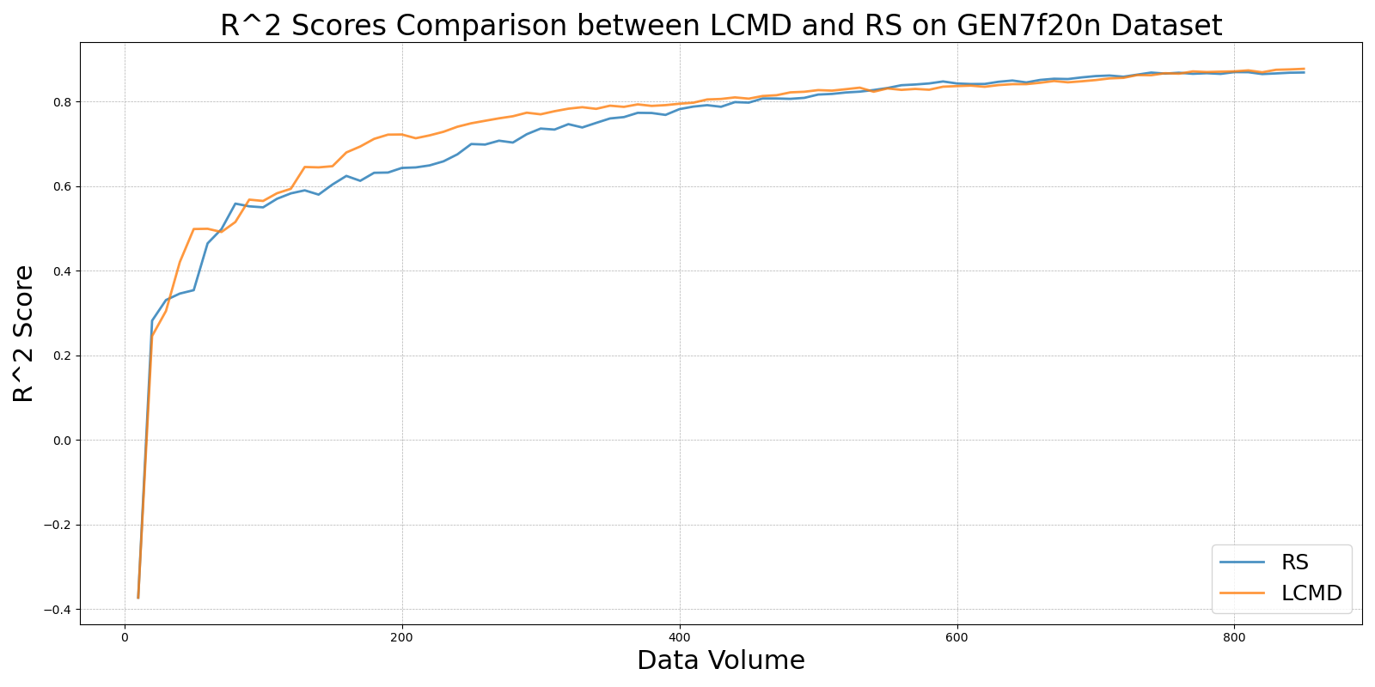

LL4AL_vs_RS_on_GEN7f20n.png

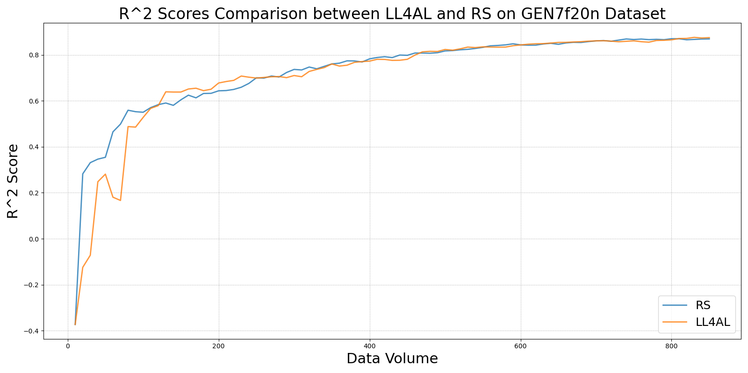

MCD_vs_RS_on_GEN7f20n.png

