R2 Samples Report for 3 Thresholds

|  |  |  |  |
| --- | --- | --- | --- |
| Strategy | R2 >= 0.6 | R2 >= 0.7 | R2 >= 0.8 |
| RS | 30 (15.31%) | 60 (30.61%) | 80 (40.82%) |
| LL4AL | 60 (30.61%) | 100 (51.02%) | 140 (71.43%) |
| LCMD | 30 (15.31%) | 40 (20.41%) | 60 (30.61%) |
| MCD | 50 (25.51%) | 60 (30.61%) | 140 (71.43%) |
| EGAL | 30 (15.31%) | 50 (25.51%) | 70 (35.71%) |
| BayesianAL | 110 (56.12%) | 110 (56.12%) | 110 (56.12%) |
| GSx | 80 (40.82%) | 80 (40.82%) | 90 (45.92%) |
| GSy | 30 (15.31%) | 30 (15.31%) | 80 (40.82%) |
| iGS | 20 (10.20%) | 30 (15.31%) | 30 (15.31%) |
| GSBAG | 60 (30.61%) | 70 (35.71%) | 70 (35.71%) |

All_Strategies_on_BFRC_fs.png

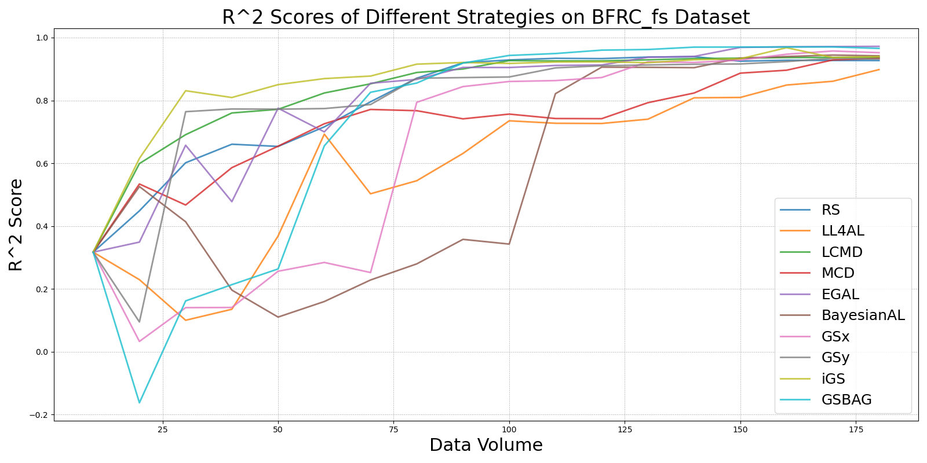

BayesianAL_vs_RS_on_BFRC_fs.png

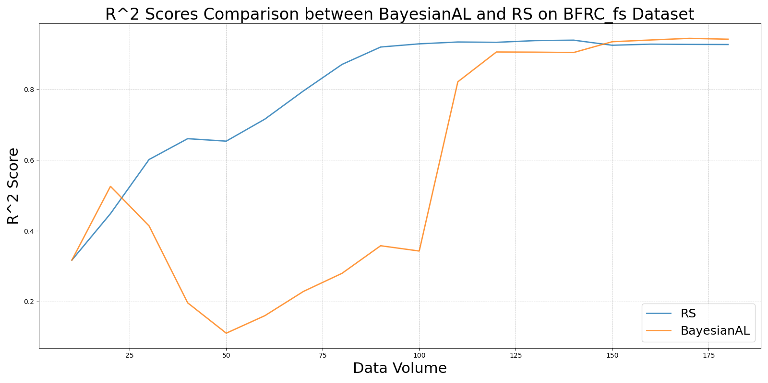

EGAL_vs_RS_on_BFRC_fs.png

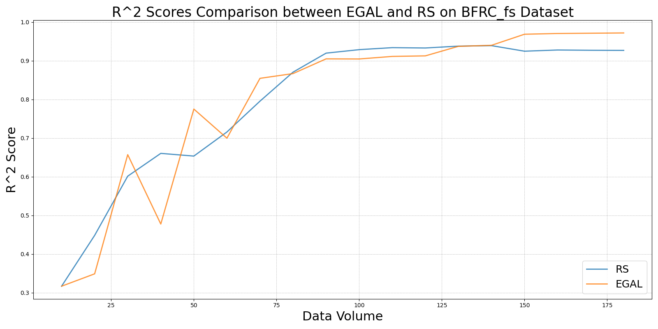

GSBAG_vs_RS_on_BFRC_fs.png

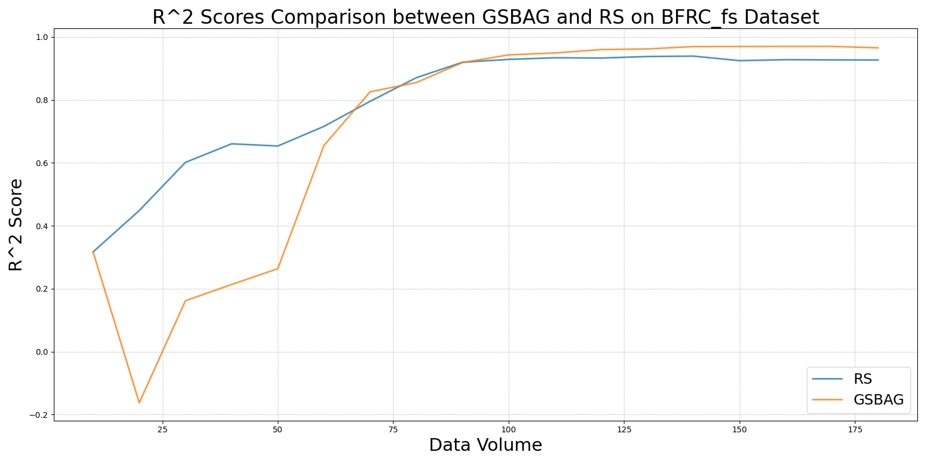

GSx_vs_RS_on_BFRC_fs.png

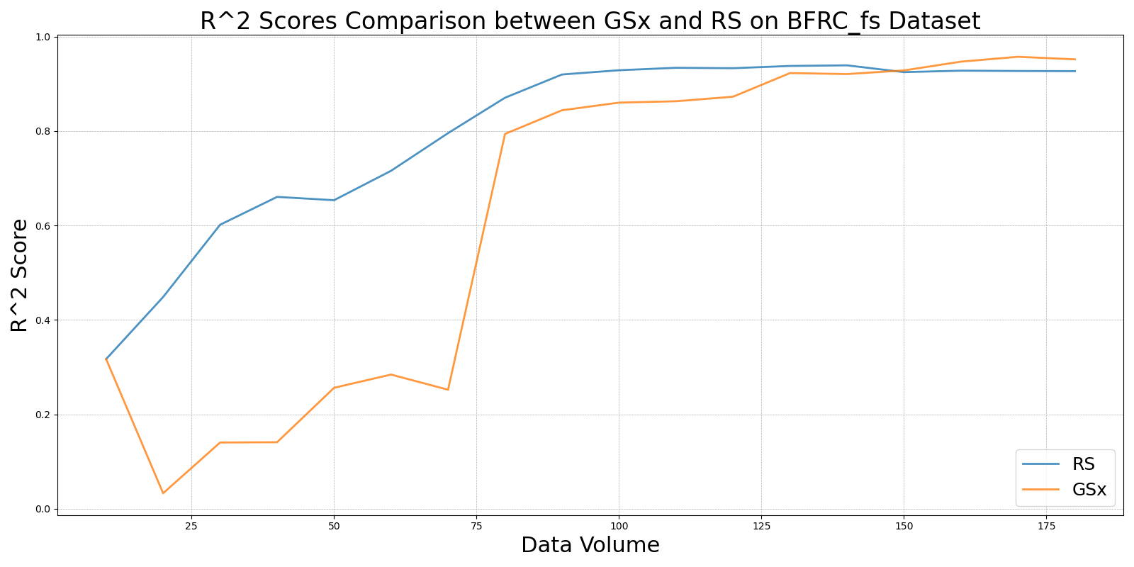

GSy_vs_RS_on_BFRC_fs.png

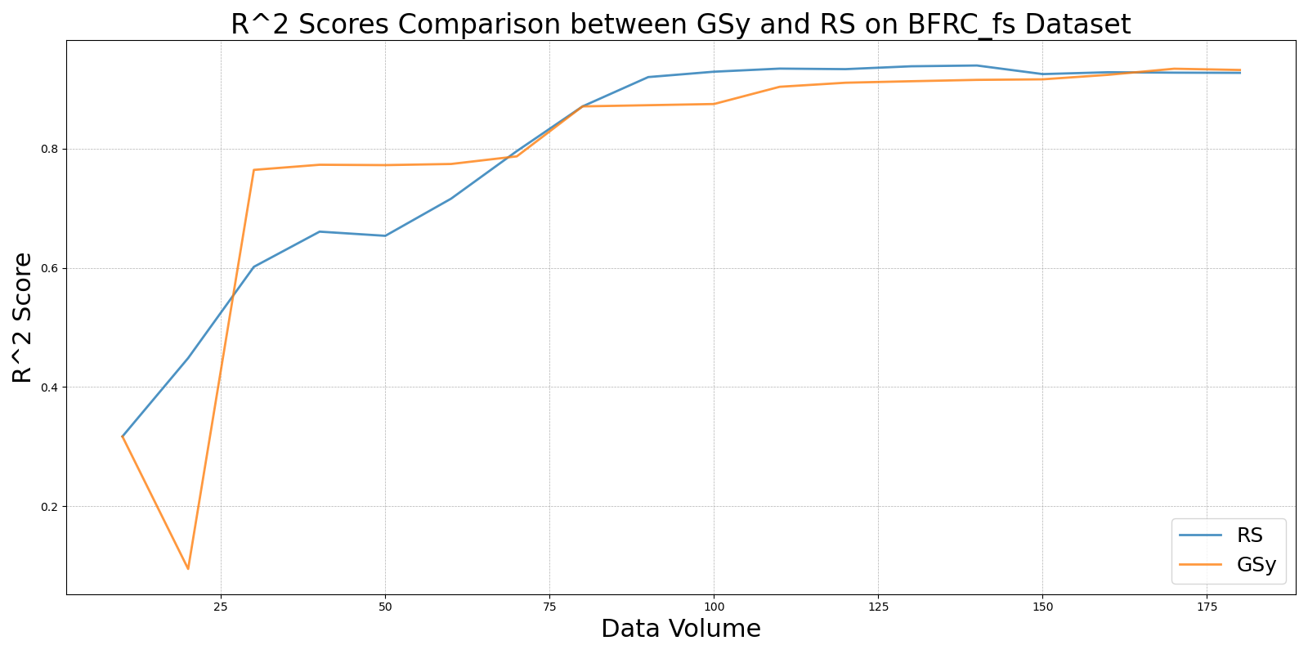

iGS_vs_RS_on_BFRC_fs.png

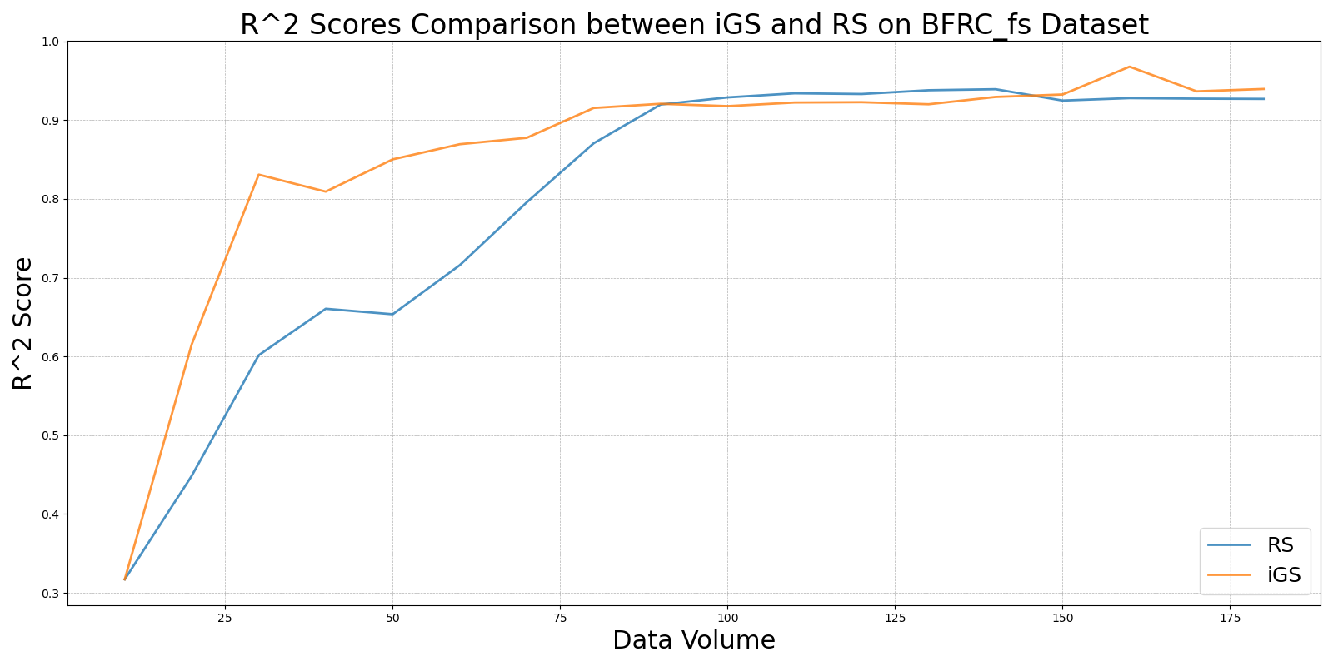

LCMD_vs_RS_on_BFRC_fs.png

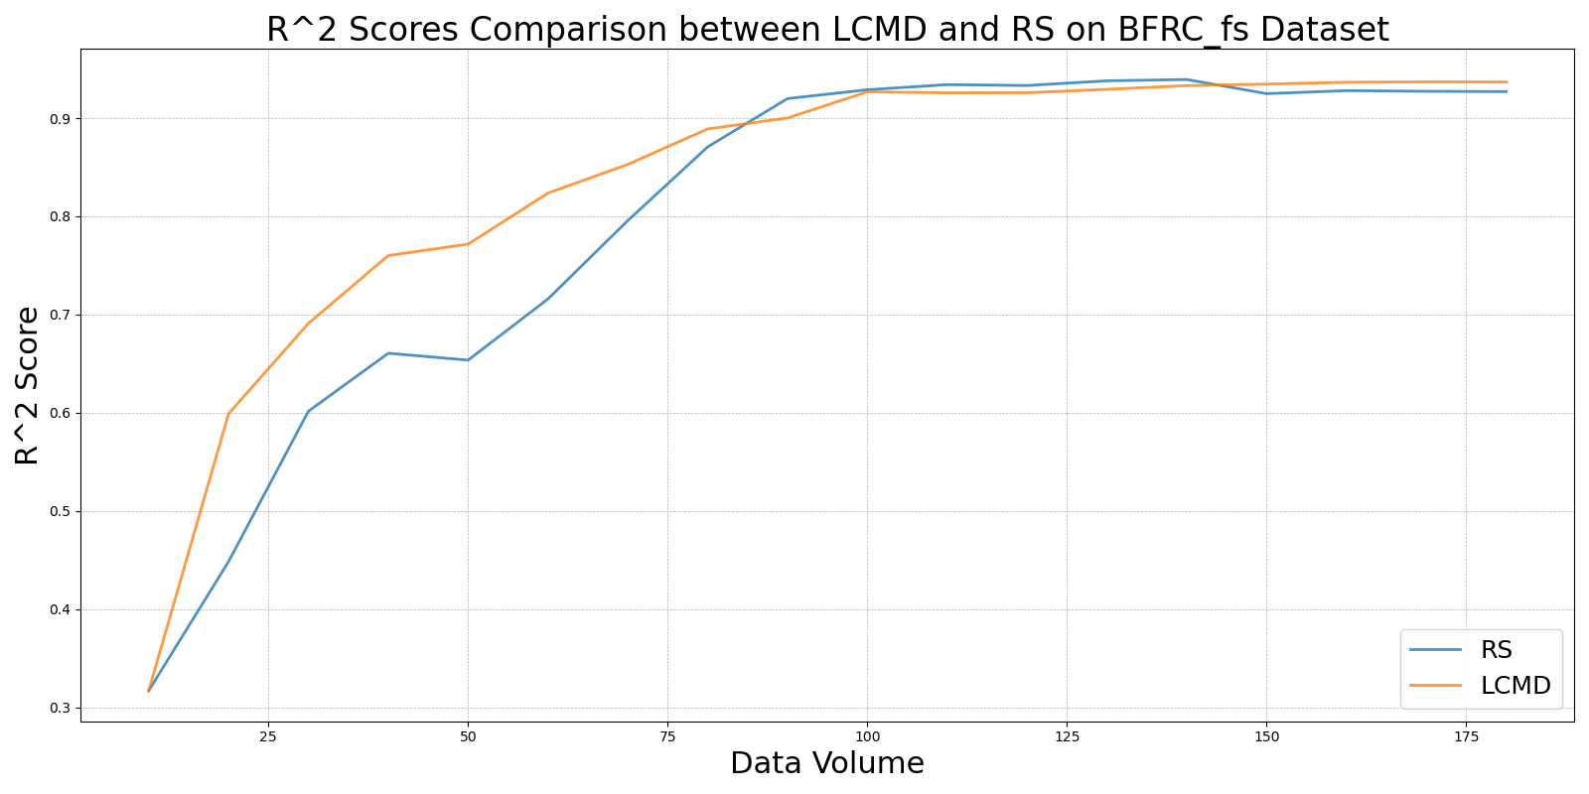

LL4AL_vs_RS_on_BFRC_fs.png

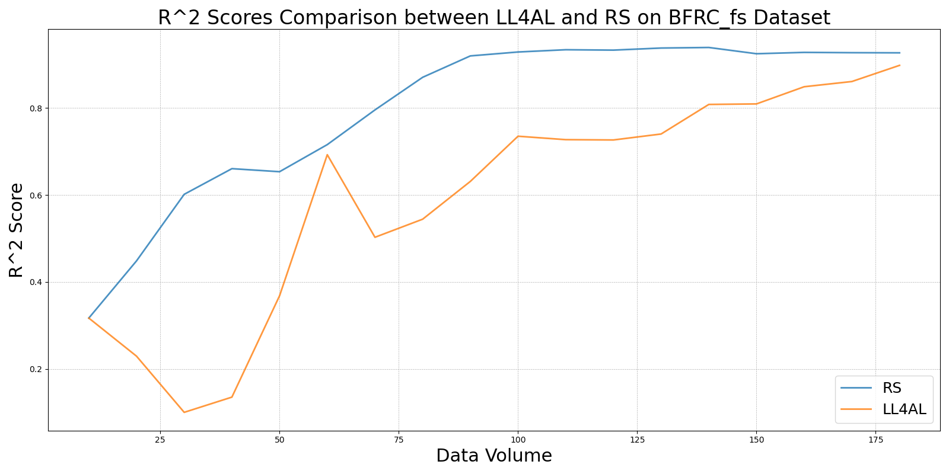

MCD_vs_RS_on_BFRC_fs.png

