R2 Samples Report for 3 Thresholds

|  |  |  |  |
| --- | --- | --- | --- |
| Strategy | R2 >= 0.6 | R2 >= 0.7 | R2 >= 0.8 |
| RS | 100 (85.62%) | N/A | N/A |
| LL4AL | 70 (59.93%) | N/A | N/A |
| LCMD | N/A | N/A | N/A |
| MCD | 100 (85.62%) | N/A | N/A |
| EGAL | N/A | N/A | N/A |
| BayesianAL | 100 (85.62%) | N/A | N/A |
| GSx | 100 (85.62%) | N/A | N/A |
| GSy | 90 (77.05%) | N/A | N/A |
| iGS | 70 (59.93%) | N/A | N/A |
| GSBAG | 100 (85.62%) | N/A | N/A |

All_Strategies_on_UHPC_fs.png

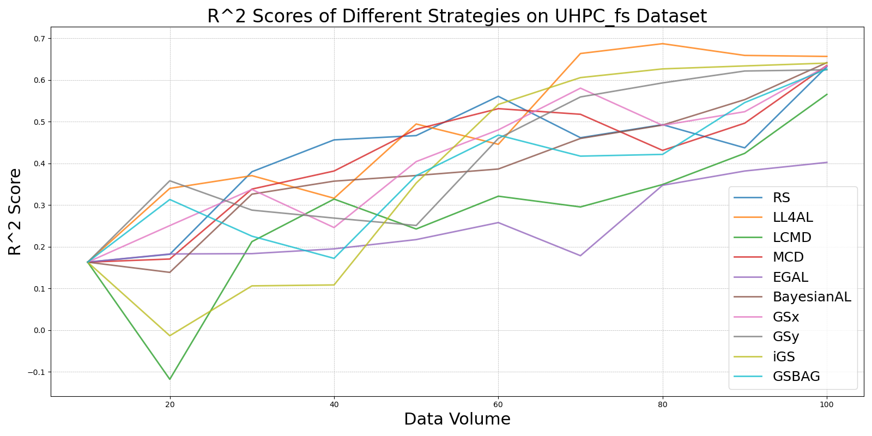

BayesianAL_vs_RS_on_UHPC_fs.png

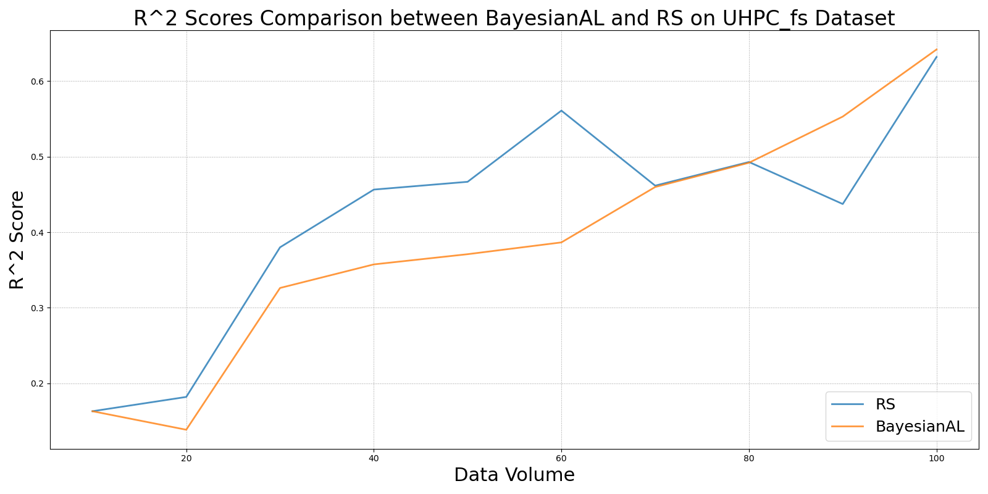

EGAL_vs_RS_on_UHPC_fs.png

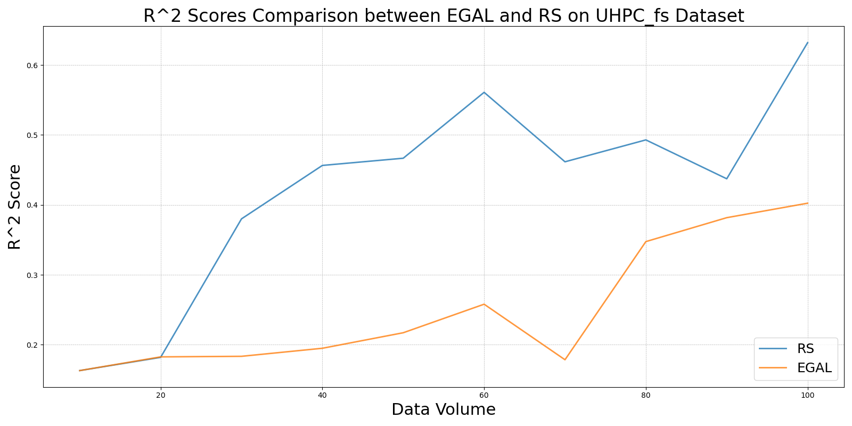

GSBAG_vs_RS_on_UHPC_fs.png

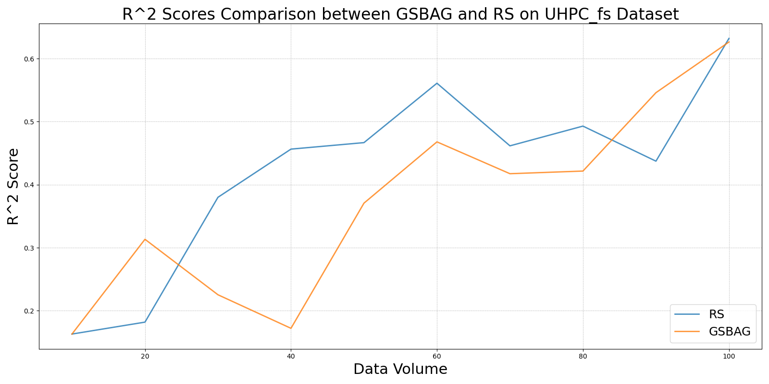

GSx_vs_RS_on_UHPC_fs.png

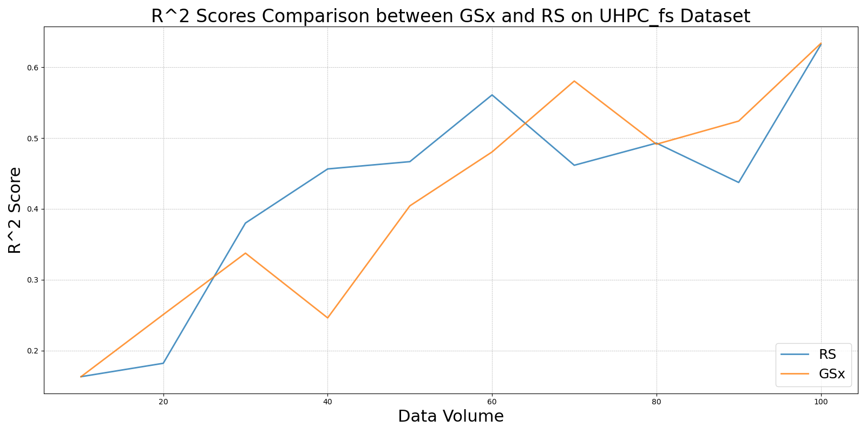

GSy_vs_RS_on_UHPC_fs.png

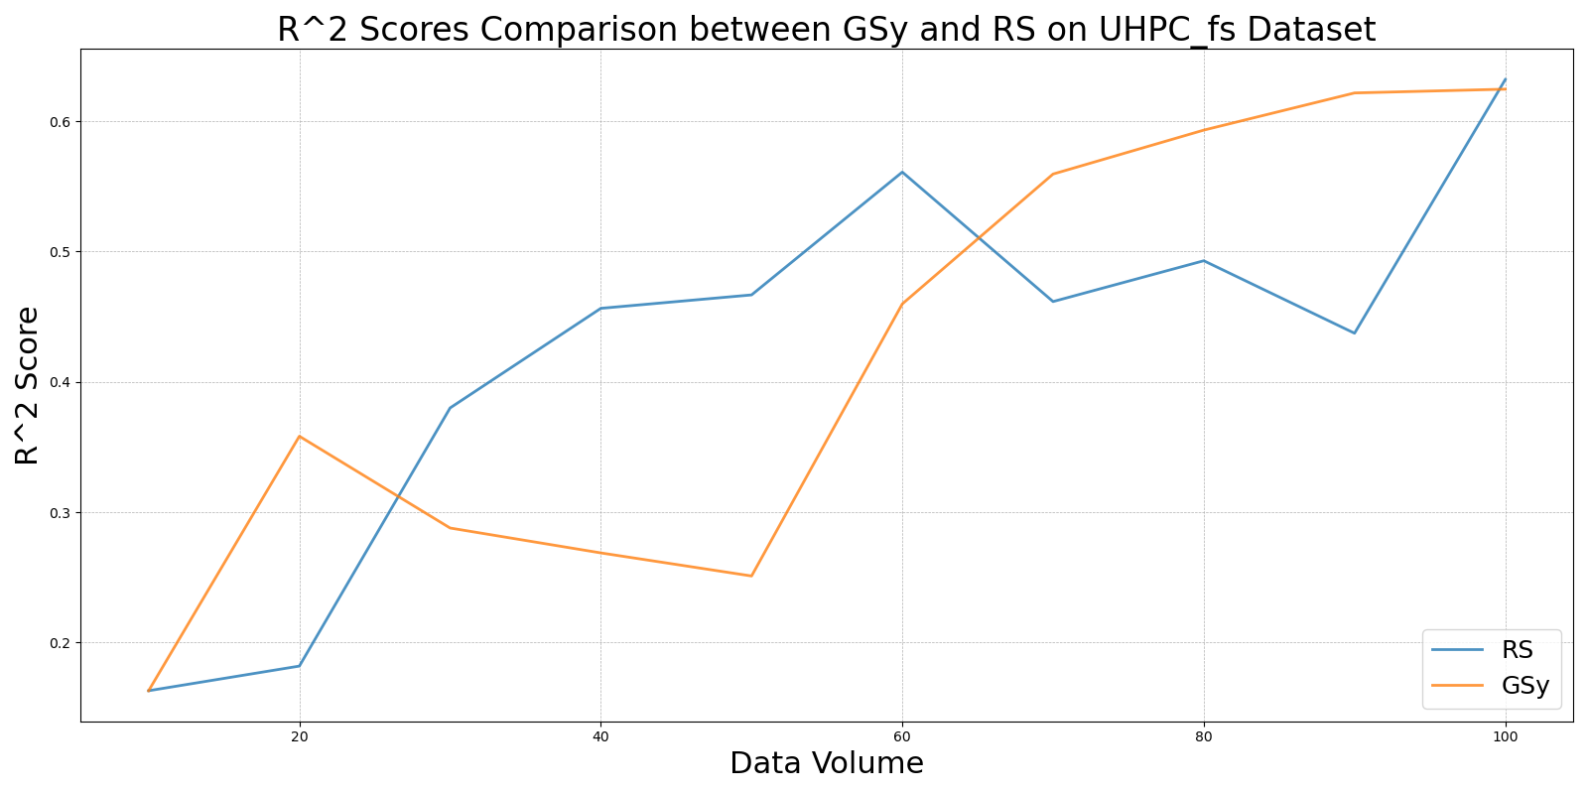

iGS_vs_RS_on_UHPC_fs.png

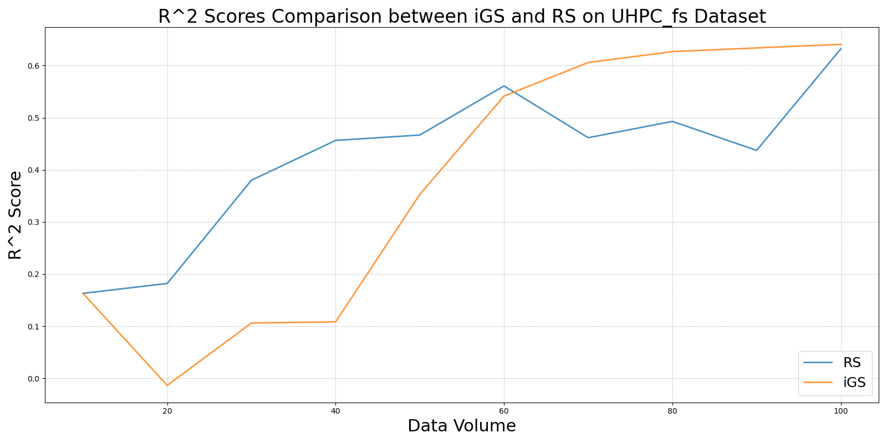

LCMD_vs_RS_on_UHPC_fs.png

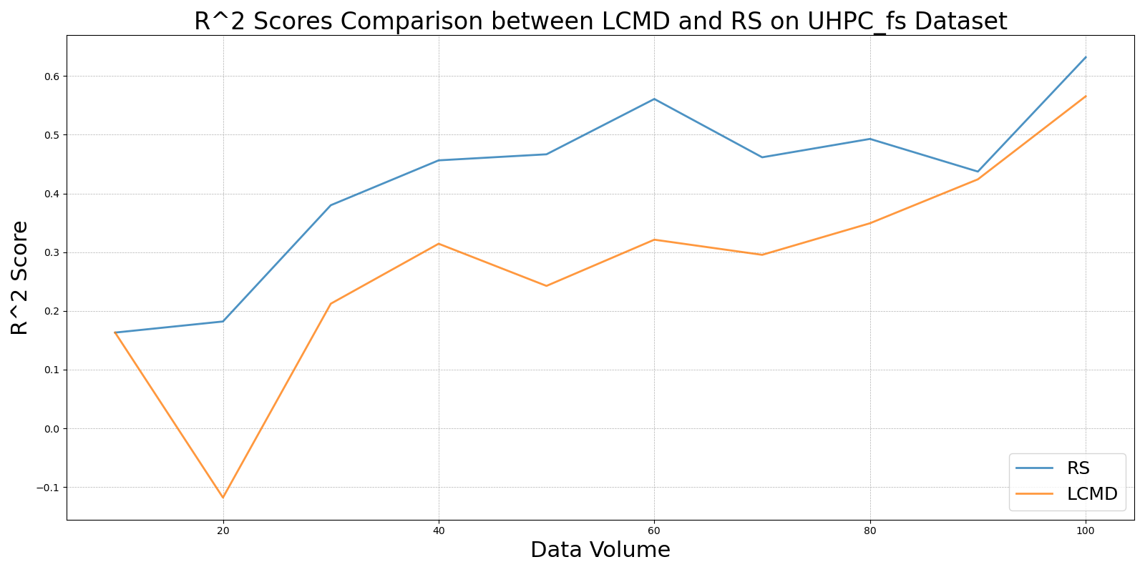

LL4AL_vs_RS_on_UHPC_fs.png

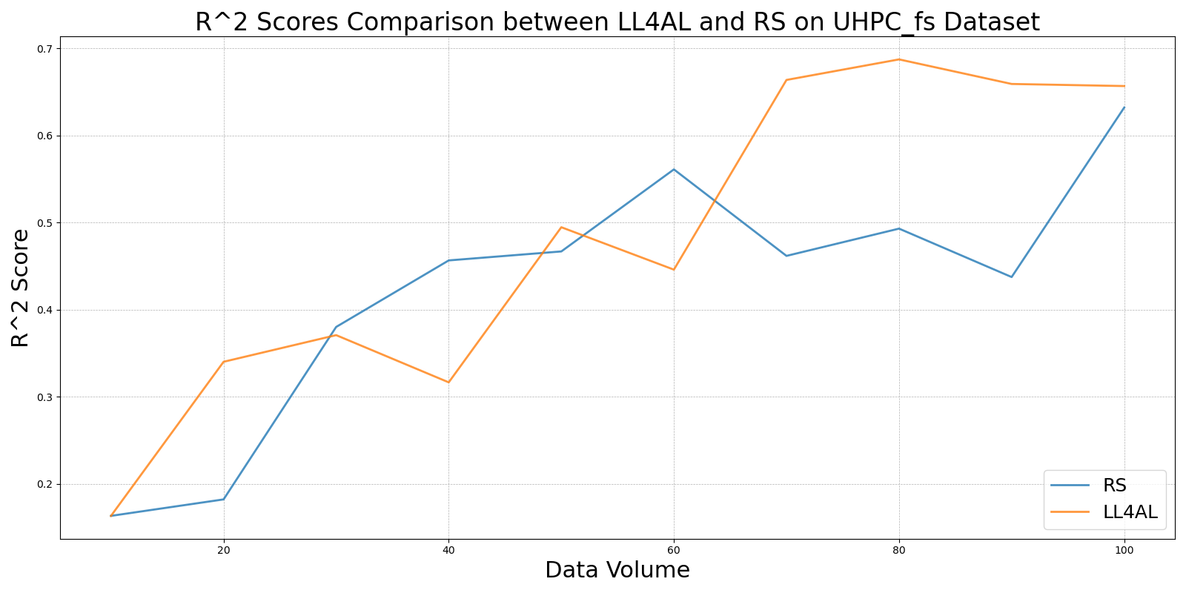

MCD_vs_RS_on_UHPC_fs.png

