R2 Samples Report for 3 Thresholds

|  |  |  |  |
| --- | --- | --- | --- |
| Strategy | R2 >= 0.6 | R2 >= 0.7 | R2 >= 0.8 |
| RS | 80 (65.79%) | 100 (82.24%) | 110 (90.46%) |
| LL4AL | 100 (82.24%) | 110 (90.46%) | N/A |
| LCMD | 40 (32.89%) | 50 (41.12%) | 60 (49.34%) |
| MCD | 40 (32.89%) | 40 (32.89%) | 100 (82.24%) |
| EGAL | 50 (41.12%) | 70 (57.57%) | 80 (65.79%) |
| BayesianAL | 60 (49.34%) | 70 (57.57%) | N/A |
| GSx | 20 (16.45%) | 30 (24.67%) | 110 (90.46%) |
| GSy | 50 (41.12%) | 60 (49.34%) | 60 (49.34%) |
| iGS | 40 (32.89%) | 50 (41.12%) | 80 (65.79%) |
| GSBAG | 50 (41.12%) | 50 (41.12%) | 90 (74.01%) |

All_Strategies_on_UHPC_mss.png

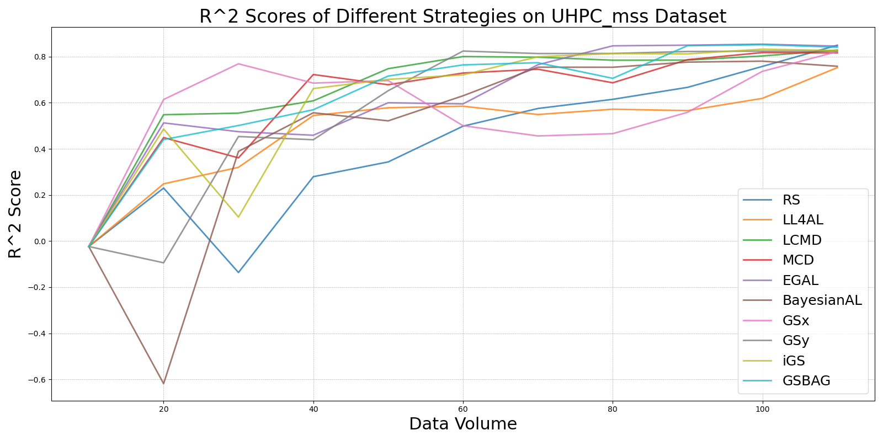

BayesianAL_vs_RS_on_UHPC_mss.png

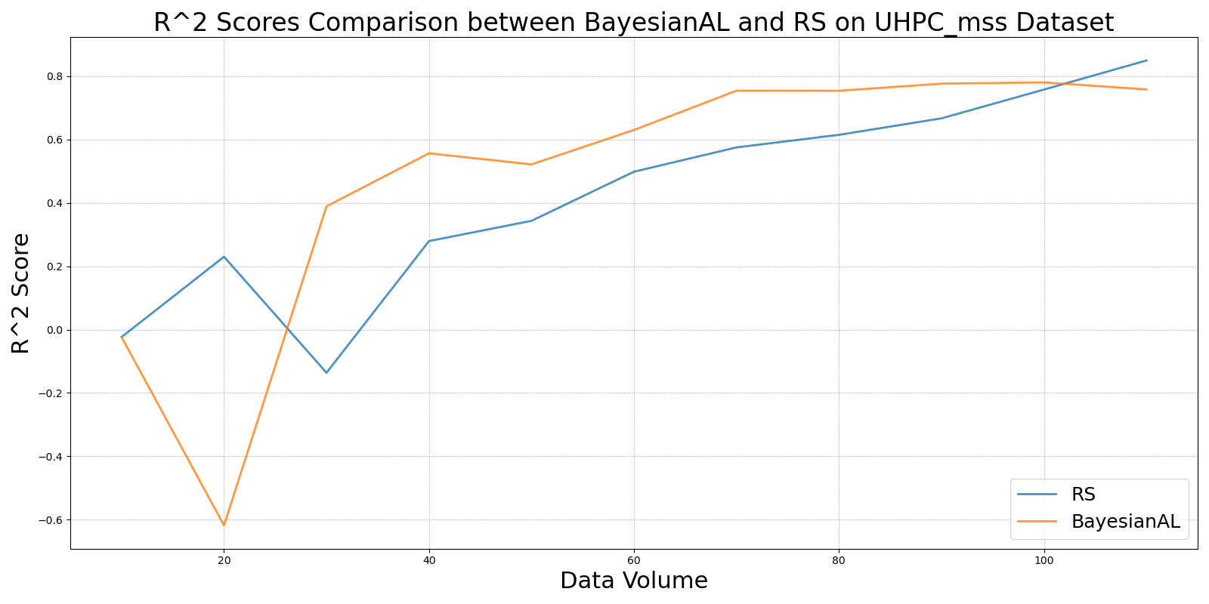

EGAL_vs_RS_on_UHPC_mss.png

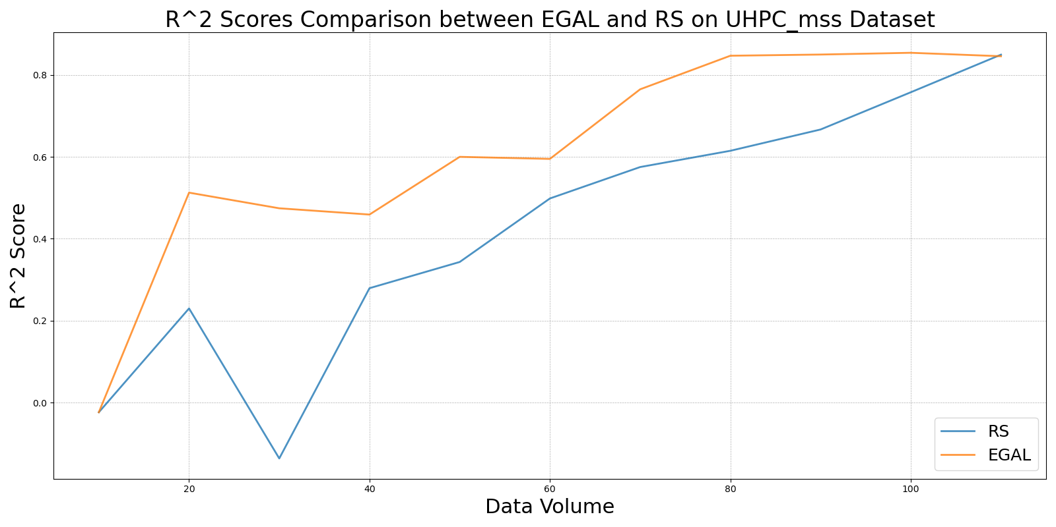

GSBAG_vs_RS_on_UHPC_mss.png

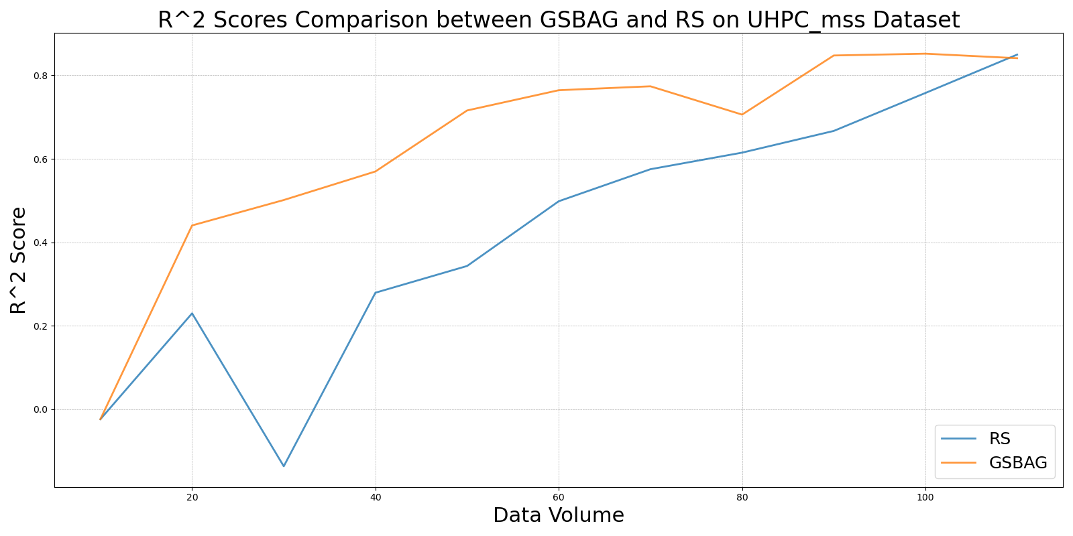

GSx_vs_RS_on_UHPC_mss.png

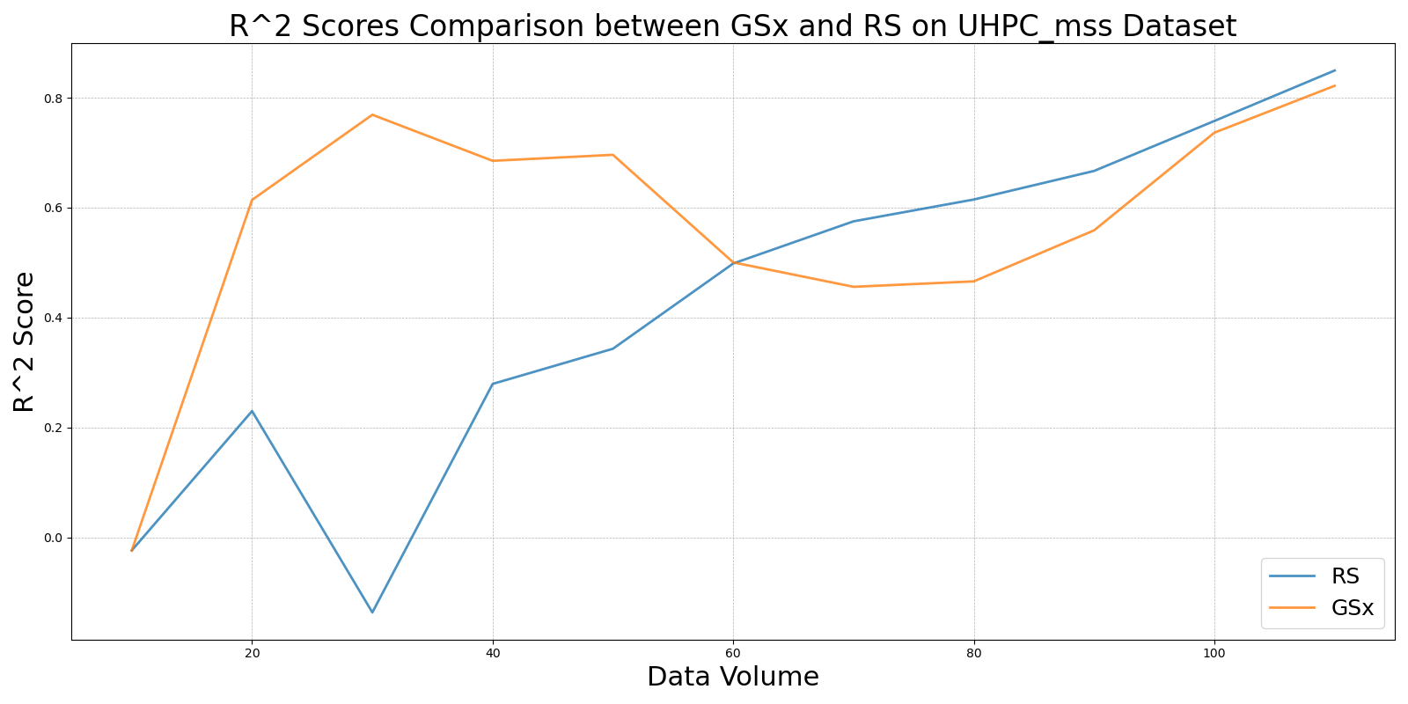

GSy_vs_RS_on_UHPC_mss.png

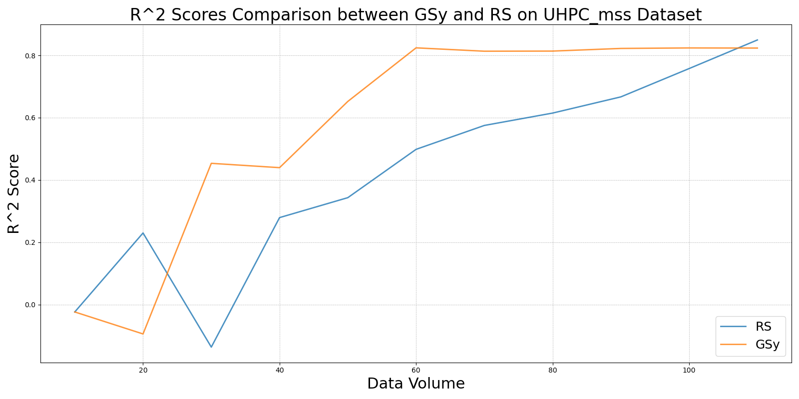

iGS_vs_RS_on_UHPC_mss.png

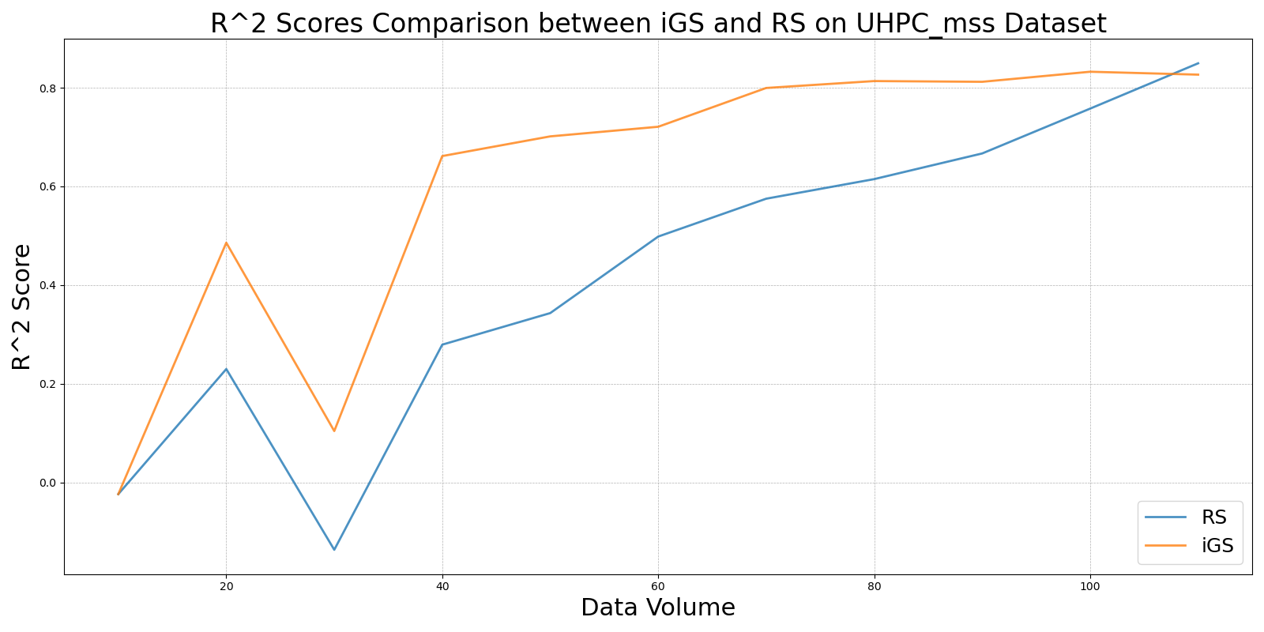

LCMD_vs_RS_on_UHPC_mss.png

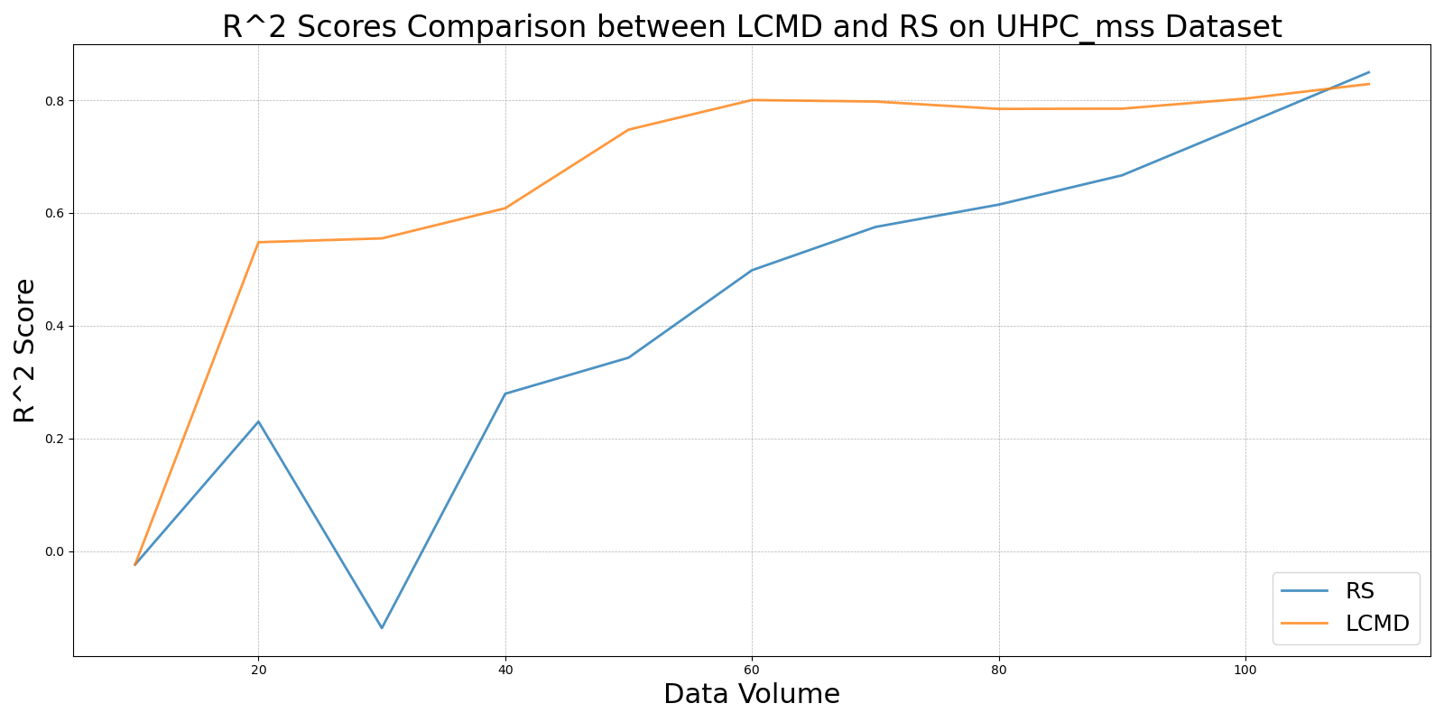

LL4AL_vs_RS_on_UHPC_mss.png

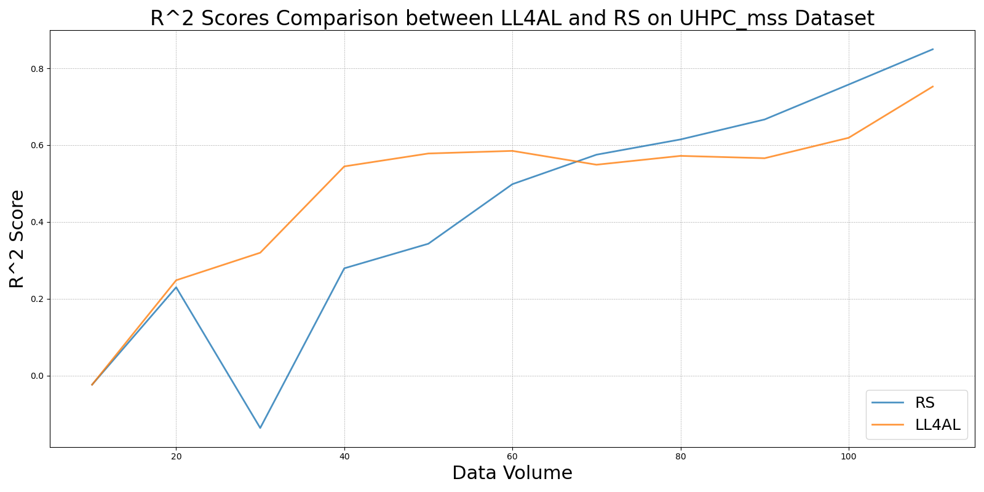

MCD_vs_RS_on_UHPC_mss.png

