R2 Samples Report for 3 Thresholds

|  |  |  |  |
| --- | --- | --- | --- |
| Strategy | R2 >= 0.6 | R2 >= 0.7 | R2 >= 0.8 |
| RS | 30 (36.41%) | 60 (72.82%) | N/A |
| LL4AL | 40 (48.54%) | 50 (60.68%) | 60 (72.82%) |
| LCMD | 20 (24.27%) | 30 (36.41%) | 50 (60.68%) |
| MCD | 30 (36.41%) | 30 (36.41%) | 50 (60.68%) |
| EGAL | 30 (36.41%) | 40 (48.54%) | 50 (60.68%) |
| BayesianAL | 30 (36.41%) | 70 (84.95%) | 70 (84.95%) |
| GSx | 40 (48.54%) | 50 (60.68%) | 50 (60.68%) |
| GSy | 30 (36.41%) | 40 (48.54%) | 70 (84.95%) |
| iGS | 30 (36.41%) | 50 (60.68%) | 70 (84.95%) |
| GSBAG | 40 (48.54%) | 40 (48.54%) | N/A |

All_Strategies_on_CST.png

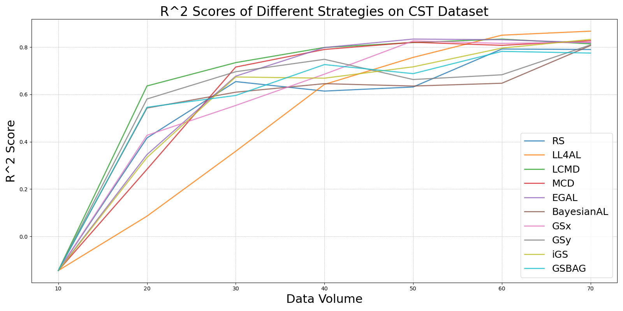

BayesianAL_vs_RS_on_CST.png

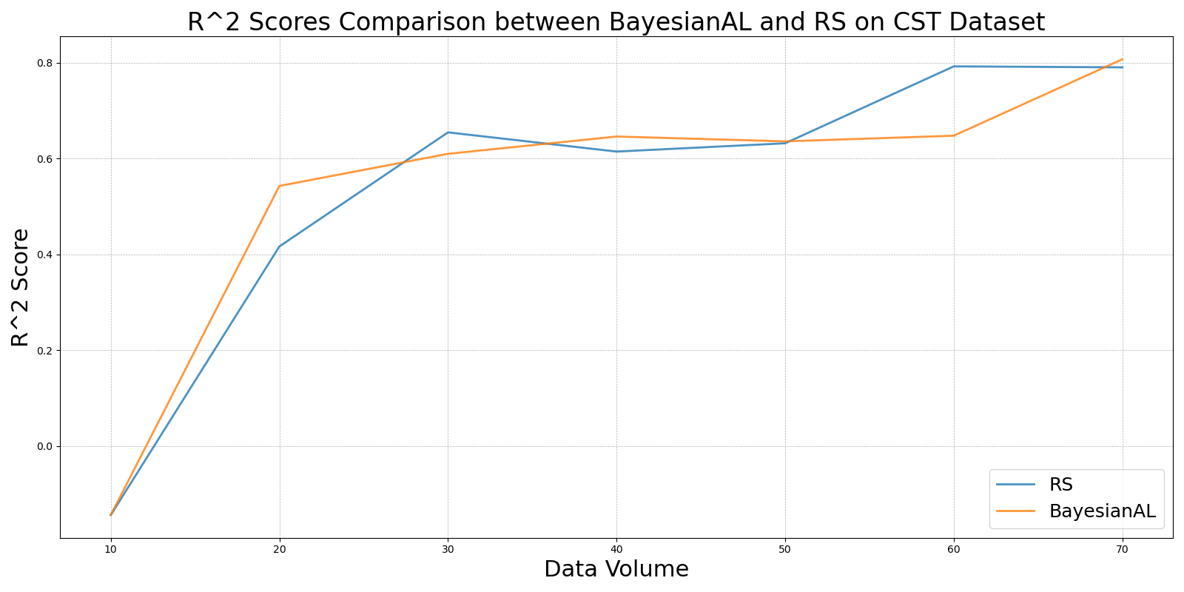

EGAL_vs_RS_on_CST.png

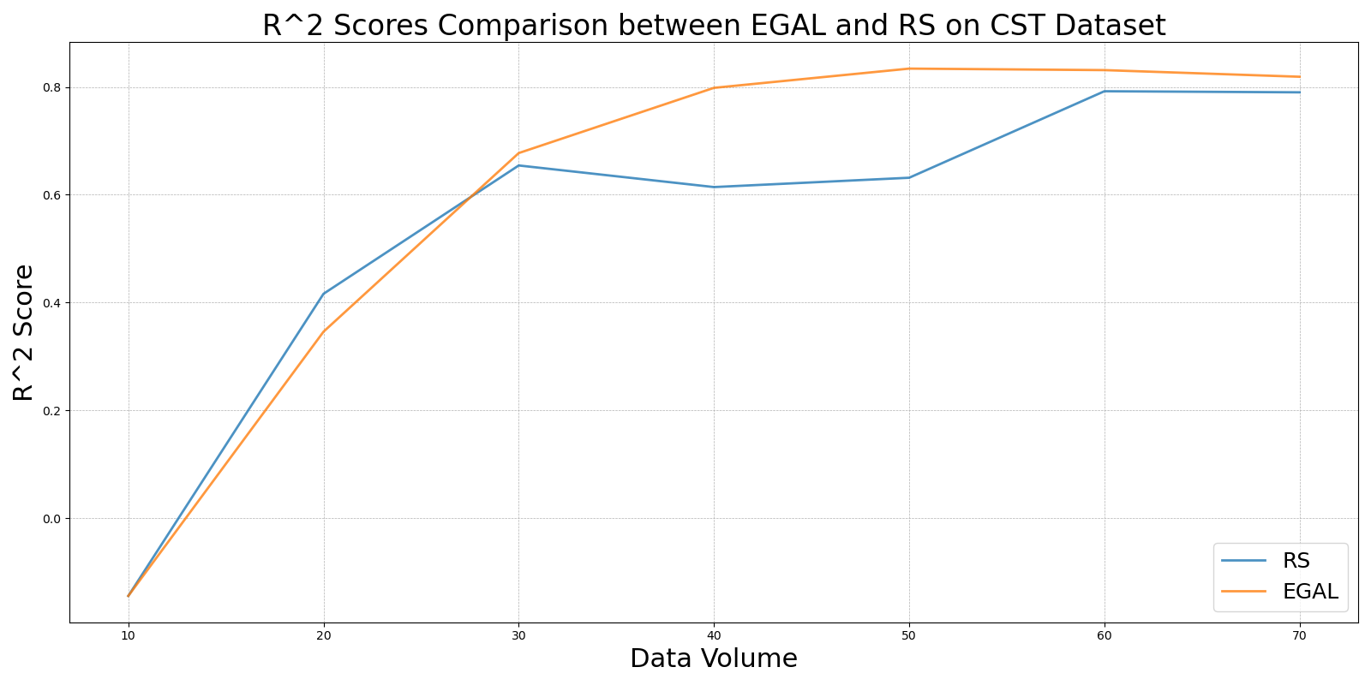

GSBAG_vs_RS_on_CST.png

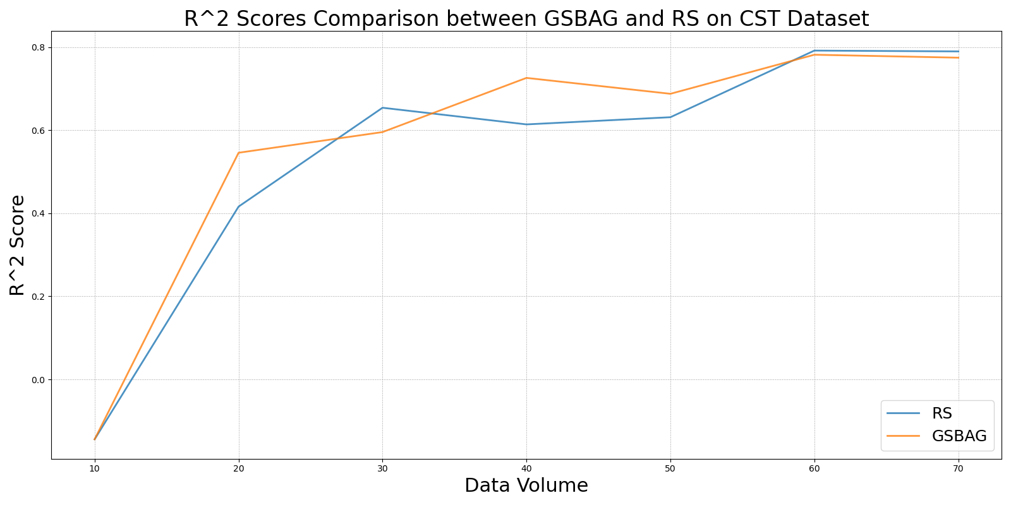

GSx_vs_RS_on_CST.png

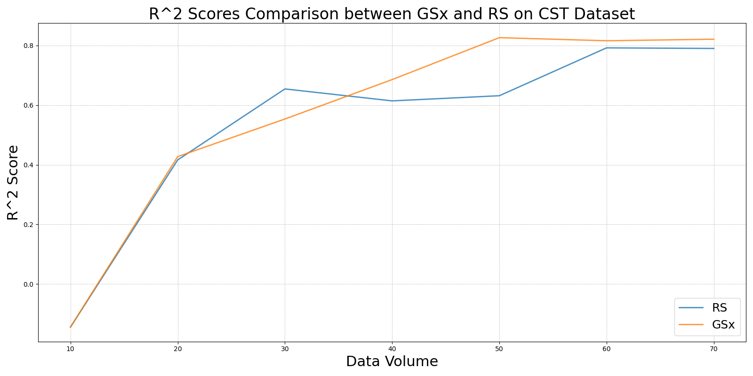

GSy_vs_RS_on_CST.png

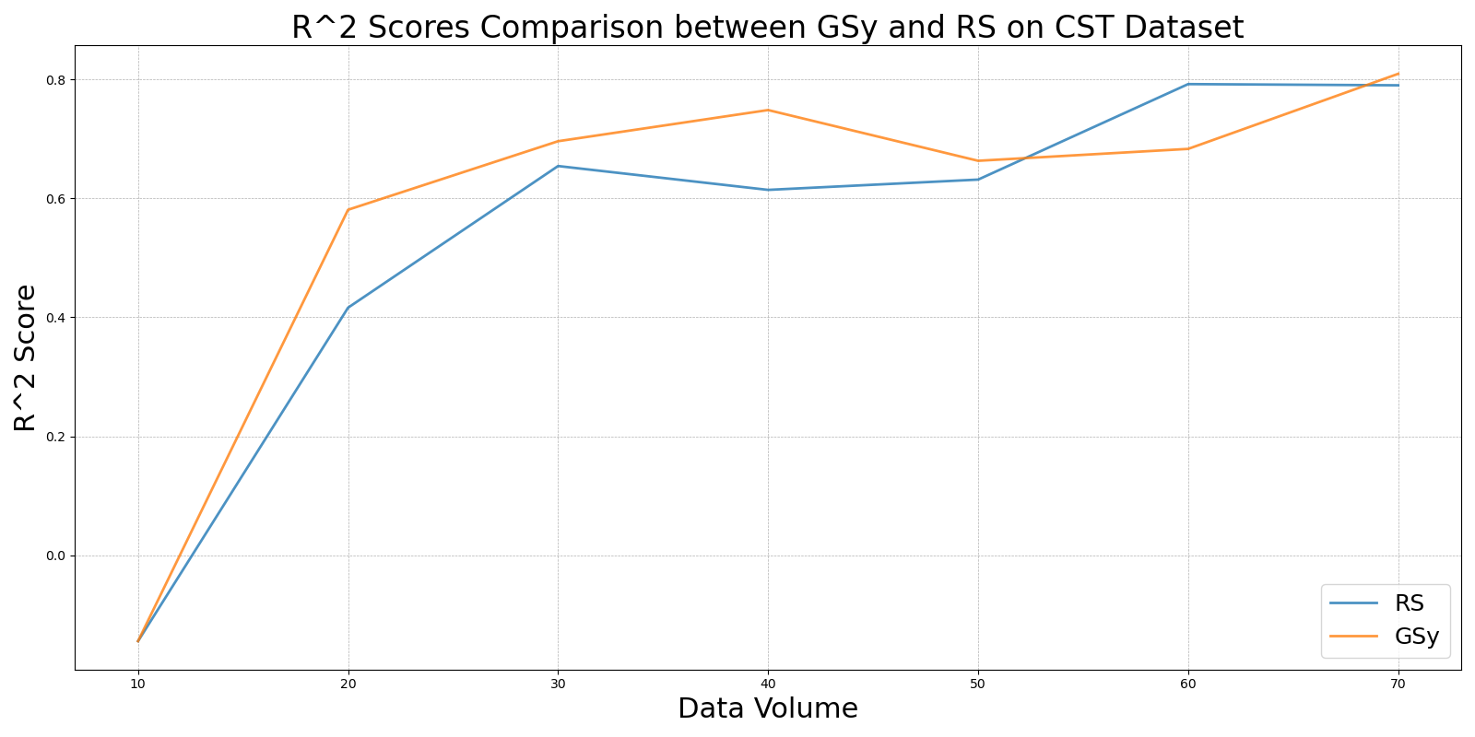

iGS_vs_RS_on_CST.png

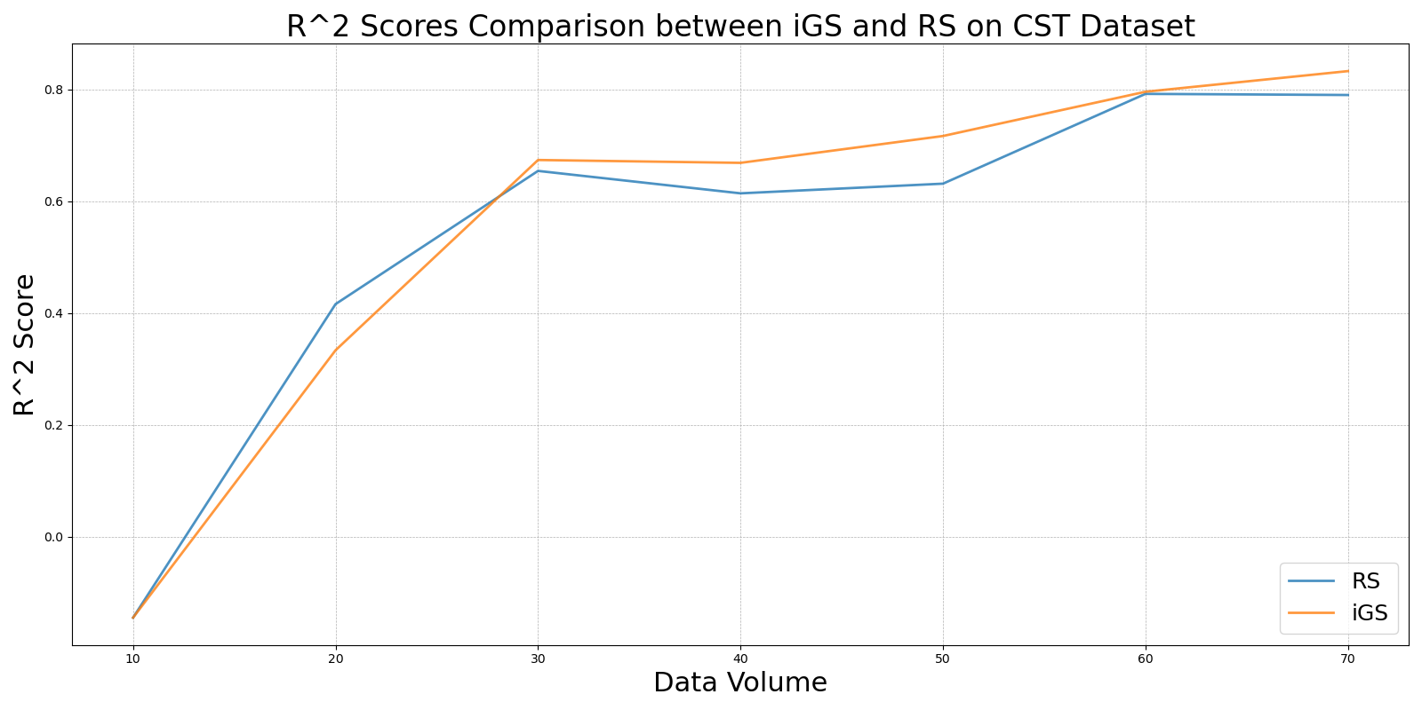

LCMD_vs_RS_on_CST.png

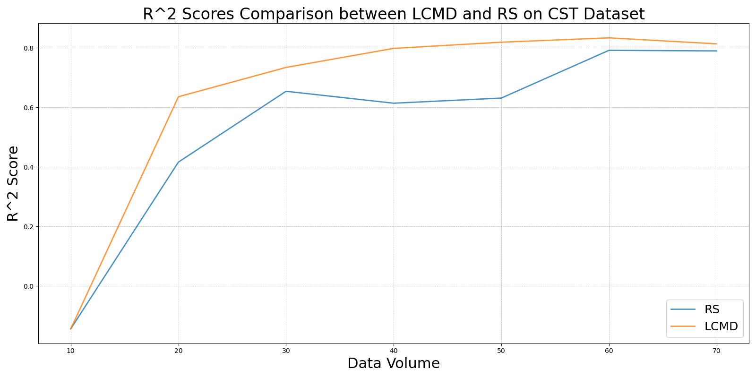

LL4AL_vs_RS_on_CST.png

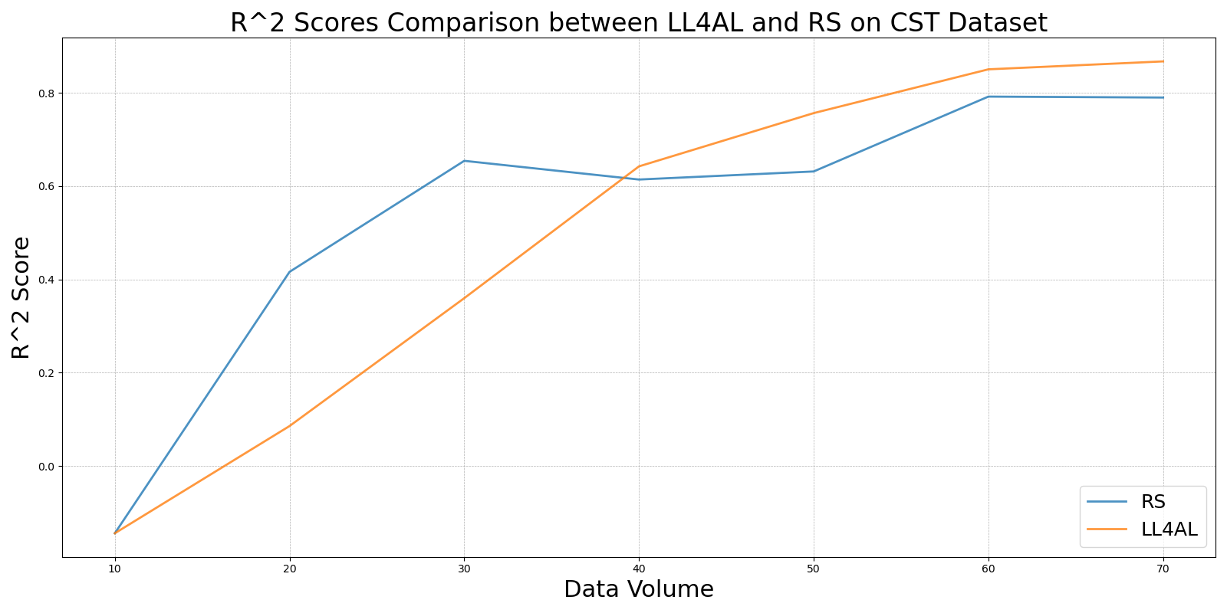

MCD_vs_RS_on_CST.png

