R2 Samples Report for 3 Thresholds

|  |  |  |  |
| --- | --- | --- | --- |
| Strategy | R2 >= 0.6 | R2 >= 0.7 | R2 >= 0.8 |
| RS | 20 (3.26%) | 40 (6.51%) | 40 (6.51%) |
| LL4AL | 20 (3.26%) | 20 (3.26%) | 20 (3.26%) |
| LCMD | 20 (3.26%) | 20 (3.26%) | 20 (3.26%) |
| MCD | 20 (3.26%) | 20 (3.26%) | 20 (3.26%) |
| EGAL | 20 (3.26%) | 20 (3.26%) | 20 (3.26%) |
| BayesianAL | 20 (3.26%) | 20 (3.26%) | 20 (3.26%) |
| GSx | 20 (3.26%) | 20 (3.26%) | 20 (3.26%) |
| GSy | 20 (3.26%) | 20 (3.26%) | 40 (6.51%) |
| iGS | 20 (3.26%) | 30 (4.88%) | 30 (4.88%) |
| GSBAG | 20 (3.26%) | 20 (3.26%) | 20 (3.26%) |

All_Strategies_on_ENB2012_HL.png

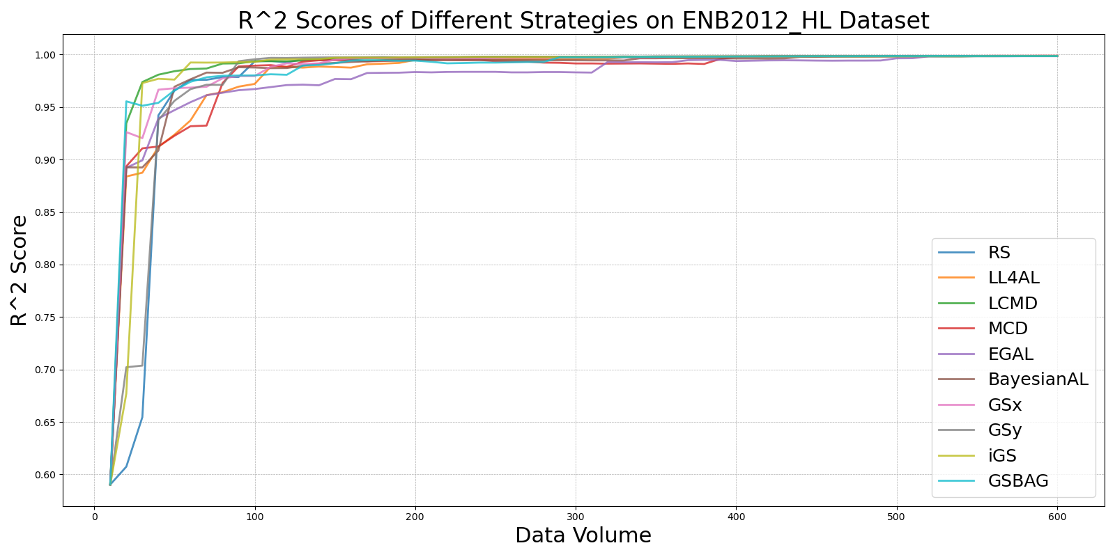

BayesianAL_vs_RS_on_ENB2012_HL.png

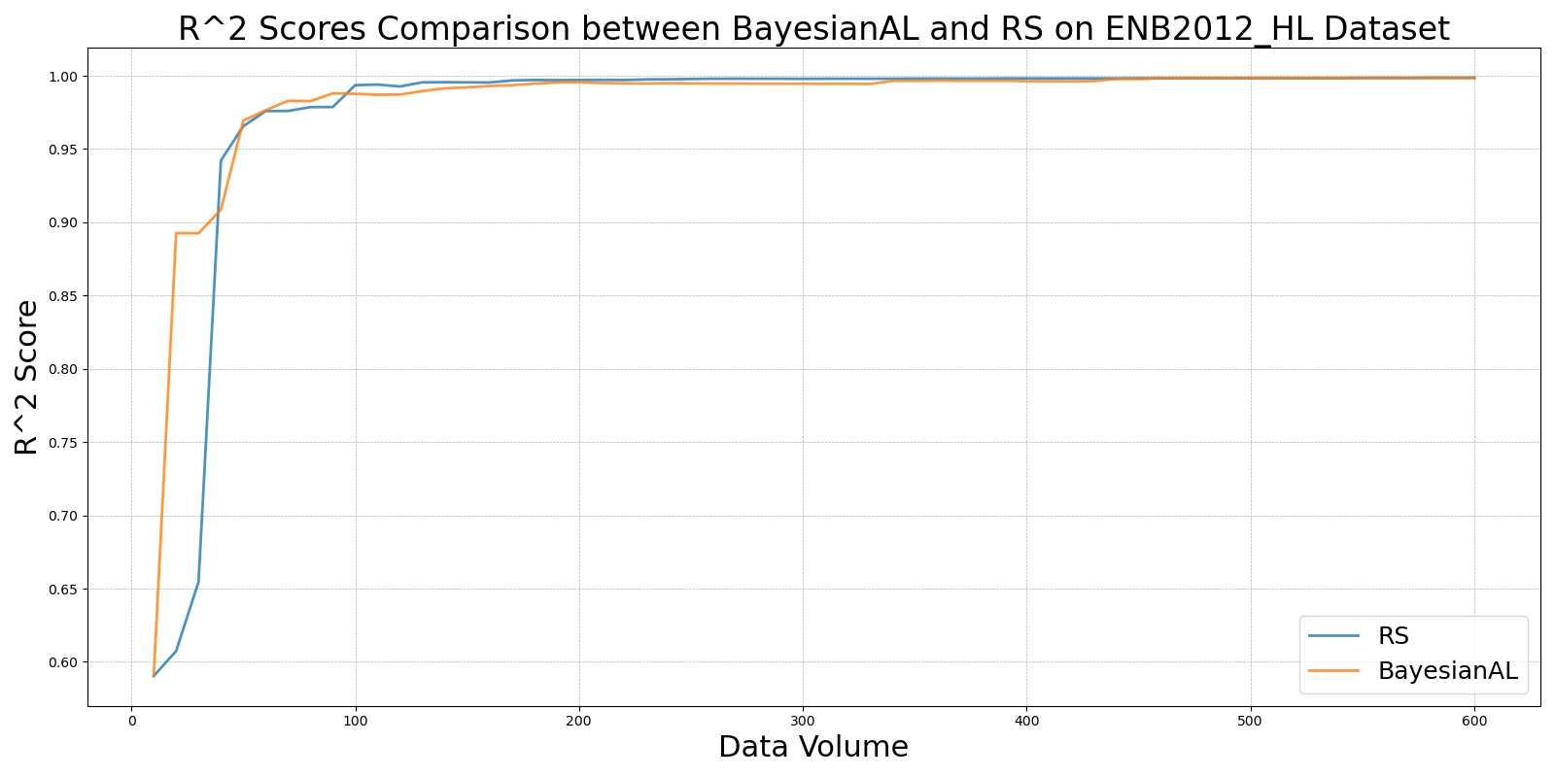

EGAL_vs_RS_on_ENB2012_HL.png

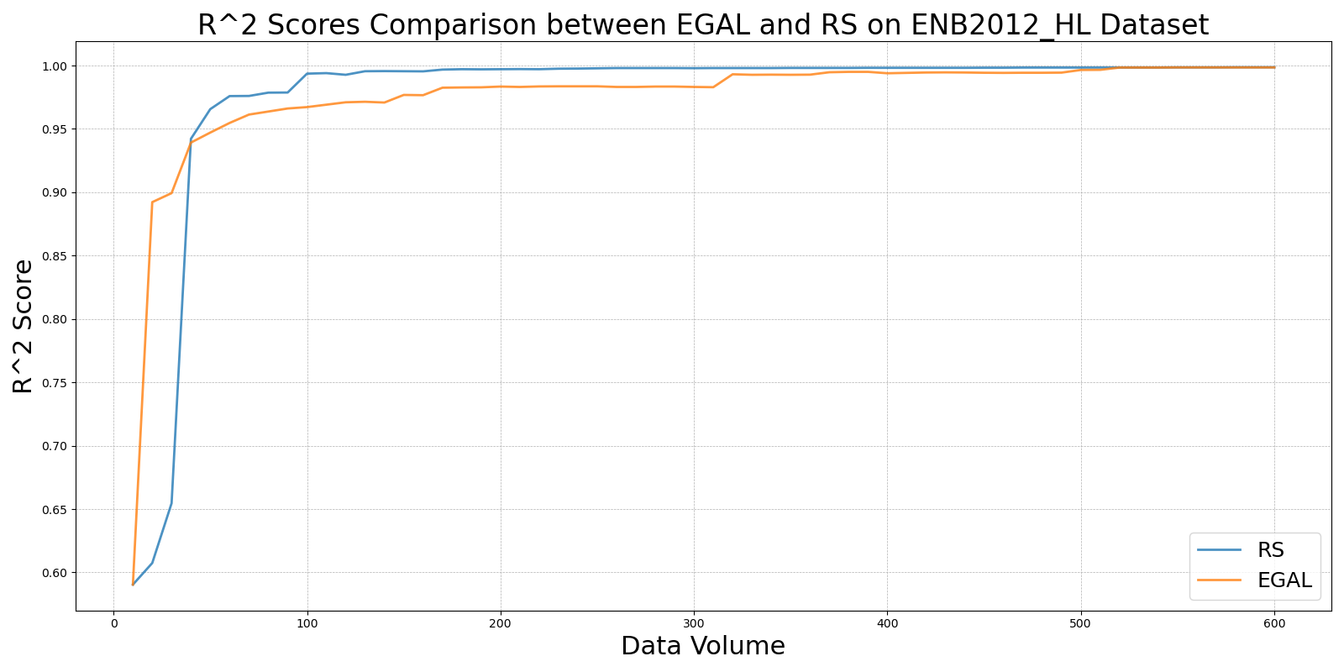

GSBAG_vs_RS_on_ENB2012_HL.png

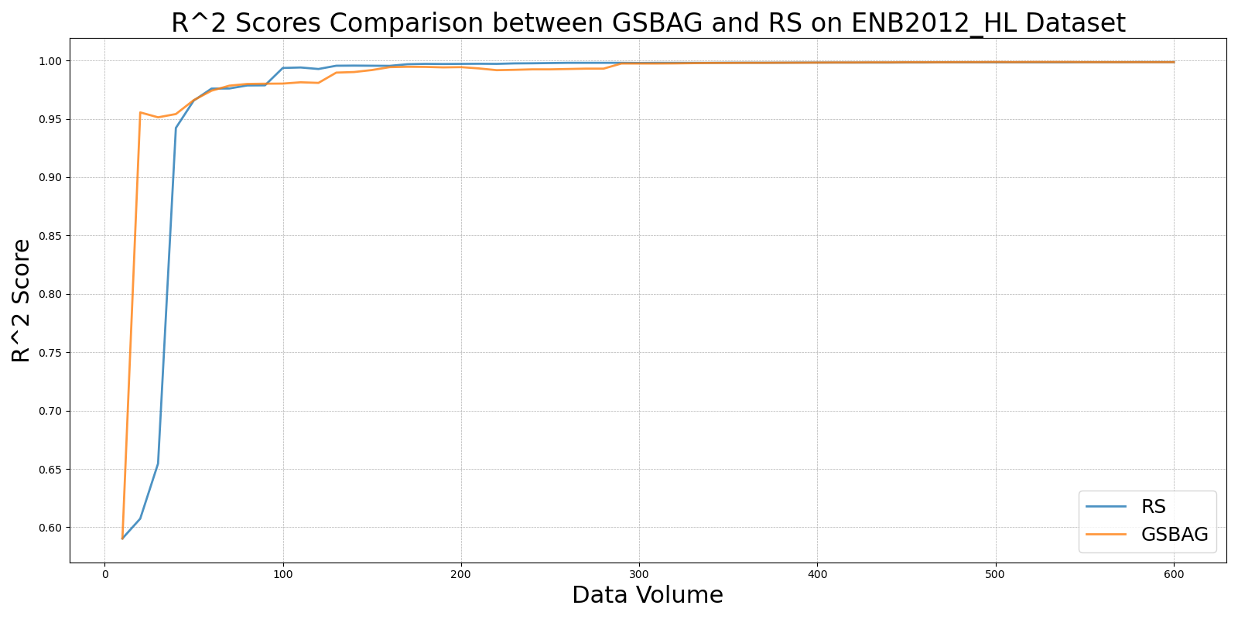

GSx_vs_RS_on_ENB2012_HL.png

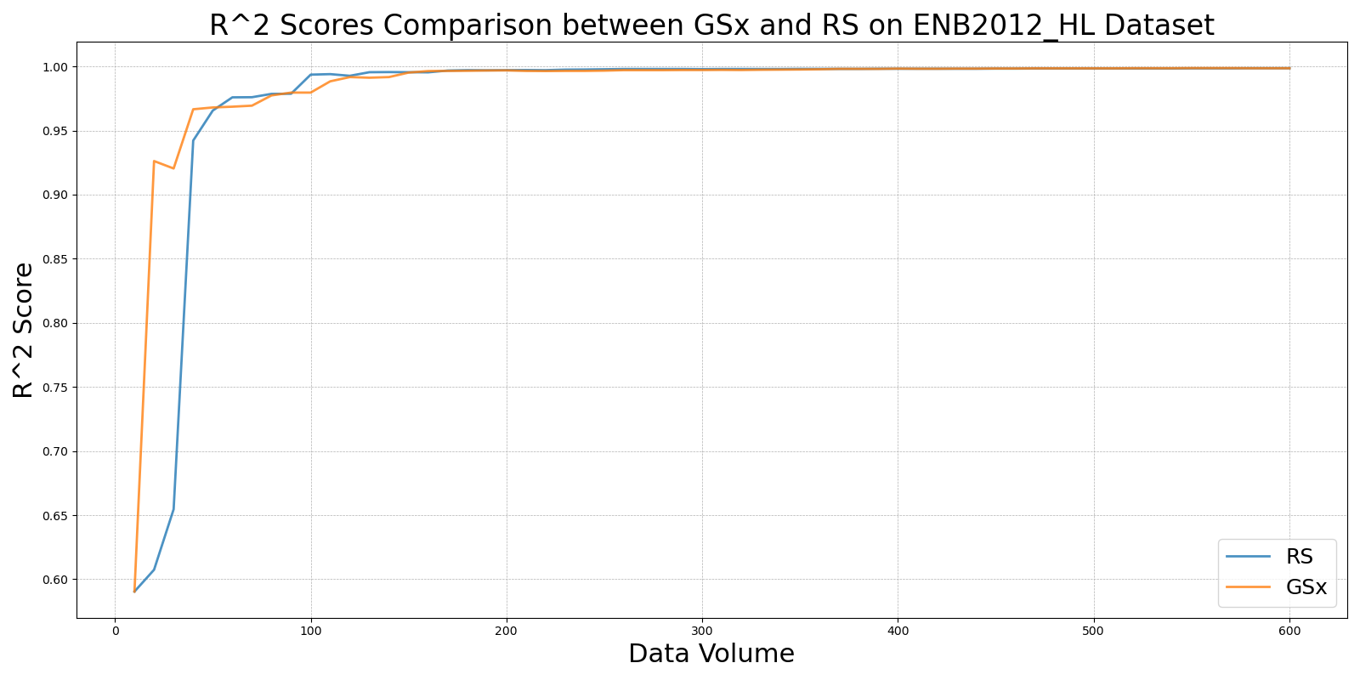

GSy_vs_RS_on_ENB2012_HL.png

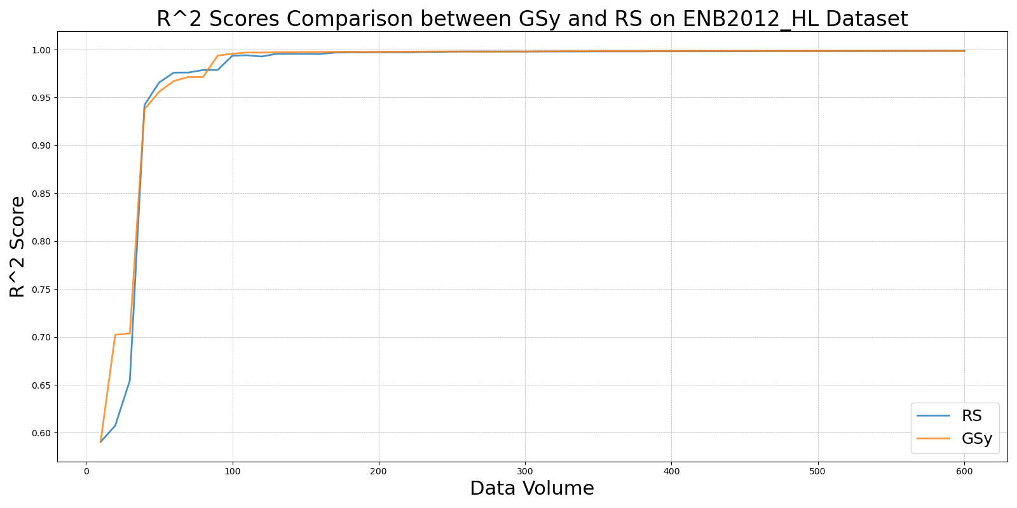

iGS_vs_RS_on_ENB2012_HL.png

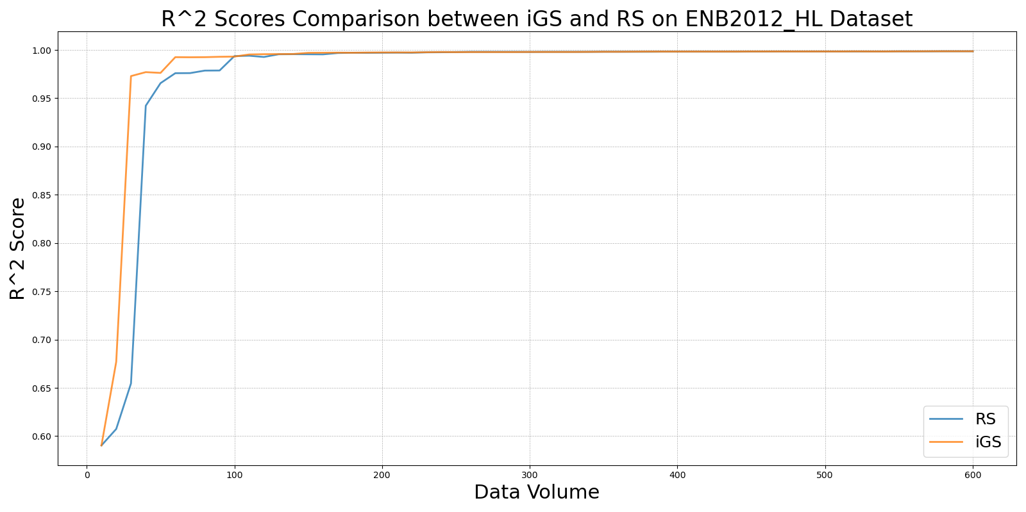

LCMD_vs_RS_on_ENB2012_HL.png

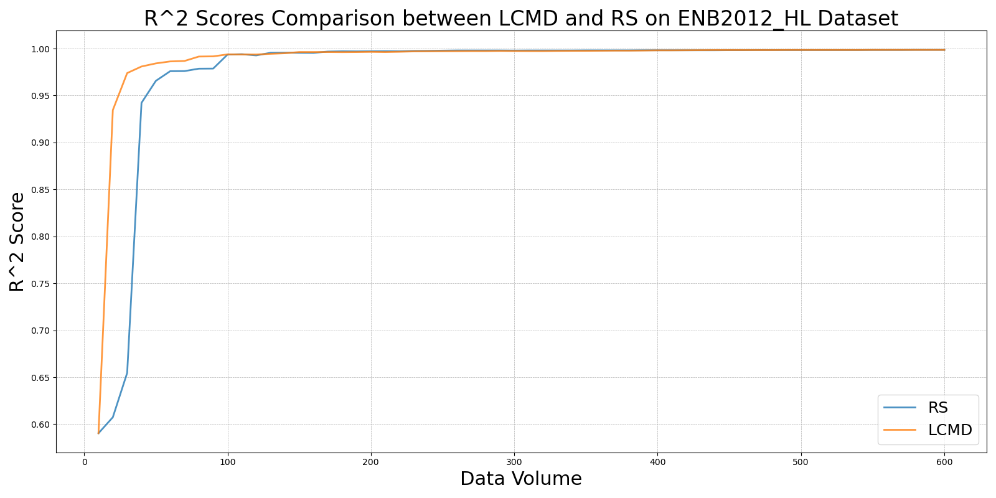

LL4AL_vs_RS_on_ENB2012_HL.png

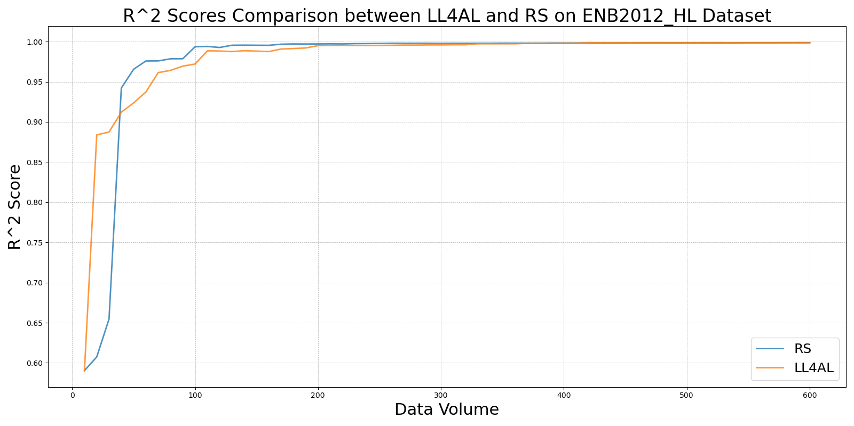

MCD_vs_RS_on_ENB2012_HL.png

