R2 Samples Report for 3 Thresholds

|  |  |  |  |
| --- | --- | --- | --- |
| Strategy | R2 >= 0.5 | R2 >= 0.7 | R2 >= 0.9 |
| RS | 40 (18.73%) | 70 (32.77%) | 170 (79.59%) |
| LL4AL | 60 (28.09%) | 120 (56.18%) | 180 (84.27%) |
| LCMD | 40 (18.73%) | 60 (28.09%) | 160 (74.91%) |
| MCD | 20 (9.36%) | 60 (28.09%) | 180 (84.27%) |
| EGAL | 40 (18.73%) | 50 (23.41%) | 170 (79.59%) |
| BayesianAL | 70 (32.77%) | 100 (46.82%) | N/A |
| GSx | 100 (46.82%) | 100 (46.82%) | 170 (79.59%) |
| GSy | 50 (23.41%) | 70 (32.77%) | 200 (93.63%) |
| GSi | 30 (14.04%) | 50 (23.41%) | 140 (65.54%) |
| GSBAG | 60 (28.09%) | 70 (32.77%) | 140 (65.54%) |

All_Strategies_on_BFRC_cs.png

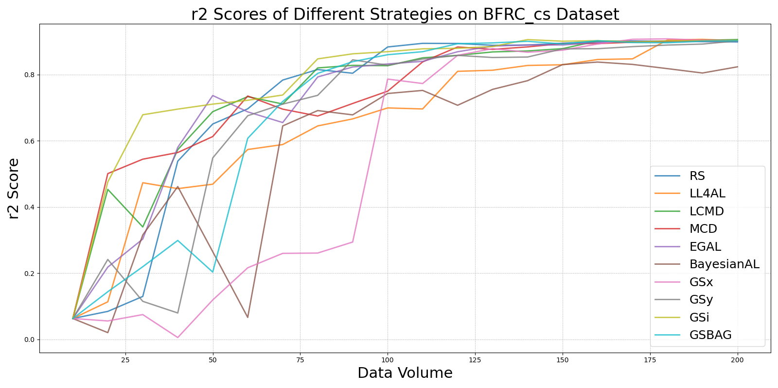

BayesianALvs_RS_on_BFRC_cs.png

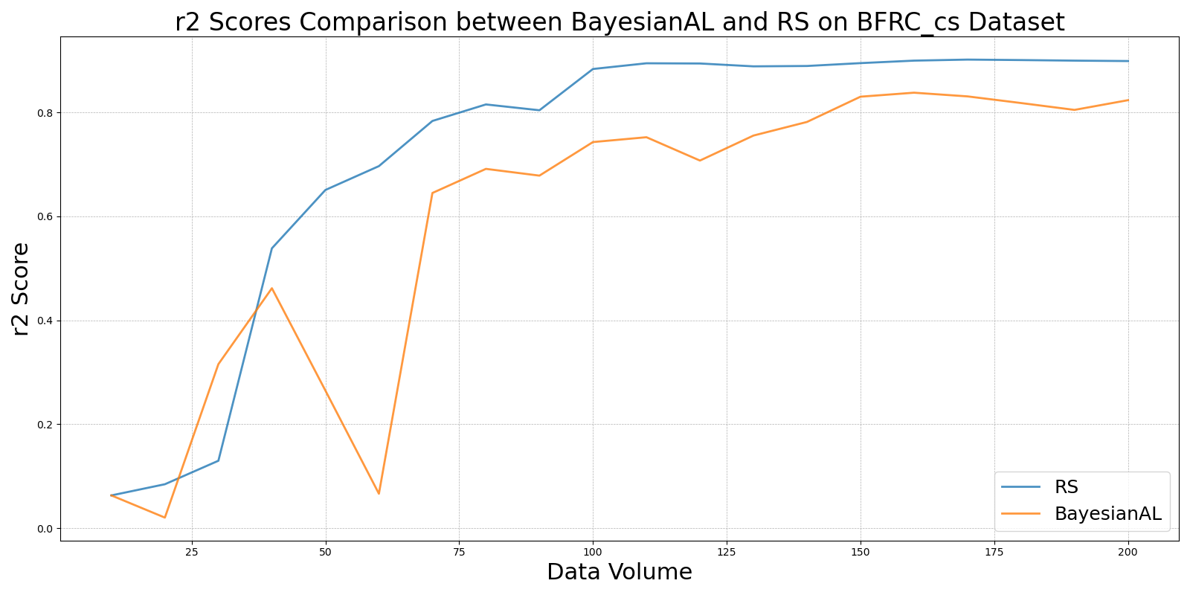

EGALvs_RS_on_BFRC_cs.png

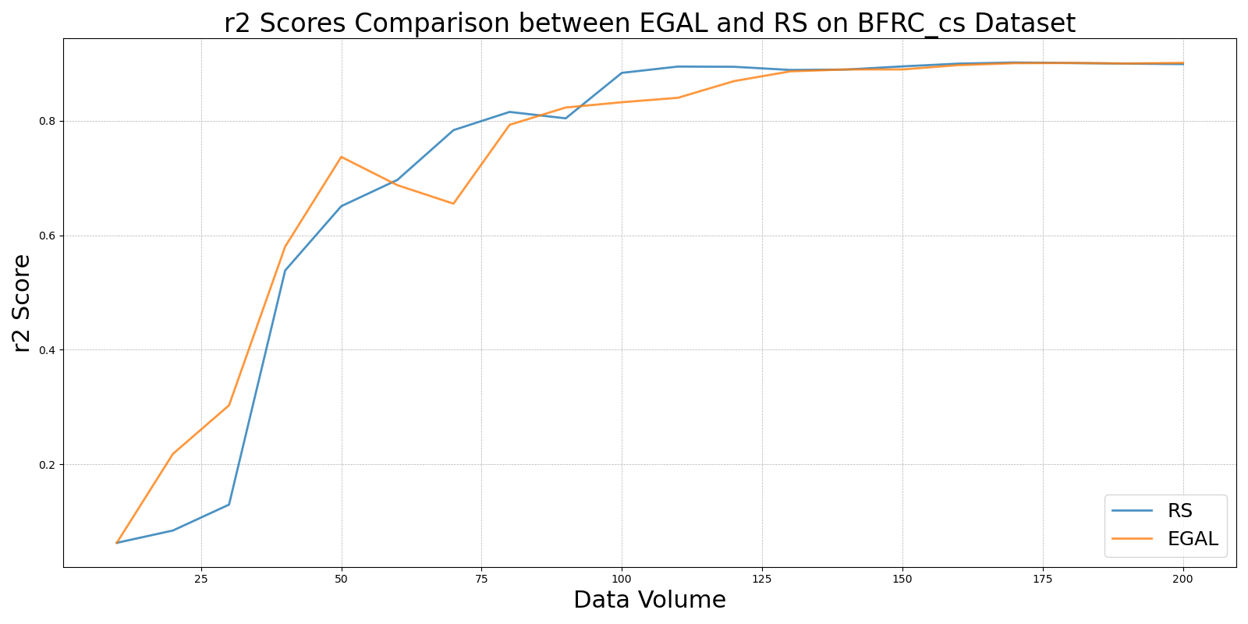

GSBAGvs_RS_on_BFRC_cs.png

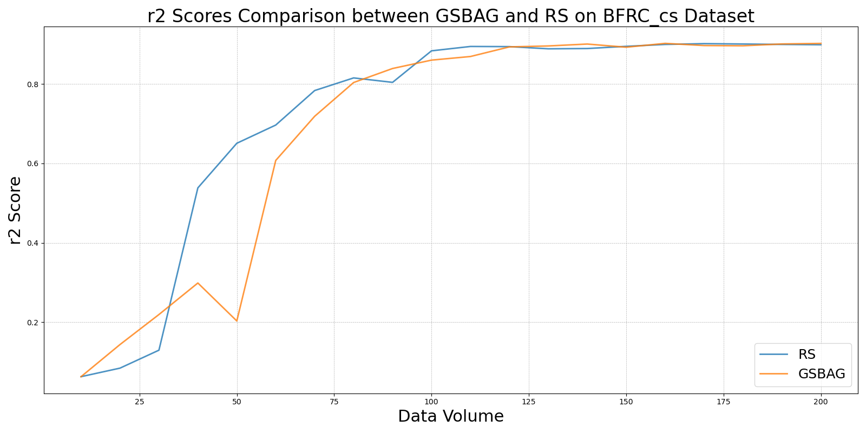

GSivs_RS_on_BFRC_cs.png

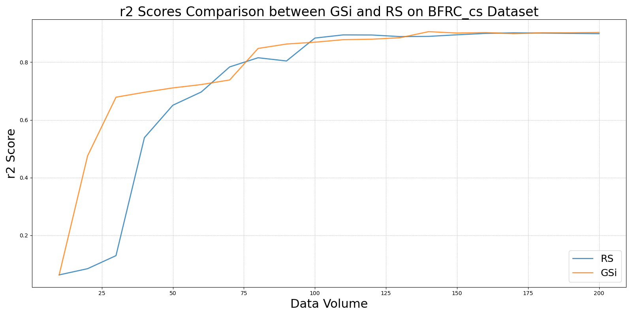

GSxvs_RS_on_BFRC_cs.png

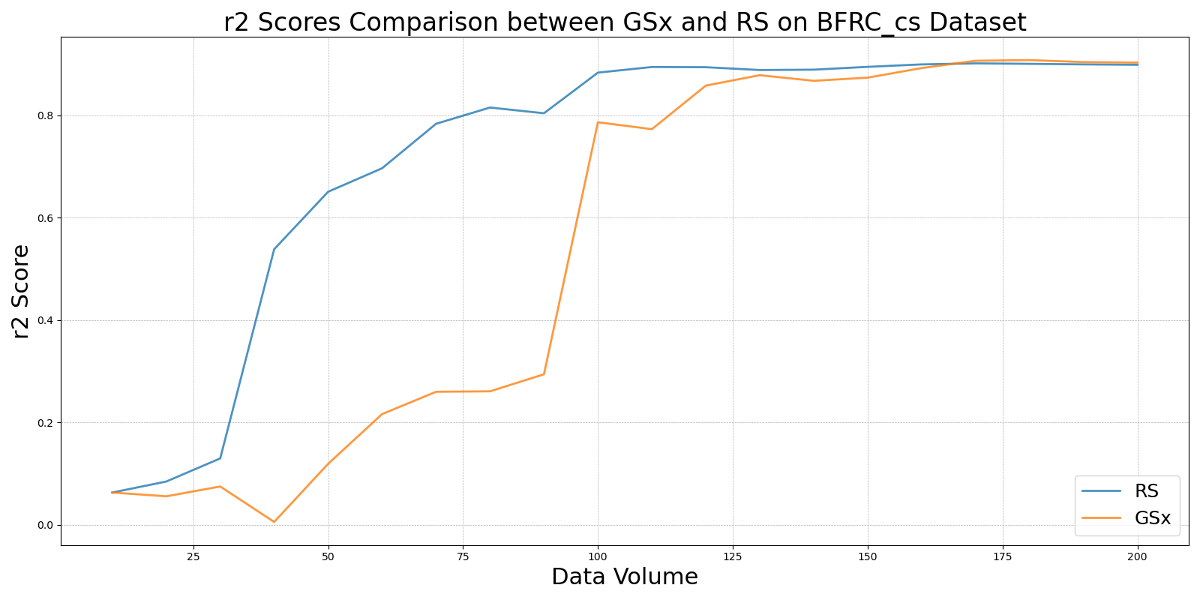

GSyvs_RS_on_BFRC_cs.png

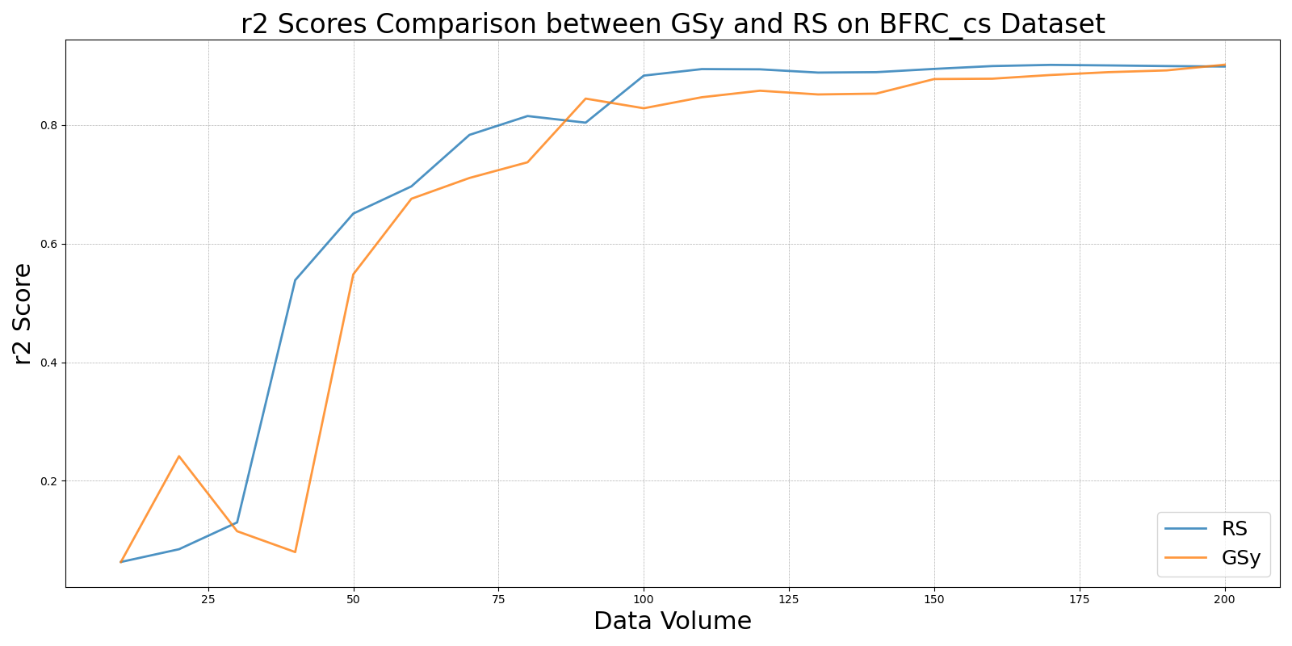

LCMDvs_RS_on_BFRC_cs.png

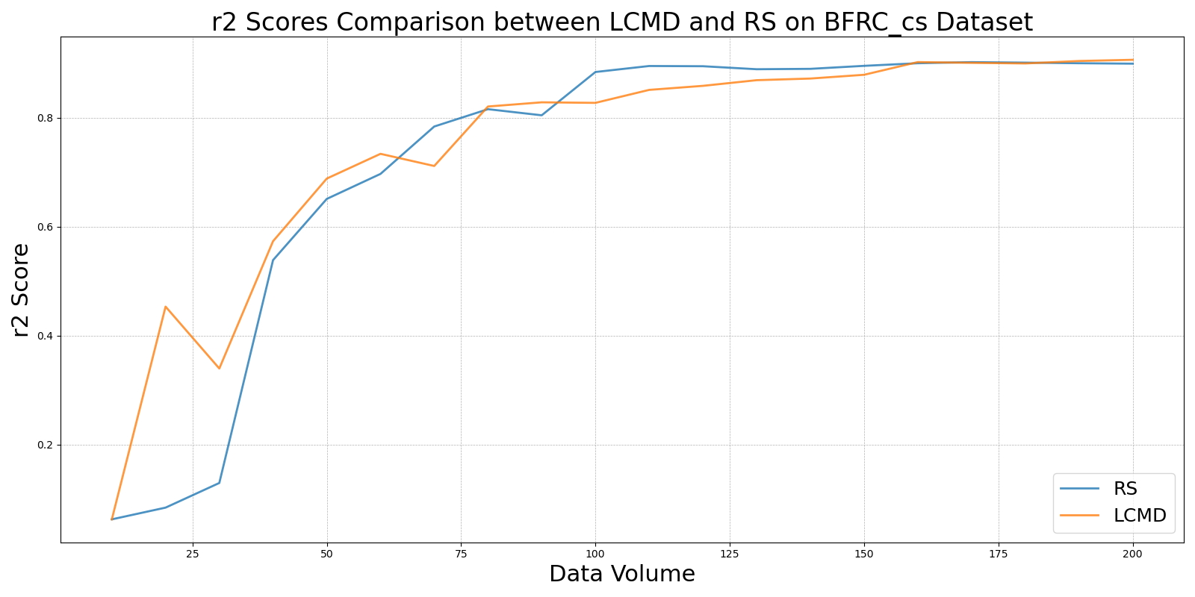

LL4ALvs_RS_on_BFRC_cs.png

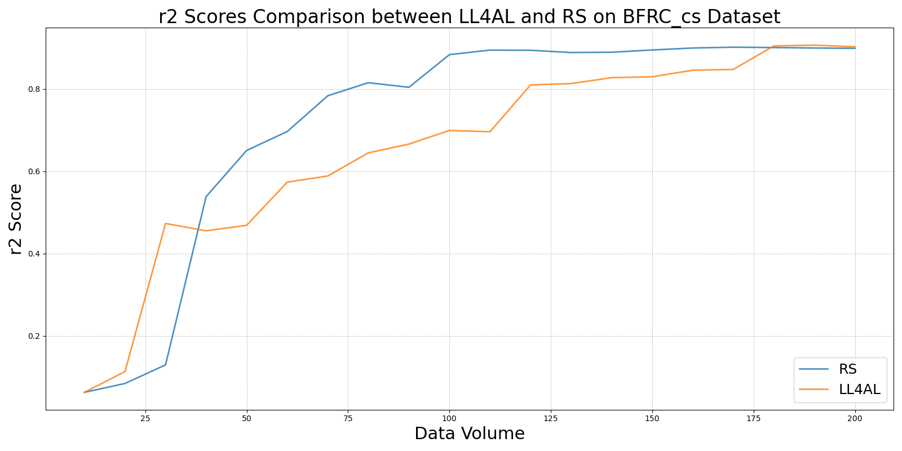

MCDvs_RS_on_BFRC_cs.png

