R2 Samples Report for 3 Thresholds

|  |  |  |  |
| --- | --- | --- | --- |
| Strategy | R2 >= 0.5 | R2 >= 0.7 | R2 >= 0.9 |
| RS | 30 (15.31%) | 60 (30.61%) | 90 (45.92%) |
| LL4AL | 60 (30.61%) | 100 (51.02%) | N/A |
| LCMD | 20 (10.20%) | 40 (20.41%) | 90 (45.92%) |
| MCD | 20 (10.20%) | 60 (30.61%) | 170 (86.73%) |
| EGAL | 40 (20.41%) | 60 (30.61%) | 100 (51.02%) |
| BayesianAL | 20 (10.20%) | 110 (56.12%) | 120 (61.22%) |
| GSx | 80 (40.82%) | 80 (40.82%) | 130 (66.33%) |
| GSy | 30 (15.31%) | 30 (15.31%) | 110 (56.12%) |
| GSi | 20 (10.20%) | 30 (15.31%) | 80 (40.82%) |
| GSBAG | 60 (30.61%) | 70 (35.71%) | 90 (45.92%) |

All_Strategies_on_BFRC_fs.png

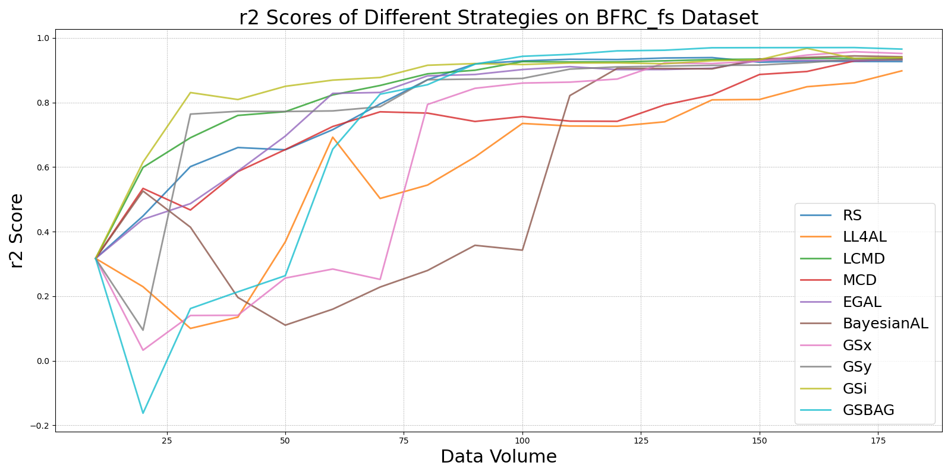

BayesianALvs_RS_on_BFRC_fs.png

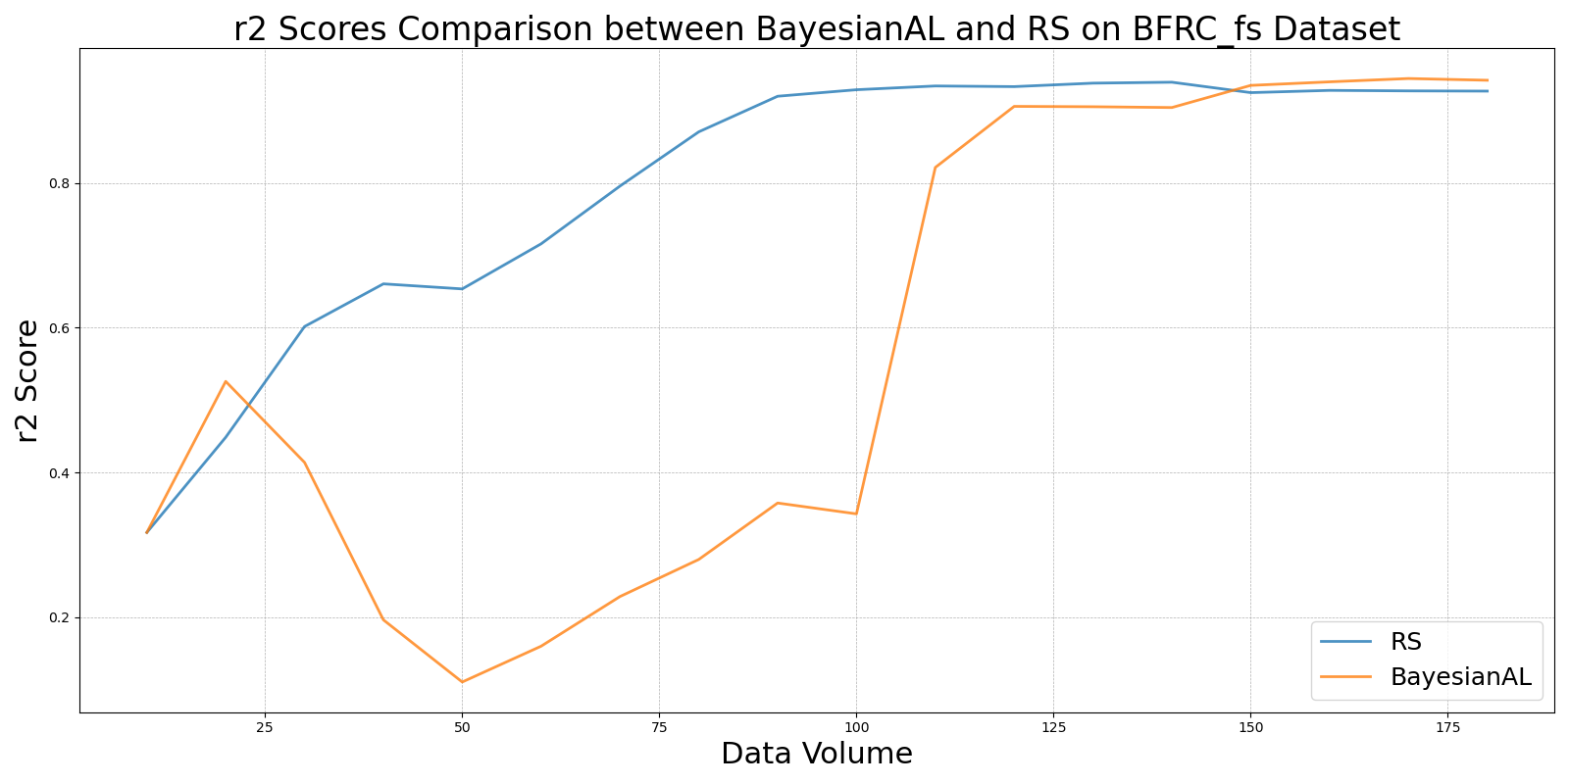

EGALvs_RS_on_BFRC_fs.png

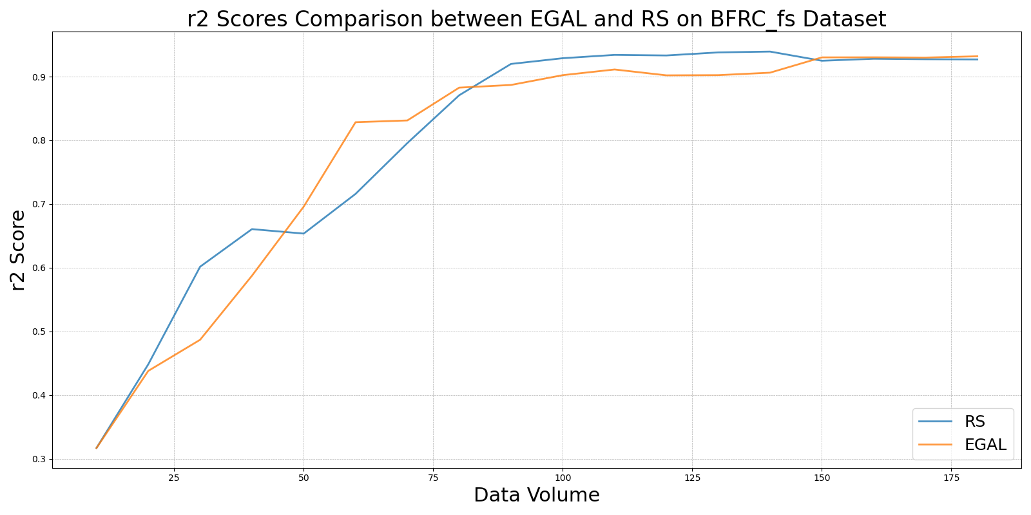

GSBAGvs_RS_on_BFRC_fs.png

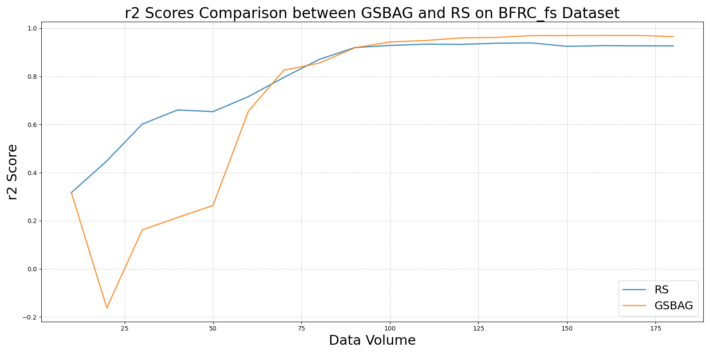

GSivs_RS_on_BFRC_fs.png

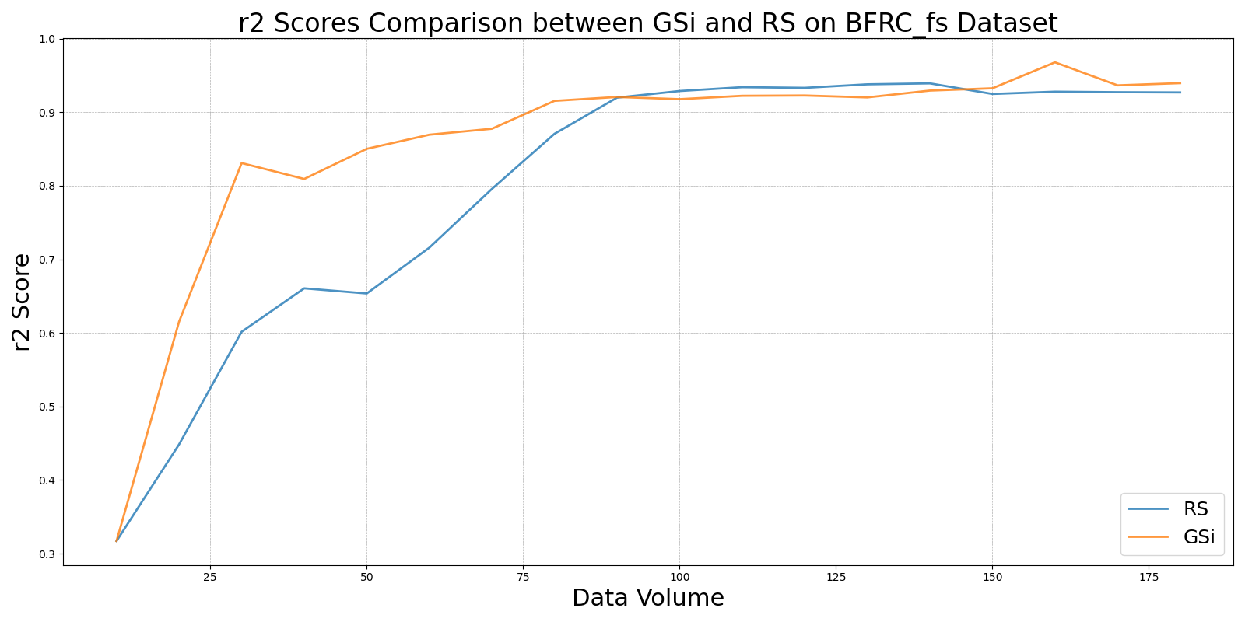

GSxvs_RS_on_BFRC_fs.png

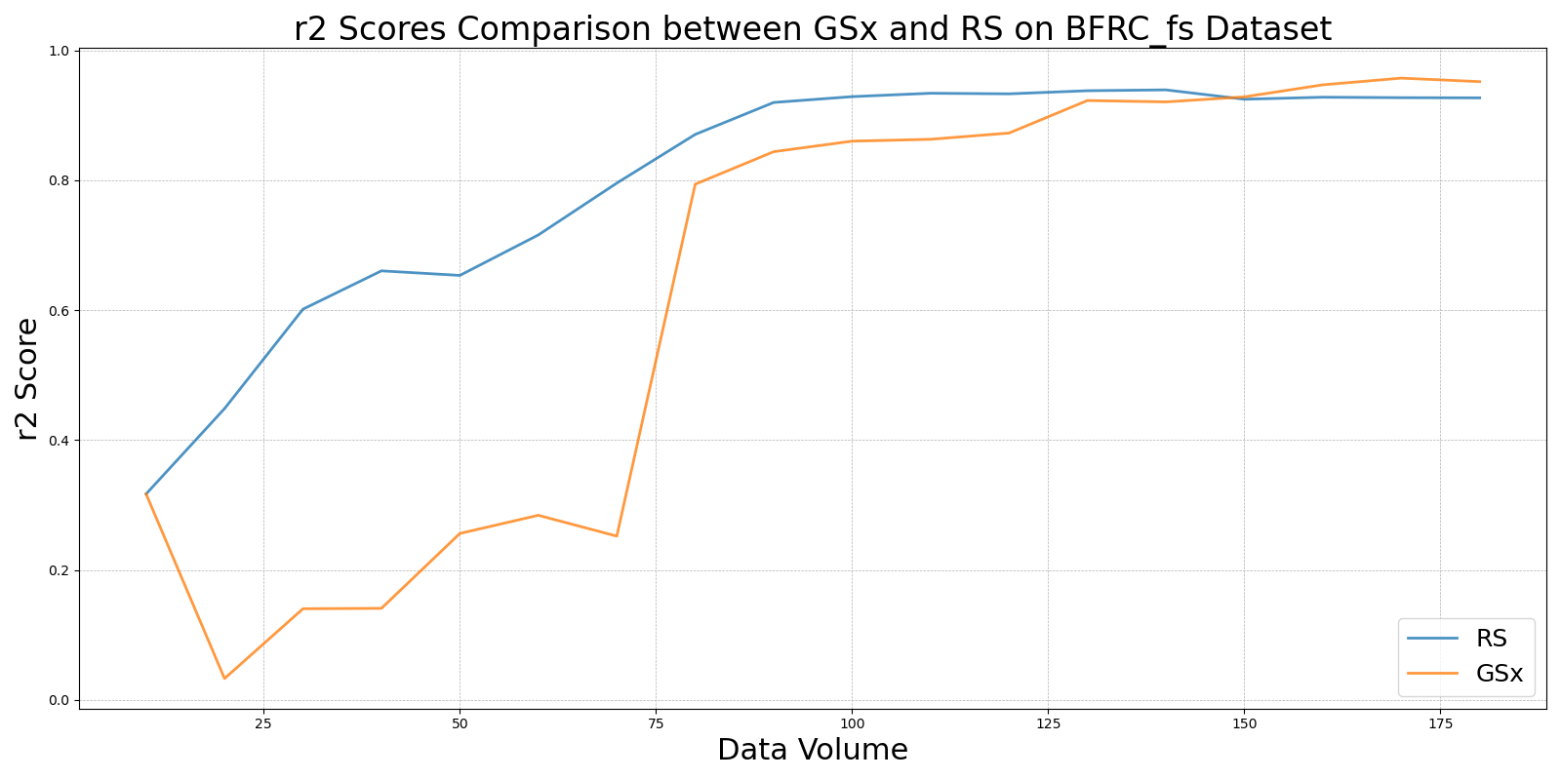

GSyvs_RS_on_BFRC_fs.png

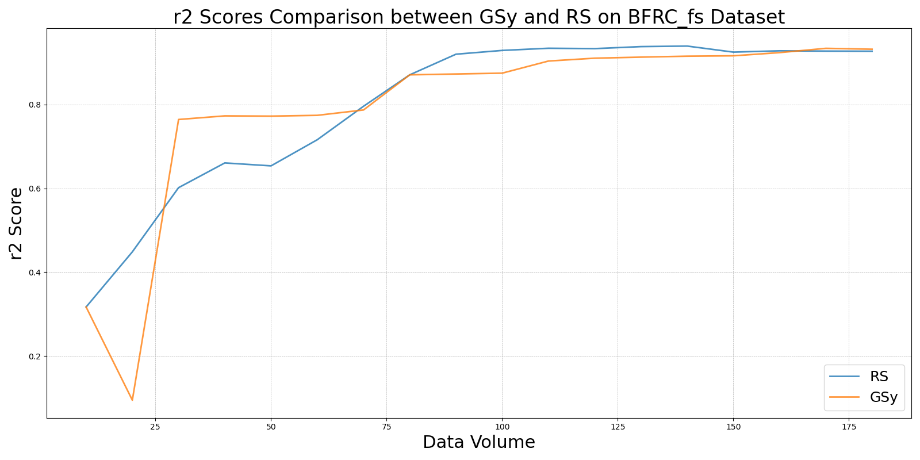

LCMDvs_RS_on_BFRC_fs.png

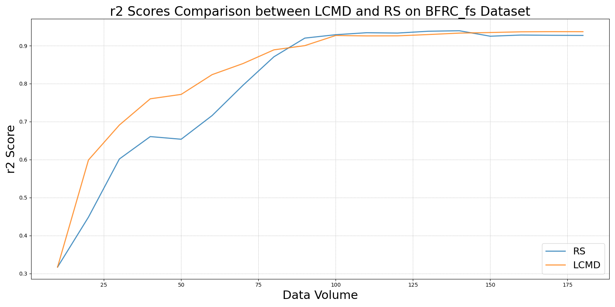

LL4ALvs_RS_on_BFRC_fs.png

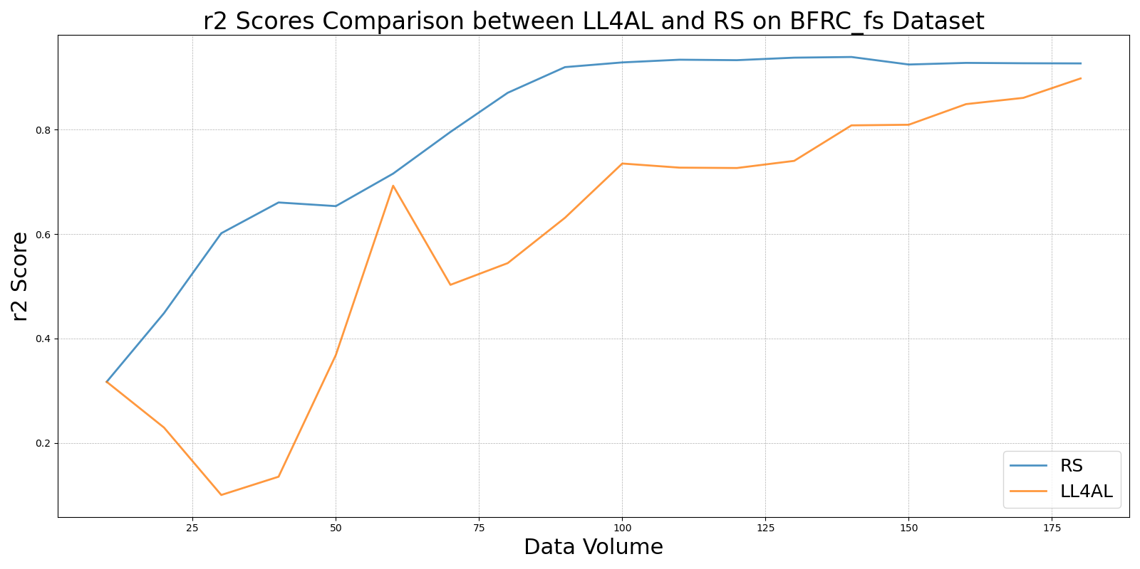

MCDvs_RS_on_BFRC_fs.png

