R2 Samples Report for 3 Thresholds

|  |  |  |  |
| --- | --- | --- | --- |
| Strategy | R2 >= 0.5 | R2 >= 0.7 | R2 >= 0.9 |
| RS | 20 (9.36%) | 60 (28.09%) | 70 (32.77%) |
| LL4AL | 100 (46.82%) | 150 (70.22%) | 160 (74.91%) |
| LCMD | 30 (14.04%) | 40 (18.73%) | 80 (37.45%) |
| MCD | 50 (23.41%) | 60 (28.09%) | 90 (42.13%) |
| EGAL | 30 (14.04%) | 40 (18.73%) | 60 (28.09%) |
| BayesianAL | 130 (60.86%) | 150 (70.22%) | 170 (79.59%) |
| GSx | 80 (37.45%) | 80 (37.45%) | 110 (51.50%) |
| GSy | 30 (14.04%) | 40 (18.73%) | 70 (32.77%) |
| GSi | 20 (9.36%) | 30 (14.04%) | 70 (32.77%) |
| GSBAG | 60 (28.09%) | 60 (28.09%) | 100 (46.82%) |

All_Strategies_on_BFRC_sts.png

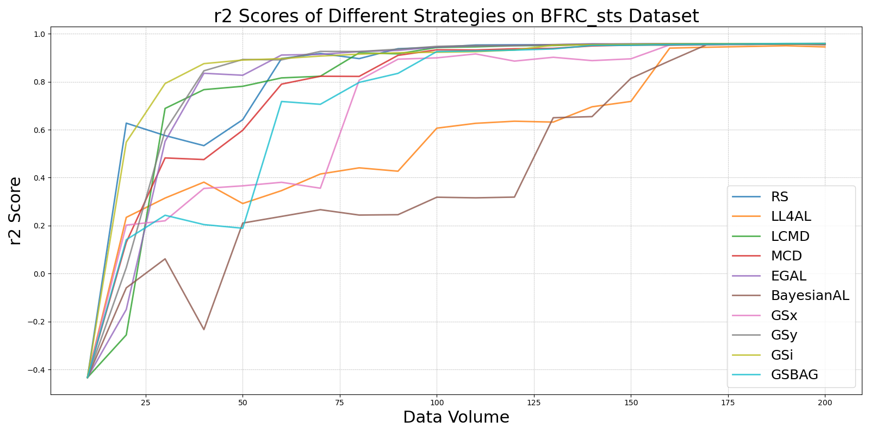

BayesianALvs_RS_on_BFRC_sts.png

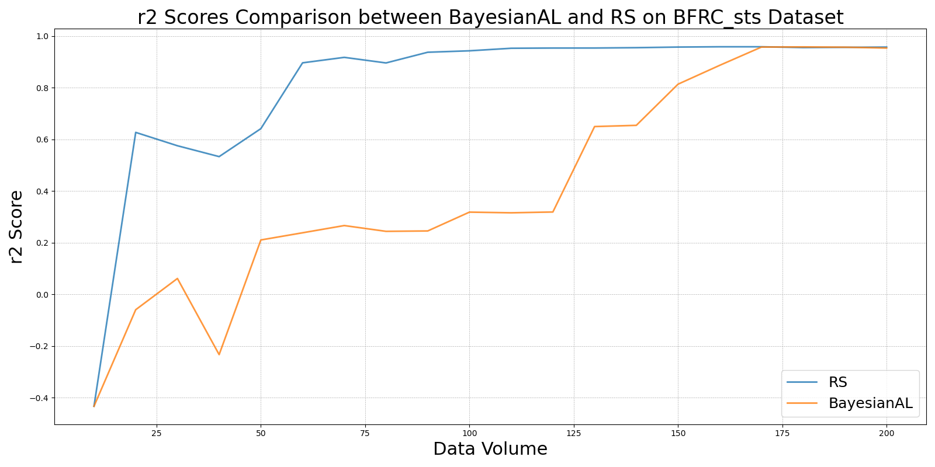

EGALvs_RS_on_BFRC_sts.png

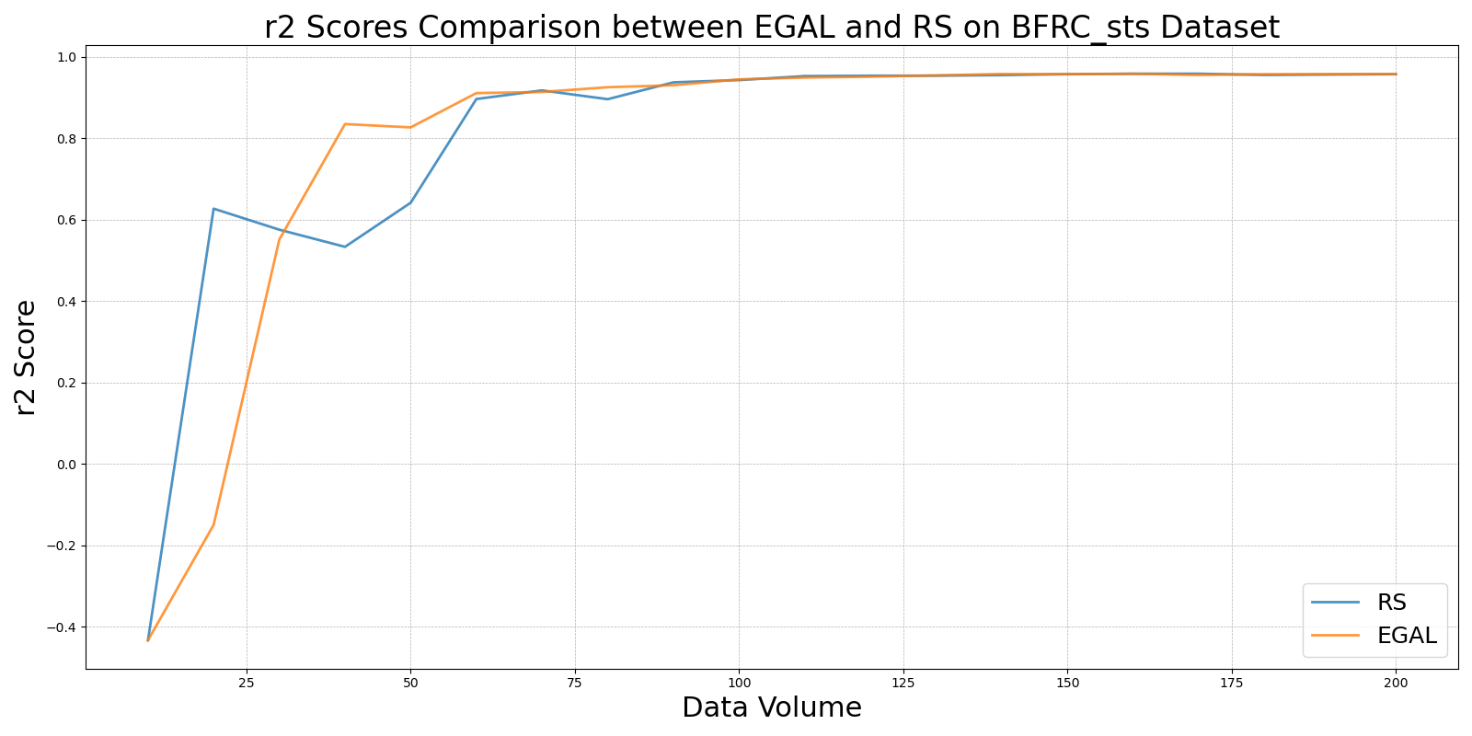

GSBAGvs_RS_on_BFRC_sts.png

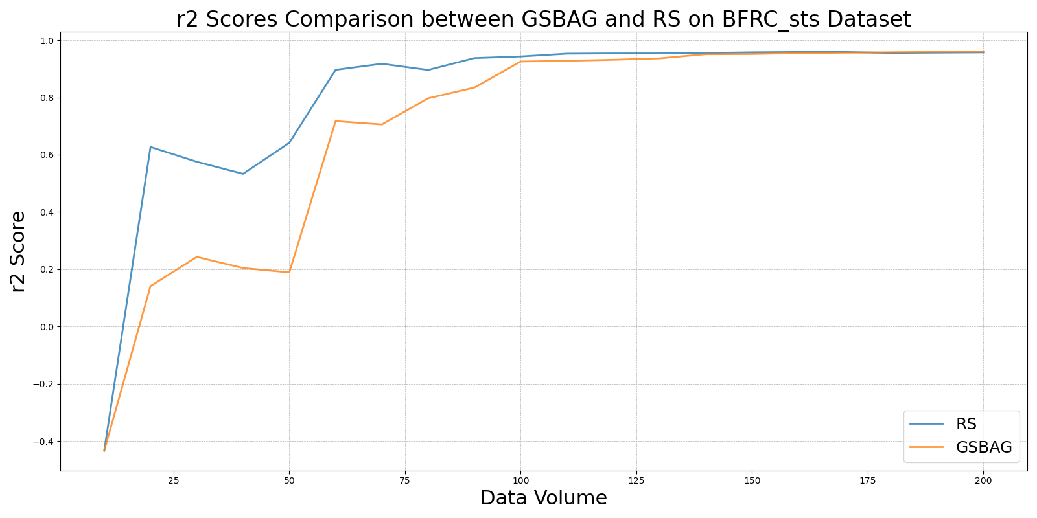

GSivs_RS_on_BFRC_sts.png

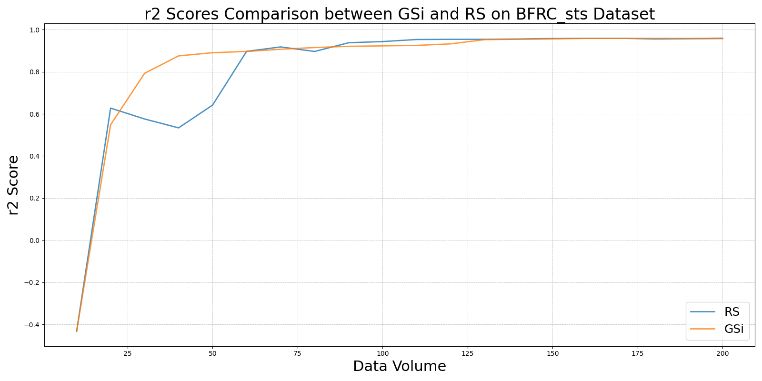

GSxvs_RS_on_BFRC_sts.png

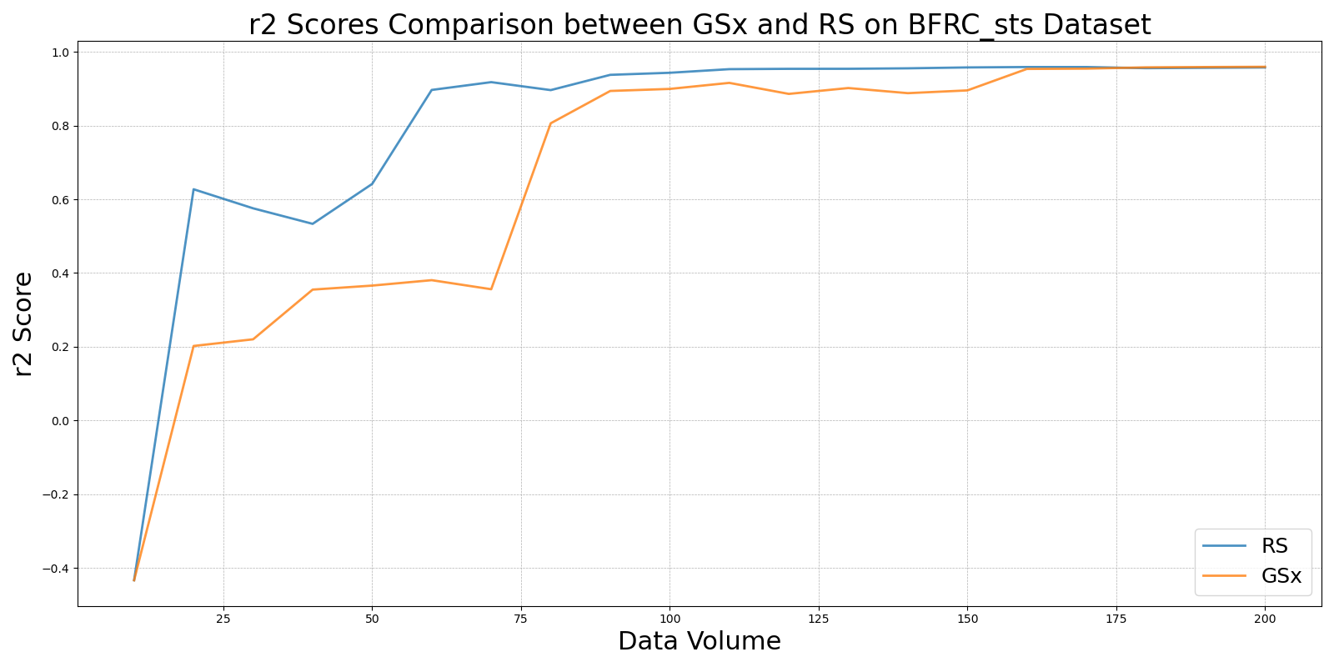

GSyvs_RS_on_BFRC_sts.png

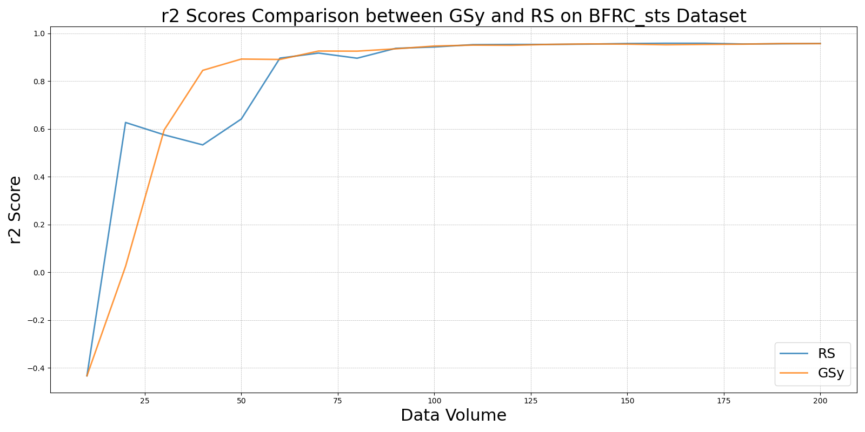

LCMDvs_RS_on_BFRC_sts.png

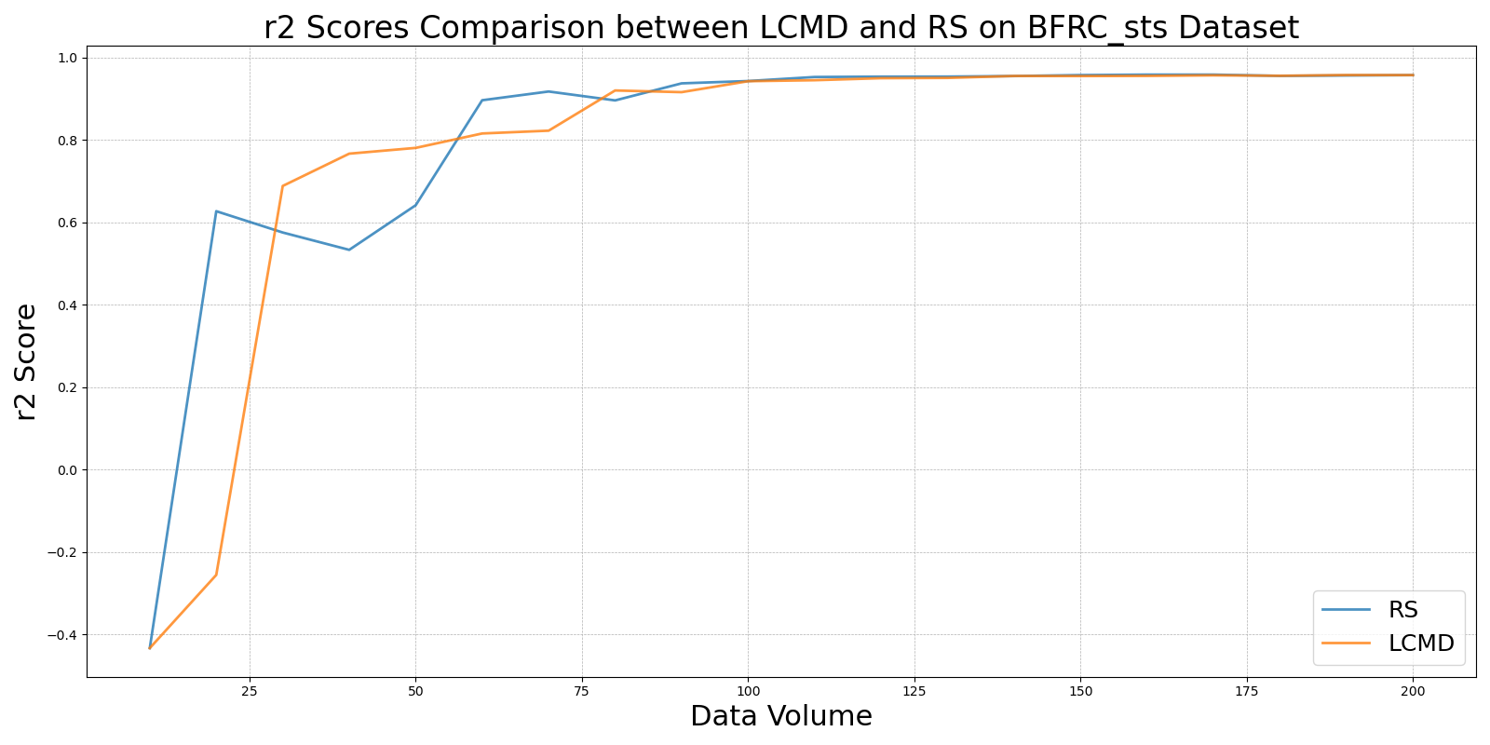

LL4ALvs_RS_on_BFRC_sts.png

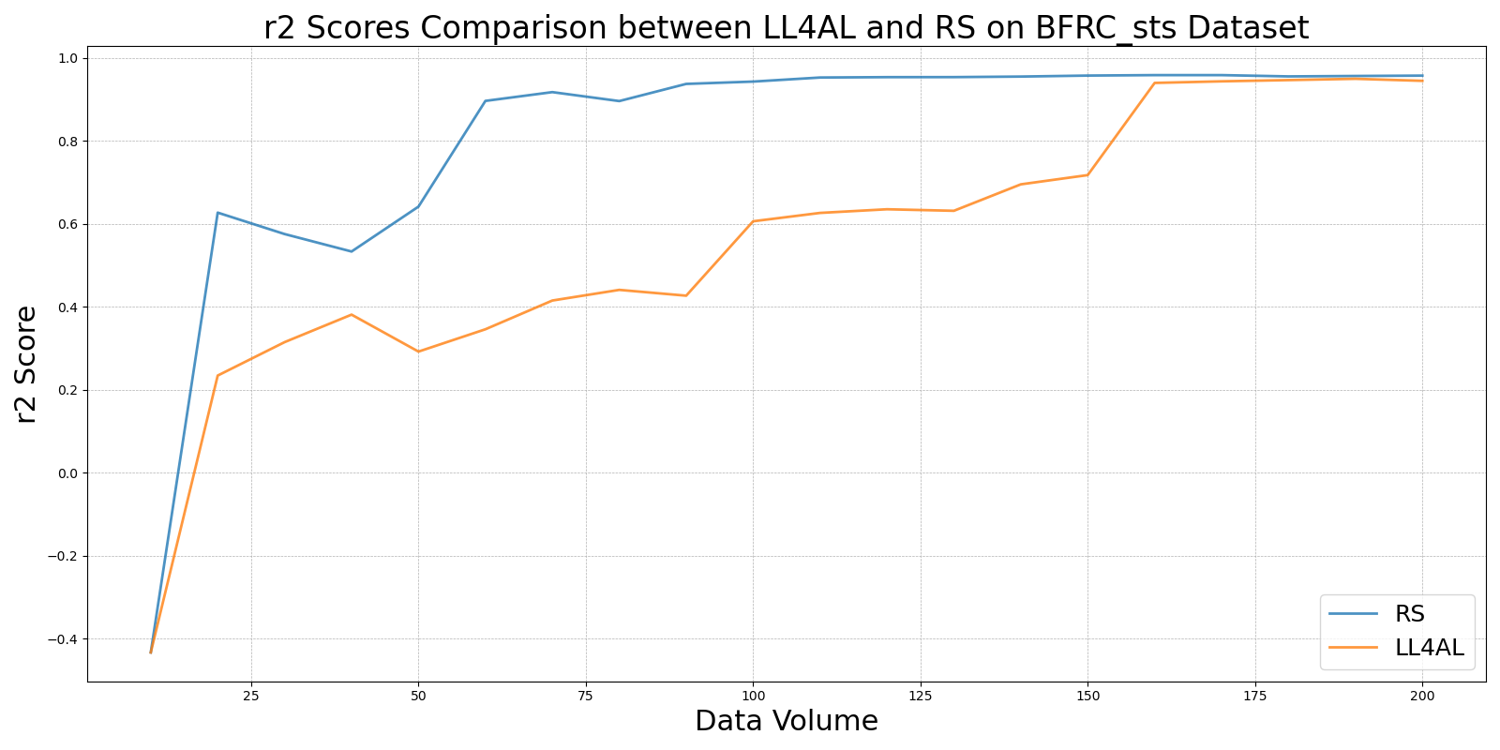

MCDvs_RS_on_BFRC_sts.png

