R2 Samples Report for 3 Thresholds

|  |  |  |  |
| --- | --- | --- | --- |
| Strategy | R2 >= 0.5 | R2 >= 0.7 | R2 >= 0.9 |
| RS | 30 (36.41%) | 60 (72.82%) | N/A |
| LL4AL | 40 (48.54%) | 50 (60.68%) | N/A |
| LCMD | 20 (24.27%) | 30 (36.41%) | N/A |
| MCD | 30 (36.41%) | 30 (36.41%) | N/A |
| EGAL | 40 (48.54%) | 40 (48.54%) | N/A |
| BayesianAL | 20 (24.27%) | 70 (84.95%) | N/A |
| GSx | 30 (36.41%) | 50 (60.68%) | N/A |
| GSy | 20 (24.27%) | 40 (48.54%) | N/A |
| GSi | 30 (36.41%) | 50 (60.68%) | N/A |
| GSBAG | 20 (24.27%) | 40 (48.54%) | N/A |

All_Strategies_on_CST.png

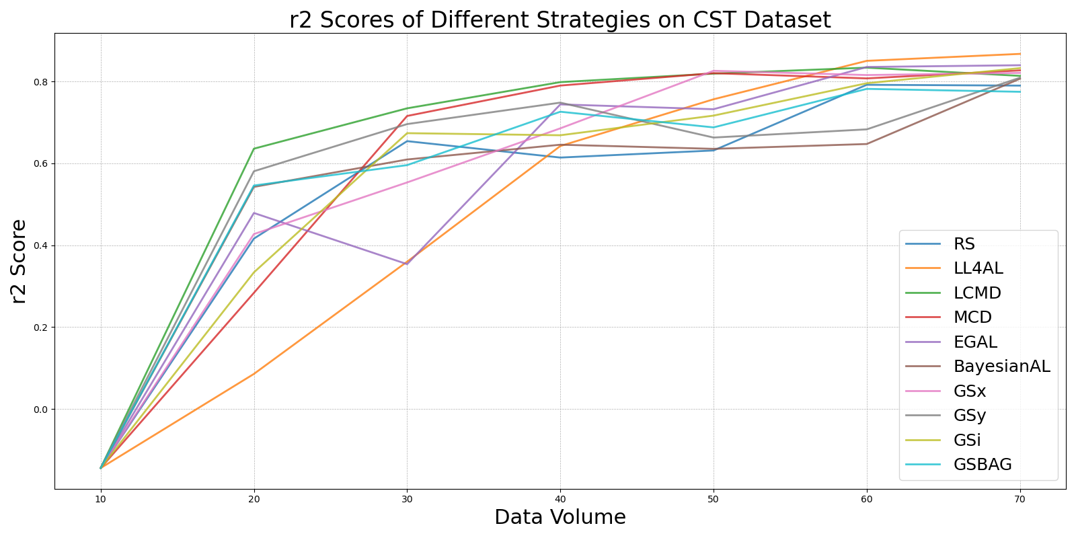

BayesianALvs_RS_on_CST.png

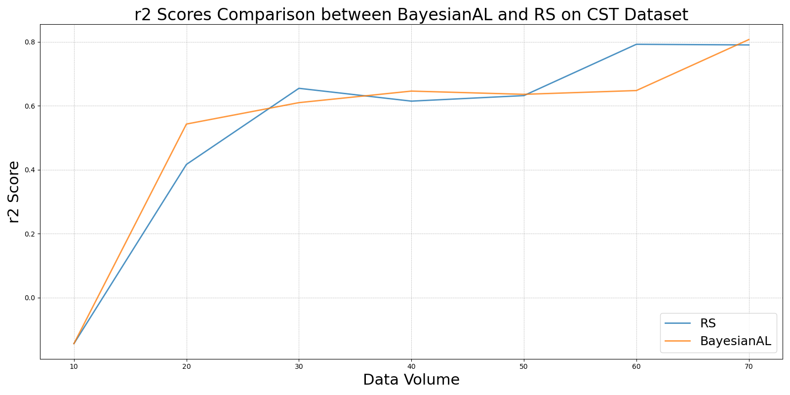

EGALvs_RS_on_CST.png

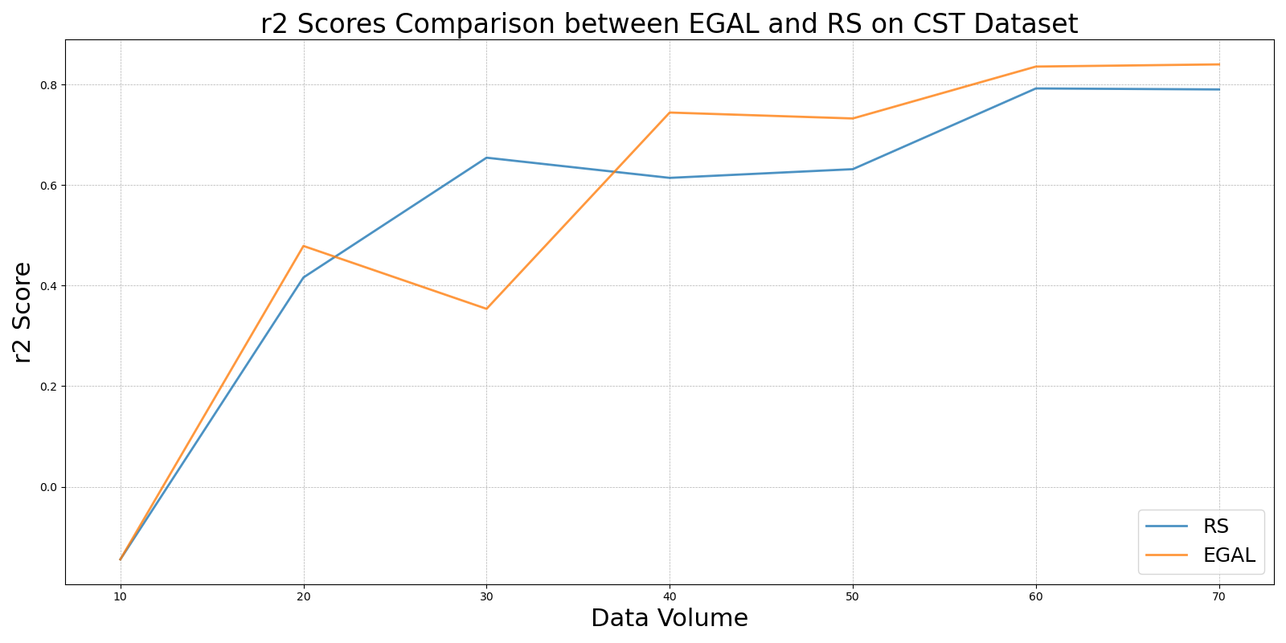

GSBAGvs_RS_on_CST.png

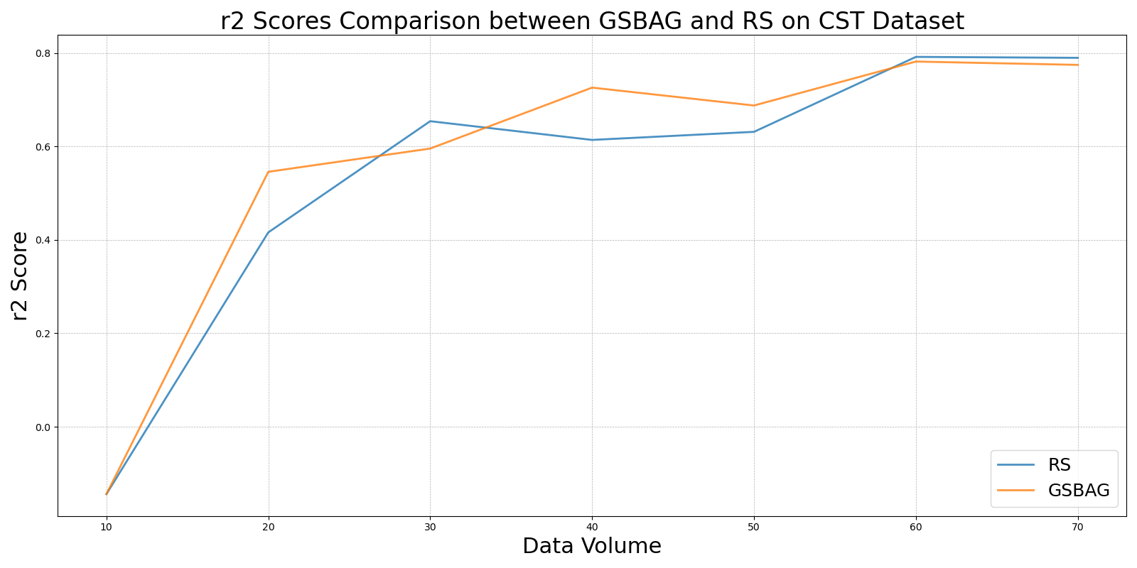

GSivs_RS_on_CST.png

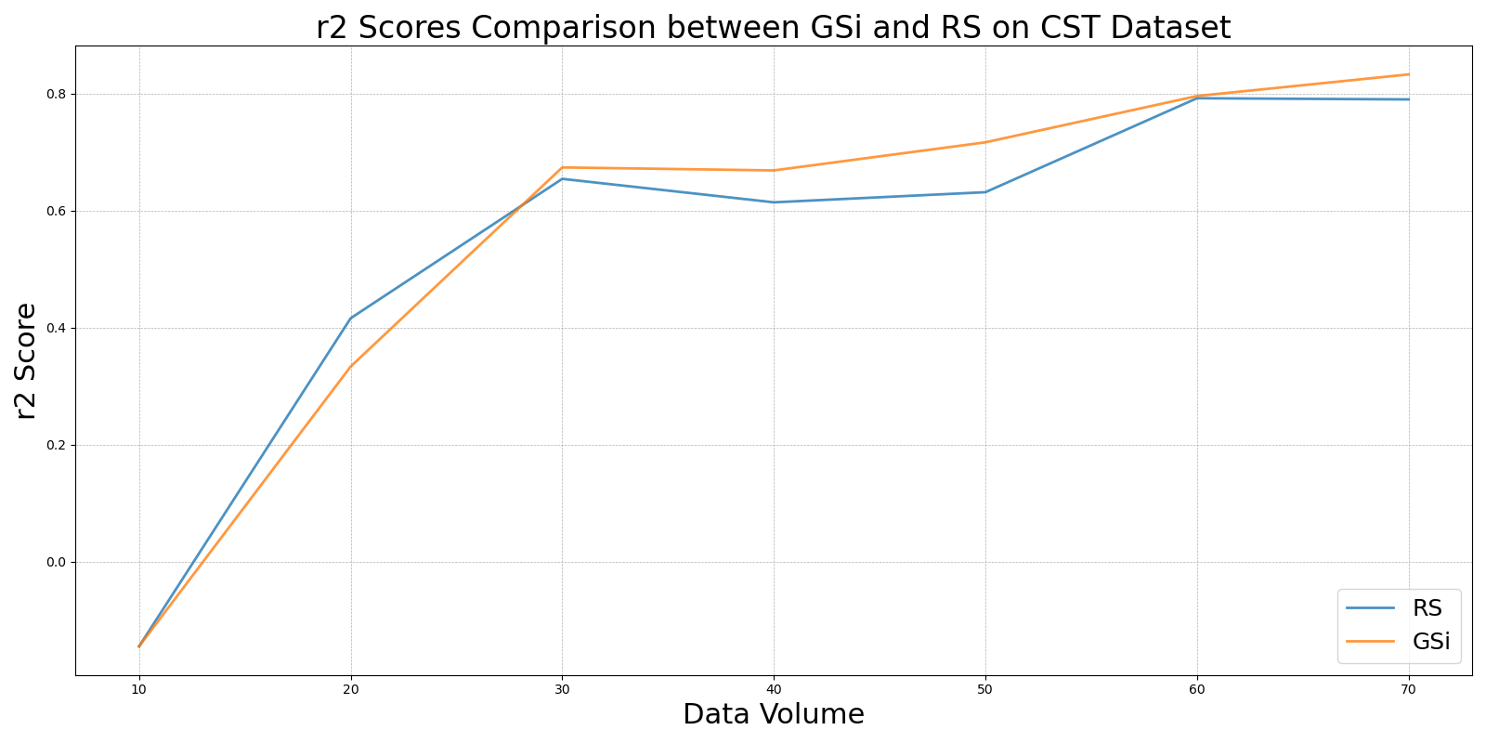

GSxvs_RS_on_CST.png

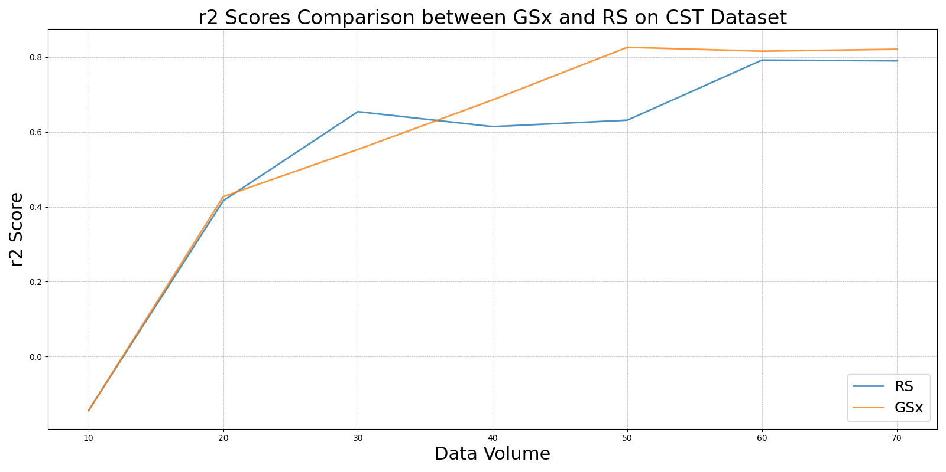

GSyvs_RS_on_CST.png

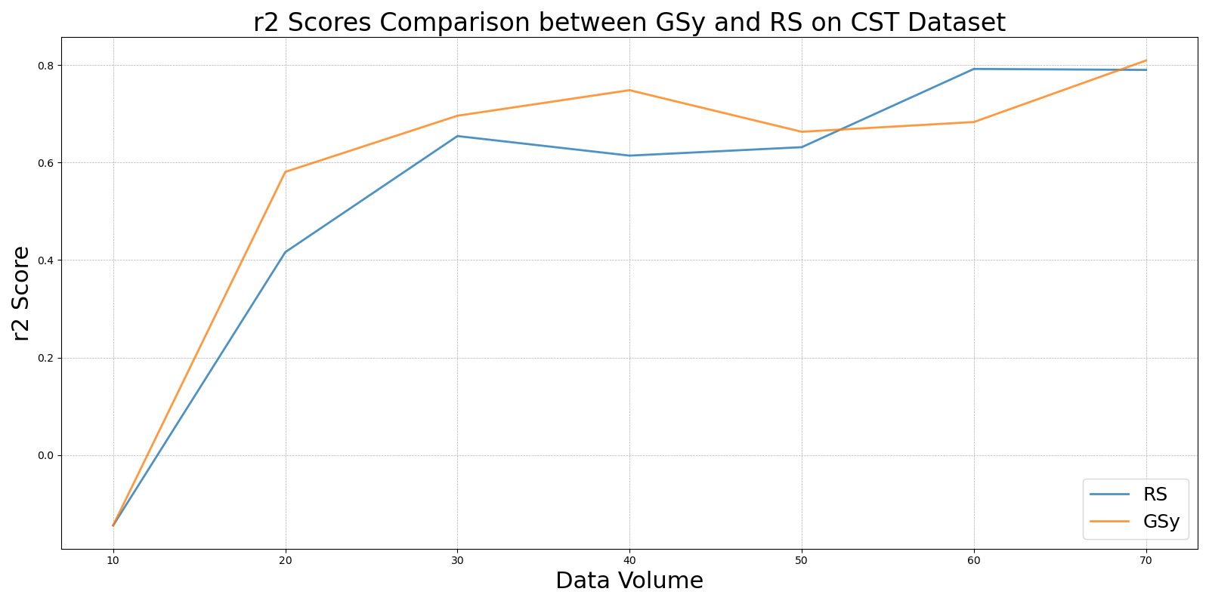

LCMDvs_RS_on_CST.png

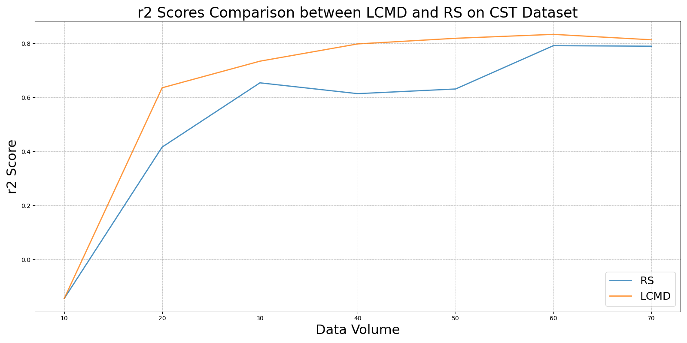

LL4ALvs_RS_on_CST.png

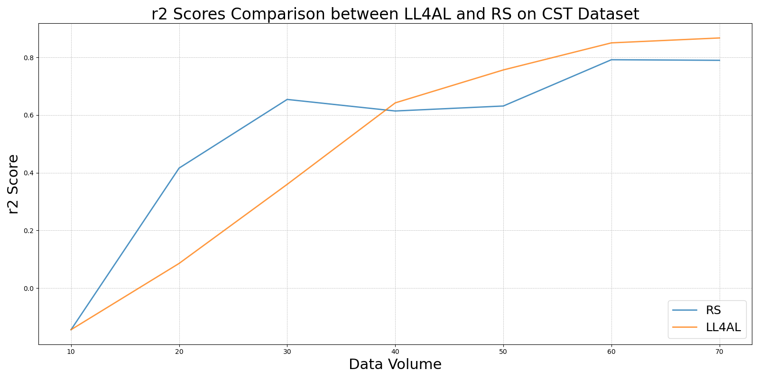

MCDvs_RS_on_CST.png

