R2 Samples Report for 3 Thresholds

|  |  |  |  |
| --- | --- | --- | --- |
| Strategy | R2 >= 0.5 | R2 >= 0.7 | R2 >= 0.9 |
| RS | 10 (1.63%) | 40 (6.51%) | 40 (6.51%) |
| LL4AL | 10 (1.63%) | 20 (3.26%) | 40 (6.51%) |
| LCMD | 10 (1.63%) | 20 (3.26%) | 30 (4.88%) |
| MCD | 10 (1.63%) | 20 (3.26%) | 40 (6.51%) |
| EGAL | 10 (1.63%) | 20 (3.26%) | 30 (4.88%) |
| BayesianAL | 10 (1.63%) | 20 (3.26%) | 50 (8.14%) |
| GSx | 10 (1.63%) | 20 (3.26%) | 40 (6.51%) |
| GSy | 10 (1.63%) | 40 (6.51%) | 50 (8.14%) |
| GSi | 10 (1.63%) | 20 (3.26%) | 30 (4.88%) |
| GSBAG | 10 (1.63%) | 20 (3.26%) | 20 (3.26%) |

All_Strategies_on_ENB2012_CL.png

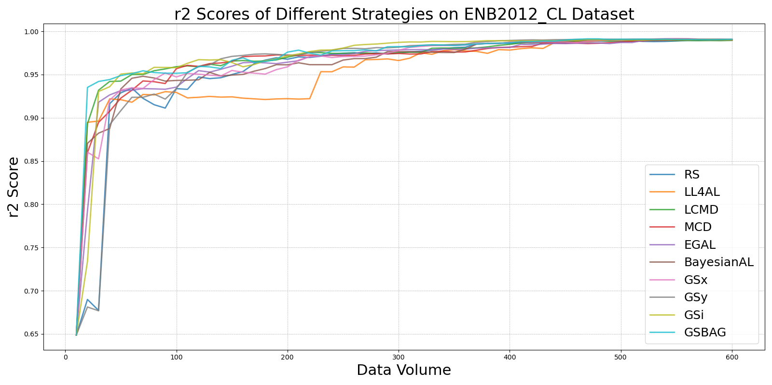

BayesianALvs_RS_on_ENB2012_CL.png

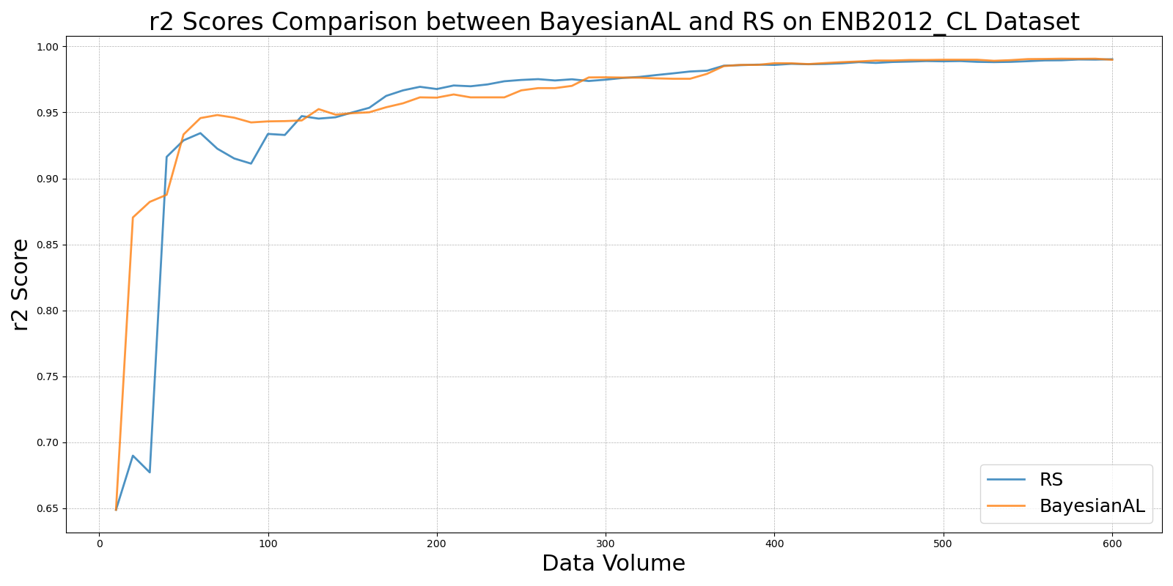

EGALvs_RS_on_ENB2012_CL.png

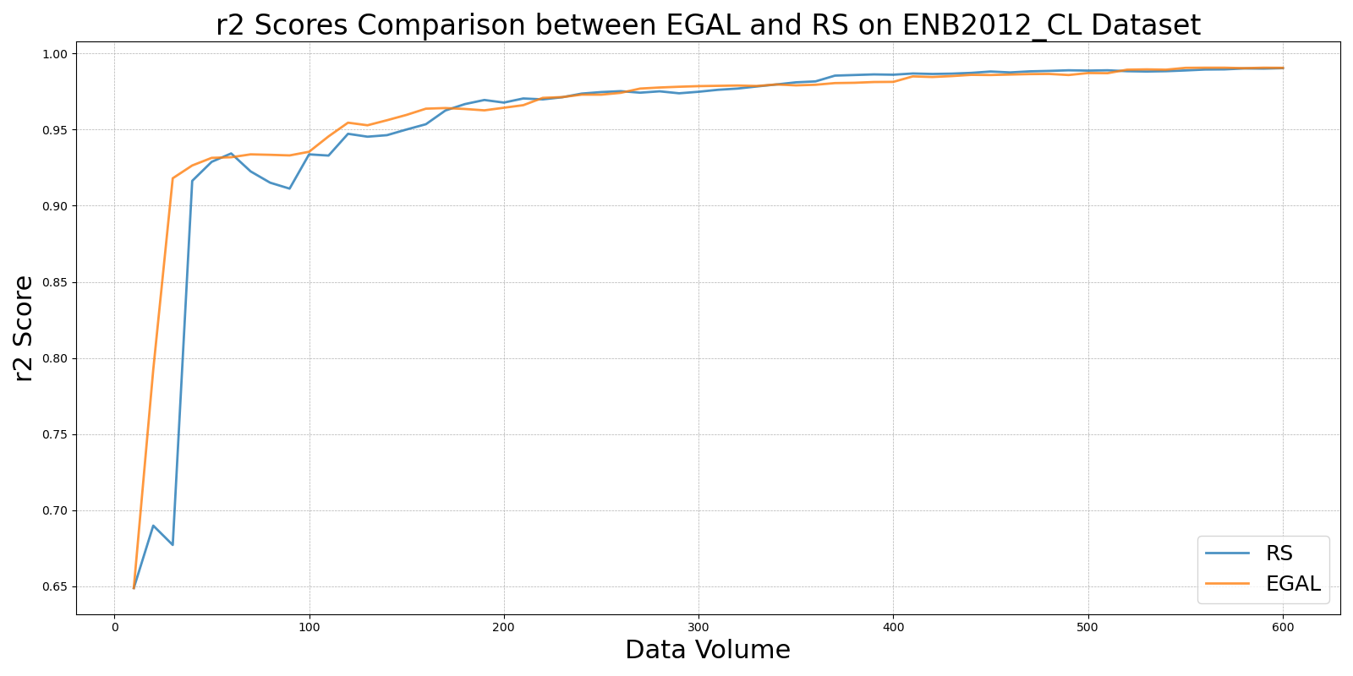

GSBAGvs_RS_on_ENB2012_CL.png

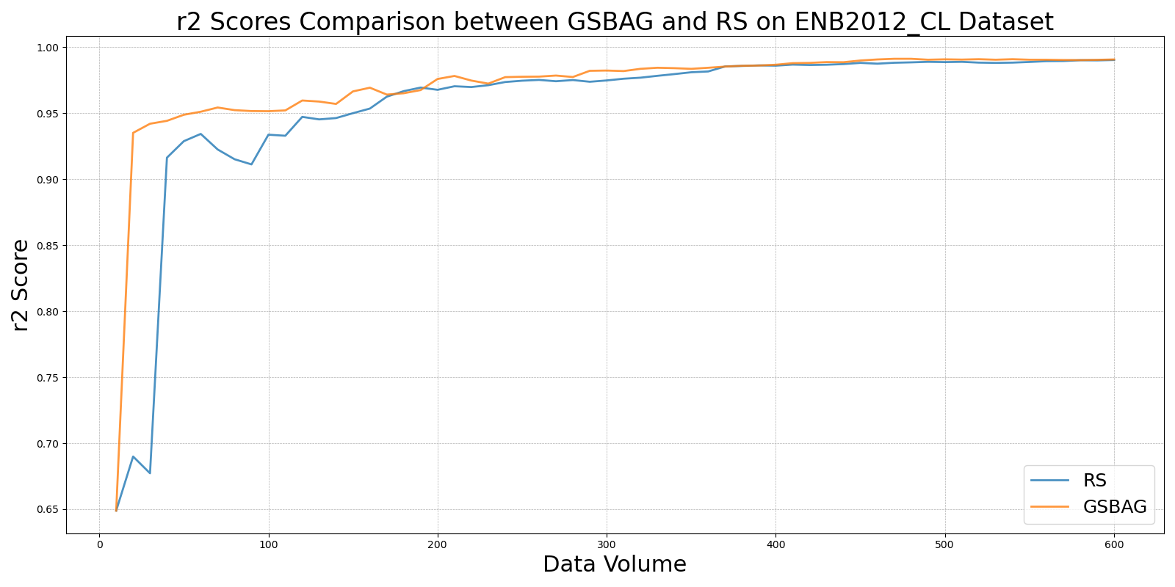

GSivs_RS_on_ENB2012_CL.png

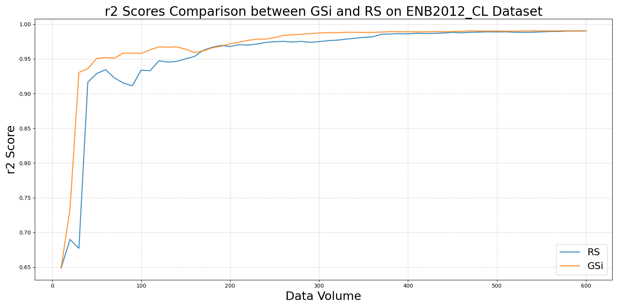

GSxvs_RS_on_ENB2012_CL.png

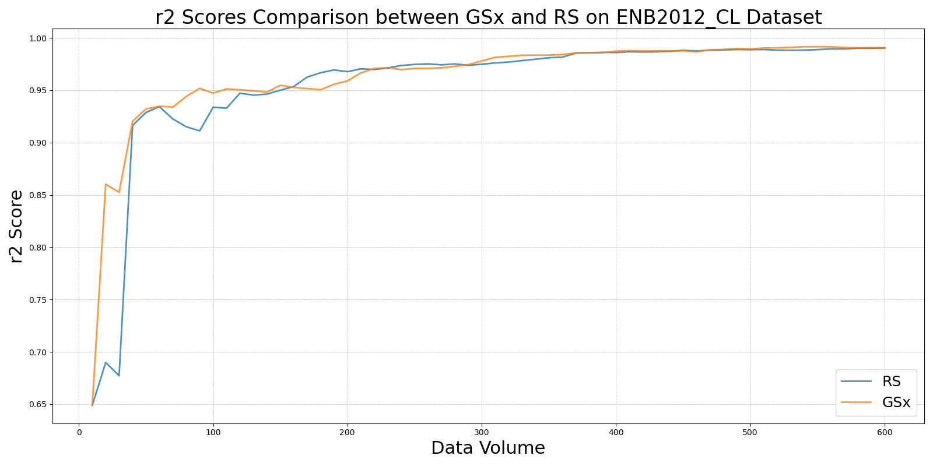

GSyvs_RS_on_ENB2012_CL.png

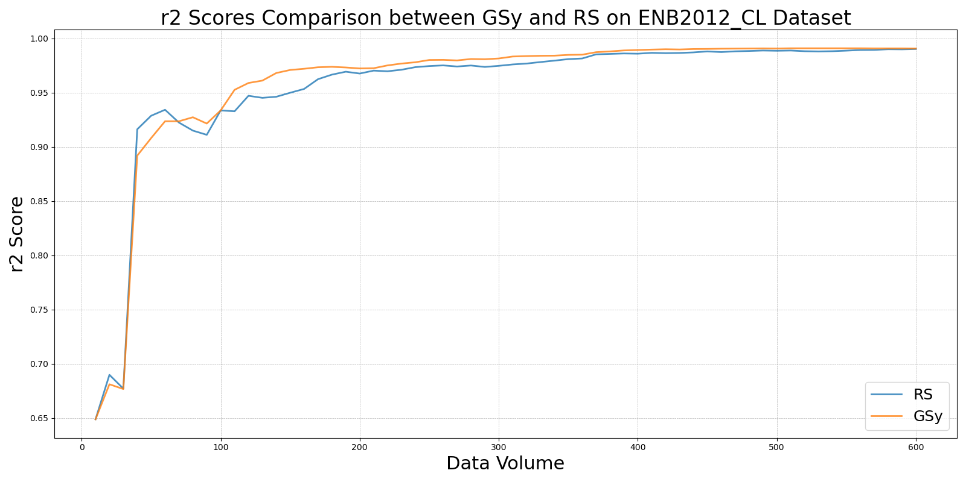

LCMDvs_RS_on_ENB2012_CL.png

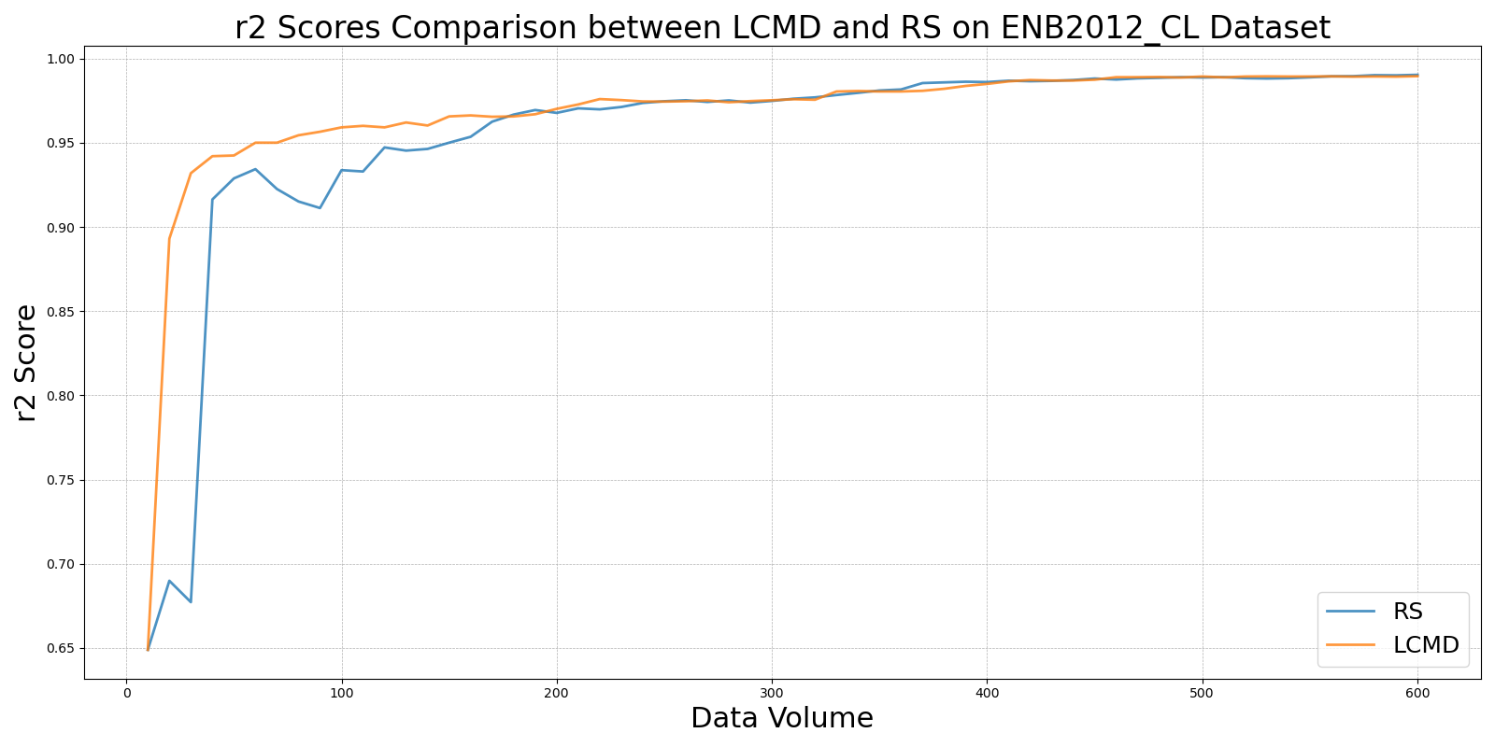

LL4ALvs_RS_on_ENB2012_CL.png

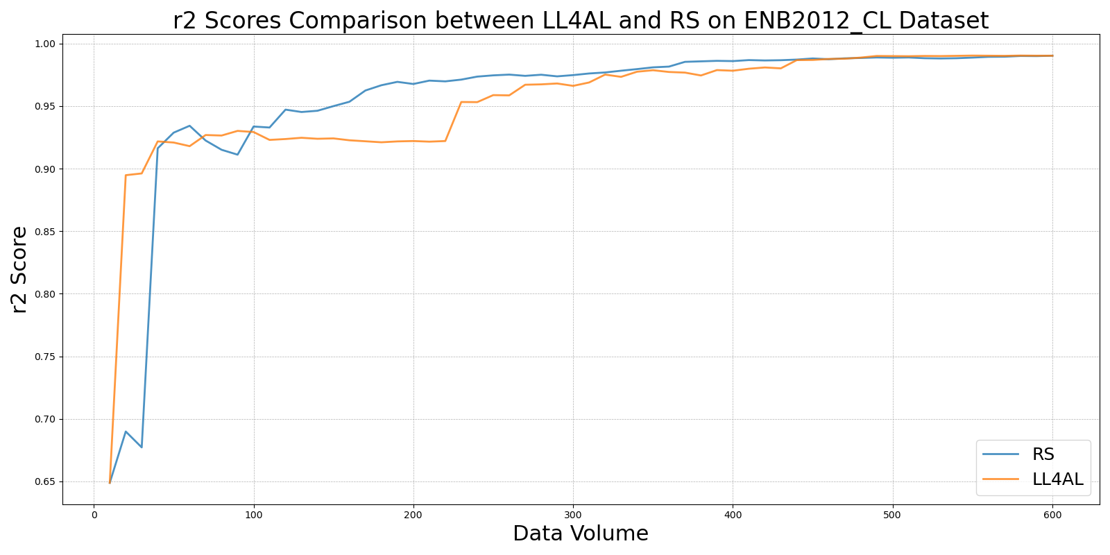

MCDvs_RS_on_ENB2012_CL.png

