R2 Samples Report for 3 Thresholds

|  |  |  |  |
| --- | --- | --- | --- |
| Strategy | R2 >= 0.5 | R2 >= 0.7 | R2 >= 0.9 |
| RS | 40 (4.55%) | 90 (10.23%) | 650 (73.86%) |
| LL4AL | 50 (5.68%) | 70 (7.95%) | 530 (60.23%) |
| LCMD | 20 (2.27%) | 60 (6.82%) | 590 (67.05%) |
| MCD | 40 (4.55%) | 90 (10.23%) | 470 (53.41%) |
| EGAL | 30 (3.41%) | 60 (6.82%) | 640 (72.73%) |
| BayesianAL | 50 (5.68%) | 110 (12.50%) | 550 (62.50%) |
| GSx | 20 (2.27%) | 50 (5.68%) | 630 (71.59%) |
| GSy | 50 (5.68%) | 90 (10.23%) | 530 (60.23%) |
| GSi | 30 (3.41%) | 80 (9.09%) | 530 (60.23%) |
| GSBAG | 30 (3.41%) | 80 (9.09%) | 610 (69.32%) |

All_Strategies_on_GEN11f5n.png

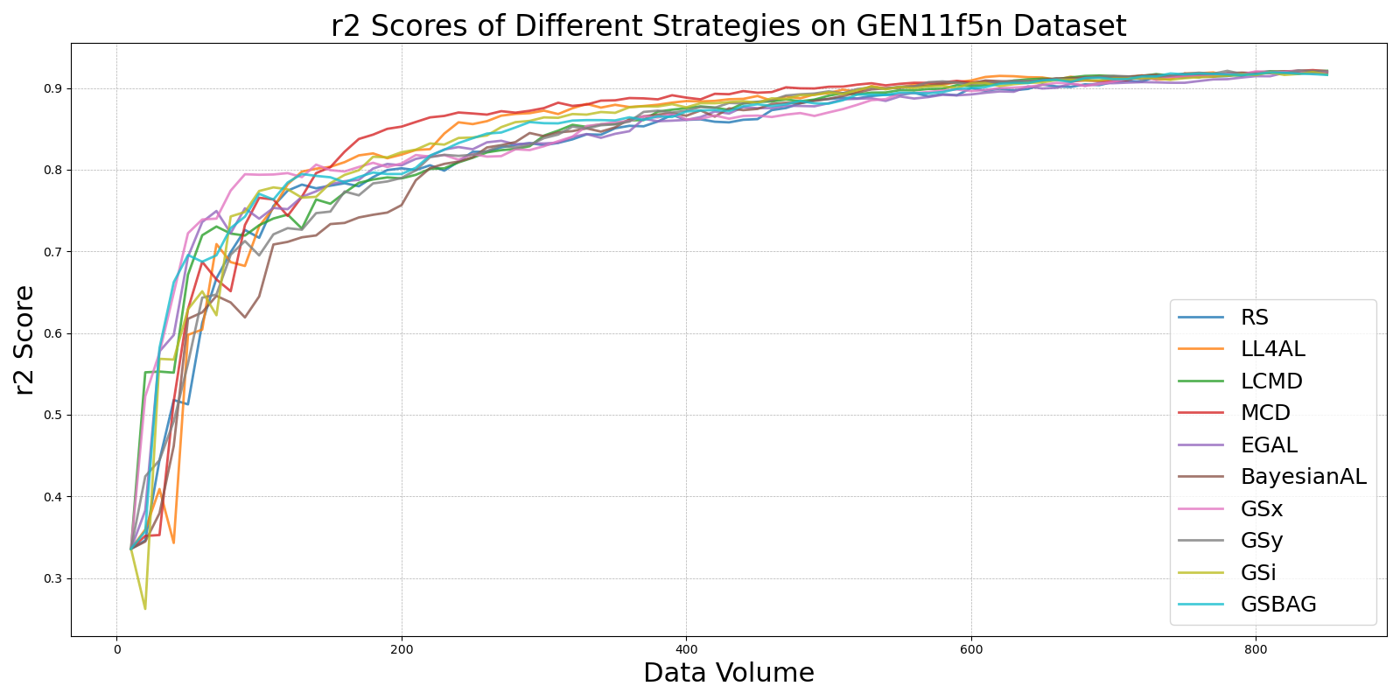

BayesianALvs_RS_on_GEN11f5n.png

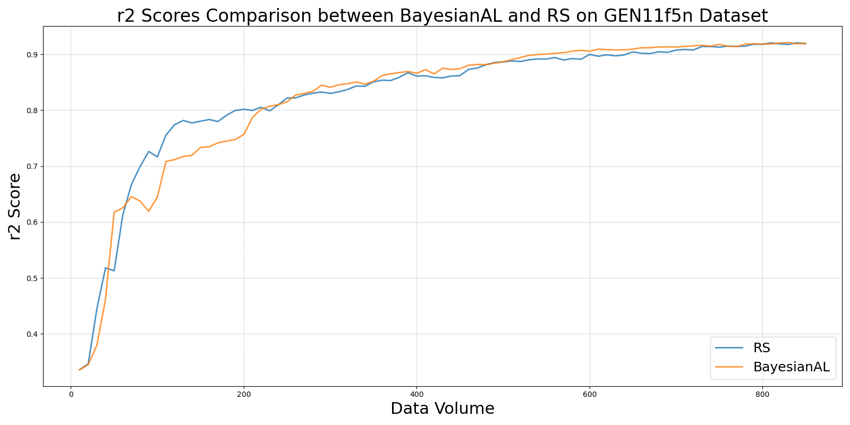

EGALvs_RS_on_GEN11f5n.png

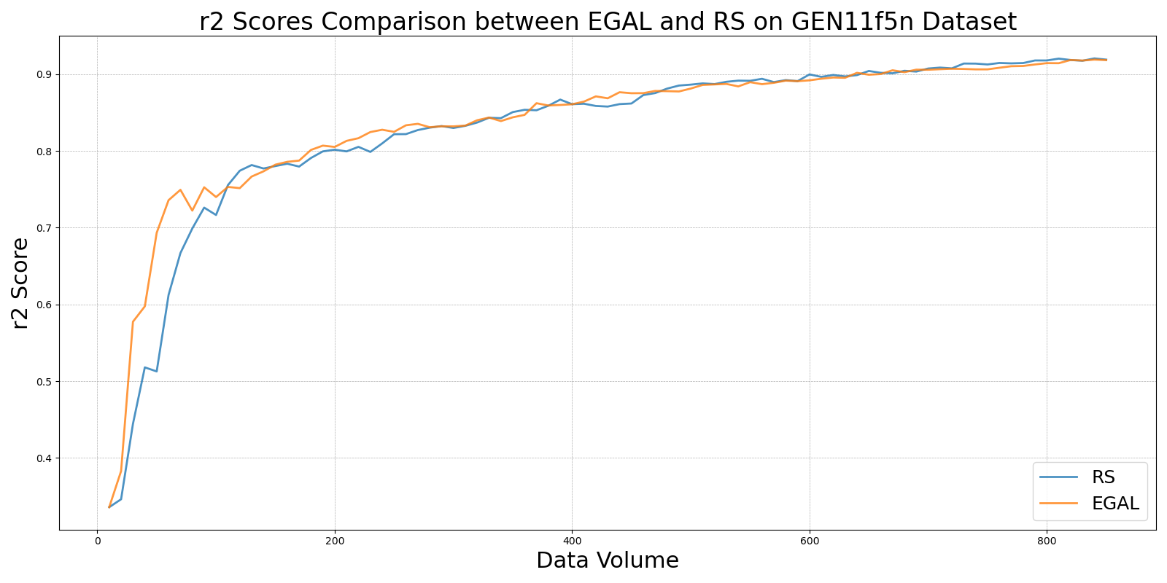

GSBAGvs_RS_on_GEN11f5n.png

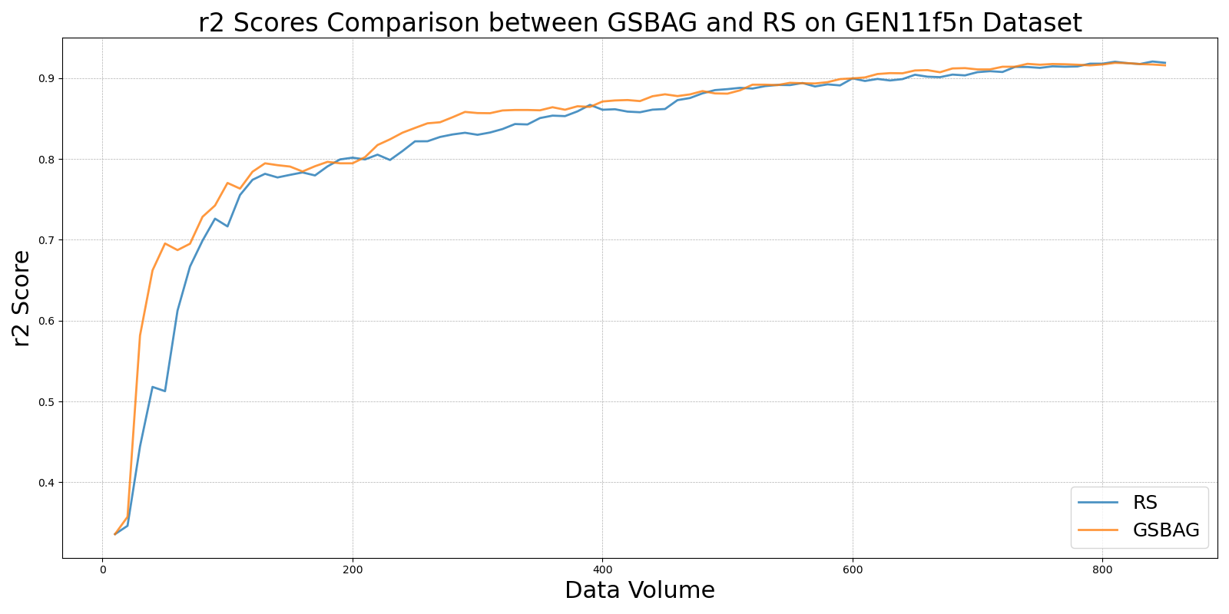

GSivs_RS_on_GEN11f5n.png

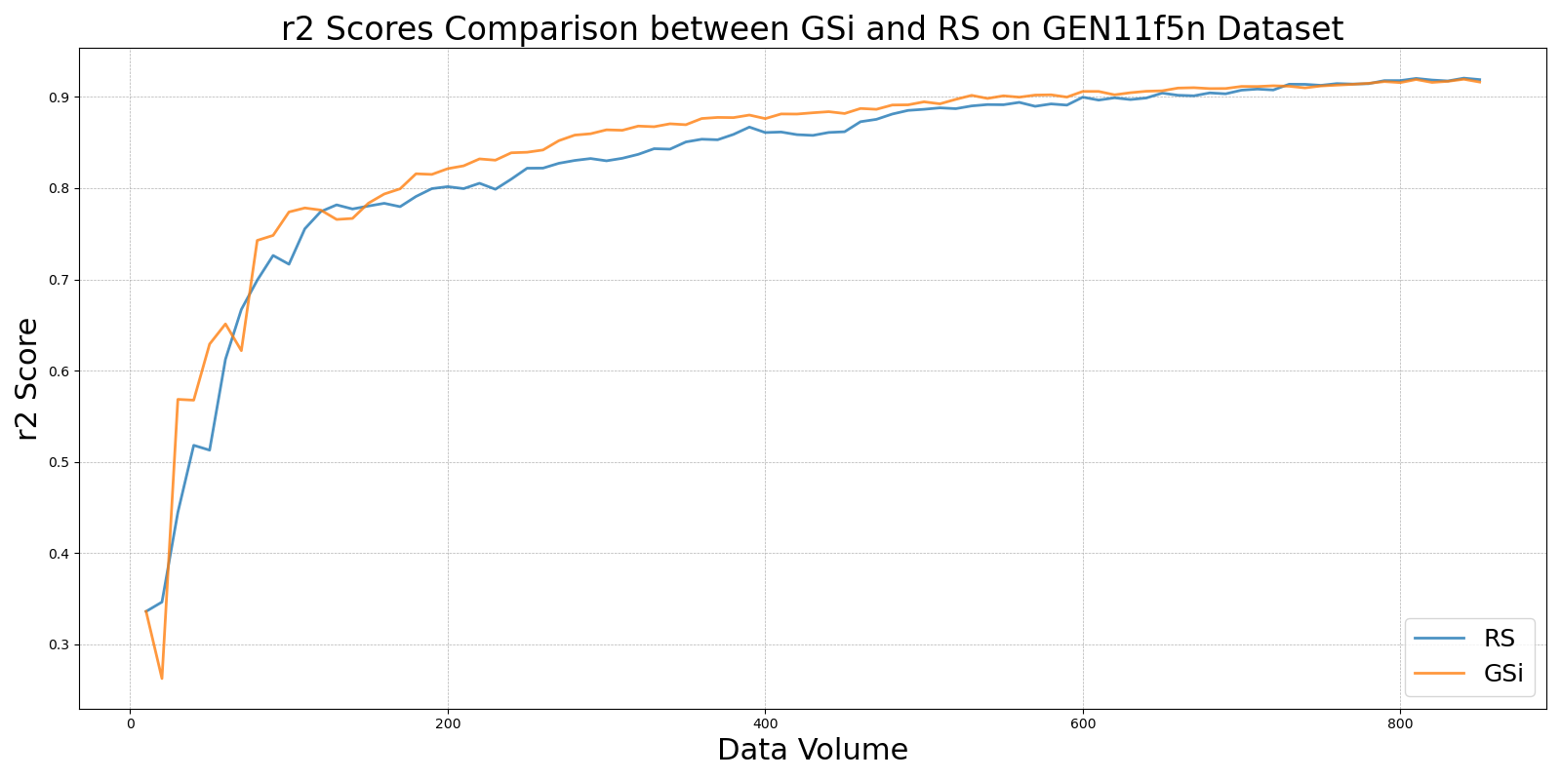

GSxvs_RS_on_GEN11f5n.png

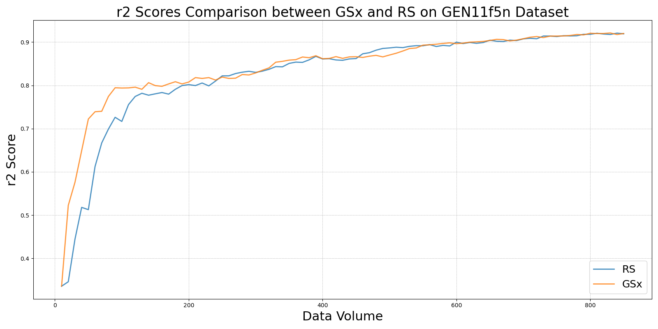

GSyvs_RS_on_GEN11f5n.png

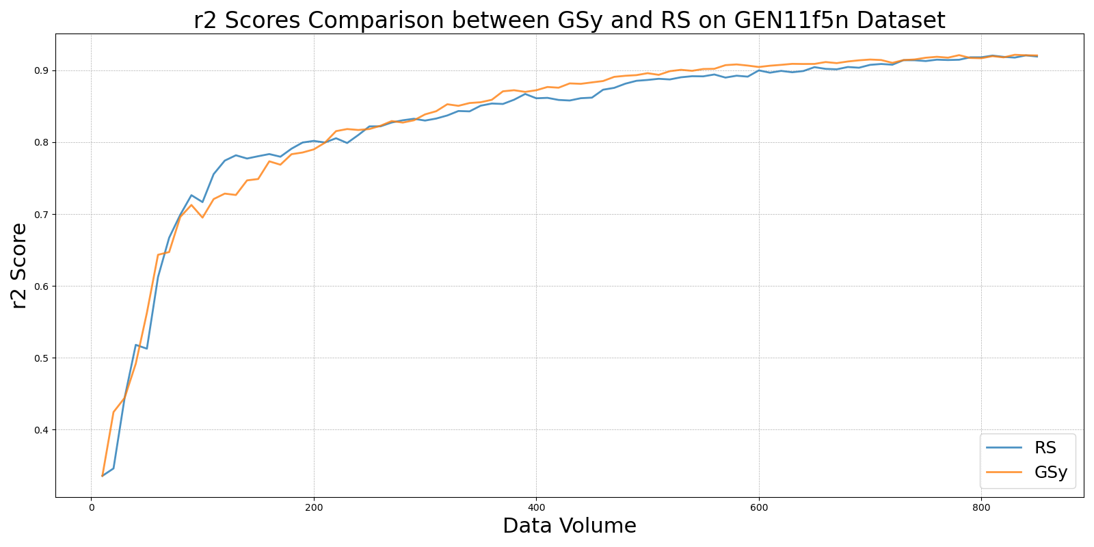

LCMDvs_RS_on_GEN11f5n.png

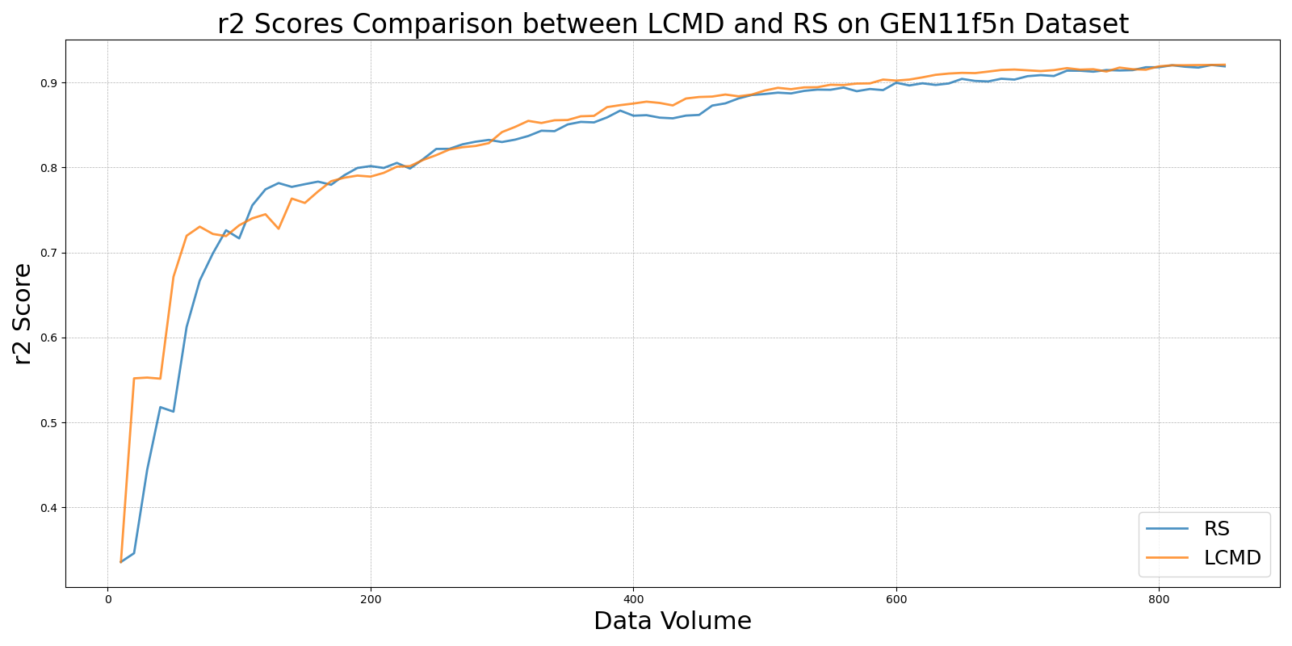

LL4ALvs_RS_on_GEN11f5n.png

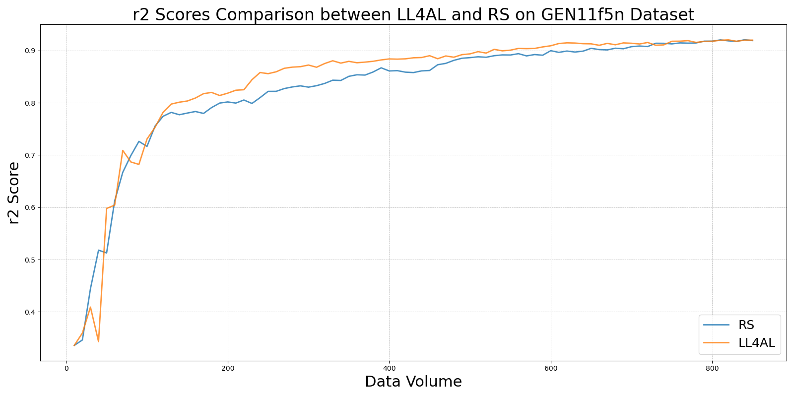

MCDvs_RS_on_GEN11f5n.png

