R2 Samples Report for 3 Thresholds

|  |  |  |  |
| --- | --- | --- | --- |
| Strategy | R2 >= 0.5 | R2 >= 0.7 | R2 >= 0.9 |
| RS | 10 (1.14%) | 20 (2.27%) | 80 (9.09%) |
| LL4AL | 10 (1.14%) | 80 (9.09%) | 170 (19.32%) |
| LCMD | 10 (1.14%) | 40 (4.55%) | 120 (13.64%) |
| MCD | 10 (1.14%) | 30 (3.41%) | 80 (9.09%) |
| EGAL | 10 (1.14%) | 40 (4.55%) | 110 (12.50%) |
| BayesianAL | 10 (1.14%) | 50 (5.68%) | 210 (23.86%) |
| GSx | 10 (1.14%) | 20 (2.27%) | 110 (12.50%) |
| GSy | 10 (1.14%) | 20 (2.27%) | 80 (9.09%) |
| GSi | 10 (1.14%) | 30 (3.41%) | 110 (12.50%) |
| GSBAG | 10 (1.14%) | 50 (5.68%) | 160 (18.18%) |

All_Strategies_on_GEN3f5n.png

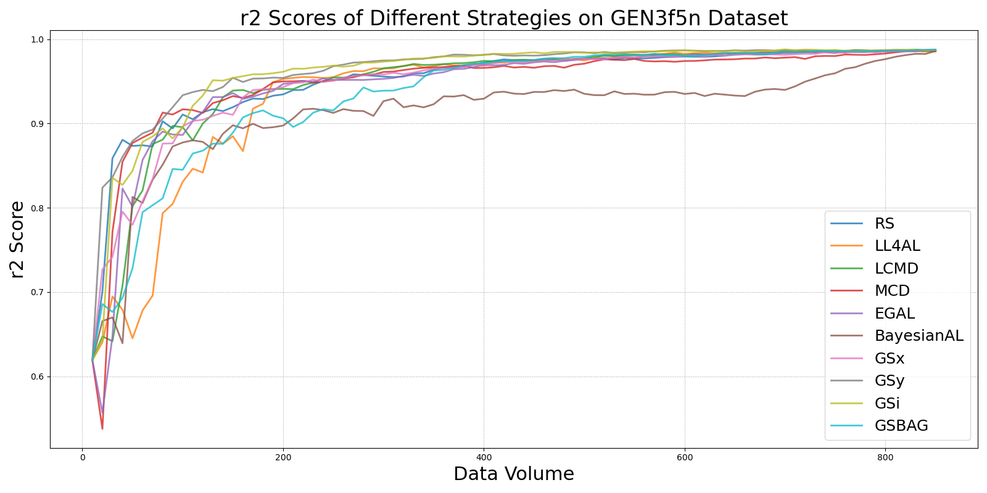

BayesianALvs_RS_on_GEN3f5n.png

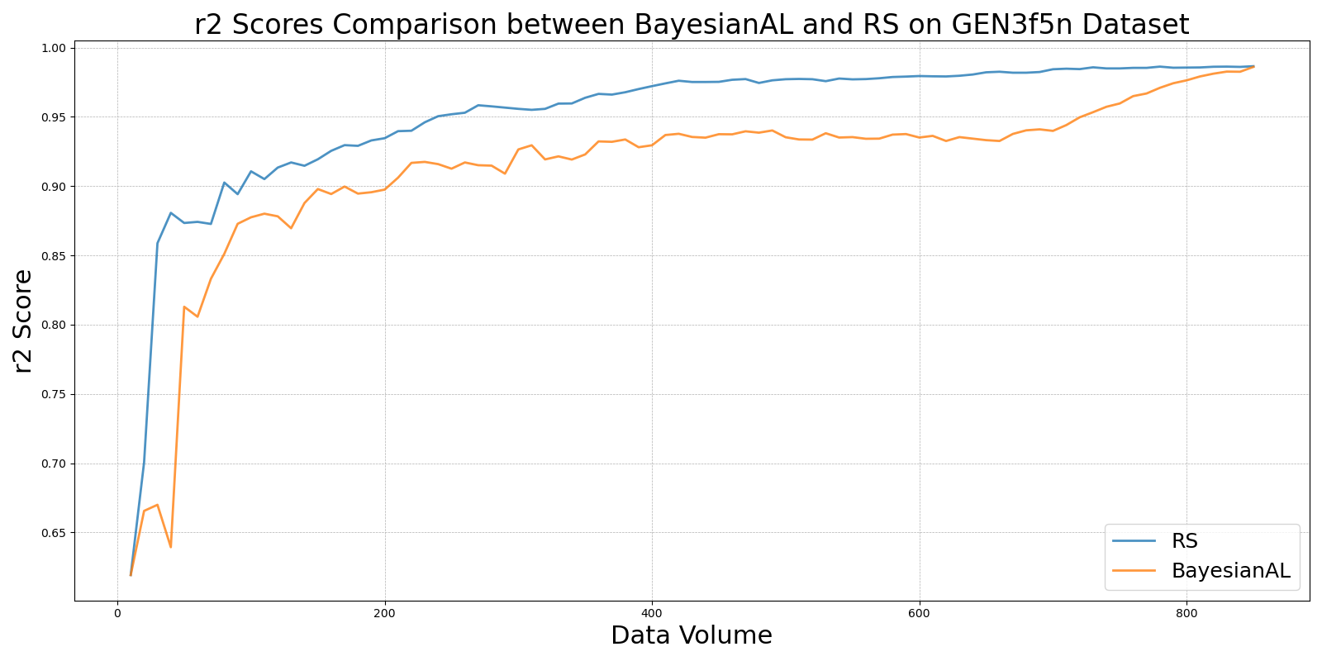

EGALvs_RS_on_GEN3f5n.png

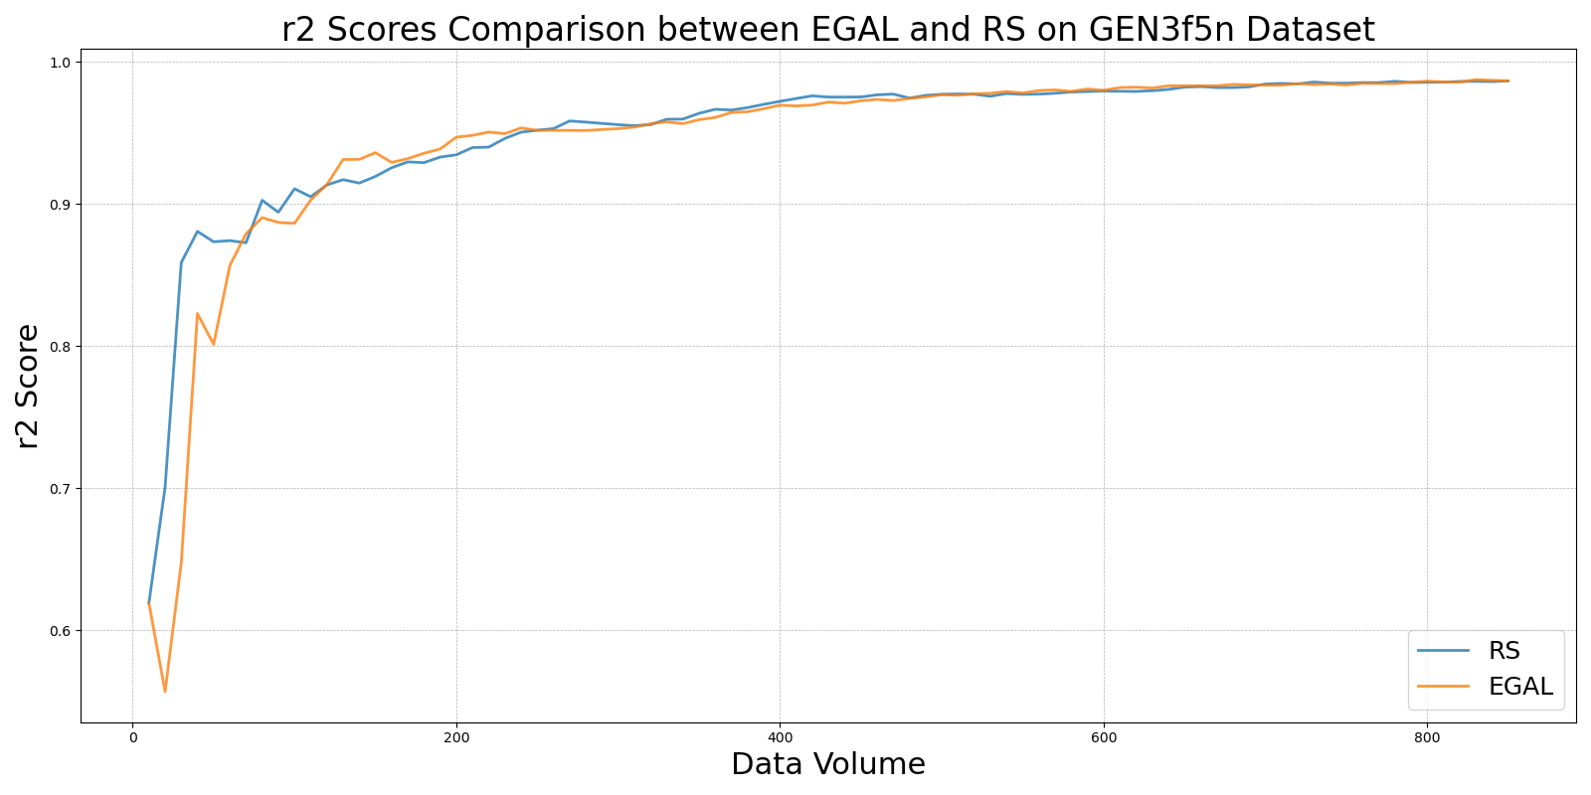

GSBAGvs_RS_on_GEN3f5n.png

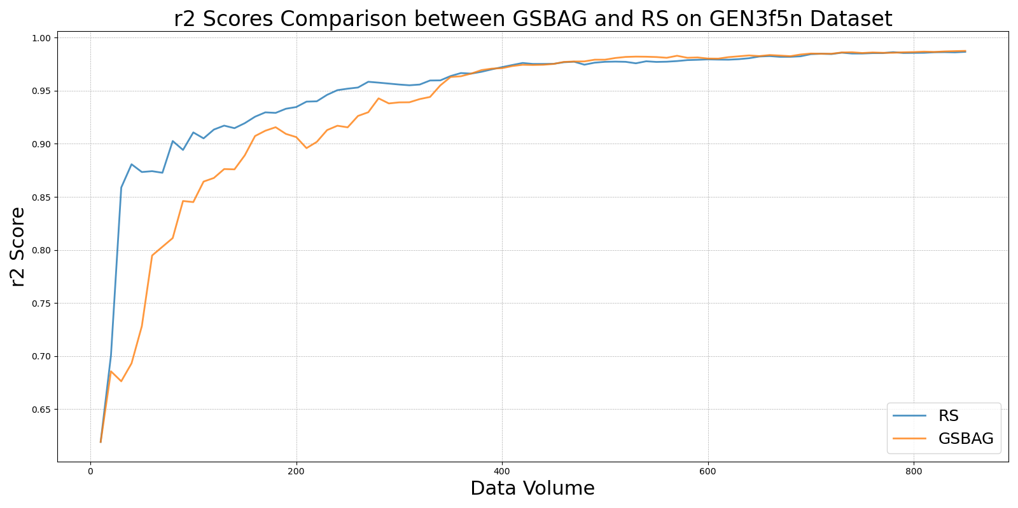

GSivs_RS_on_GEN3f5n.png

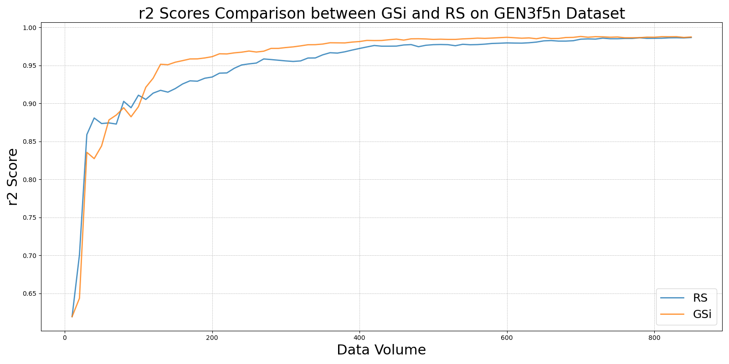

GSxvs_RS_on_GEN3f5n.png

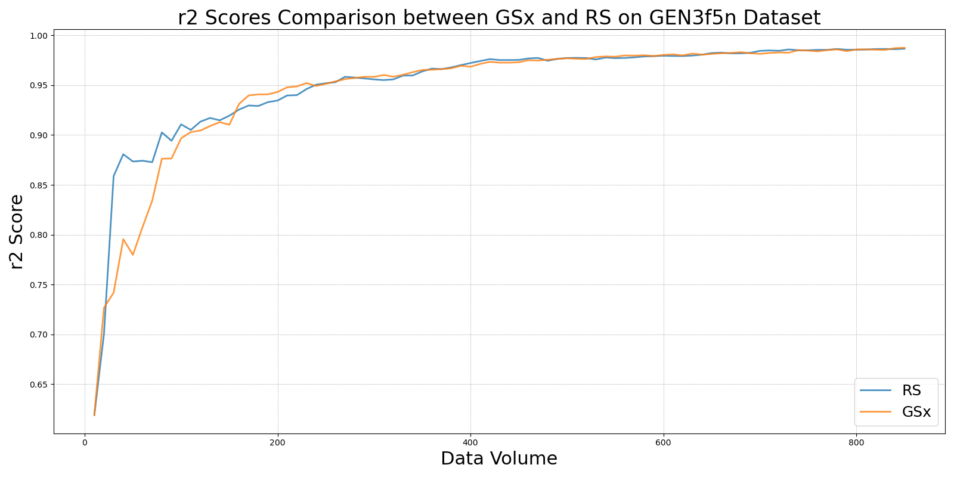

GSyvs_RS_on_GEN3f5n.png

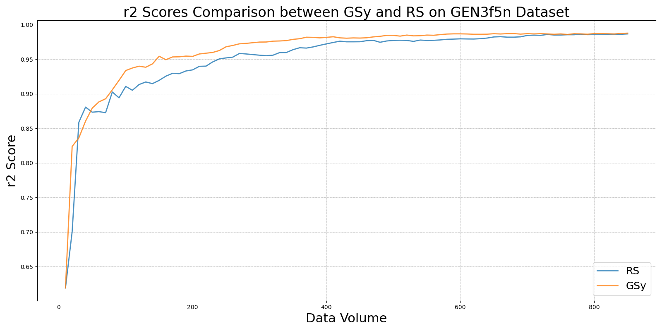

LCMDvs_RS_on_GEN3f5n.png

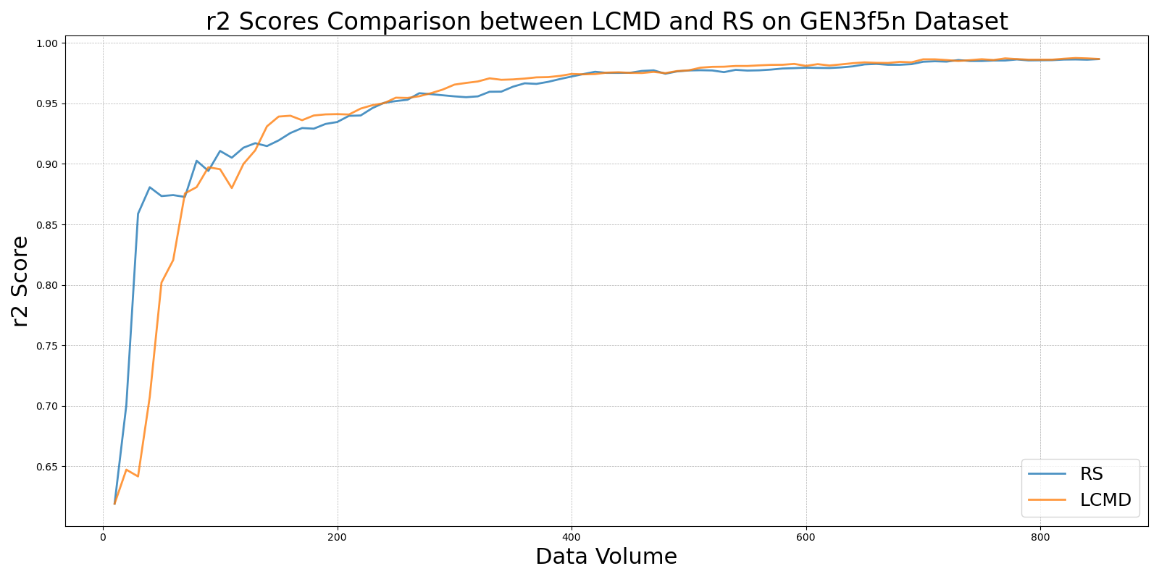

LL4ALvs_RS_on_GEN3f5n.png

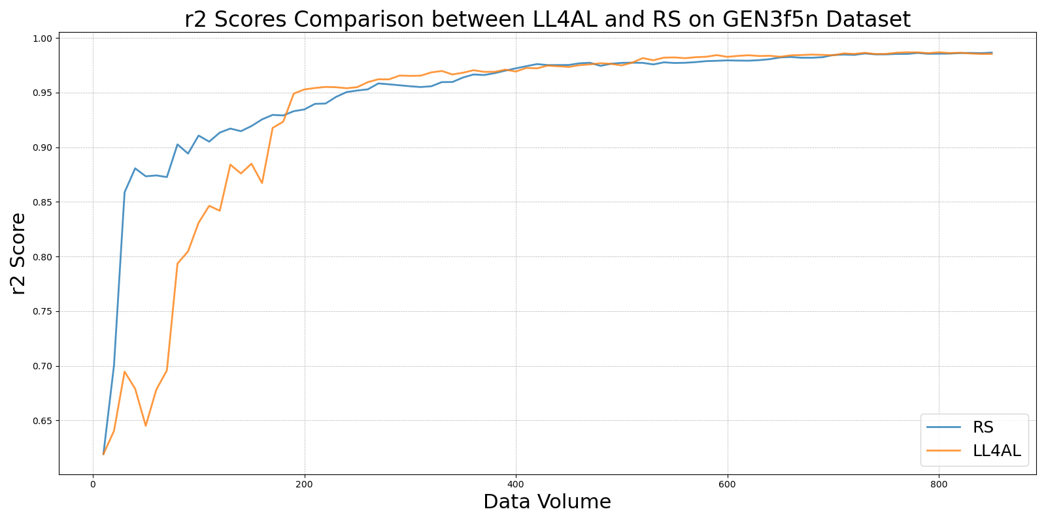

MCDvs_RS_on_GEN3f5n.png

