R2 Samples Report for 3 Thresholds

|  |  |  |  |
| --- | --- | --- | --- |
| Strategy | R2 >= 0.5 | R2 >= 0.7 | R2 >= 0.9 |
| RS | 40 (4.55%) | 80 (9.09%) | 280 (31.82%) |
| LL4AL | 70 (7.95%) | 180 (20.45%) | 490 (55.68%) |
| LCMD | 30 (3.41%) | 50 (5.68%) | 240 (27.27%) |
| MCD | 30 (3.41%) | 40 (4.55%) | 330 (37.50%) |
| EGAL | 30 (3.41%) | 70 (7.95%) | 260 (29.55%) |
| BayesianAL | 30 (3.41%) | 60 (6.82%) | 610 (69.32%) |
| GSx | 30 (3.41%) | 100 (11.36%) | 360 (40.91%) |
| GSy | 60 (6.82%) | 140 (15.91%) | 470 (53.41%) |
| GSi | 30 (3.41%) | 130 (14.77%) | 370 (42.05%) |
| GSBAG | 30 (3.41%) | 130 (14.77%) | 450 (51.14%) |

All_Strategies_on_GEN5f5n.png

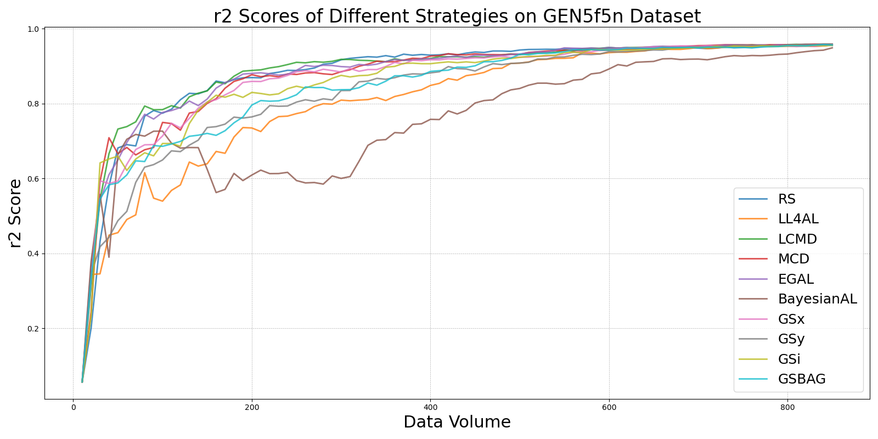

BayesianALvs_RS_on_GEN5f5n.png

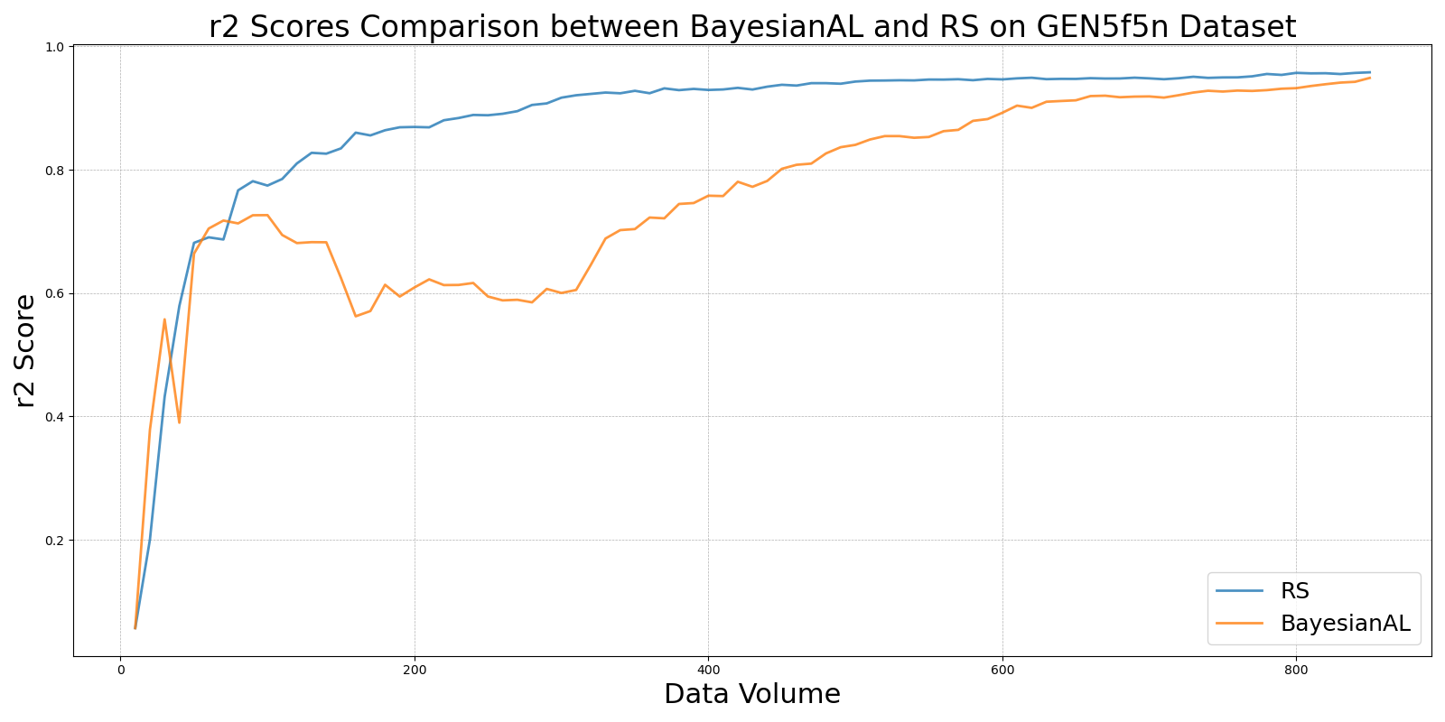

EGALvs_RS_on_GEN5f5n.png

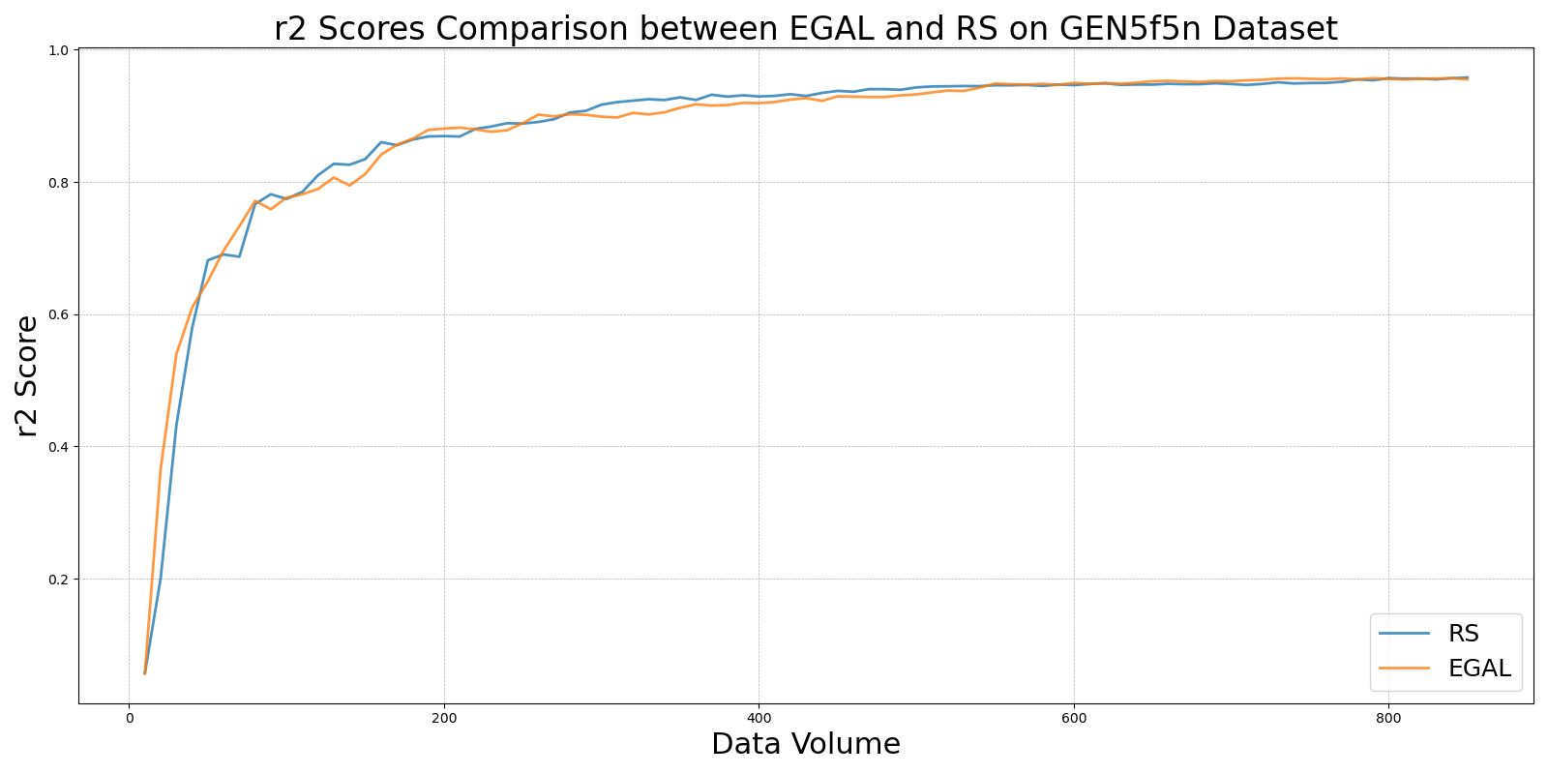

GSBAGvs_RS_on_GEN5f5n.png

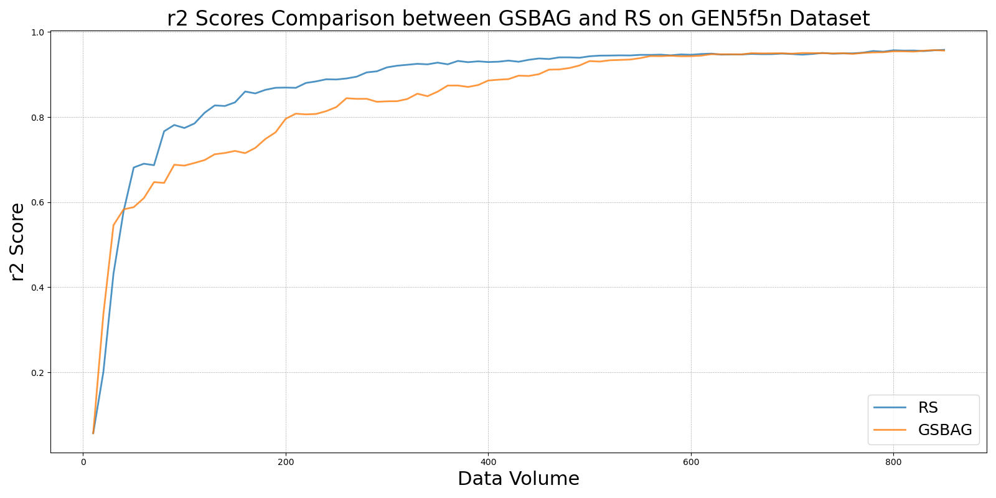

GSivs_RS_on_GEN5f5n.png

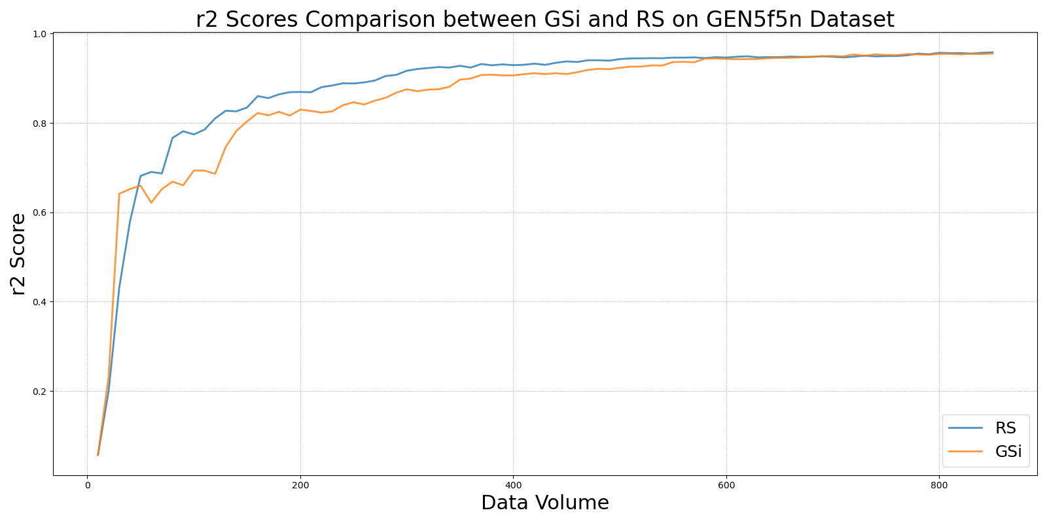

GSxvs_RS_on_GEN5f5n.png

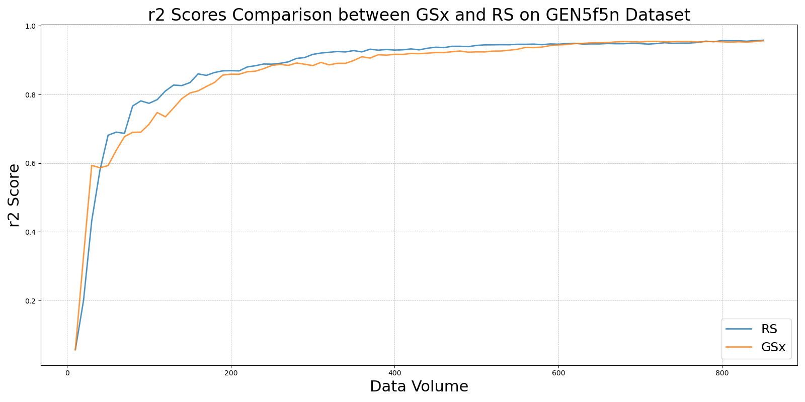

GSyvs_RS_on_GEN5f5n.png

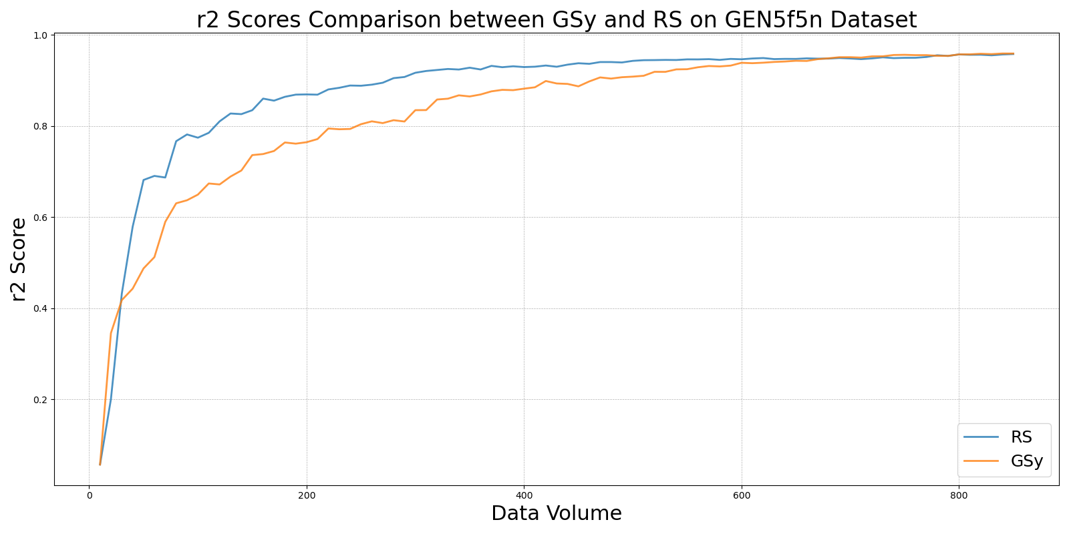

LCMDvs_RS_on_GEN5f5n.png

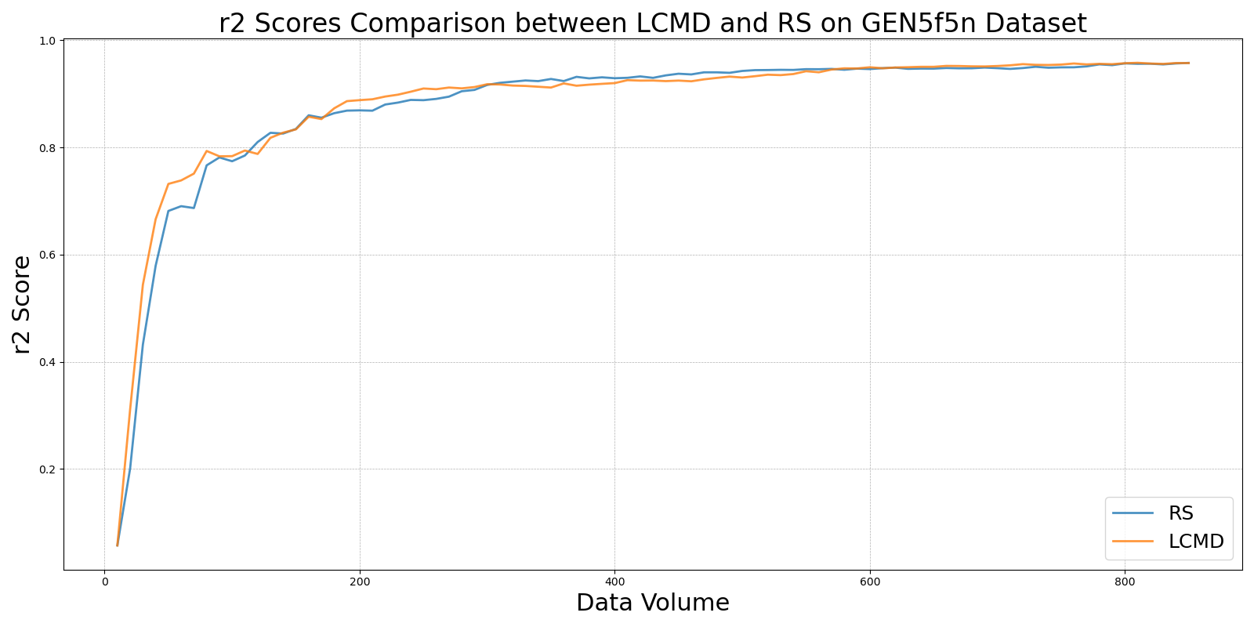

LL4ALvs_RS_on_GEN5f5n.png

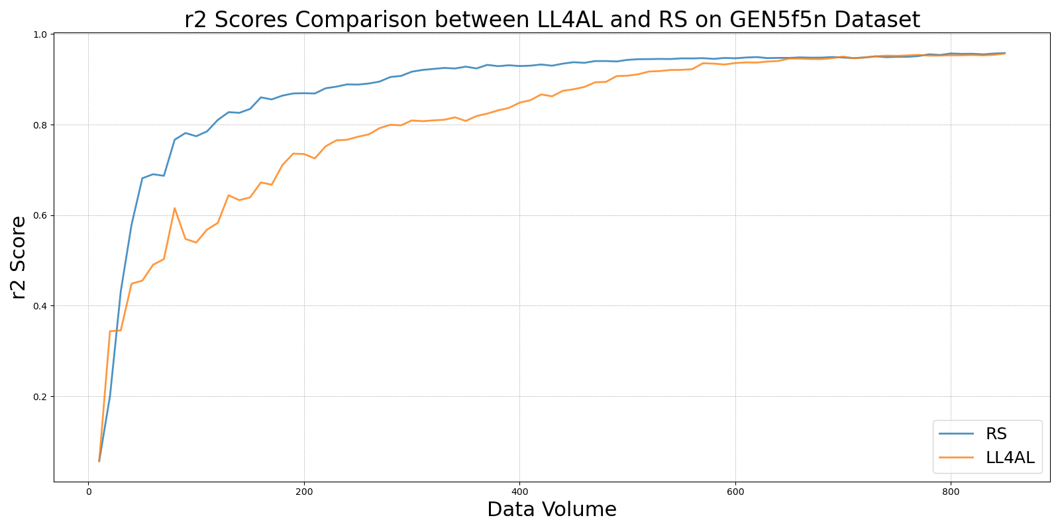

MCDvs_RS_on_GEN5f5n.png

