R2 Samples Report for 3 Thresholds

|  |  |  |  |
| --- | --- | --- | --- |
| Strategy | R2 >= 0.5 | R2 >= 0.7 | R2 >= 0.9 |
| RS | 60 (6.82%) | 100 (11.36%) | 530 (60.23%) |
| LL4AL | 60 (6.82%) | 390 (44.32%) | 720 (81.82%) |
| LCMD | 50 (5.68%) | 150 (17.05%) | 640 (72.73%) |
| MCD | 80 (9.09%) | 140 (15.91%) | 550 (62.50%) |
| EGAL | 40 (4.55%) | 110 (12.50%) | 620 (70.45%) |
| BayesianAL | 60 (6.82%) | 400 (45.45%) | 800 (90.91%) |
| GSx | 50 (5.68%) | 130 (14.77%) | 660 (75.00%) |
| GSy | 40 (4.55%) | 70 (7.95%) | 530 (60.23%) |
| GSi | 30 (3.41%) | 120 (13.64%) | 600 (68.18%) |
| GSBAG | 60 (6.82%) | 180 (20.45%) | 650 (73.86%) |

All_Strategies_on_GEN7f5n.png

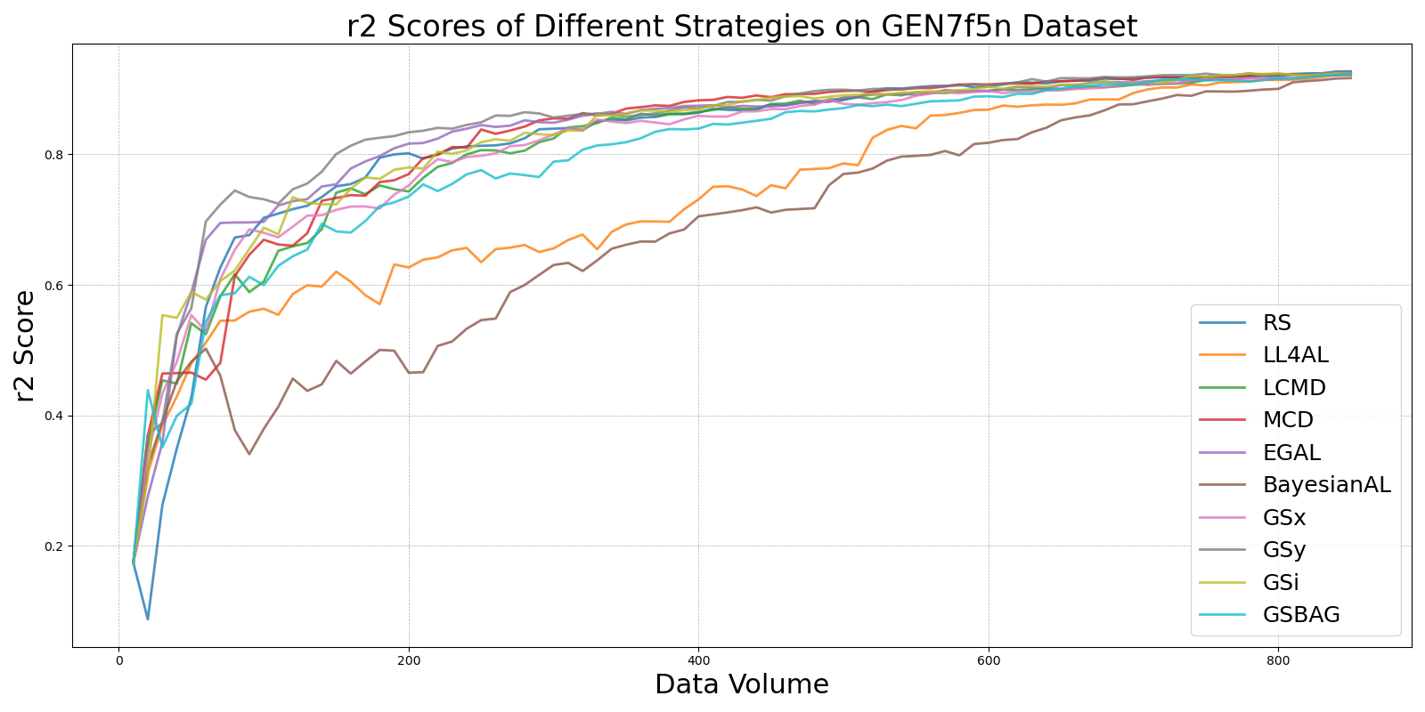

BayesianALvs_RS_on_GEN7f5n.png

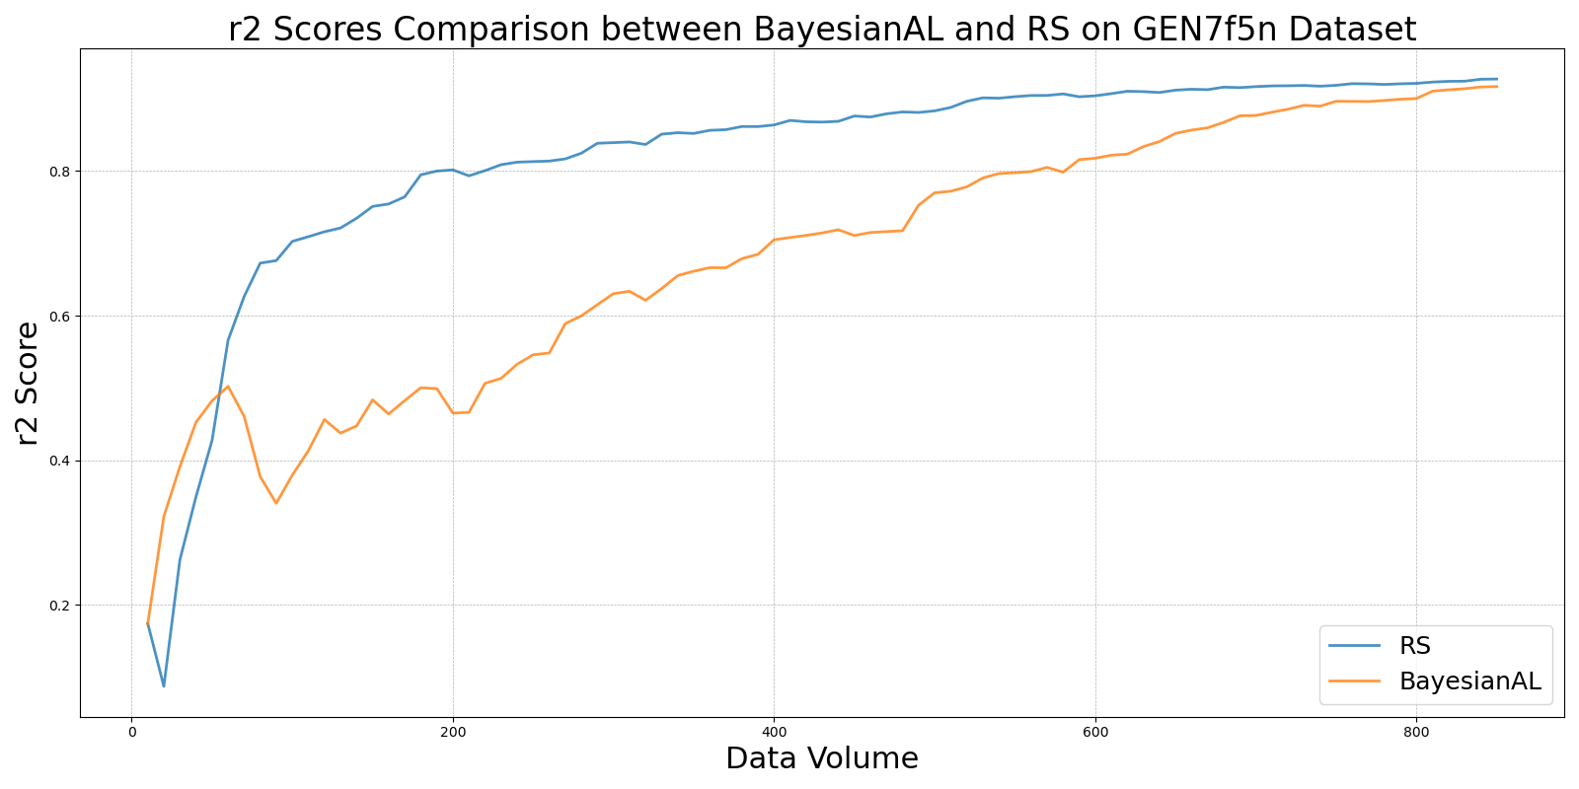

EGALvs_RS_on_GEN7f5n.png

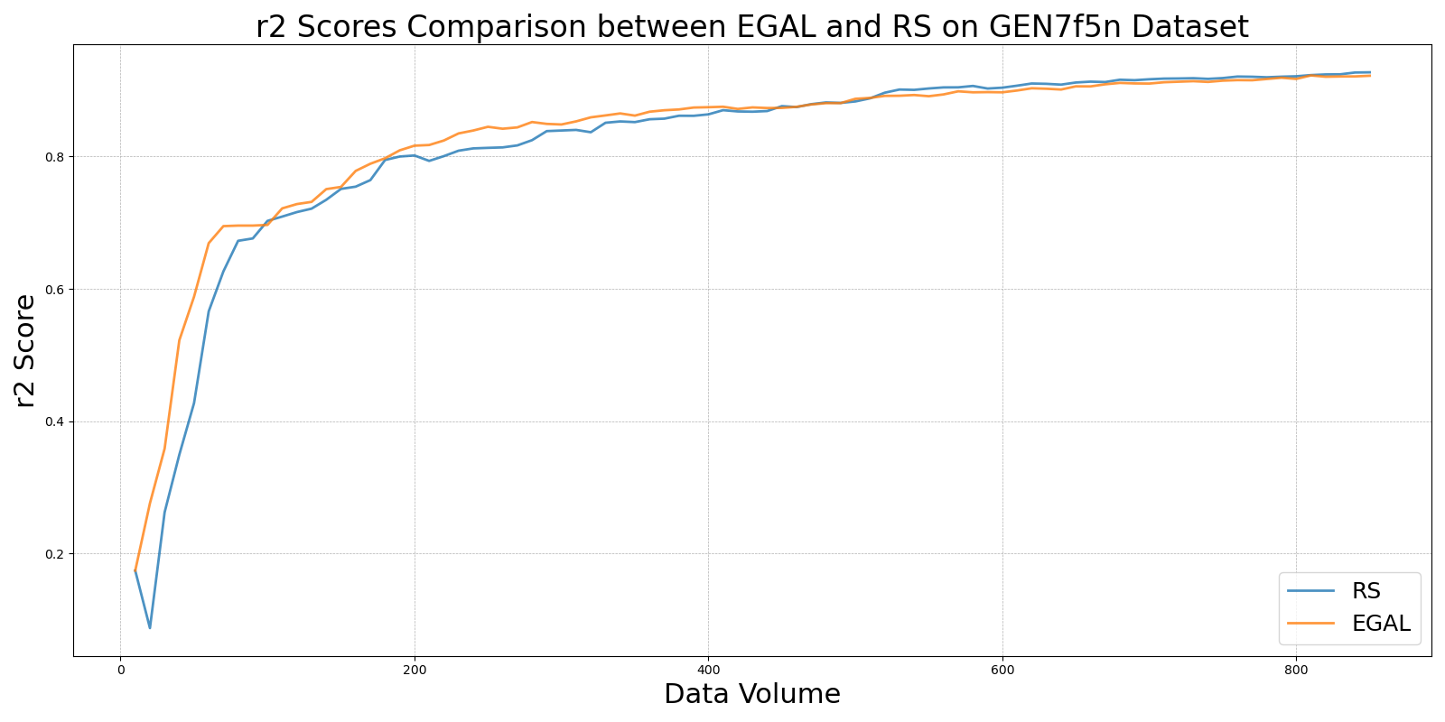

GSBAGvs_RS_on_GEN7f5n.png

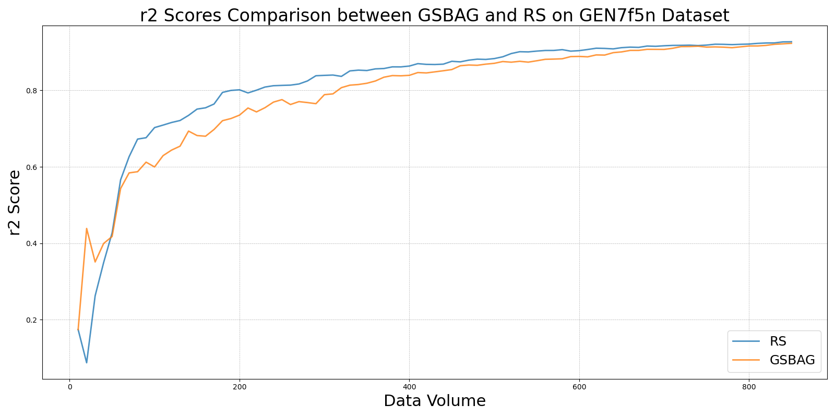

GSivs_RS_on_GEN7f5n.png

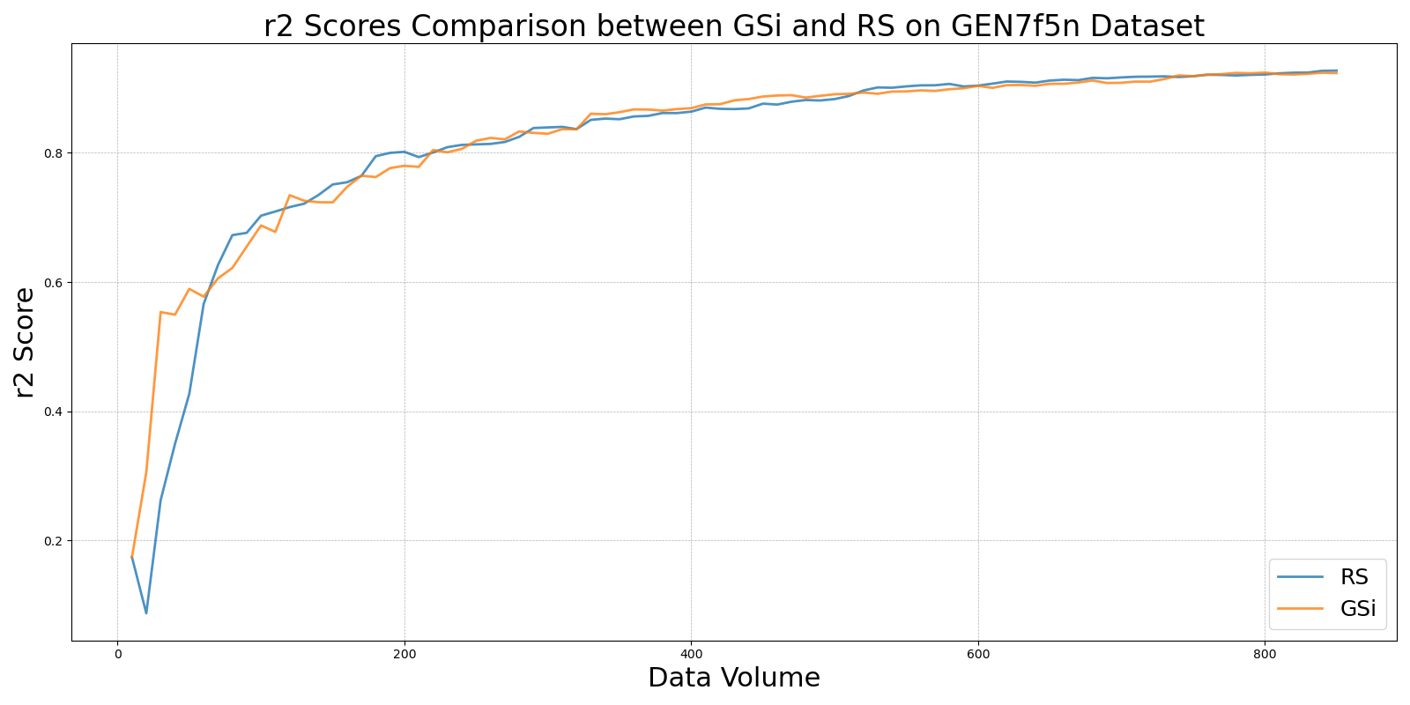

GSxvs_RS_on_GEN7f5n.png

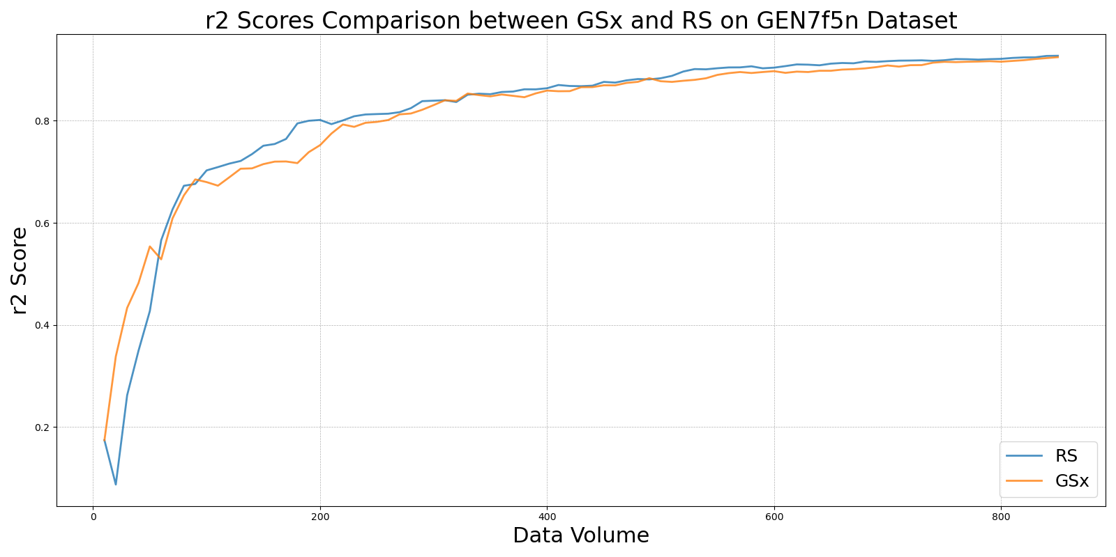

GSyvs_RS_on_GEN7f5n.png

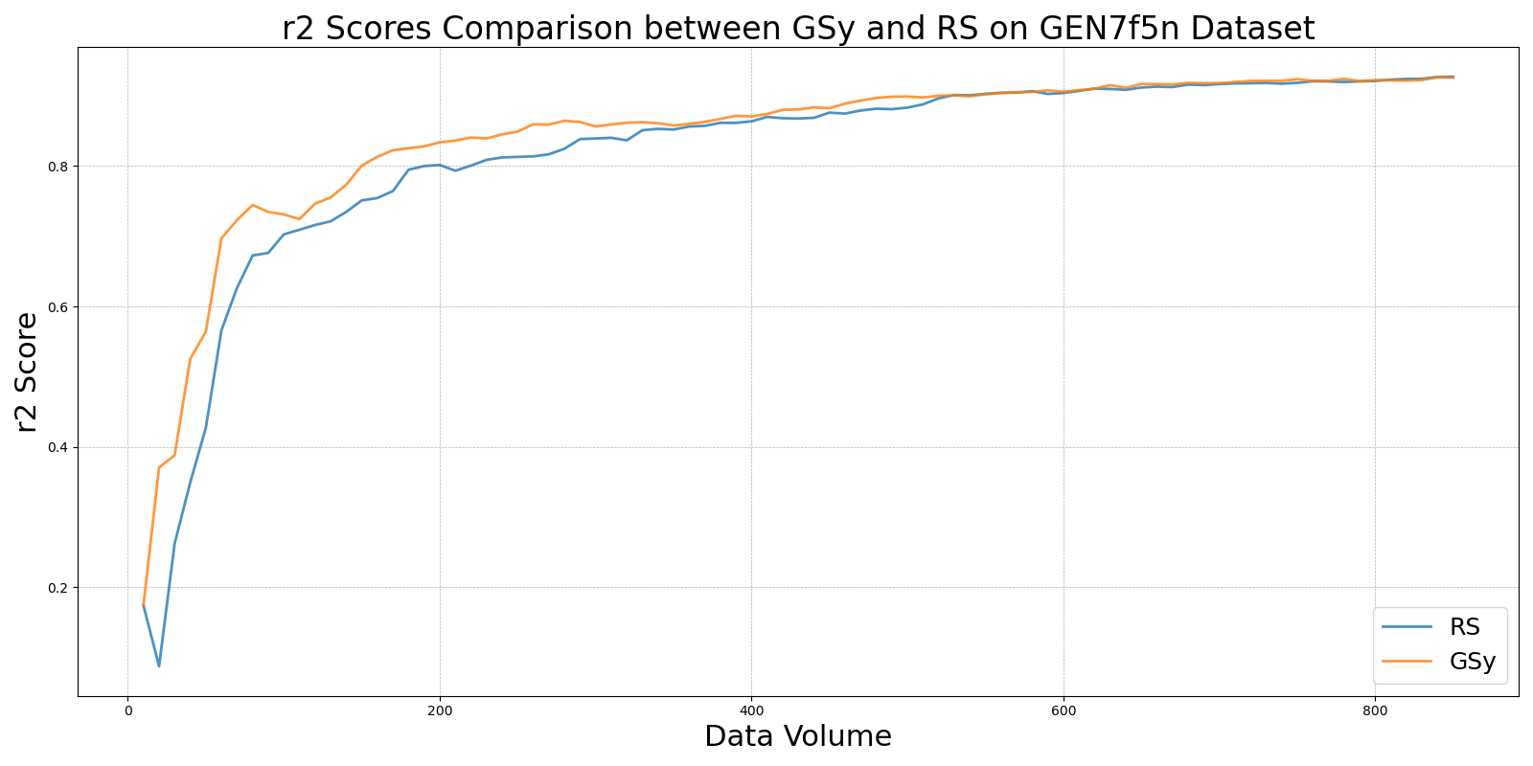

LCMDvs_RS_on_GEN7f5n.png

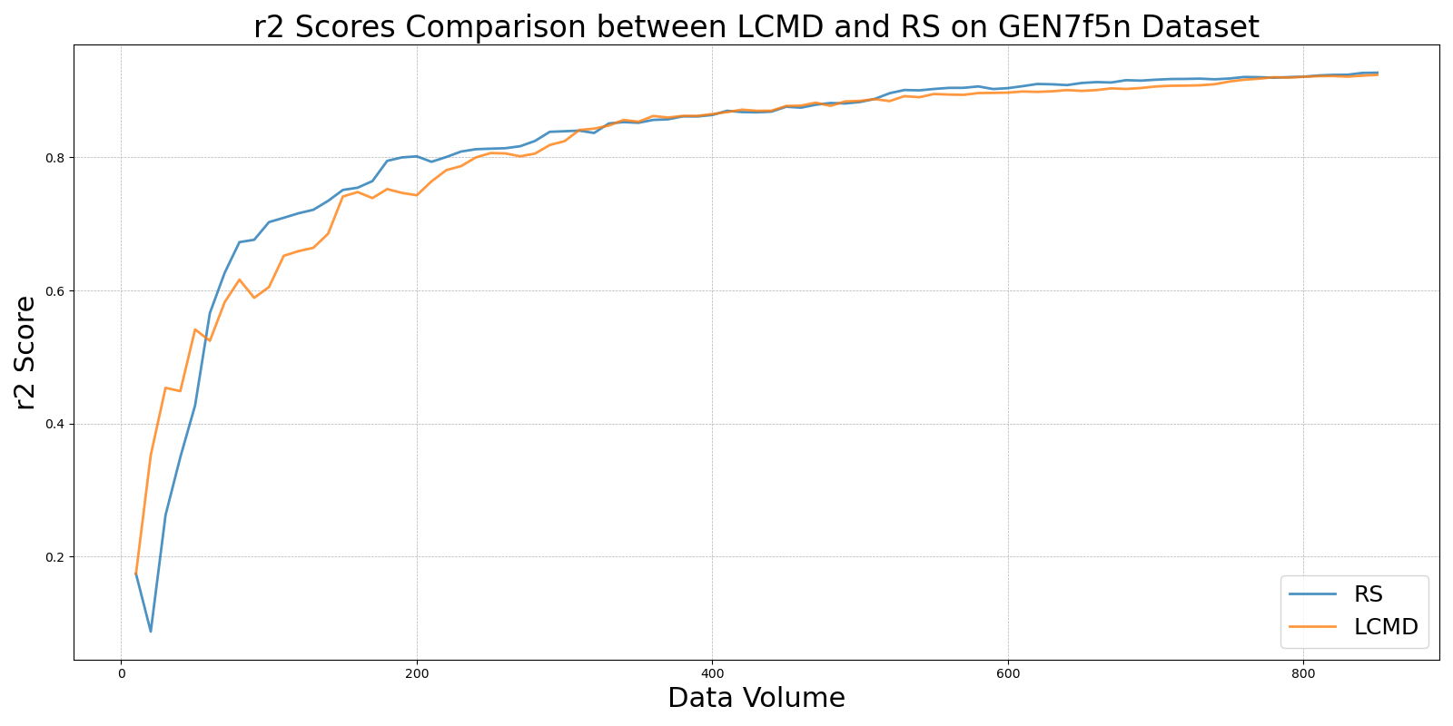

LL4ALvs_RS_on_GEN7f5n.png

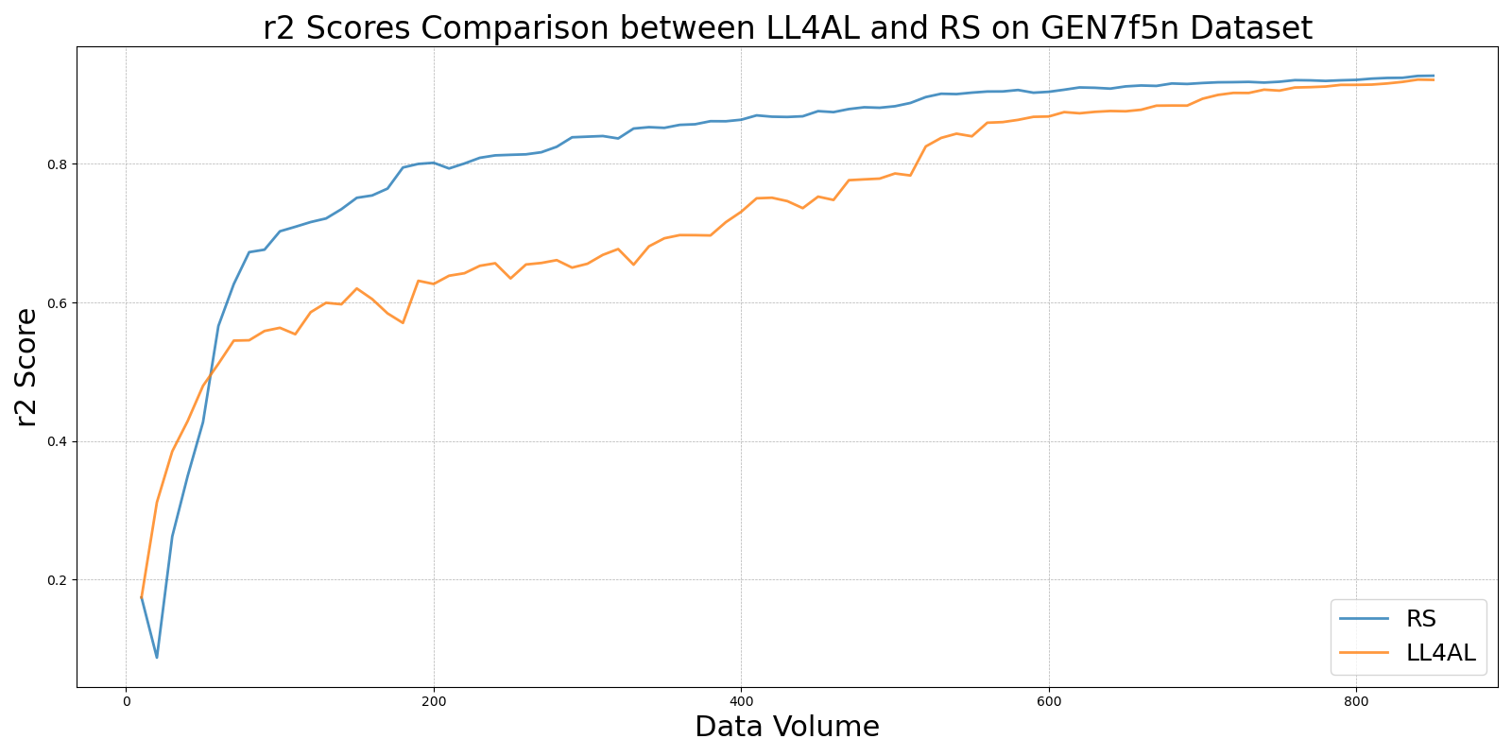

MCDvs_RS_on_GEN7f5n.png

