R2 Proportions Analysis

# RS Strategy - R2 Proportions

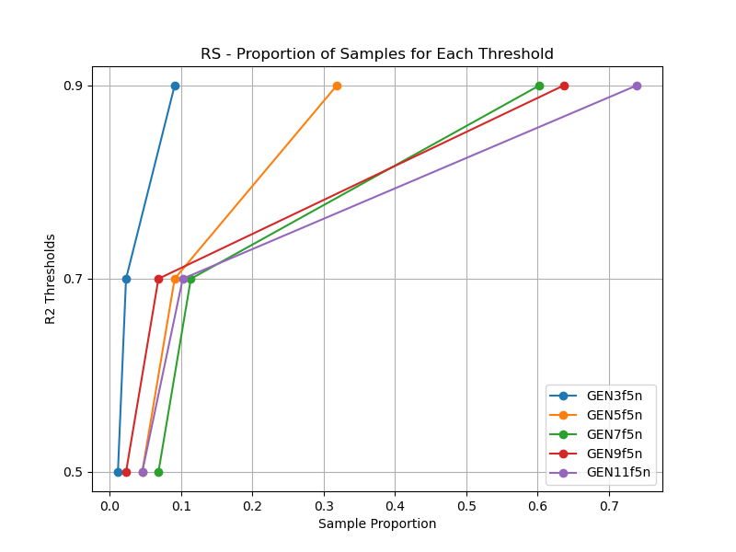

# LL4AL Strategy - R2 Proportions

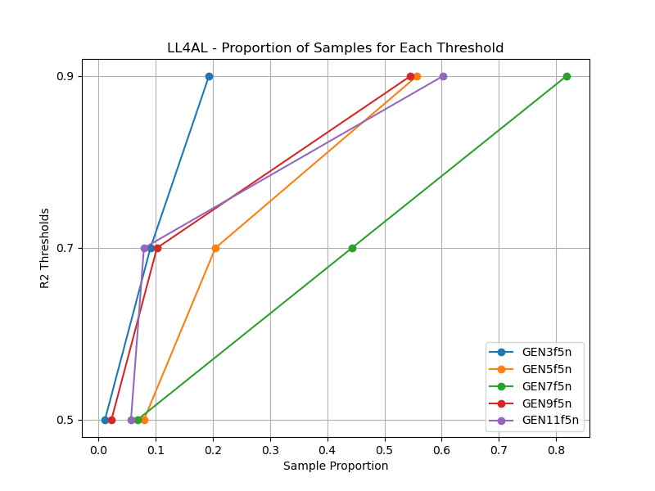

# LCMD Strategy - R2 Proportions

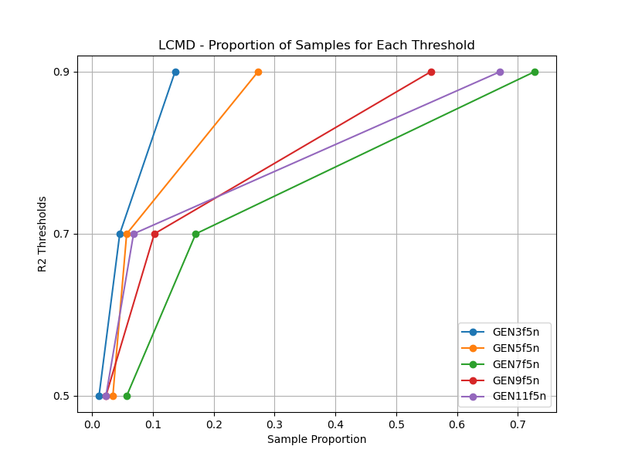

# MCD Strategy - R2 Proportions

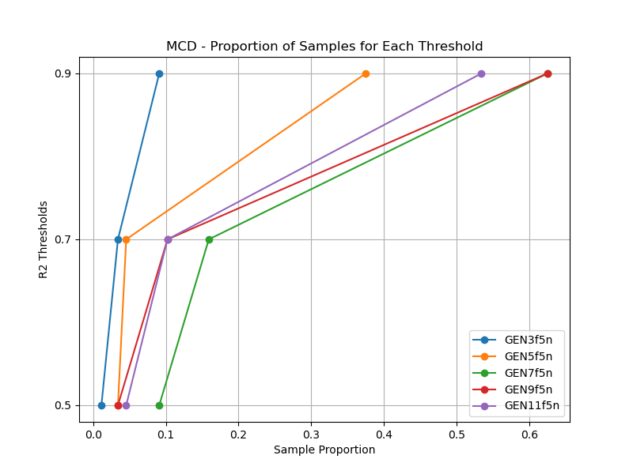

# EGAL Strategy - R2 Proportions

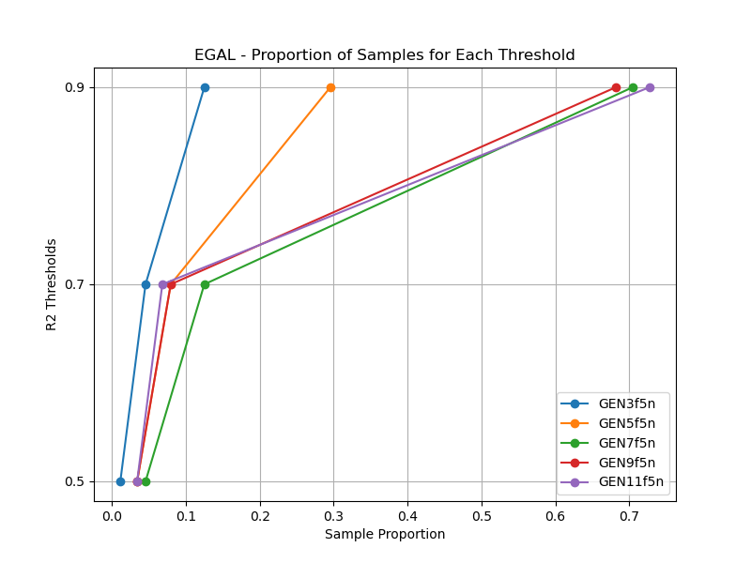

# BayesianAL Strategy - R2 Proportions

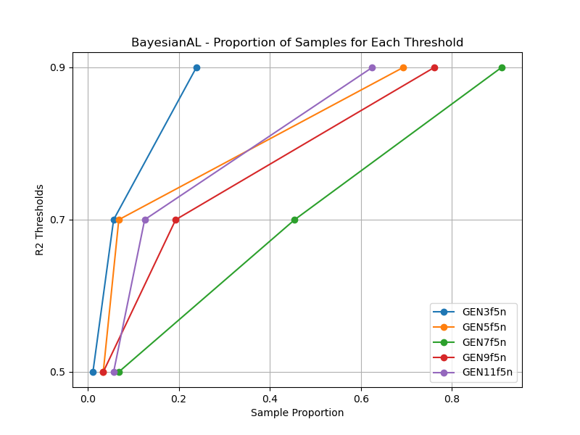

# GSx Strategy - R2 Proportions

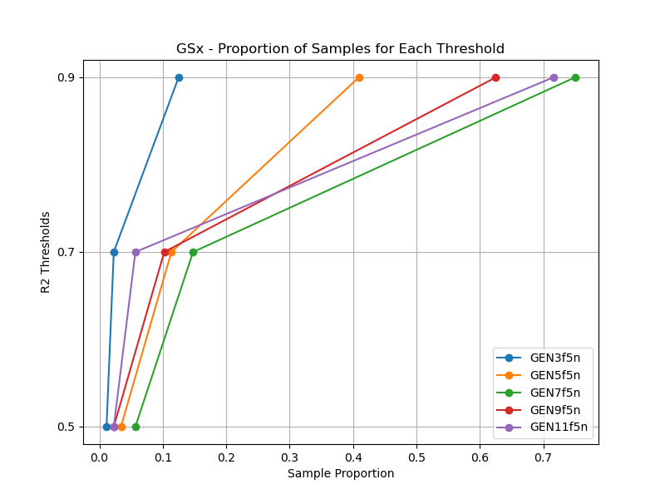

# GSy Strategy - R2 Proportions

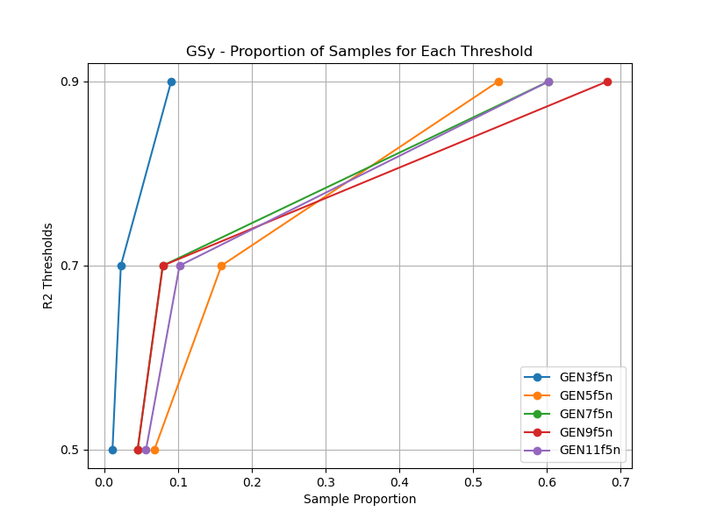

# GSi Strategy - R2 Proportions

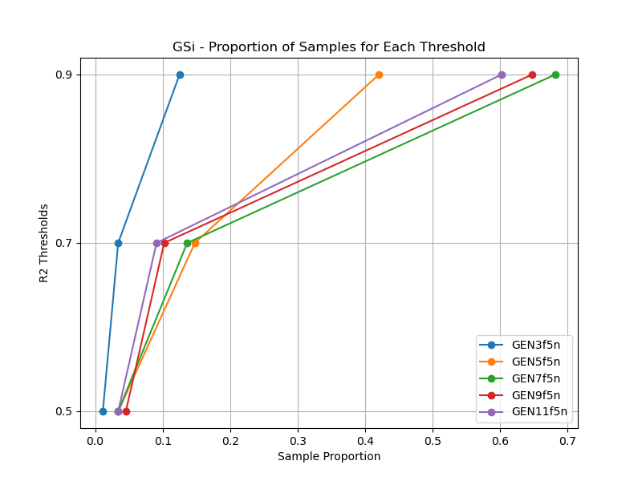

# GSBAG Strategy - R2 Proportions

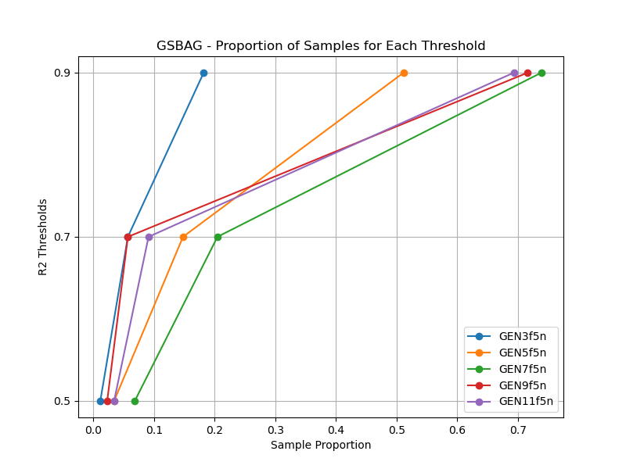

# RS Strategy - Proportion Table

|  |  |  |  |
| --- | --- | --- | --- |
| Dataset | R2 ≥ 0.5 | R2 ≥ 0.7 | R2 ≥ 0.9 |
| GEN3f5n | 0.01 | 0.02 | 0.09 |
| GEN5f5n | 0.05 | 0.09 | 0.32 |
| GEN7f5n | 0.07 | 0.11 | 0.60 |
| GEN9f5n | 0.02 | 0.07 | 0.64 |
| GEN11f5n | 0.05 | 0.10 | 0.74 |

# LL4AL Strategy - Proportion Table

|  |  |  |  |
| --- | --- | --- | --- |
| Dataset | R2 ≥ 0.5 | R2 ≥ 0.7 | R2 ≥ 0.9 |
| GEN3f5n | 0.01 | 0.09 | 0.19 |
| GEN5f5n | 0.08 | 0.20 | 0.56 |
| GEN7f5n | 0.07 | 0.44 | 0.82 |
| GEN9f5n | 0.02 | 0.10 | 0.55 |
| GEN11f5n | 0.06 | 0.08 | 0.60 |

# LCMD Strategy - Proportion Table

|  |  |  |  |
| --- | --- | --- | --- |
| Dataset | R2 ≥ 0.5 | R2 ≥ 0.7 | R2 ≥ 0.9 |
| GEN3f5n | 0.01 | 0.05 | 0.14 |
| GEN5f5n | 0.03 | 0.06 | 0.27 |
| GEN7f5n | 0.06 | 0.17 | 0.73 |
| GEN9f5n | 0.02 | 0.10 | 0.56 |
| GEN11f5n | 0.02 | 0.07 | 0.67 |

# MCD Strategy - Proportion Table

|  |  |  |  |
| --- | --- | --- | --- |
| Dataset | R2 ≥ 0.5 | R2 ≥ 0.7 | R2 ≥ 0.9 |
| GEN3f5n | 0.01 | 0.03 | 0.09 |
| GEN5f5n | 0.03 | 0.05 | 0.38 |
| GEN7f5n | 0.09 | 0.16 | 0.62 |
| GEN9f5n | 0.03 | 0.10 | 0.62 |
| GEN11f5n | 0.05 | 0.10 | 0.53 |

# EGAL Strategy - Proportion Table

|  |  |  |  |
| --- | --- | --- | --- |
| Dataset | R2 ≥ 0.5 | R2 ≥ 0.7 | R2 ≥ 0.9 |
| GEN3f5n | 0.01 | 0.05 | 0.12 |
| GEN5f5n | 0.03 | 0.08 | 0.30 |
| GEN7f5n | 0.05 | 0.12 | 0.70 |
| GEN9f5n | 0.03 | 0.08 | 0.68 |
| GEN11f5n | 0.03 | 0.07 | 0.73 |

# BayesianAL Strategy - Proportion Table

|  |  |  |  |
| --- | --- | --- | --- |
| Dataset | R2 ≥ 0.5 | R2 ≥ 0.7 | R2 ≥ 0.9 |
| GEN3f5n | 0.01 | 0.06 | 0.24 |
| GEN5f5n | 0.03 | 0.07 | 0.69 |
| GEN7f5n | 0.07 | 0.45 | 0.91 |
| GEN9f5n | 0.03 | 0.19 | 0.76 |
| GEN11f5n | 0.06 | 0.12 | 0.62 |

# GSx Strategy - Proportion Table

|  |  |  |  |
| --- | --- | --- | --- |
| Dataset | R2 ≥ 0.5 | R2 ≥ 0.7 | R2 ≥ 0.9 |
| GEN3f5n | 0.01 | 0.02 | 0.12 |
| GEN5f5n | 0.03 | 0.11 | 0.41 |
| GEN7f5n | 0.06 | 0.15 | 0.75 |
| GEN9f5n | 0.02 | 0.10 | 0.62 |
| GEN11f5n | 0.02 | 0.06 | 0.72 |

# GSy Strategy - Proportion Table

|  |  |  |  |
| --- | --- | --- | --- |
| Dataset | R2 ≥ 0.5 | R2 ≥ 0.7 | R2 ≥ 0.9 |
| GEN3f5n | 0.01 | 0.02 | 0.09 |
| GEN5f5n | 0.07 | 0.16 | 0.53 |
| GEN7f5n | 0.05 | 0.08 | 0.60 |
| GEN9f5n | 0.05 | 0.08 | 0.68 |
| GEN11f5n | 0.06 | 0.10 | 0.60 |

# GSi Strategy - Proportion Table

|  |  |  |  |
| --- | --- | --- | --- |
| Dataset | R2 ≥ 0.5 | R2 ≥ 0.7 | R2 ≥ 0.9 |
| GEN3f5n | 0.01 | 0.03 | 0.12 |
| GEN5f5n | 0.03 | 0.15 | 0.42 |
| GEN7f5n | 0.03 | 0.14 | 0.68 |
| GEN9f5n | 0.05 | 0.10 | 0.65 |
| GEN11f5n | 0.03 | 0.09 | 0.60 |

# GSBAG Strategy - Proportion Table

|  |  |  |  |
| --- | --- | --- | --- |
| Dataset | R2 ≥ 0.5 | R2 ≥ 0.7 | R2 ≥ 0.9 |
| GEN3f5n | 0.01 | 0.06 | 0.18 |
| GEN5f5n | 0.03 | 0.15 | 0.51 |
| GEN7f5n | 0.07 | 0.20 | 0.74 |
| GEN9f5n | 0.02 | 0.06 | 0.72 |
| GEN11f5n | 0.03 | 0.09 | 0.69 |