R2 Samples Report for 3 Thresholds

|  |  |  |  |
| --- | --- | --- | --- |
| Strategy | R2 >= 0.5 | R2 >= 0.7 | R2 >= 0.9 |
| RS | 40 (4.85%) | 70 (8.50%) | 600 (72.82%) |
| LL4AL | 70 (8.50%) | 130 (15.78%) | 680 (82.52%) |
| LCMD | 30 (3.64%) | 60 (7.28%) | 420 (50.97%) |
| MCD | 70 (8.50%) | 80 (9.71%) | 580 (70.39%) |
| EGAL | 40 (4.85%) | 70 (8.50%) | 540 (65.53%) |
| BayesianAL | 60 (7.28%) | 80 (9.71%) | 550 (66.75%) |
| GSx | 30 (3.64%) | 100 (12.14%) | 520 (63.11%) |
| GSy | 60 (7.28%) | 120 (14.56%) | 700 (84.95%) |
| GSi | 40 (4.85%) | 100 (12.14%) | 660 (80.10%) |
| GSBAG | 30 (3.64%) | 40 (4.85%) | 420 (50.97%) |

All_Strategies_on_concrete_uci.png

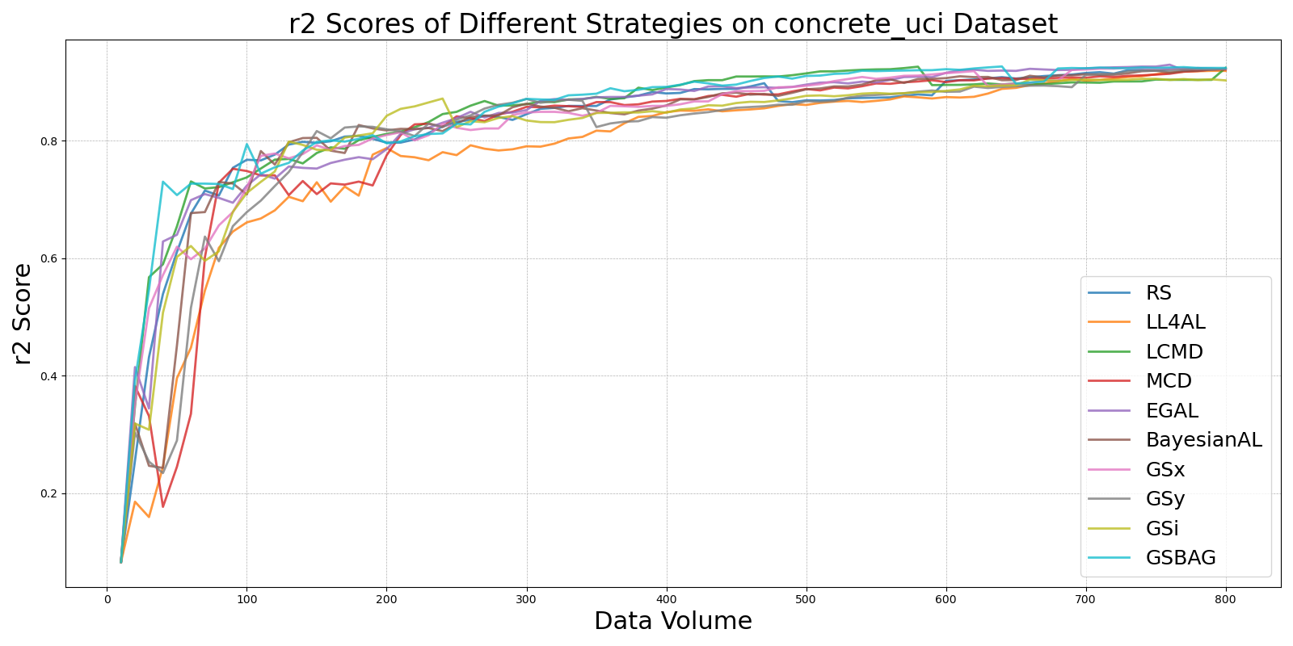

BayesianALvs_RS_on_concrete_uci.png

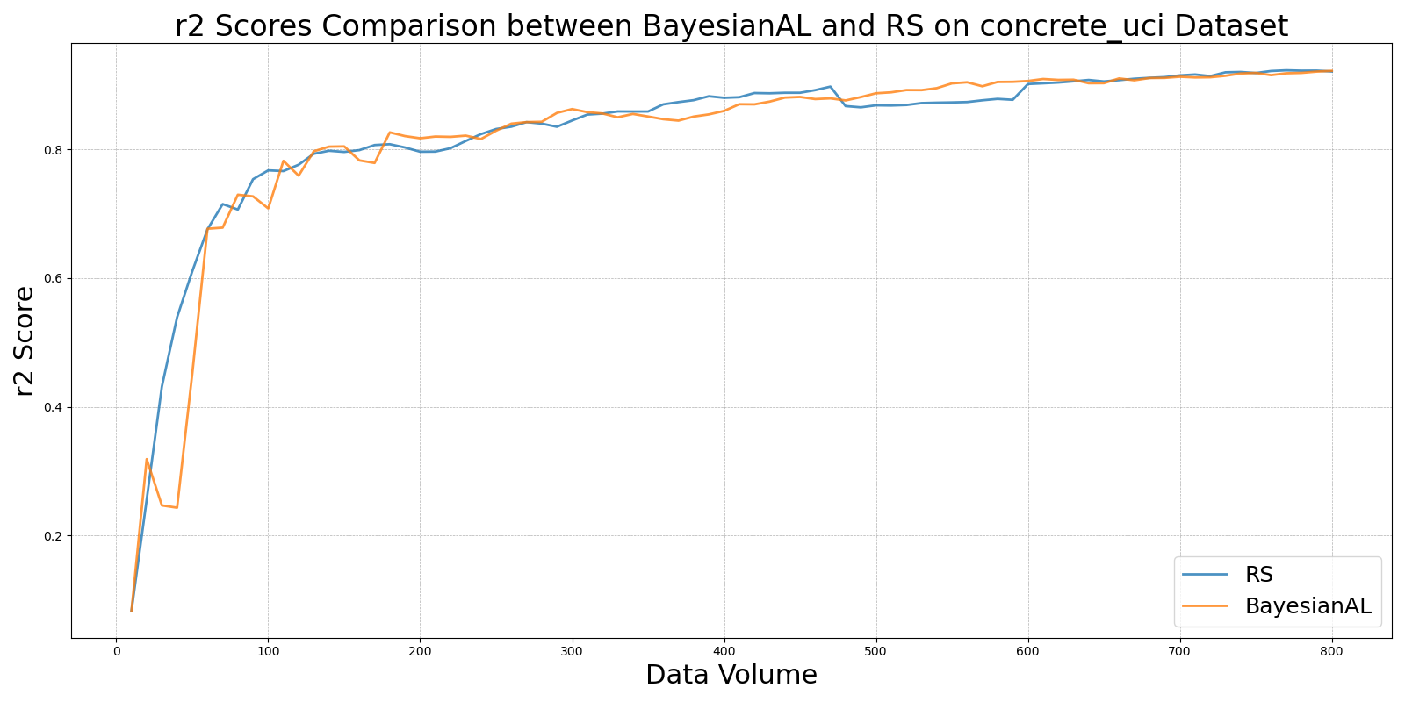

EGALvs_RS_on_concrete_uci.png

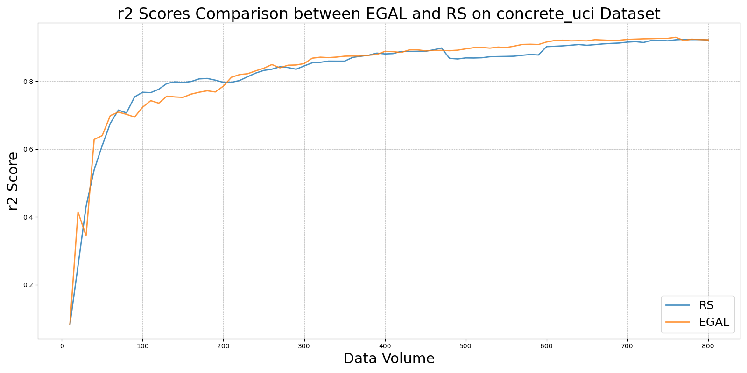

GSBAGvs_RS_on_concrete_uci.png

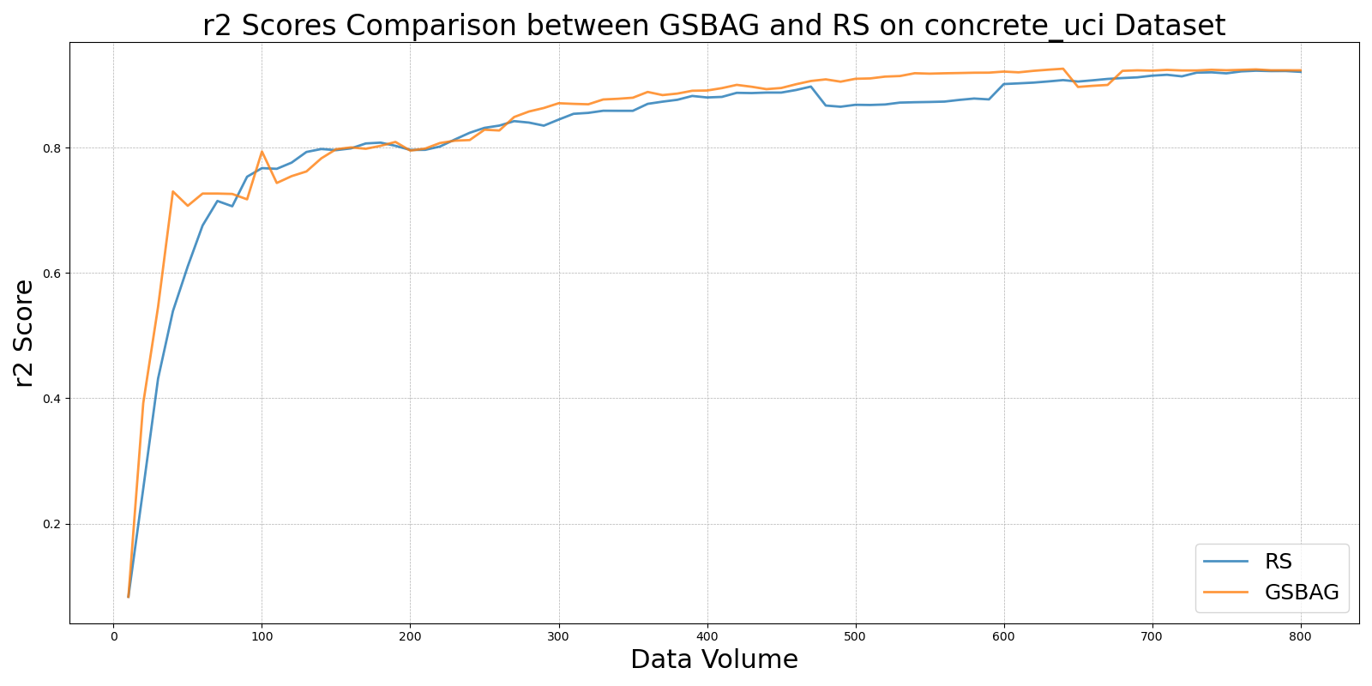

GSivs_RS_on_concrete_uci.png

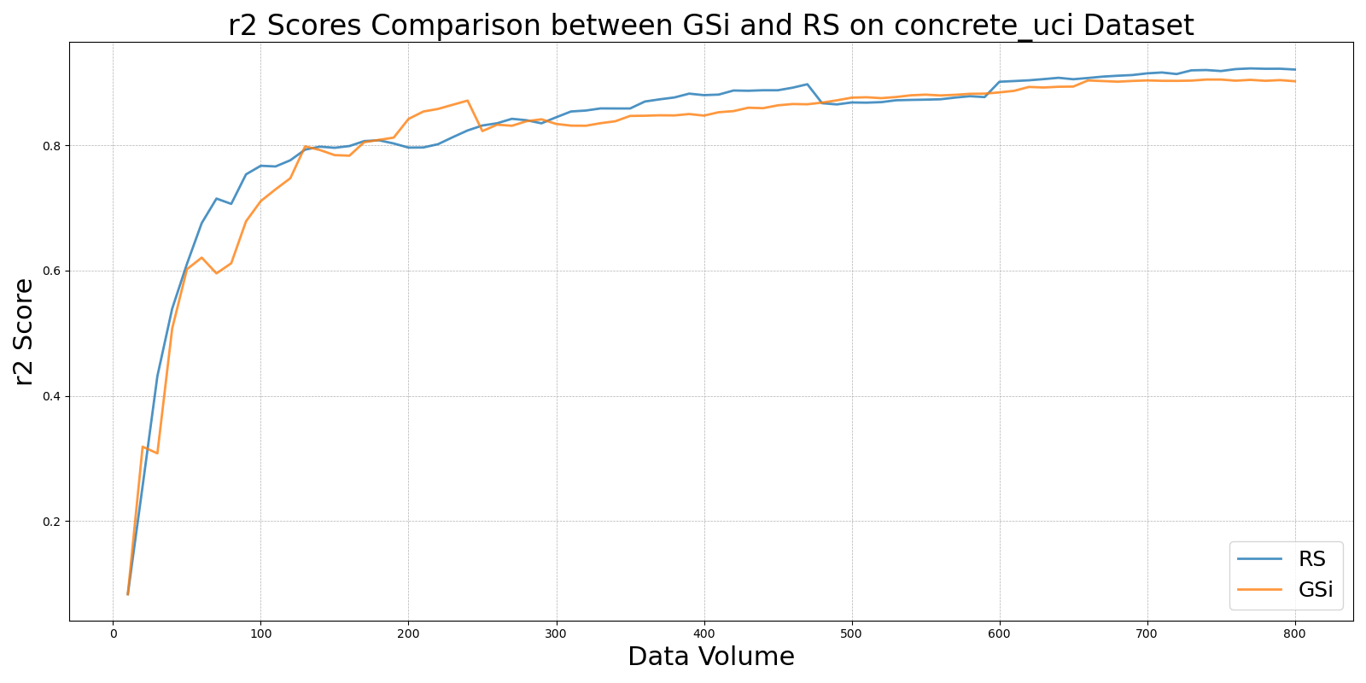

GSxvs_RS_on_concrete_uci.png

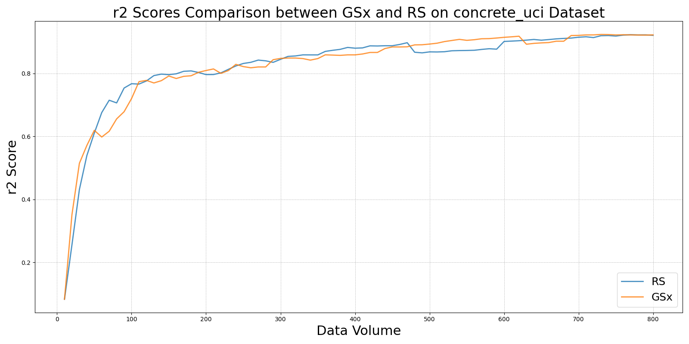

GSyvs_RS_on_concrete_uci.png

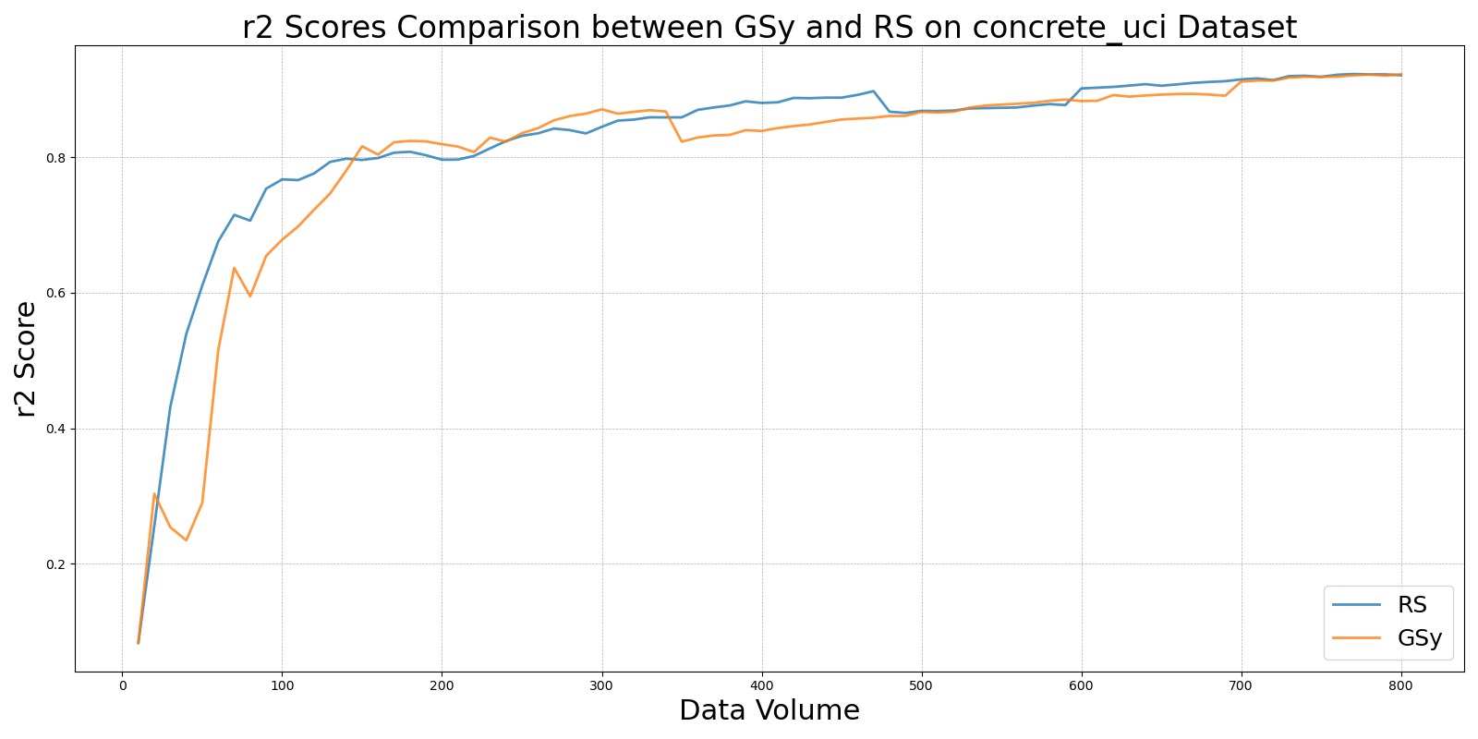

LCMDvs_RS_on_concrete_uci.png

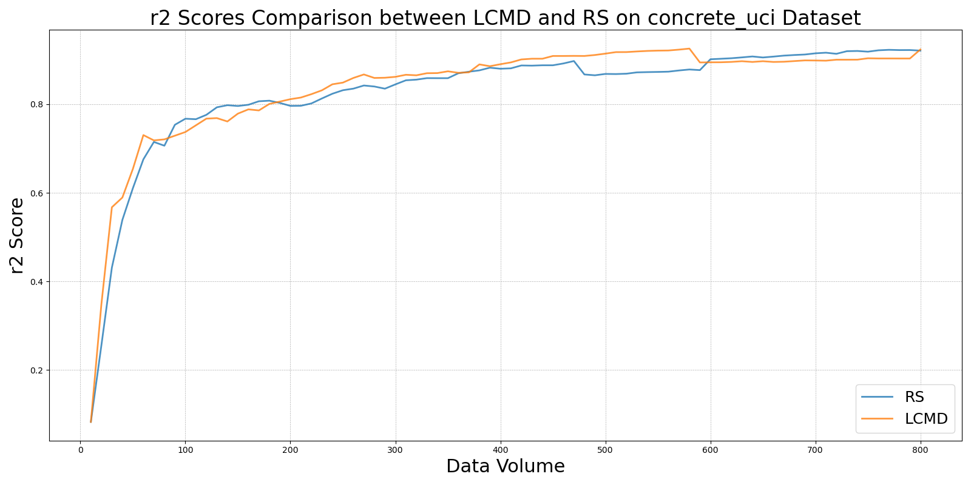

LL4ALvs_RS_on_concrete_uci.png

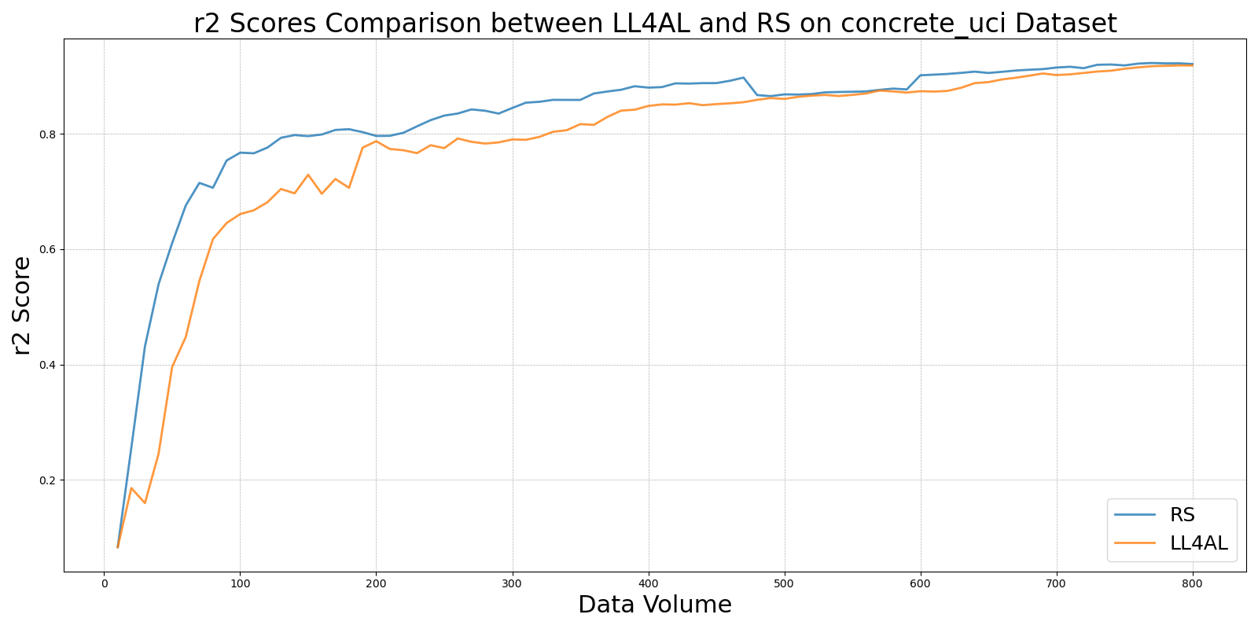

MCDvs_RS_on_concrete_uci.png

