R2 Samples Report for 3 Thresholds

|  |  |  |  |
| --- | --- | --- | --- |
| Strategy | R2 >= 0.5 | R2 >= 0.7 | R2 >= 0.9 |
| RS | 30 (4.08%) | 30 (4.08%) | 70 (9.53%) |
| LL4AL | 50 (6.81%) | 50 (6.81%) | 190 (25.87%) |
| LCMD | 20 (2.72%) | 20 (2.72%) | 20 (2.72%) |
| MCD | 20 (2.72%) | 20 (2.72%) | 30 (4.08%) |
| EGAL | 60 (8.17%) | 60 (8.17%) | 150 (20.42%) |
| BayesianAL | 60 (8.17%) | 60 (8.17%) | 60 (8.17%) |
| GSx | 20 (2.72%) | 20 (2.72%) | 320 (43.57%) |
| GSy | 90 (12.25%) | 90 (12.25%) | 100 (13.62%) |
| GSi | 20 (2.72%) | 20 (2.72%) | 20 (2.72%) |
| GSBAG | 20 (2.72%) | 20 (2.72%) | 20 (2.72%) |

All_Strategies_on_pullout_fmax.png

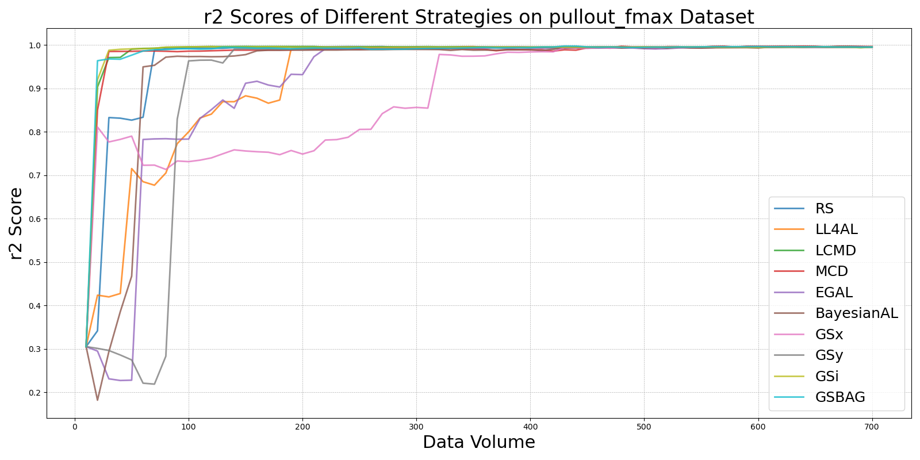

BayesianALvs_RS_on_pullout_fmax.png

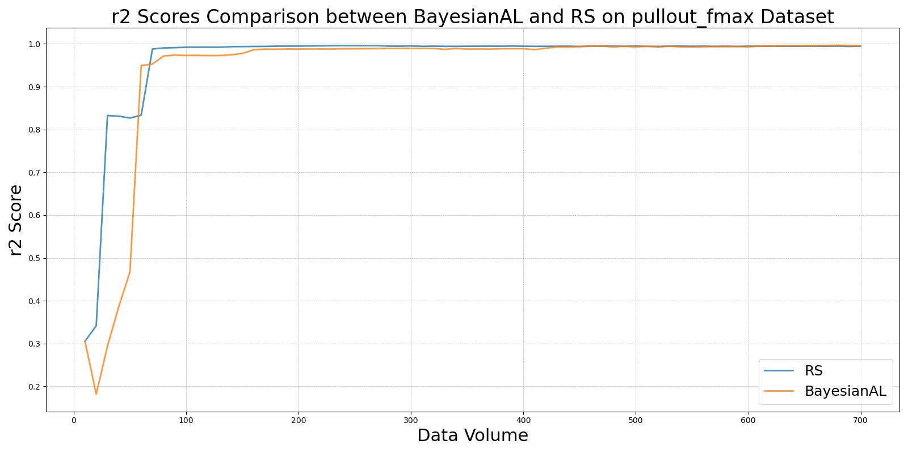

EGALvs_RS_on_pullout_fmax.png

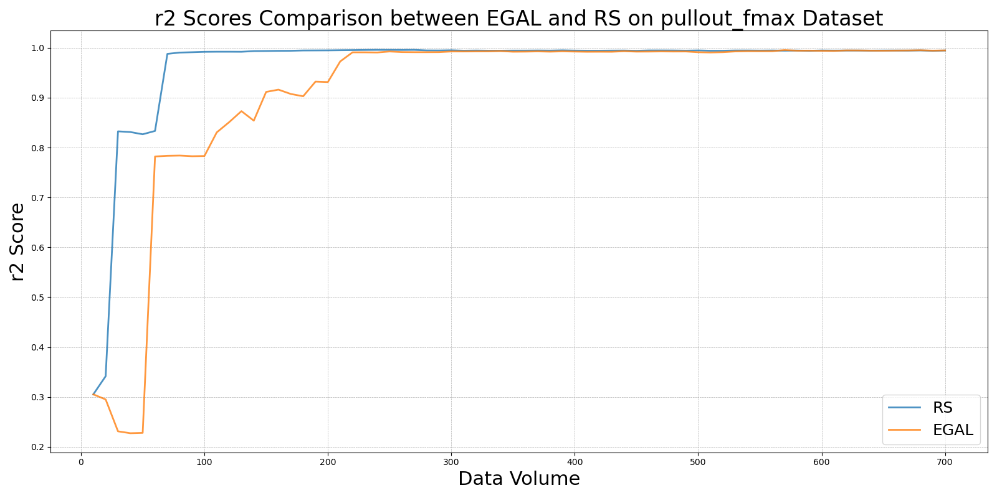

GSBAGvs_RS_on_pullout_fmax.png

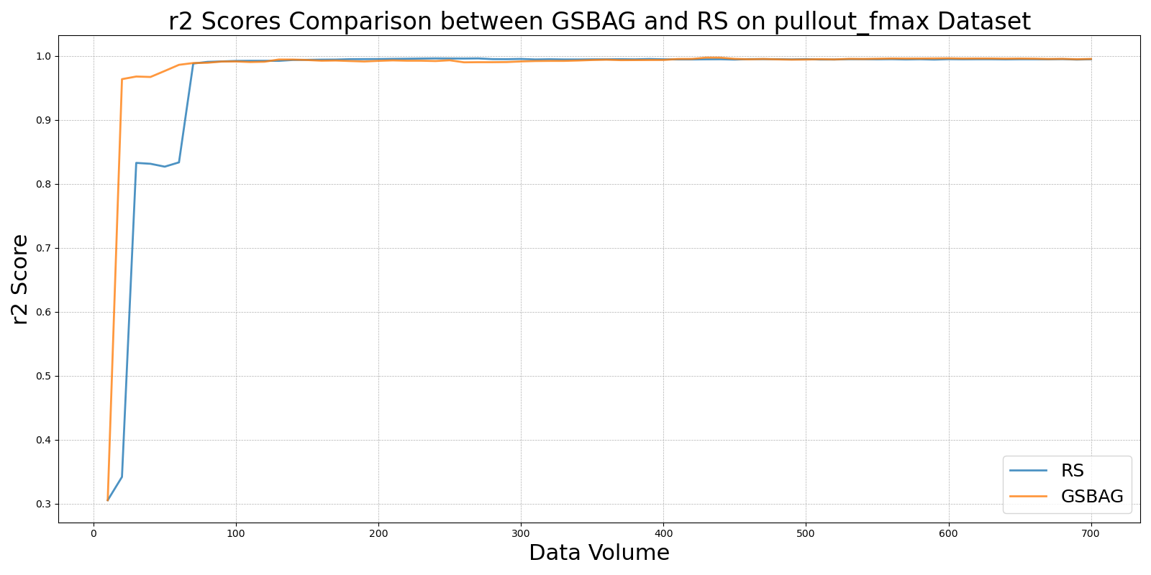

GSivs_RS_on_pullout_fmax.png

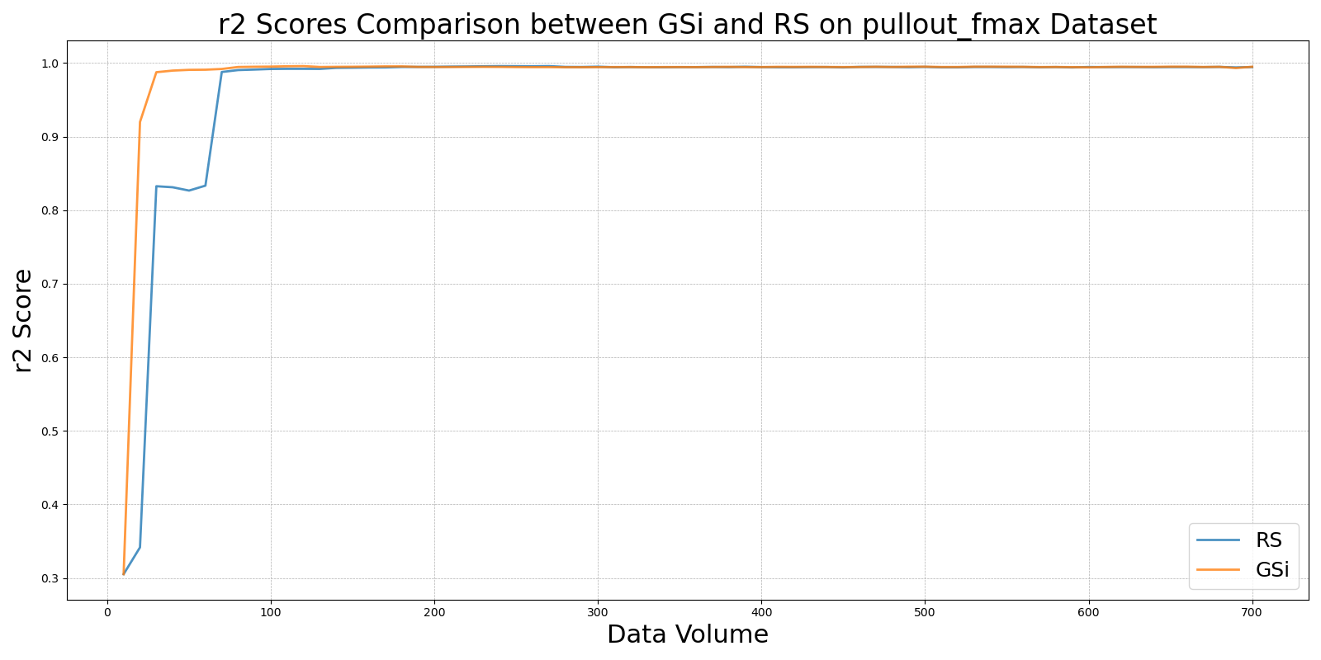

GSxvs_RS_on_pullout_fmax.png

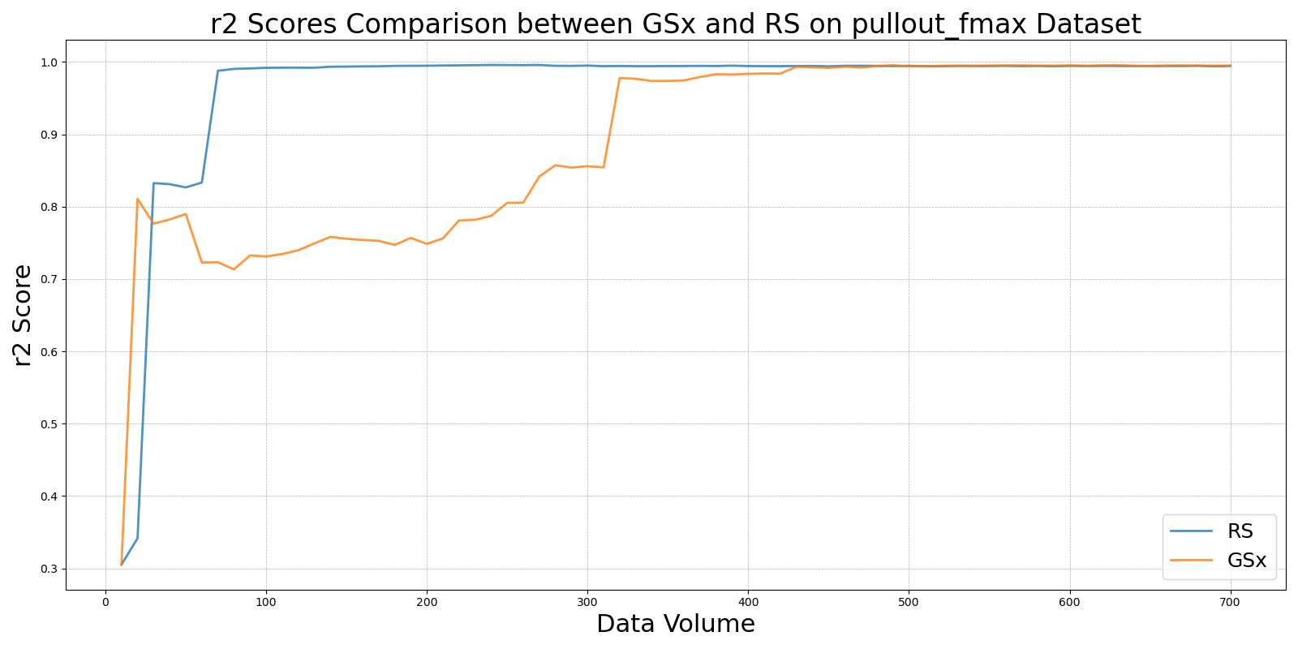

GSyvs_RS_on_pullout_fmax.png

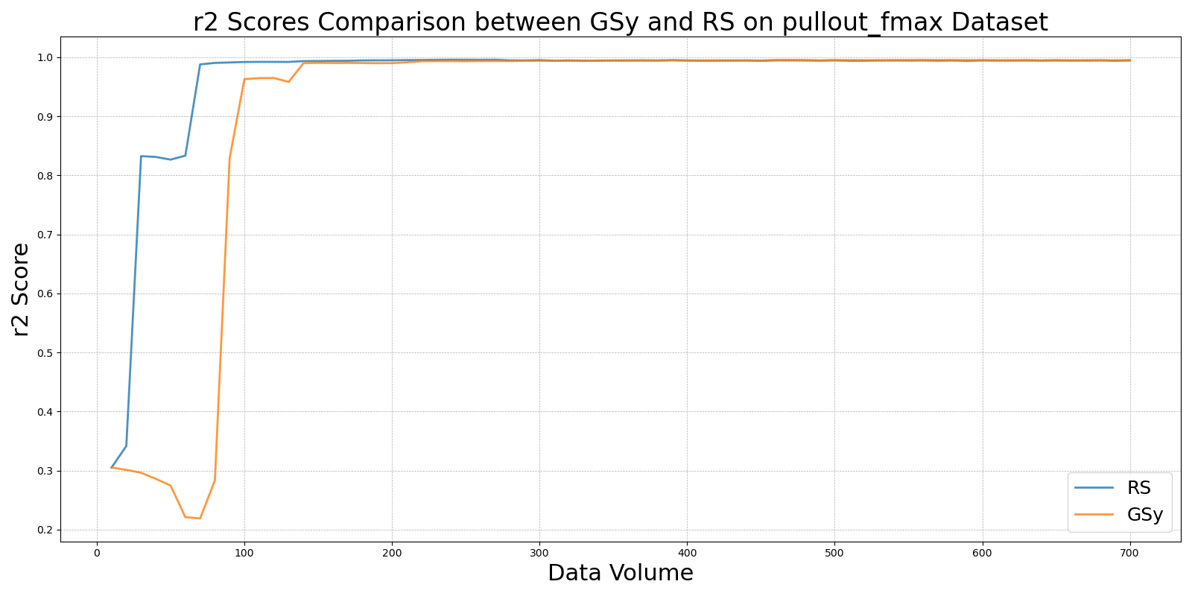

LCMDvs_RS_on_pullout_fmax.png

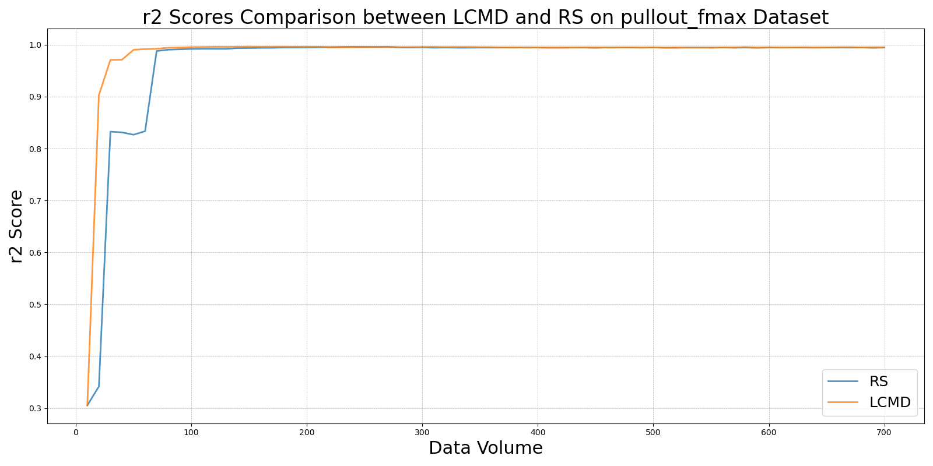

LL4ALvs_RS_on_pullout_fmax.png

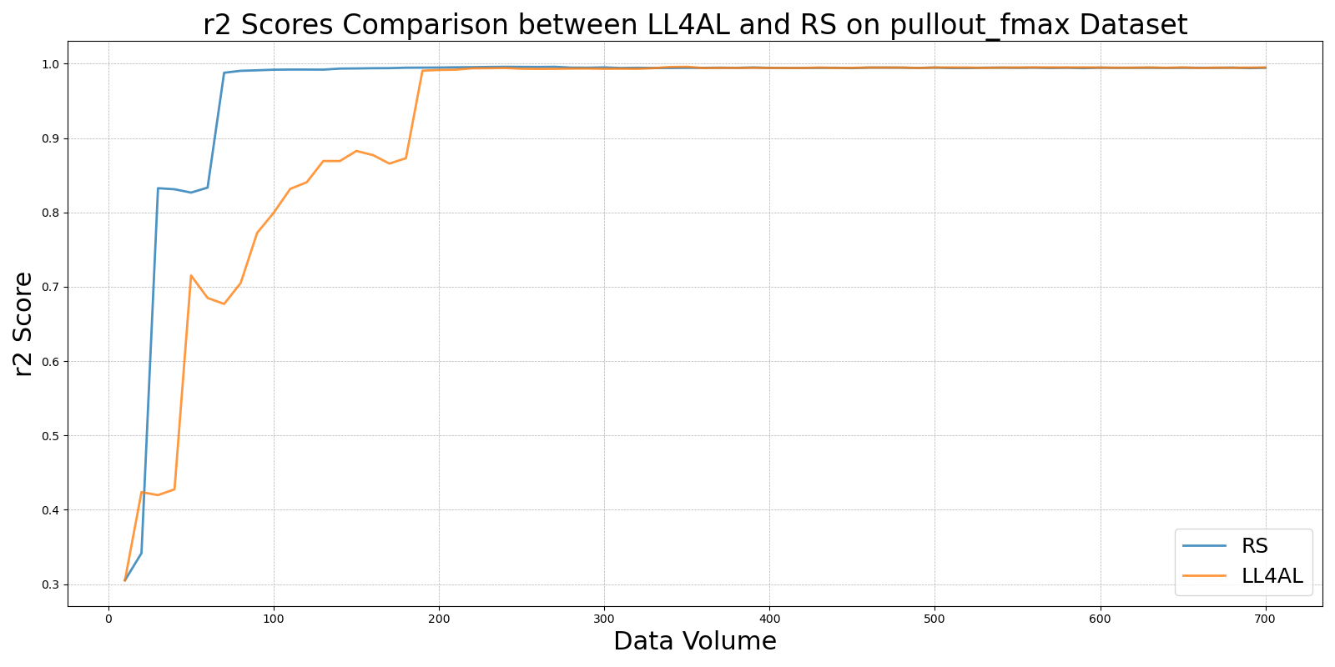

MCDvs_RS_on_pullout_fmax.png

