R2 Samples Report for 3 Thresholds

|  |  |  |  |
| --- | --- | --- | --- |
| Strategy | R2 >= 0.5 | R2 >= 0.7 | R2 >= 0.9 |
| RS | 10 (1.36%) | 50 (6.81%) | 70 (9.53%) |
| LL4AL | 10 (1.36%) | 30 (4.08%) | 190 (25.87%) |
| LCMD | 10 (1.36%) | 20 (2.72%) | 70 (9.53%) |
| MCD | 10 (1.36%) | 90 (12.25%) | 120 (16.34%) |
| EGAL | 10 (1.36%) | 80 (10.89%) | 80 (10.89%) |
| BayesianAL | 10 (1.36%) | 260 (35.40%) | 620 (84.42%) |
| GSx | 10 (1.36%) | 20 (2.72%) | 180 (24.51%) |
| GSy | 10 (1.36%) | 30 (4.08%) | 40 (5.45%) |
| GSi | 10 (1.36%) | 20 (2.72%) | 50 (6.81%) |
| GSBAG | 10 (1.36%) | 20 (2.72%) | 90 (12.25%) |

All_Strategies_on_pullout_ifss.png

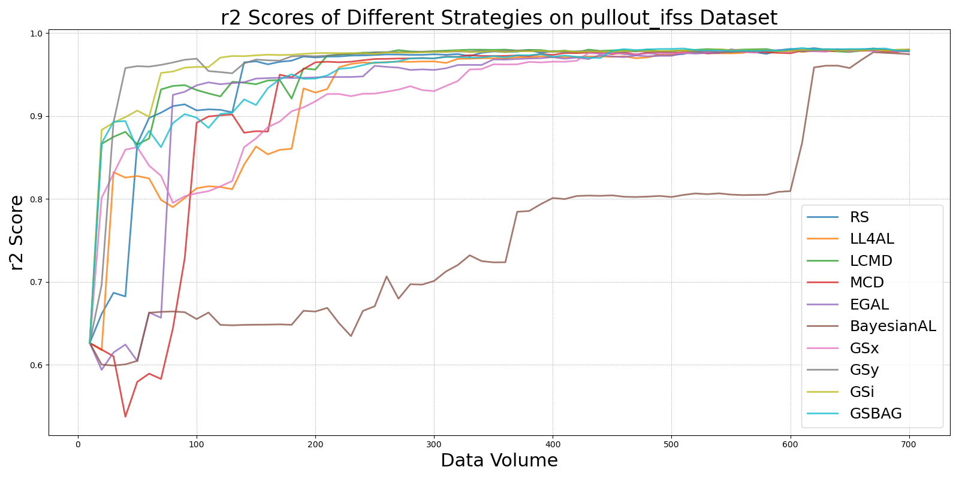

BayesianALvs_RS_on_pullout_ifss.png

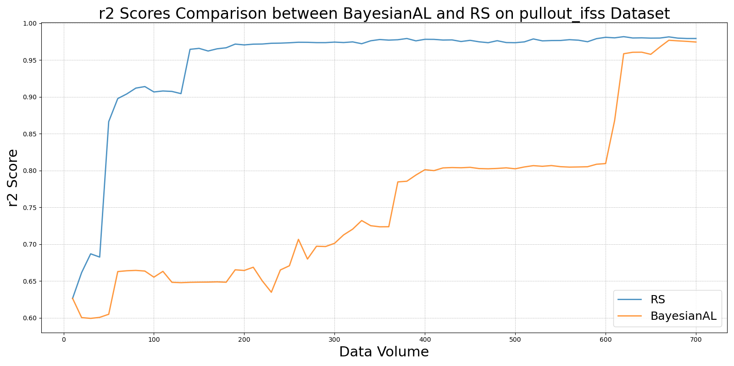

EGALvs_RS_on_pullout_ifss.png

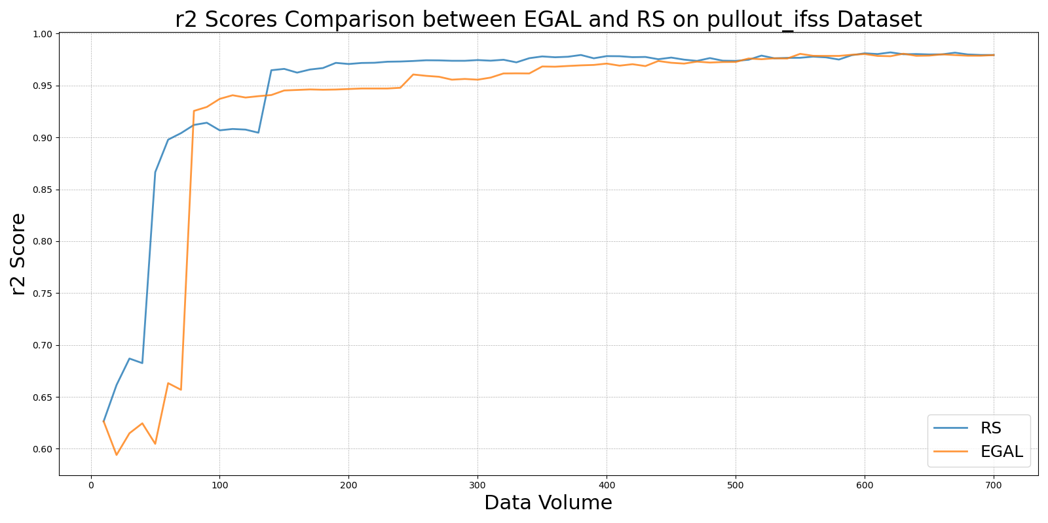

GSBAGvs_RS_on_pullout_ifss.png

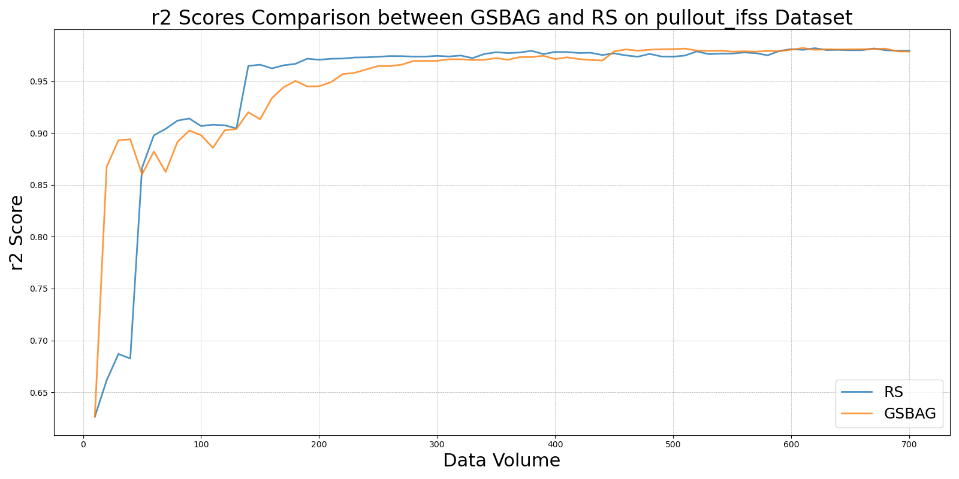

GSivs_RS_on_pullout_ifss.png

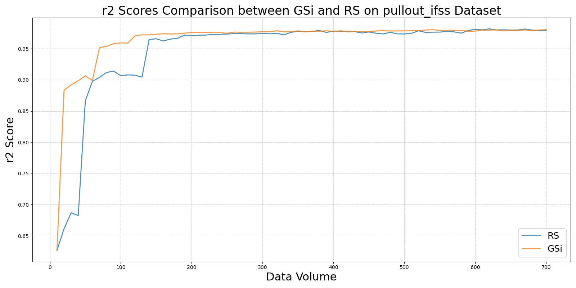

GSxvs_RS_on_pullout_ifss.png

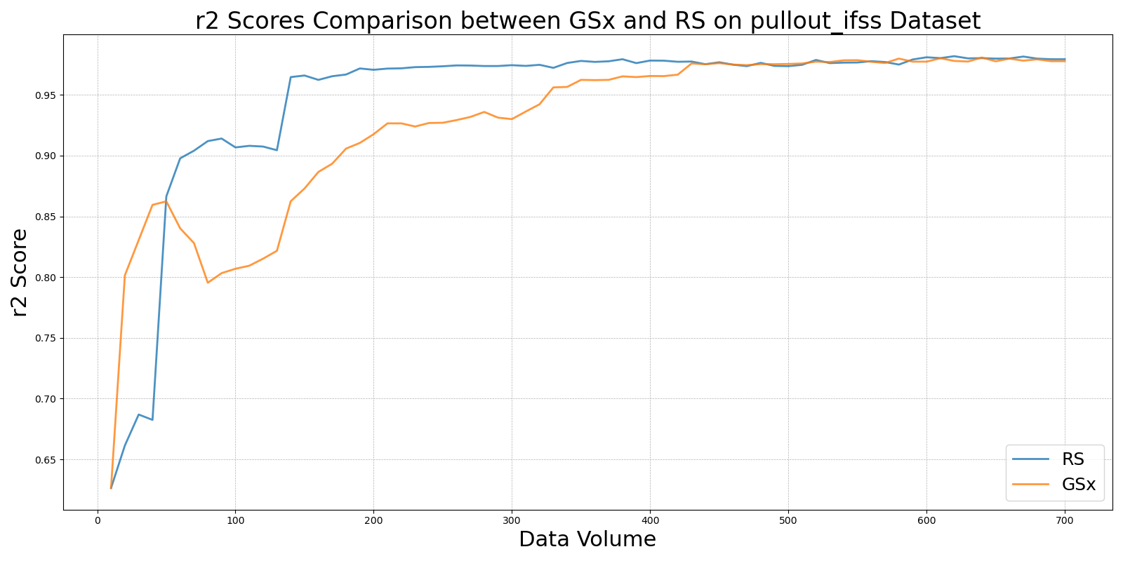

GSyvs_RS_on_pullout_ifss.png

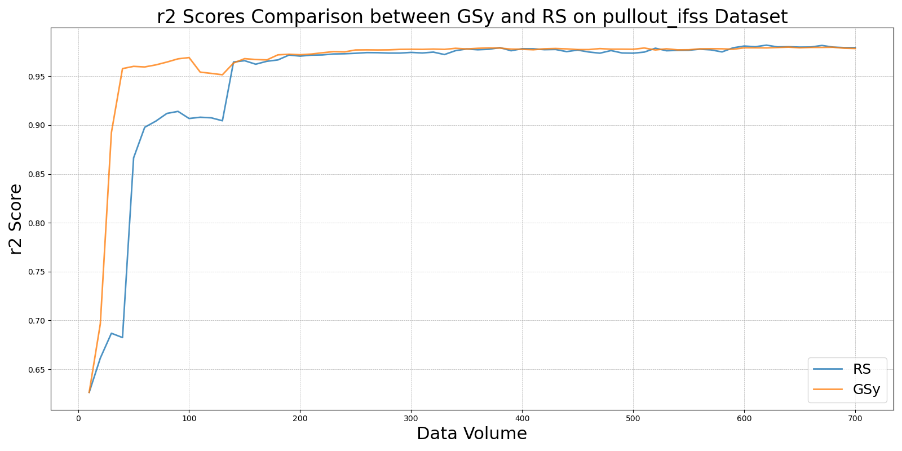

LCMDvs_RS_on_pullout_ifss.png

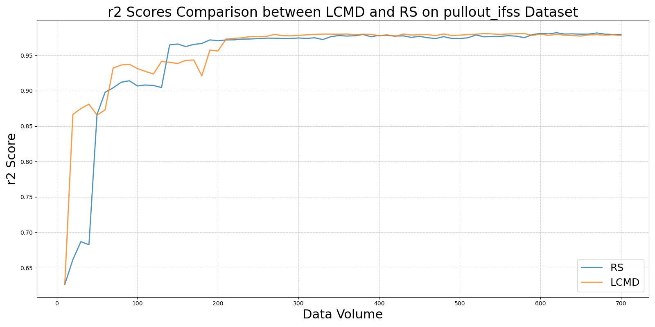

LL4ALvs_RS_on_pullout_ifss.png

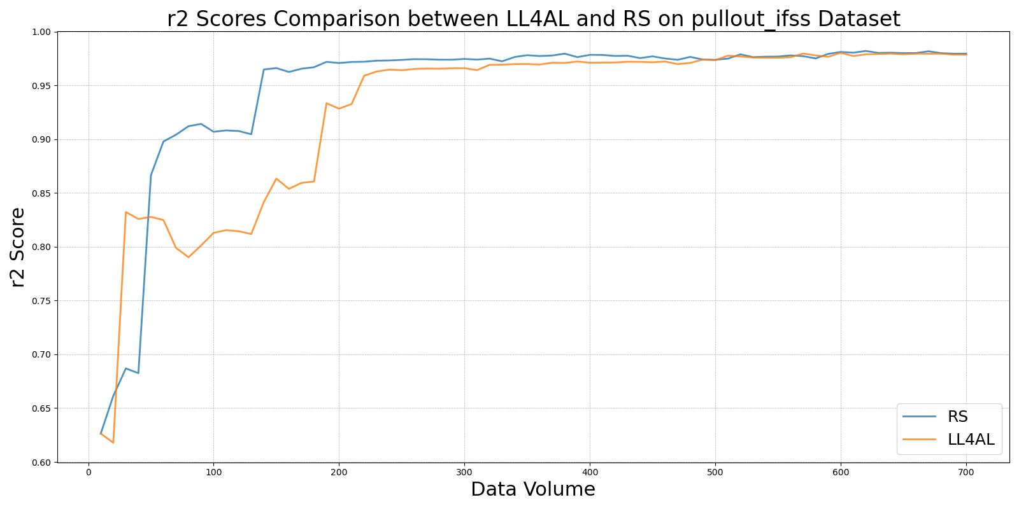

MCDvs_RS_on_pullout_ifss.png

