R2 Samples Report for 3 Thresholds

|  |  |  |  |
| --- | --- | --- | --- |
| Strategy | R2 >= 0.5 | R2 >= 0.7 | R2 >= 0.9 |
| RS | 60 (19.79%) | 140 (46.17%) | N/A |
| LL4AL | 250 (82.45%) | 290 (95.65%) | N/A |
| LCMD | 70 (23.09%) | 130 (42.88%) | N/A |
| MCD | 100 (32.98%) | 200 (65.96%) | N/A |
| EGAL | 120 (39.58%) | 200 (65.96%) | N/A |
| BayesianAL | 190 (62.66%) | 230 (75.86%) | N/A |
| GSx | 120 (39.58%) | 170 (56.07%) | N/A |
| GSy | 60 (19.79%) | 120 (39.58%) | N/A |
| GSi | 110 (36.28%) | 130 (42.88%) | N/A |
| GSBAG | 120 (39.58%) | 230 (75.86%) | N/A |

All_Strategies_on_uhpc_cs.png

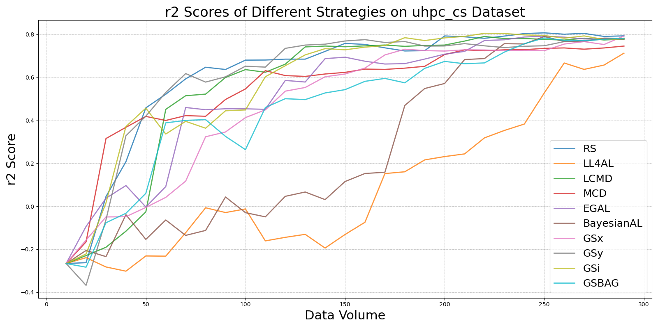

BayesianALvs_RS_on_uhpc_cs.png

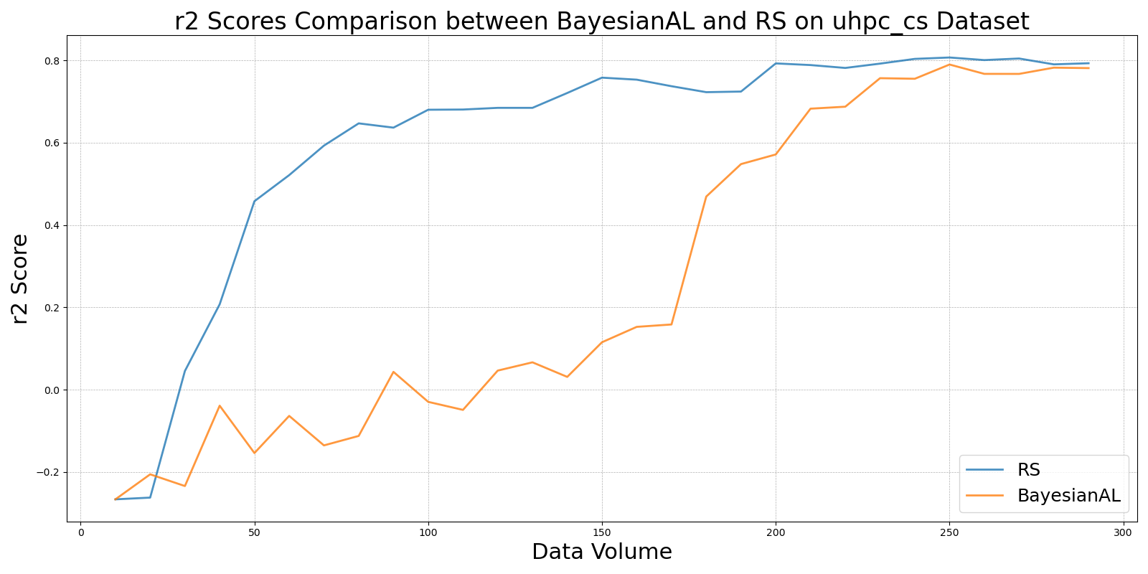

EGALvs_RS_on_uhpc_cs.png

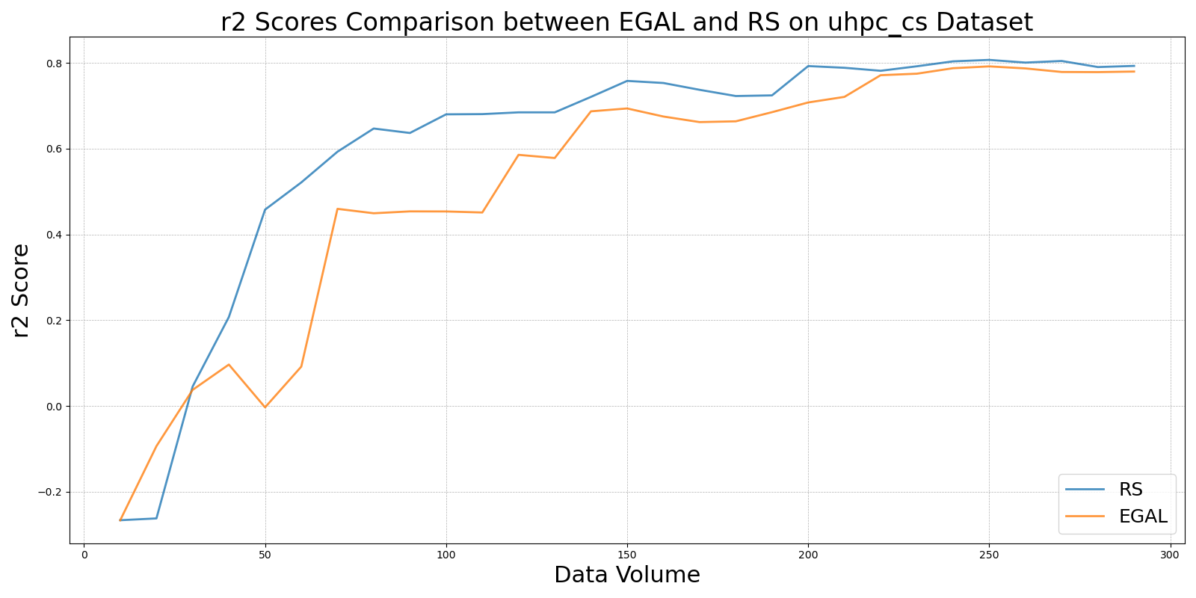

GSBAGvs_RS_on_uhpc_cs.png

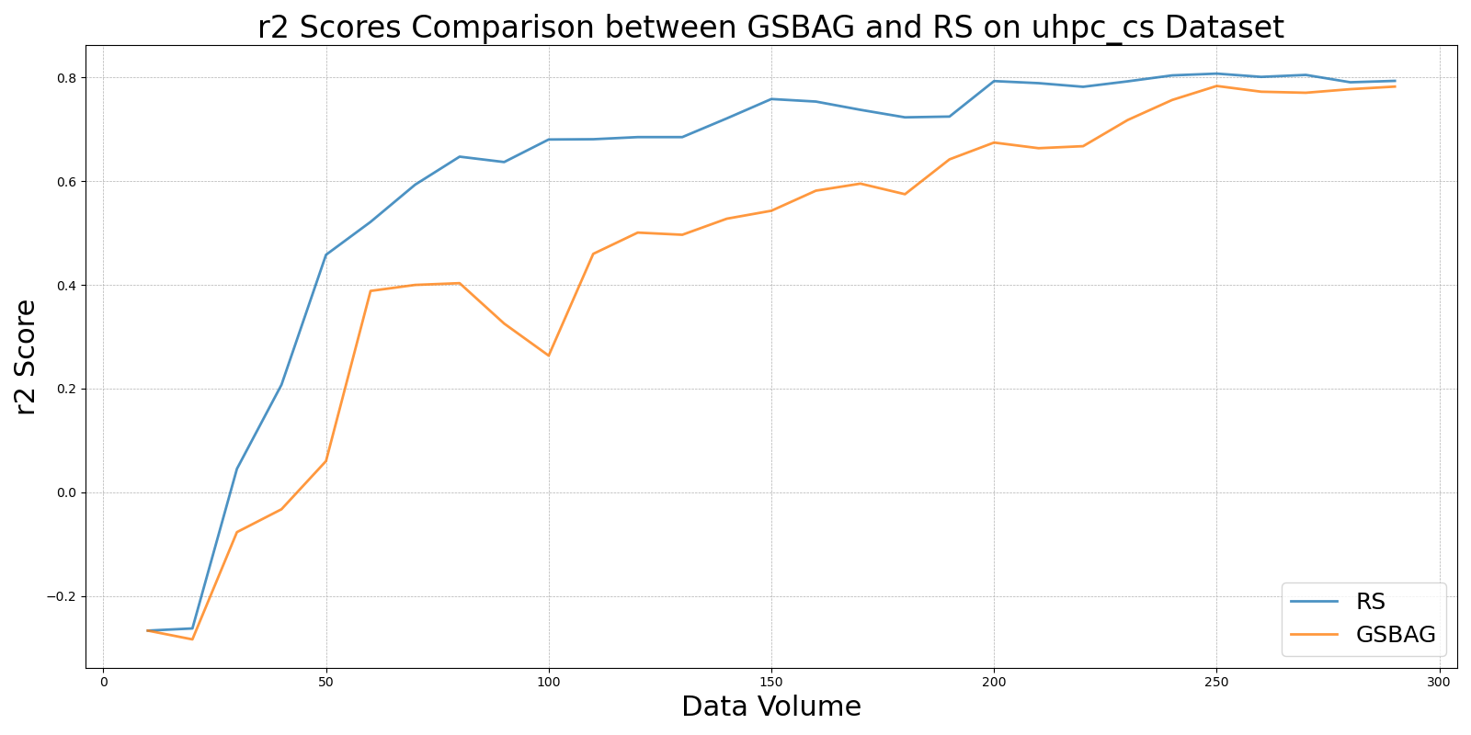

GSivs_RS_on_uhpc_cs.png

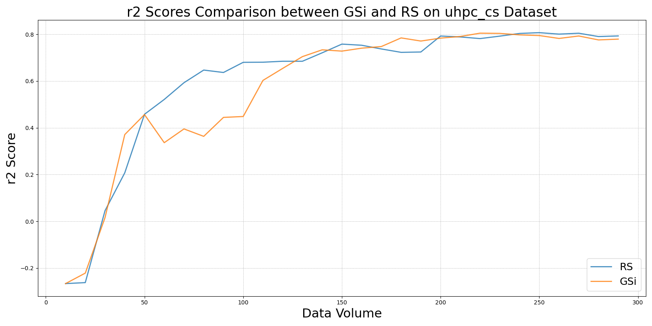

GSxvs_RS_on_uhpc_cs.png

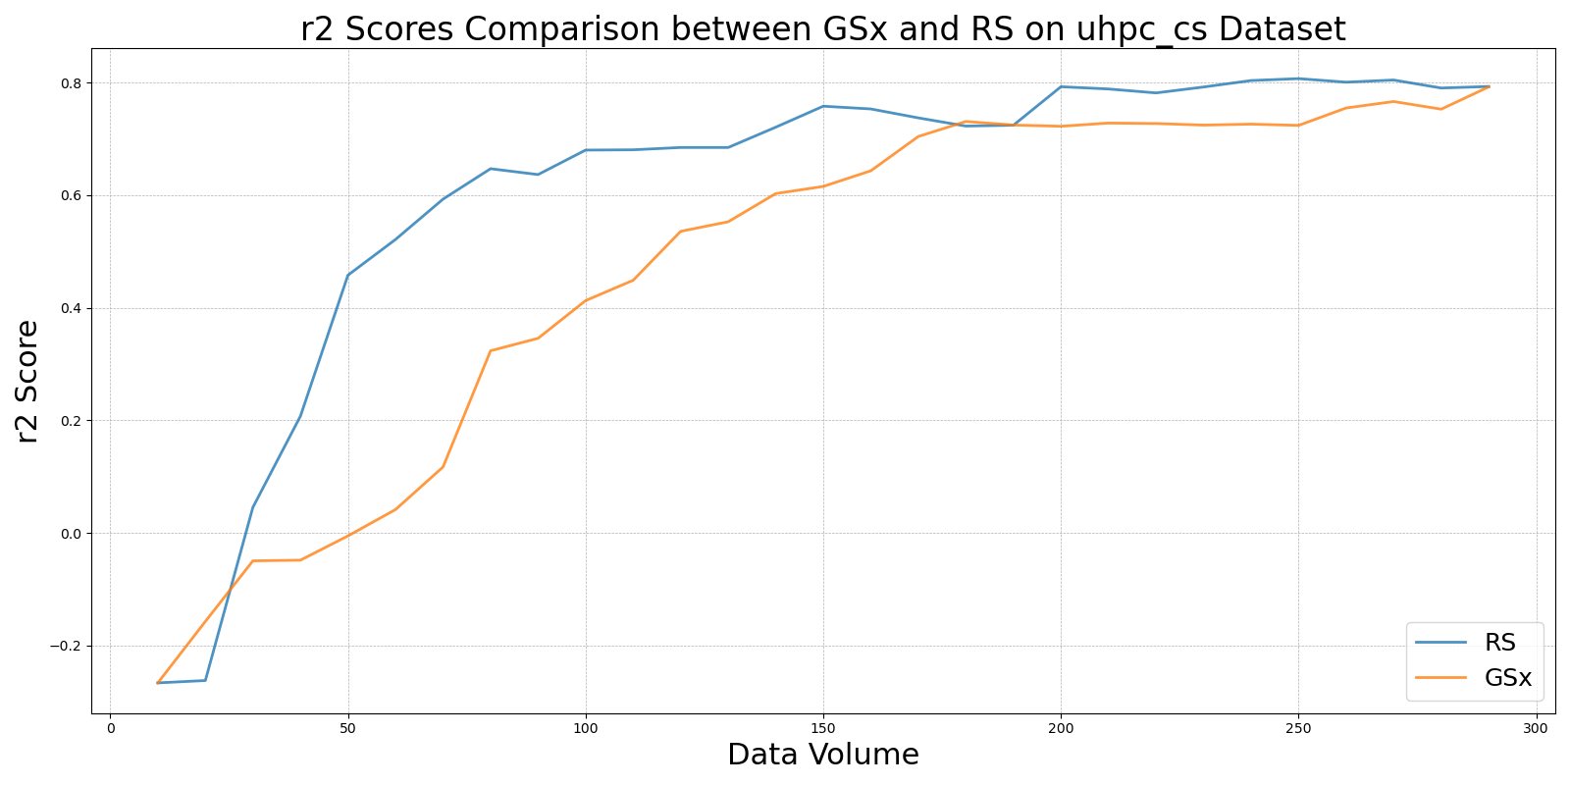

GSyvs_RS_on_uhpc_cs.png

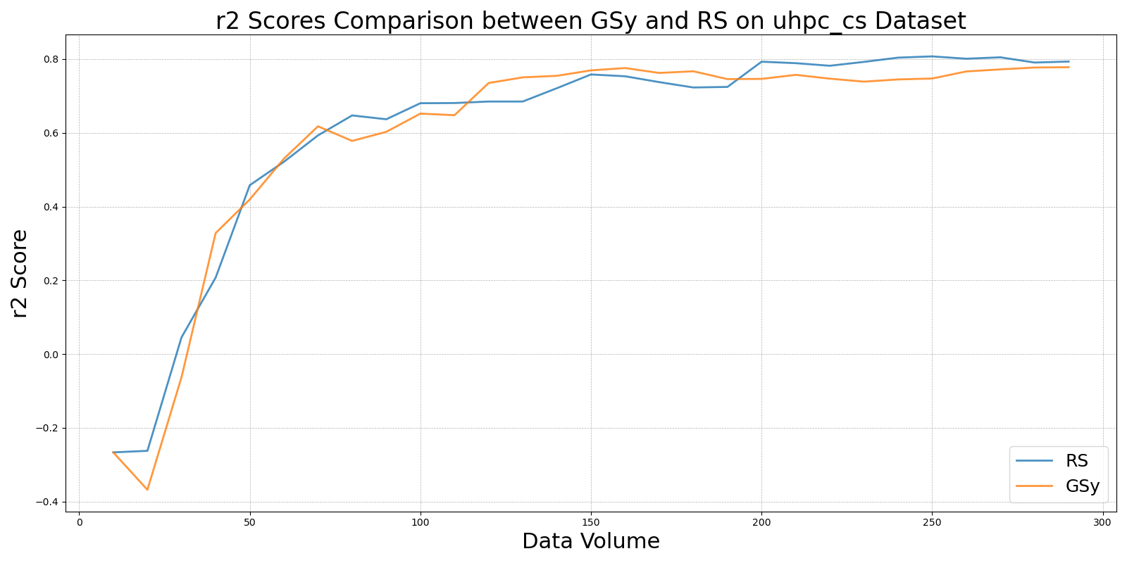

LCMDvs_RS_on_uhpc_cs.png

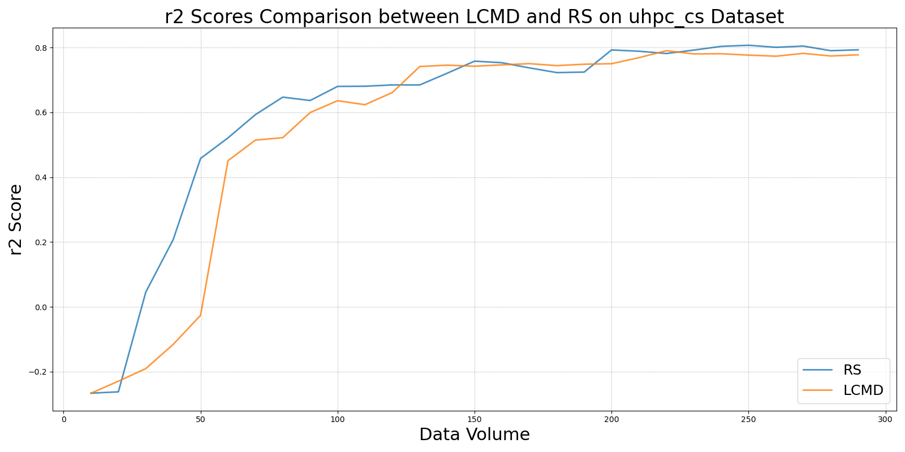

LL4ALvs_RS_on_uhpc_cs.png

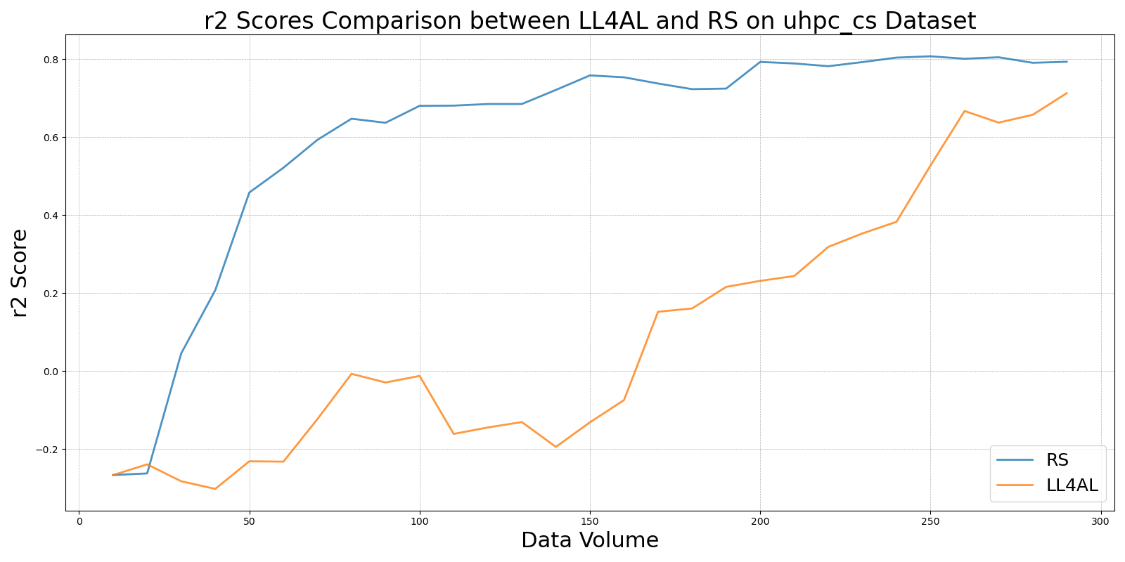

MCDvs_RS_on_uhpc_cs.png

