R2 Samples Report for 3 Thresholds

|  |  |  |  |
| --- | --- | --- | --- |
| Strategy | R2 >= 0.5 | R2 >= 0.7 | R2 >= 0.9 |
| RS | 60 (51.37%) | N/A | N/A |
| LL4AL | 70 (59.93%) | N/A | N/A |
| LCMD | 100 (85.62%) | N/A | N/A |
| MCD | 60 (51.37%) | N/A | N/A |
| EGAL | 90 (77.05%) | N/A | N/A |
| BayesianAL | 90 (77.05%) | N/A | N/A |
| GSx | 70 (59.93%) | N/A | N/A |
| GSy | 70 (59.93%) | N/A | N/A |
| GSi | 60 (51.37%) | N/A | N/A |
| GSBAG | 90 (77.05%) | N/A | N/A |

All_Strategies_on_uhpc_fs.png

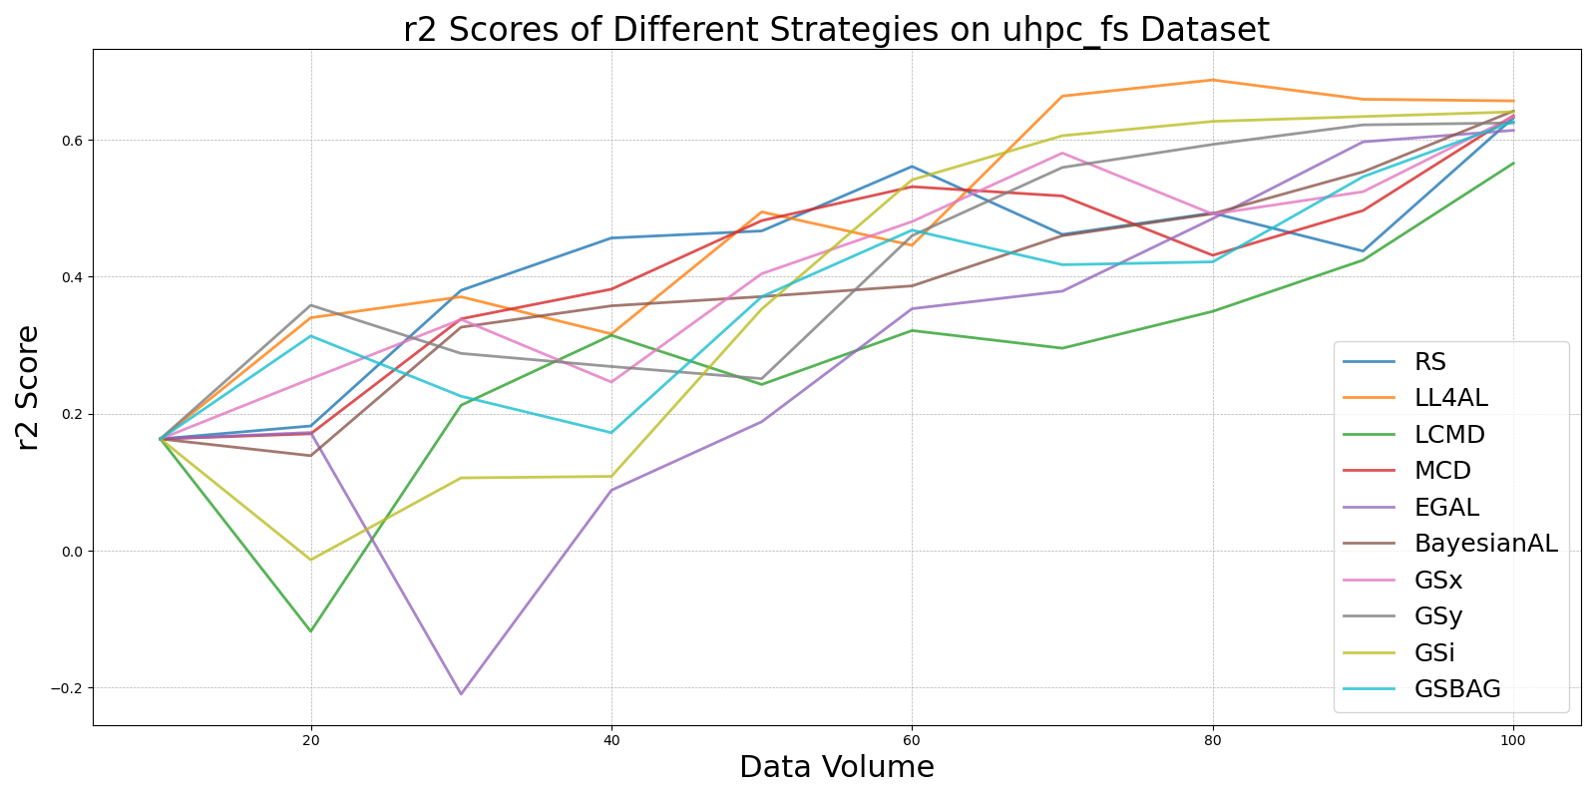

BayesianALvs_RS_on_uhpc_fs.png

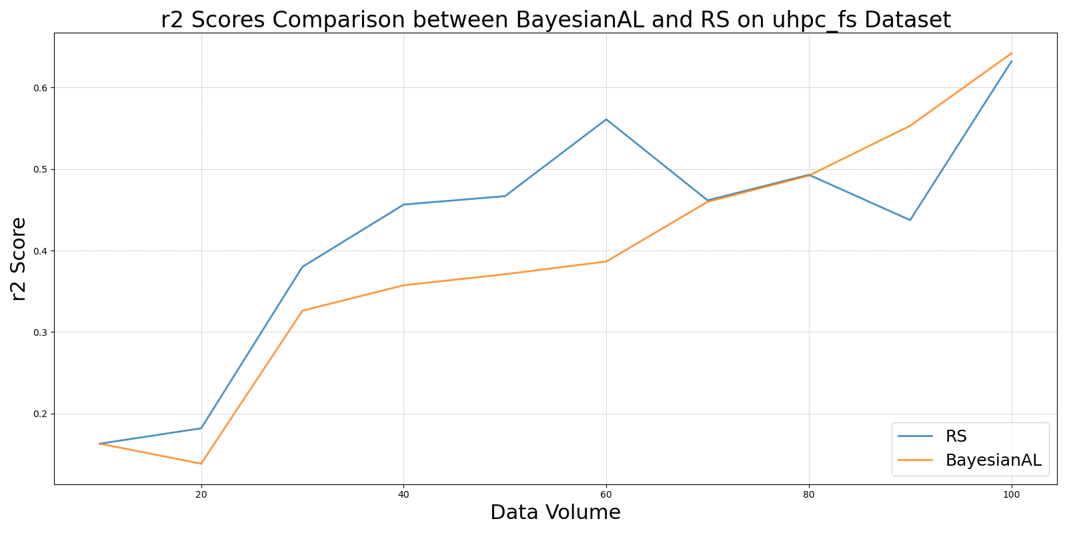

EGALvs_RS_on_uhpc_fs.png

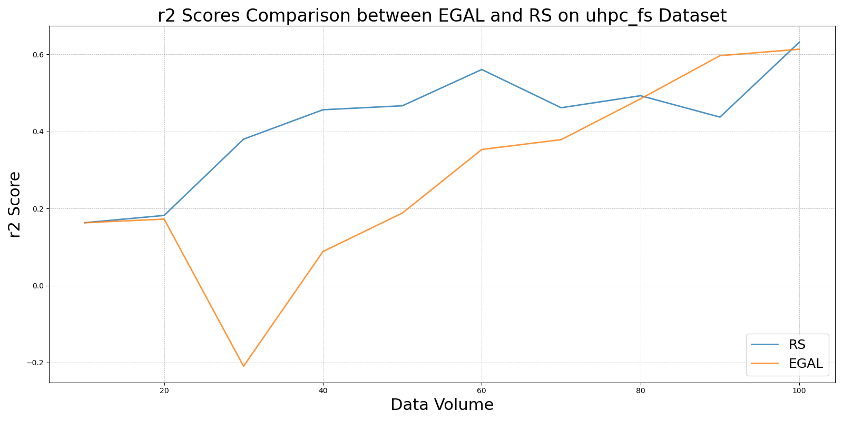

GSBAGvs_RS_on_uhpc_fs.png

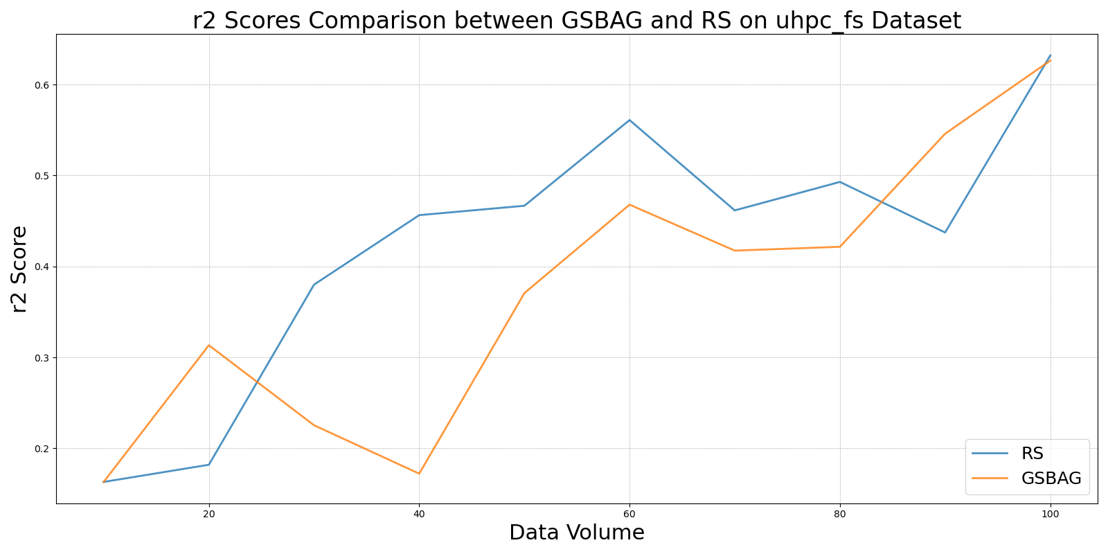

GSivs_RS_on_uhpc_fs.png

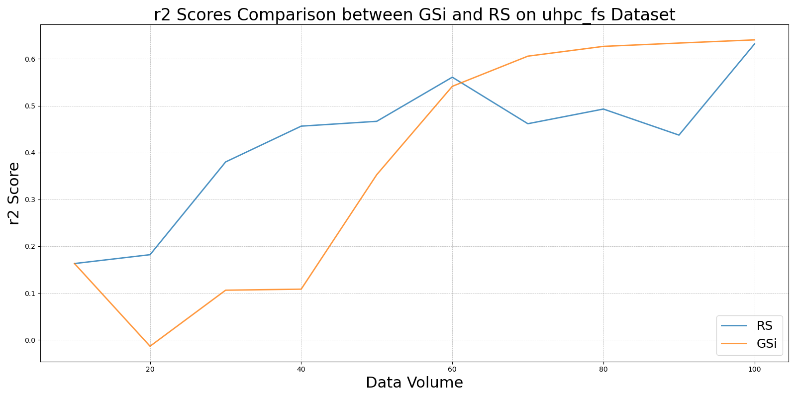

GSxvs_RS_on_uhpc_fs.png

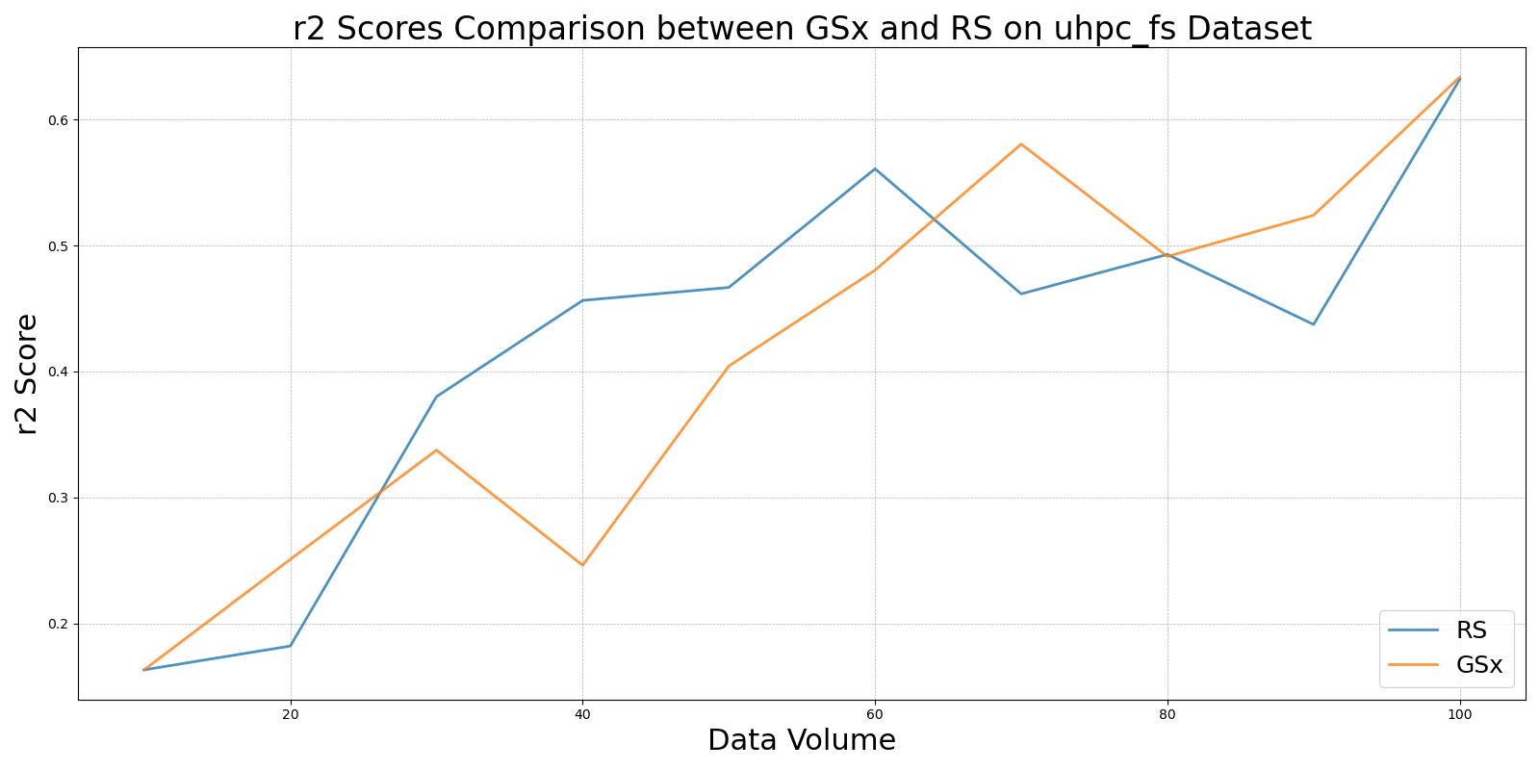

GSyvs_RS_on_uhpc_fs.png

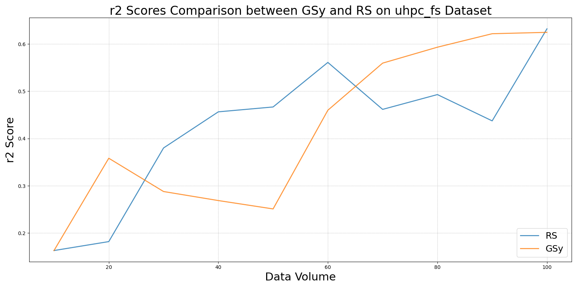

LCMDvs_RS_on_uhpc_fs.png

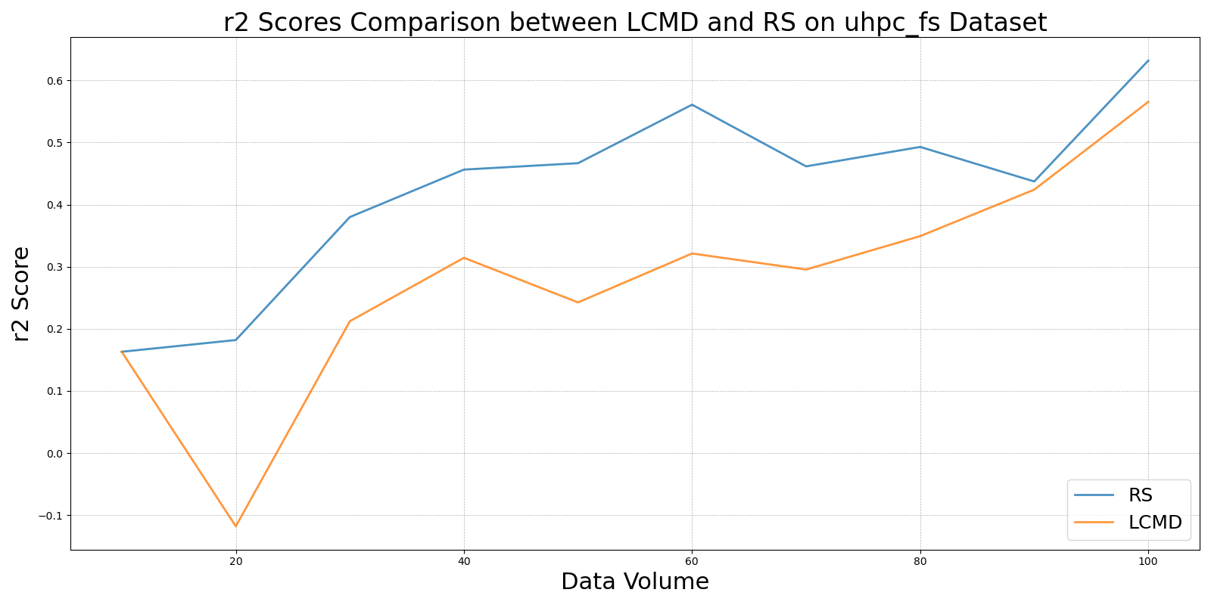

LL4ALvs_RS_on_uhpc_fs.png

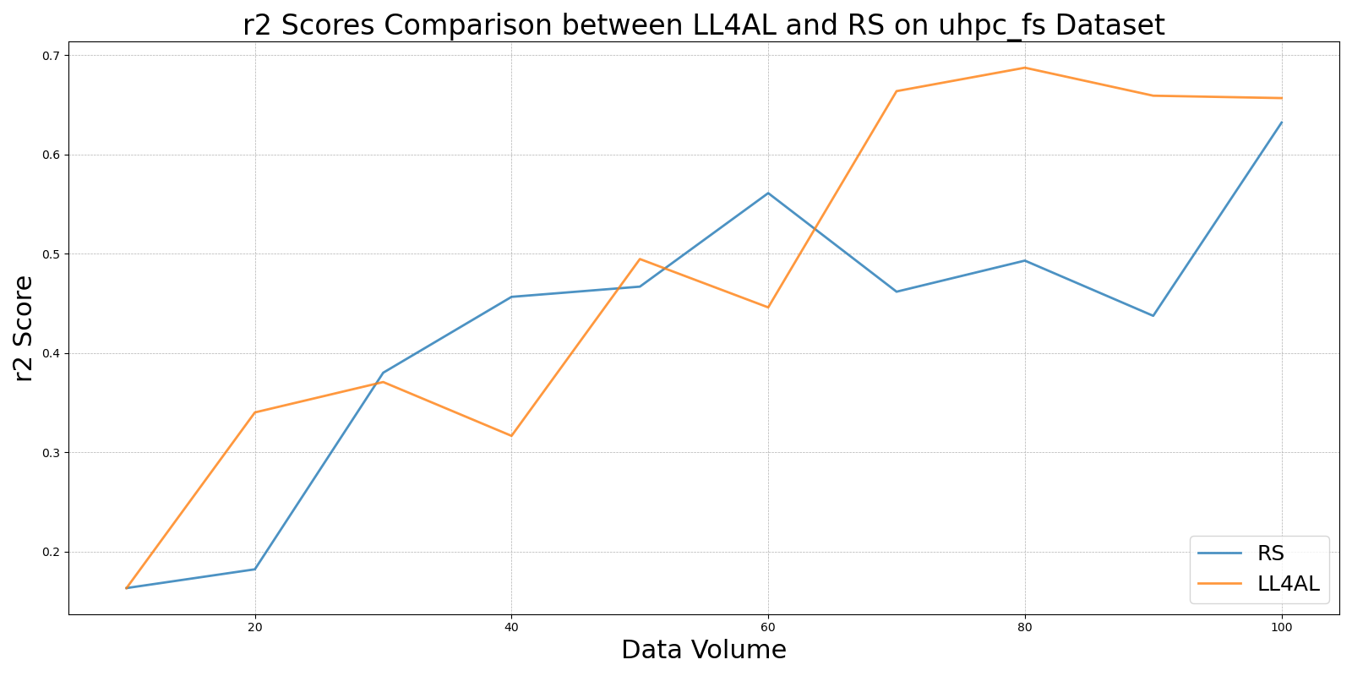

MCDvs_RS_on_uhpc_fs.png

